Understanding and managing UHC complexity

1. Level of understanding and attitudes toward UHC: the questions are numerous while values, interests, access to information and knowledge of stakeholders vary immensely.

UHC is defined by the World Health Organization (WHO) as ensuring that all people can use the promotive, preventive, curative, and rehabilitative health services they need, of sufficient quality to be effective, while also ensuring that the use of these services does not expose the user to financial hardship. The UHC cube helps to illustrate the three dimension of population, service and cost coverage in a simple way.

However, UHC is far more complex. To get a fuller picture one needs to go beyond the cube and consider the realities that are not shown in this technical graph.

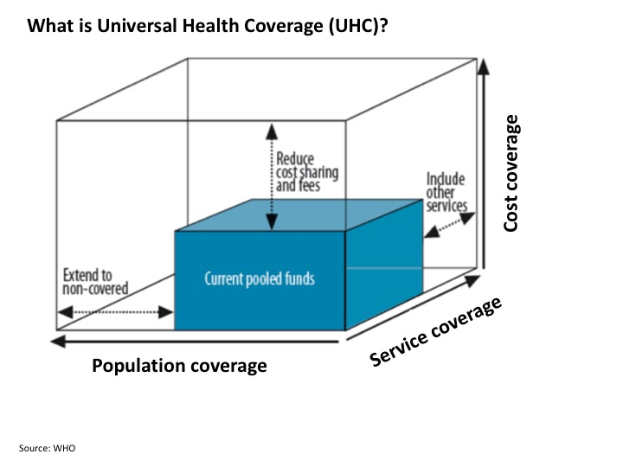
--> UHC cube slides (1 and 2)
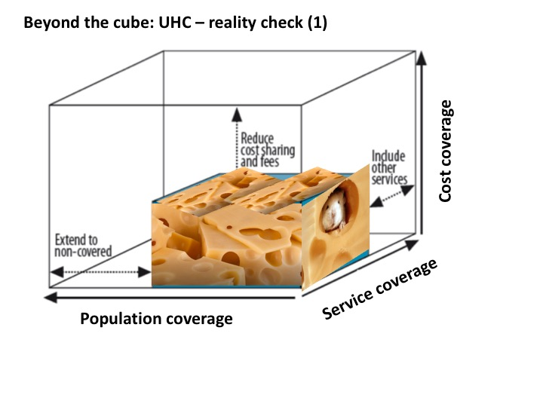

- The current coverage may not be as homogenous as illustrated in the cube. In reality, there are many and often hidden gaps in coverage and variation in access between rural and urban areas, differences in quality of services, etc. and not to forget leakages in the system.
- UHC is a concept strongly affiliated with values of human rights, solidarity or equity. In particular the aspect of social justice, i.e. providing needed services to everyone irrespective of their social, economic or ethnic status while ensuring financial risk protection (cost coverage) requires not only technical but more importantly political solutions.
- Designing and implementing such solutions requires cooperation among a number of diverse actors and support across various institutions, who may have different values, beliefs, interests, access to information and knowledge about UHC. Equitable distribution of resources and the process of redistributing resources and power is contentious. For instance, stakeholders that belief that health is more of an individual than a state responsibility may rather be battling against UHC. Political parties that do not value equity and inclusiveness may not place UHC on their manifesto even if it was technically feasible.
- Financial interests of the health professionals and pharmaceutical industries can strongly differ from health financing agents.
- High-level authorities often don’t have direct exposure to ground level experience and reality. Information circulation among all involved stakeholders is insufficient and evidence-based knowledge can be hidden, ignored or dismissed.

2. Who's business is UHC: the number of stakeholders is huge and growing

--> P4H framework slide
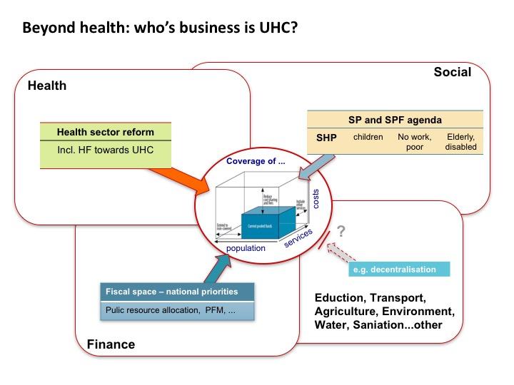
- Conceptually, UHC is at the intersection of health, finance and social protection. This includes respective ministries, health and social services providers, pharmaceutical and other industries, health professionals, etc.
- Financing UHC, in particular the aspect of equity, social justice and financial risk protection is a national issue which concerns the head of state, cabinet and parliament as well as civil society at large.
- With the continuous expansion of preventive, promotive and curative services included in the UHC concept, other sectors playing an important role in the quest for health and well-being are: education, environment, water and sanitation, transport, agriculture, etc.
- In decentralised countries local administrations need to be included.
- Others are media, international organizations, development partners and foundations.
- Every listed stakeholder category is a particular ecosystem as such, with internal institutional subdivisions and individuals carrying their respective mandates in autonomous ways.

3. Operating structures are simultaneously vertical and horizontal

--> 3D version of framework slide
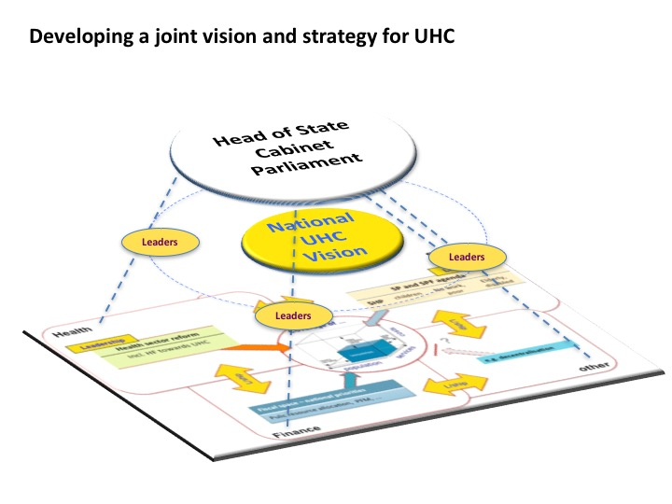
- Moving towards UHC without highest level commitment and political will is difficult. It is important to bring sectors together, galvanise their energies to jointly advocate for the head of state, cabinet and parliamentarians to become involved and support the agenda.
- However, the dynamics across sectors and levels can be very complex and challenging.

4. Interactions among stakeholders are rich and unstable
Interactions take place both at institutional representative level as well as between the subdivisions of the various stakeholders without necessarily involving all subdivisions of the two stakeholders concerned. The department of budget of the ministry of finance exchanges strategic information with the department of social protection of the ministry of labour without sharing with other parts.

These multiple interactions affect both the stakeholders involved as well as the UHC system as a whole and can quickly modify previously existing interactions. The department of social protection of the ministry of labour informs its alter ego in the ministry of health and triggers a new interaction between ministry of health and ministry of finance that has negative consequences on the previous interaction.

Key message: There is widespread support for the idea of UHC, but actually realizing UHC at country level is contentious. Key players and groups hold divergent values, beliefs and interests, and technical efforts to advance reform often stall when these interests cannot be aligned.

5. The nature of the stakeholders’ influence is modulated
Media has a strong influence on high-level authorities but has a very limited influence on health professionals in their daily practice. Health professionals have a strong influence on the pharmaceutical industry and vice versa but very limited on the international organizations and civil society. Etc.

6. Managing change toward UHC: processes are non-linear

--> 3rd UHC cube slide
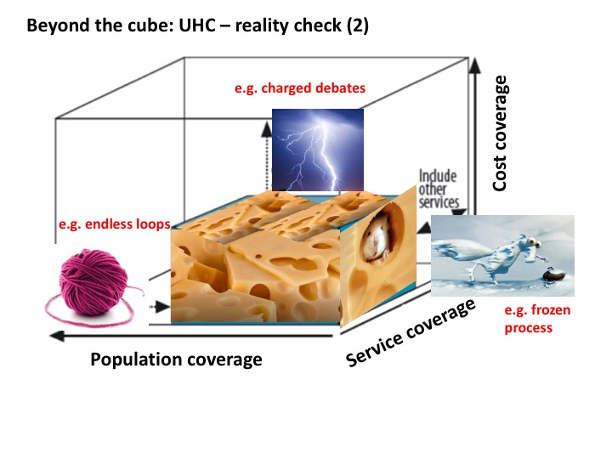
- Due to the political nature of UHC, reforms for expanding population, service and cost coverage are hardly linear processes (in contrast to the straight arrows in the cube). The experience shows that moving towards UHC comes with never ending loops, back and forth on contentious issues; charged and heated debates about redistribution of resources; or simply getting stuck in the process (frozen process).
- Another issue, which adds complexity is the inter-connectedness of the three dimension and related trade-offs (e.g. expanding benefits to all is leads to a reduction of benefits)

One way of improving our understanding of UHC is to look beyond the surface by applying system thinking and using respective tools for analysing the underlying issues.

6.1. Introducing system thinking

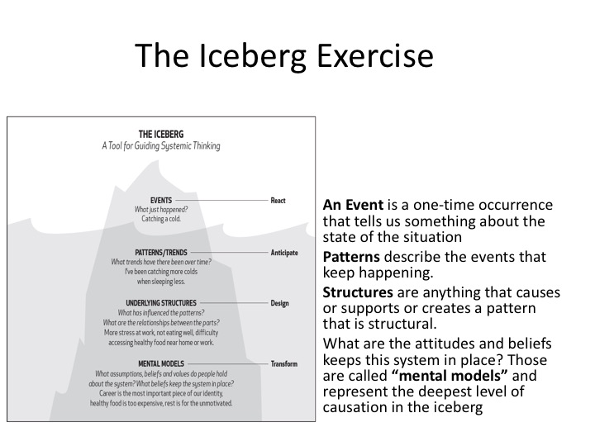
--> Iceberg slide

Systems thinking is a way of approaching problems that asks how various elements within a system influence one another. Rather than reacting to individual problems that arise, a systems thinker will ask about relationships to other activities within the system, look for patterns over time, and seek root causes.
One systems thinking model that is helpful for understanding global issues is the iceberg model. We know that an iceberg has only 10 percent of its total mass above the water while 90 percent is underwater. But that 90 percent is what the ocean currents act on, and what creates the iceberg’s behavior at its tip.

LEVELS OF THINKING
1. The Event Level. The event level is the level at which we typically perceive the world. While problems observed at the event level can often be addressed with a simple readjustment, the iceberg model pushes us not to assume that every issue can be solved by simply treating the symptom or adjusting at the event level.
2. The Pattern Level. If we look just below the event level, we often notice patterns. Similar events have been taking place over time. Observing patterns allows us to forecast and forestall events.
3. The Structure Level. Below the pattern level lies the structure level. When we ask, “What is causing the pattern we are observing?” the answer is usually some kind of structure.
4. The Mental Model Level. Mental models are the attitudes, beliefs, morals, expectations, and values that allow structures to continue functioning as they are.

6.2. Example of a UHC-related mental model.
Access to care as a right versus access to health not being a right, rather seen as individual responsibility or as earned privilege

--> Applying system thinking (iceberg model) to UHC
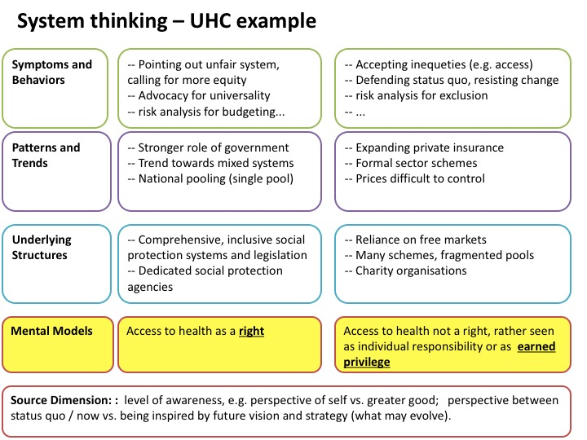

Systems thinking (in particular the iceberg model) can help in getting a better understanding of the underlying mental models and different positions that may need political dialogue and consensus building. One point of caution: experience shows, that most discussions about UHC are happening at the event or symptom level. Talking about underlying issues of UHC often means entering the political sphere and leaving one's comfort zone. A facilitated discussion and use of some leadership tools may help to deal with underlying challenges more effectively.

6.3. Beyond the surface: examples of underlying opposite positions influencing UHC reform

--> Beyond the surface slide
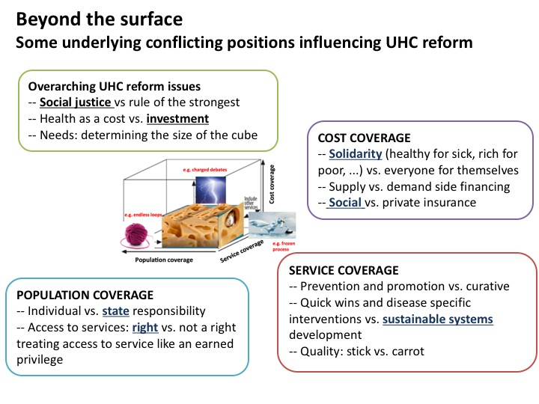
There are multiple paths to UHC - another important aspect, which is adding complexity. The reason why countries take different routes depends to a large extent on stakeholders' underlying values, beliefs and interests, especially when technical options do not have clear cut advantages among one another. However, we also need to keep in mind that there may be some hierarchies and interactions between different mental models. For example someone, who values personal freedom the most may not be in favour of being tied up in social contracts. Though this person may not be against the principle of solidarity or considering access to health services as a human right, she or he may want to keep this rather voluntarily than mandatory, e.g. favouring private voluntary health insurance. This in turn is often linked to believes that free markets would serve health needs better than government intervention and public services. So people may not necessarily be opposed to the idea of UHC, their values, beliefs and interests may still lead them to vote against mandatory participation in redistributional national social protection systems.

Below is a list of other common examples of mental models that are strongly influencing the process at the surface, e.g. when developing UHC policies and strategies. A deeper understanding of these issues may help leaders to facilitate processes and stakeholder interactions more effectively, e.g. who to form coalitions with, when to involve different stakeholders and how to effectively communicate key messages. The list is neither exhaustive nor in a particular order.
- Do stakeholders believe in social justice or prefer the rule of the strongest?
- Access to services: right vs. not a right, e.g. treating access to service like an earned privilege
- Freedom to choose: Should participation in national health programs be mandatory or voluntary; should people have the choice to opt out of the system?
- Is UHC considered a state or an individual responsibility?
- Do stakeholders believe that free markets would serve health needs better than government interventions and public services?
- Is there support for the principle of solidarity (healthy for sick, rich for poor, ...) or is it everyone for themselves?
- Do stakeholders prefer a supply-side approach over demand-side financing, e.g. a public national health service versus social health insurance?
- Is spending on health perceived as a cost or an investment?
- Do stakeholders prefer incremental versus big bang change? E.g. conservative approach versus preparedness to take some calculated risks.
- Are curative services considered more important than health prevention and promotion?
- Are quick wins and disease specific interventions preferred over sustainable systems development? This question is often linked to political interests of showing results within an election cycle.
- When it comes to improving the quality of health services, do stakeholders belief in sticks or carrots? E.g. using standards and regulation versus incentives, which stimulate intrinsic motivation?

7. Discrepancy between legal and operational implementation processes.
A UHC law is passed but without proper preparation, without implementation capacity and with new legal provisions being passed before implementation of the previous legal set of norms.

8. History influences the present
UHC processes are not situated in a temporal vacuum. Some or all of the questions raised in section 2 have been answered in the past and some elements of these answers have been implemented. The path followed results in both the present UHC situation as well as acquired patterns that influence the way to answer these same questions presently.

9. Conclusion
UHC is complex, characterized by emergent properties and behaviour. On one hand UHC is a moving target considering evolving medical technology and changing health and social needs, on the other hand stakeholder positions and interactions are in a continuous flow and hard to predict. Even if we understand individual aspects and parts, it is still difficult to understand the behaviour of the entire system.

Leaders can facilitate dialogue to foster a common language and understanding of UHC issues, but also the dynamics and perspectives of various stakeholders. Leader can initiate and facilitate the development of a vision; promote and lead a strategic approach; and become an agent and champion of change. As UHC is everyone's business, leaders can help in getting everyone on board and broaden ownership, build up a movement for UHC, including people and media; forming inter-sectoral fora and facilitate dialogue within and across sectors; help building consensus and coherent policies within and across sectors and levels.

--> Role of leadership slide:
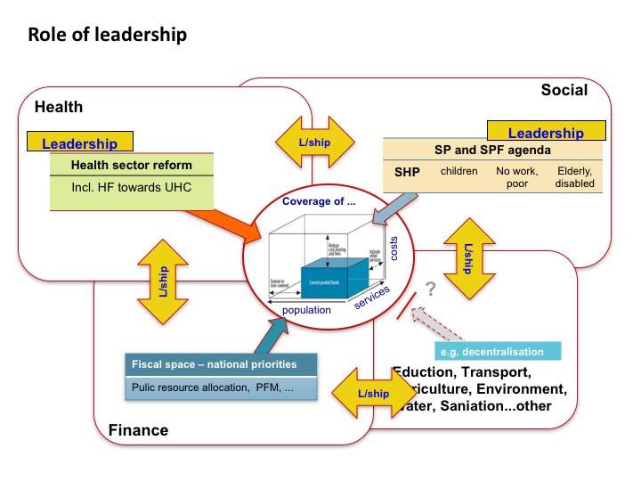

Links to other sessions that are expected to contribute to a better understanding of UHC:
- Definition and reflections on UHC, global and regional overview (e.g. key notes by UHC experts);
- Sculpting (UHC aspect);
- Visioning and strategizing for UHC (envisioning the future);
- Country presentations;
- Knowledge cafe topics: prioritizing health; power; etc. [how well do the chosen topics serve the objective?]
- UHC aspect of sensing journeys
- Participation in RRIs, discussion of RRIs (UHC aspect) in module 3
- ...?

