
UNITED REPUBLIC OF TANZANIA

MINISTRY OF HEALTH, COMMUNITY DEVELOPMENT, GENDER, ELDERLY AND CHILDREN

HEALTH SECTOR PUBLIC EXPENDITURE REVIEW, 2015/16

PREPARED BY:
DIRECTORATE OF POLICY AND PLANNING
MINISTRY OF HEALTH, COMMUNITY DEVELOPMENT, GENDER, ELDERLY AND CHILDREN

DAR ES SALAAM

DRAFT,

Table of Contents

Table of Contents ii
List of Tables iii
List of Figures iv
List of Abbreviations v
Executive Summary vi
1.0 Introduction 1
2.0 Review of PER FY2014/15 Recommendations and Actions Taken 3
3.0 Health Budget and Expenditure Analysis 6
3.1 Introduction 6
3.2 Total Public Health Spending 6
3.3 Sources of Funds for the Public Health Expenditure 10
3.4 Trends in Recurrent and Development Expenditures 11
3.5 Performance of the Health Sector Budget 13
3.6 Health Sector Budget and Expenditure by Levels of Government 15
4.0 Complementary Health Financing 17
4.1 Introduction 17
4.2 Health Services Fund 17
4.3 The National Health Insurance Fund 17
4.3.1 Membership and Utilization of Health Services 17
4.3.2 Income and Expenditure 18
4.3.3 NHIF Spending by Ownership of Facilities 18
4.3.4 NHIF Spending by Levels of Health System 19
4.3.5 NHIF Spending by Regions 20
4.4 Community Health Fund 22
4.5 CHF Revenues and Matching Funds 24
5.0 Local Government Health Sector Spending 25
5.1 Introduction 25
5.2 LGAs Budget and Expenditure by Source of Funds 25
5.3 Recurrent and Development Spending at LGA 27
5.4 Budget and Expenditure by LGAs Sub-Votes 29
5.5 Budget Performance at LGA Level 29
6.0 Conclusions and Recommendations 31
6.1 Health Financing 31
6.2 Recommendations 34
ANNEXES 35
Annex A: Aggregate Data Used For Analysis (Tzs Million) 36
Annex B: CHF Enrollment Per Region 37

List of Tables

Table 2.1: Summary of PER FY2014/15 Recommendations and Actions Taken 3
TABLE 3.1: INDICATORS OF PUBLIC HEALTH FINANCING …………………………………………………………………………………………….9
Table 3.2: Sources of Health Financing (BN TZS) 10
Table 3.3: Summary of Recurrent and Development Budget and Expenditures (BN TZS) 11
Table 3.4: Health Spending by Levels of Government (BN TZS) 16
Table 4.1: HSF Revenues and Expenditures, FY2012/13 – FY2015/16 17
Table 4.2: Basic Data on NHIF Membership and Utilization of Health Services, FY2012/13 – FY2015/16 18
Table 4.3: Basic Data on NHIF Income and Expenditure, FY2012/13 – 2015/16, (MN TZS) 18
Table 4.4: NHIF Claims by Region, 2015/16 21
Table 4.5: NHIF Data on Matching Grant Funding Received and Paid Out, 2012/13 – 2015/16 24
Table 5.1: LGA Budget and Expenditure by Source (MN TZS) 26
Table 5.2: Government Recurrent and Development Budget and Expenditures at LGAs, FY 2014/15 28
Table 5.3: Budget and Expenditure by LGAs Sub-Votes 29

List of Figures

Figure 3.1a: Public Health Budget Trends (BN TZS) 6
Figure 3.1b: Public Health Expenditure Trends (BN TZS) 7
Figure 3.2a: Health Spending as % of Government Budget 7
Figure 3.2b: Actual Health Spending as % of Government Spending 8
Figure 3.3a: Trends of Per Capita Public Health Budget 8
Figure 3.3b: Trends of Per Capita Public Health Expenditure 9
Figure 3.4: Government and Foreign Contribution to Health Expenditures 10
Figure 3.5: Trend of Shares of Recurrent and Development Budget and Expenditures 13
Figure 3.6a: Overal Budget Execution 13
Figure 3.6b: Local Funding Budget Execution 14
Figure 3.6c: Foreign Funding Budget Execution 14
Figure 3.6d: Budget Execution by MoHCDGEC Department, 2015/16 15
Figure 3.7: Shares of Health Resources to the Different Levels of Government 16
Figure 4.1: NHIF Payments by Facility Ownership Type, FY 2012/13 – 2015/16 19
Figure 4.2: NHIF Spending by Type of Facility, 2014/15 20
Figure 4.3: NHIF Value Cost by Region, 2015/16 22
Figure 4.4: CHF Coverage and Membership, 2012/13 – 2015/16 22
Figure 4.5: Estimated CHF Coverage by Regions, 2015/16 23
Figure 5.1: LGA Budget and Expenditure by Source 27
Figure 5.2: Government Recurrent and Development Spending at LGA 28
Figure 5.3: Budget Performance at LGA, 2012/13-2014/15 30

List of Abbreviations

ADDOs Accredited Drug Dispensing Outlets
CCHPs Comprehensive Council Health Plans
CFS Consolidated Fund Services
CHF Community Health Fund
CHMT Council Health Management Team
DHIS2 District Health Information 2
FFARS Facility Financing, Accounting, and Reporting System
FY Financial Year
GoT Government of Tanzania
HBF Health Basket Fund
HPSS Health Promotion and Systems Strengthening
HSF Health Services Fund
HSSPs Health Sector Strategic Plan
ICT Information, Community, and Technology
LGAs Local Government Authorities
MDGs Millennium Development Goals
MoFP Ministry of Finance and Planning
MoHCDGEC Ministry of Health, Community Development, Gender, Elderly and Children
MN Million
NHIF National Health Insurance Fund
OC Other Charges
PE Personal Emoluments
PER Public Expenditure Review
PO-RALG President’s Office - Regional Administration and Local Government
PRSP Poverty Reduction Strategy Paper
PS3 Public Sector Systems Strengthening
SDGs Sustainable Development Goals
UHC Universal Health Coverage
TZS Tanzanian Shillings
WHO World Health Organization

Executive Summary

The Health Sector PER for 2015/16 Financial Year sets out to assess the budgetary allocations and expenditures to inform stakeholders about progress made in key health financing milestones over the 2012/13–2016/17 period. Specifically, the PER FY15/16 provides:
- A review of PER FY14/15 findings and actions taken by the sector in response to those findings, indicating unaccomplished/pending actions, and identifying follow-up actions.
- Analysis of the trends in the sources of funding for the health sector for the past five fiscal years.
- Analysis of the trend of recurrent and development budget and expenditures for the past five fiscal years.
- Analysis of budget and expenditure trends for the different sectoral and sub-sectoral levels including the central-local government split.
- Assessment of budget performance (allocation versus actual spending) by classification (development and recurrent), funding sources (government funding and foreign funding), and different levels (central and local).

Key PER Findings

(a) General Trend in Health Financing

The share of government actual spending to the health sector has not kept pace with general government spending between 2012/13 and 2015/16 – it has declined with and without Consolidated Fund Services (CFS):

Although the total public health budget in both nominal and real terms increased significantly from 2012/13 to 2015/16 (94.1% and 67.3% increase respectively), the actual health spending in both nominal and real terms showed a modest increase (37.1% and 17% increase respectively). However, the share of actual health spending in total government spending (excluding CFS) declined from 9.2% in 2012/13 to 7.3% in 2015/16, while with CFS included the decline in the share of health spending was from 8.7% in 2012/13 to 8.0 in 2015/16.

Despite the increase in the public health spending overtime, it has not kept pace with the population growth thus leaving just a modest amount to be spent per capita:

In real terms, there is an upward trend for both per capital budget allocation and actual expenditure – increase from TZS 16,228 (USD 10.27) in 2012/13 to TZS 18,315 (USD 10.59) in 2015/16 and TZS 13,480 (USD 8.53) in 2012/13 to TZS 14,540 (USD 8.41) in 2015/16 respectively. Because of population growth, domestic inflation and depreciation of the shilling, the estimated per capita health expenditures in real terms have consistently remained below USD 10 throughout the review period which is shot of USD 54 recommended by the World Health Organization (WHO).

(B) Sources of Financing

Government funding remains the dominant source of public health financing. The donor funding has been unpredictable especially the non-basket source:

The actual government spending increased from TZS 765.3 billion in 2012/13 to TZS 1,260.8 billion in 2015/16 which is a 64.7% increase while the actual expenditure for foreign funds declined from TZS 289.9 billion in 2012/13 to TZS 190.4 billion in 2015/16 which is a 52.3% decline. The expenditure from health basket in particular, declined by 24% from TZS 142.8 billion in 2012/13 to TZS 96.9 billion in 2015/16. Comparing the non-basket funds approved estimates for 2015/16 with the actual expenditure there is a significant difference – TZS 419,350 billion, meaning that only 18% of the approved estimate was released.

(C) Recurrent and Development Expenditures

Dwindling development expenditure is a concern given the need to improve health facility infrastructure especially in the rural areas:

The share of actual recurrent expenditure increased significantly from 64% in 2012/13 to 87% in 2015/16. However, actual development expenditure decreased by 41%, from TZS 324.3 billion, in 2012/13 to TZS 191.4 in 2015/16. Throughout the review period, development expenditure has been consistently low than the recurrent expenditure.

(D) Budget Performance

There is inconsistency in budget performance which is detrimental to service delivery. At the Ministry of Health level, the Preventive Services Department has worse performance (9%). This is a concern given the importance of protecting communities from infections through properly designed health prevention programs:

Overall, the execution of the total budget was consistently high (above 80%) from 2011/12 but it experienced a significant decline in 2015/16; declined to 70%. The performance of the basket fund is consistently high – above 89% for each year in the review period. Execution of non-basked funding is the lowest. Although the performance was 82% in 2013/14 it declined to 41% in 2014/15 and as low as 18% in 2015/16.

(E) Budget and Expenditure by Levels of Government

There is a significant change of shares of resources among levels of government with more resources directed to the LGAs. This increase reflects the efforts of the current Government to channel resources to the local level where poverty levels are high:

The share of centrally controlled budgeted resources declined from 50% in 2012/13 to 42% in 2015/16. The actual expenditure also decreased from 50% in 2012/13 to 29% in 2015/16. The share of budgeted resources going to LGAs increased from 42% of the budget in 2012/13 to 58% in 2016/17 while the actual spending increased from 41% in 2012/13 to 49% 2015/16.

(F) Complementary Financing

There is significant increase in NHIF revenue and decline in surplus which is commendable. The increase in the contribution and decline in the surplus signify the contribution NHIF is making in financing health services:

A comparison of figures from 2012/13 and 2015/16 indicates an increase in the total revenue from TZS 256,959 million to TZS 453,997 million which is a 77% increase. The NHIF surplus declined from 51% in 2012/13 to 37% in 2016/17, addressing the concern raised in previous PERs on huge unspent balances. Despite this progress:
- Government health facilities continue to receive low and constant total reimbursement which is a concern given the fact that they provide more services than faith-based and private for-profit health facilities.
- Some regions raised claims but these were not honored, e.g. Lindi, Rukwa Geita, Njombe and Katavi. Unfortunately, these are some of the remote and marginalized regions.

Although there is progress in CHF expansions, the coverage is still low leaving huge population in rural areas unprotected. This means that the country is very far away from reaching the Universal Health Coverage goals:

There is improvement in estimated CHF population coverage from 7% in 2012/13 to 14% in 2014/15 and 18% in 2015/16. Singida region has the highest CHF enrollment followed by Tanga and Mbeya regions. The low figures for Dodoma, Morogoro, and Shinyanga are surprising given the presence of Health Promotion and System Strengthening (HPSS) Project.
(G) Expenditures at the Local Government Authorities (LGAs) Level

Block grant continues to be the major source of funds at LGAs level:

In terms of actual spending, the share of block grant increased from 70% in 2012/13 to 74% in 2015/16 while the basket fund expenditure decreased from 20% in 2012/13 to 14% in 2015/16. Expenditures from Council Own Source are broadly similar across years, at 3% - 4% of the total expenditure. Expenditures from own sources may decrease even further in the future given the current move of moving some of the revenue sources to the central level. This implies that the block grant has to increase even further to cover the gap left by declining own resource revenue.

There is a reversal in spending with Council Health Management Teams (CHMTs) having higher expenditures than dispensaries. This is a concern given the need to channel resources at the health services delivery points:

For the 2012/13 and 2013/14 financial years, Sub-vote 508E (Dispensaries) had the highest expenditures followed by Sub-vote 508A (CHMT). This trend was reversed in the 2014/15 and 2015/16 financial years with CHMT having higher expenditures than Dispensaries.

Recommendations

- Given the unpredictability of donor funding, the government is urged to develop sustainable health financing strategies to curb the unexpected future budget deficits.
- NHIF should commission a study that will provide an analysis of the factors responsible for the delays in disbursement of matching fund.
- NHIF should install the e-claim system in all health facilities in order to smoothen the claiming and process. Clarification on how e-claim solved the claiming problems should be provided.
- NHIF to explore the possibility of using Accredited Drug Dispensing Outlets (ADDOs) to reach the poor and marginalized communities through the use of CHF contributions.
- Explore and address the reasons for the decline of the matching funds received from the Ministry of Health to LGAs.
- Explore the possibility of addressing data inconsistencies through District Health Information System 2 (DHIS2) and the redesigned PlanRep.

1.0 Introduction

Health care financing is increasingly becoming an important policy issue in Tanzania. The government has created an enabling environment to develop the health sector through various national policy frameworks including the Tanzania Development Vision 2025, the Poverty Reduction Strategy Paper (PRSP), the National Strategy for Growth and Reduction of Poverty (MKUKUTA I & II), National Five Year Development Plans, among others. The Health Policy of 2003 has translated the overarching national policy frameworks into sector specific issues and it has been implemented through various Health Sector Strategic Plans (HSSPs). The health budget has been allocated in line with the priorities outlined in HSSPs (in particular HSSP III and HSSP IV) and the Government’s development and poverty reduction plans. The health sector priorities are also in line with the international conventions and declarations that the country has ratified including various World Health Organization (WHO) conventions, the Millennium Development Goals (MDGs) and the Sustainable Development Goals (SDGs). SGDs were recently adopted by the United Nations member States and Goal 3 in particular (ensure healthy lives and promote well-being for all at all ages) pushes further the Universal Health Coverage (UHC) agenda.

Overtime, HSSPs have been seen as blueprints for the health sector that aims at enabling the Ministry responsible for Health to critically examine and identify areas that are core to the Ministry and as stipulated by its mandate, and strategically allocate the limited resources to priority areas where they will have the most impact, in line with national development and poverty reduction frameworks. The Public Expenditure Review (PER) aims at monitoring the trend of health spending that passes though the exchequer system and complementary funding, and provides policy recommendations relevant for achieving HSSPs objectives. Financing sources which pass through exchequer system include public funds which are specified as block grant specifically allocated for Personal Emoluments (PE) and Other Charges (OC), and external/donor funding, distinguishing between the pooled Health Basket Fund (HBF) and other non-basket sources.

The Health Sector PER for 2015/16 Financial Year (FY) sets out to assess the budgetary allocations and expenditures to inform stakeholders about progress made in key health financing milestones over the 2012/13–2016/17 period. Specifically, the PER FY15/16 provides:
- A review of PER FY14/15 findings and actions taken by the sector in response to those findings, indicating unaccomplished/pending actions, and identifying follow-up actions.
- Analysis of the trends in the sources of funding for the health sector for the past five fiscal years.
- Analysis of the trend of recurrent and development budget and expenditures for the past five fiscal years.
- Analysis of budget and expenditure trends for the different sectoral and sub-sectoral levels including the central-local government split.
- Assessment of budget performance (allocation versus actual spending) by classification (development and recurrent), funding sources (government funding and foreign funding), and different levels (central and local).

This PER is informed by data collected from both the central-level institutions and Local Government Authorities (LGAs). The central-level institutions include: the Ministry of Finance and Planning (MoFP); the Ministry of Health, Community Development, Gender, Elderly and Children (MoHCDGEC); the President’s Office, Regional Administration and Local Government (PO-RALG), and the National Health Insurance Fund (NHIF). Data from the LGAs were collected mainly from Epicor and PlanRep.

The PER FY15/16 is organized in six chapters. After the introduction in Chapter 1, the second chapter presents a review of PER FY14/15 recommendations and follow-up actions. Chapter 3 summarizes trends in overall public health spending (trends in the total public health budget and expenditures) and various subsector trends, with some detailed analysis of particular recurrent expenditure items and the development budget. Share of expenditure at different levels and budget execution of various sources of funds and by MoHCDGEC departments has also been presented. Analysis of the contribution of complementary funds in health care financing is presented in Chapter 4. Chapter 5 gives an overview of budgets and expenditures in LGAs using information from PlanRep and Epicor and Chapter 6 points out key messages from the analysis and provides recommendations for the way forward.

2.0 Review of PER FY2014/15 Recommendations and Actions Taken

The main recommendations of the PER FY2014/15, together with actions taken during FY 2015/16 or planned, are presented in Table 2.1 below.

Table 2.1: Summary of PER FY2014/15 Recommendations and Actions Taken
Issue | Recommendations | Actions Taken
NHIF provided directives on funding request in every months but the reimbursement is not done every month. Also there is no feedback mechanism on unpaid claims. | Feedback mechanism for the unpaid claims and matching fund should be strengthened. | It was reported that NHIF has established e-claim system which has been installed in 2,186 health facilities.
Due to continuous complaints on out of stock of drugs, there is a need to address financing factors including budget execution for pharmaceuticals. | Budget execution data for pharmaceutical should be included in the future PER report. | The analysis of pharmaceuticals will be undertaken in the PER 2016/17.
There is inconsistency of LGA data in Plan Rep and Epicor | Efforts should be undertaken to ensure that all complementary funding and own source are captured under the Epicor system | PO-RALG in collaboration from the Public Sector Systems Strengthening (PS3) project has developed Facility Financing, Accounting and Reporting System (FARS). Which is expected to improve accounting report at the facility level.
Although the Community Health Fund (CHF) matching fund application protocol has been reviewed, still it takes too long to access fund. There is a need to review the protocol again to establish the major causes of delays in receiving matching funds. | Provide an analysis of the factors responsible for the delays in disbursement of matching fund. | The analysis will be conducted in the PER 2016/17.
There is no database for CHF and NHIF members and the excepted utilization rate. | Integration of Utilization for CHF, NHIF members and the excepted in the HMIS system | The Ministry will develop health financing indicators to incorporate in MTUHA book so as to have financing data from the lower level. .
NHIF claims and CHF matching funding in some districts are deposited to district account then to facilities. This has led to delays in disbursement or no disbursed of funds to the facilities. | NHIF/CHF to deposit the claims and the matching funds directly into facility bank accounts. | Since June 2016 NHIF reimbursement ae done directly to facility with an exception of facilities which do not have bank account where fund are still deposited at district.
Delays in working on claims which results to long delays in facilities’ reimbursement. | NHIF should modify the reimbursement process and ensure that reimbursement is done on monthly bases. | In order to ensure the delays in reimbursement are minimized the NHIF is continue to establish e claim system. The e claim system is expected reduce the length in verification of the claims.
There is no clear linkage to some of the activities and funding source between Planrep and Epicor | Link the Plan Rep and Epicor. | The PO RALG is in the process of finalize the integration of Epicor and Plan Rep.
When comparing cost per claims with the previous years there is an increase in cost per claim which suggests higher cost per visit. | It is recommended analyze the cost drivers | The analysis will be undertaken in 2016/17
There in concertation of spending in referral hospitals which are mostly located in Dar es Salaam. | It is recommended that more analysis should be done on spending by specific facilities– e.g. Muhimbili National Hospital (MNH), ORCI, Dar-based private facilities etc.  For equity purposes, there might also be a need to conduct bed census to establish how many patients actually originate from outside Dar es Salaam. | Data will be requested from NHIF to be included in the PER 2016/17
There is inconsistency of LGA spending data | Due to inconsistency of LGA data it is recommended on capacity building at health facility and LGA level, and also closer supervision and follow-up by council and regional management, in order to ensure that all data are filled per guidelines. Issue of the Epicor cost centers – needs urgent resolution as they combine true cost centers (i.e. levels within the council health system) with project or source of fund codes. | PO-RALG in collaboration with the Ministry of Health and PS3 has developed the Facility Financing and Accounting Reporting System(FFARS). FFARS is expected to improve the budgeting and reporting system from the lower level and hence improve expenditure data from Epicor.

3.0 Health Budget and Expenditure Analysis

3.1 Introduction

This chapter presents an assessment of public health budget and expenditure trends during the 2012/13 - 2016/17 financial years. The focus of this chapter is on public health sector expenditures that are financed by Government of Tanzania (GoT), including health insurance contributions on behalf of public servants, and by development partners through health basket and non-basket mechanisms, in as far as these are captured on-budget. The data used to carry out the analysis is appended at the end of this report (Annex A).

3.2 Total Public Health Spending

Figures 3.1a and 3.1b show the trends of public health budget and actual spending respectively in nominal and real terms between 2012/13 and 2016/17. The total public health budget in nominal terms increased significantly from Tanzanian Shillings (TZS) 1.270 trillion in 2012/13 to TZS 1.821 trillion in 2015/16, and was projected to increase further to TZS 2.465 trillion in 2016/17. In real terms, the total public health budget also increased significantly from TZS 715 billion in 2012/13 to TZS 876 billion in 2015/16, and was projected to increase further to TZS 1.196 trillion in 2016/17. That is, between 2012/13 and 2016/17 there has been a 94.1% increase in the public health budget in nominal terms, and a 67.3% increase in real terms.

In terms of actual health spending, it increased from TZS 1.055 trillion in 2012/13 to TZS 1.446 trillion in 2015/16 which is a 37.1% increase, while actual public health spending in real terms increased by 17% - an increase from TZS 594 billion in 2012/13 to TZS 695 billion in 2015/16 (Figure 3.1b).

Figure 3.1a: Public Health Budget Trends (BN TZS)

Figure 3.1b: Public Health Expenditure Trends (BN TZS)

Figures 3.2a and 3.2b show the share of public health budget and expenditure in the total government budget, including and excluding Consolidated Fund Services (CFS). The share of public health budget in total government budget, excluding CFS, was 9.3% in 2012/13 and it increased to 10.1% in 2015/16. With the CFS included, the share of health budget actually fell from 9.4% in 2012/13 to a mere 8.1% in 2015/16.

Similarly, the share of actual health spending in total government spending (excluding CFS) declined from 9.2% in 2012/13 to 7.3% in 2015/16, while with CFS included the decline in the share of health spending was from 8.7% in 2012/13 to 8.0 in 2015/16. Based on the figures presented in Figures 3.2a and 3.2b, it is quite clear that the share of government actual spending to the health sector has not kept pace with general government spending between 2012/13 and 2015/16 – it has declined with and without CFS.

Figure 3.2a: Health Spending as % of Government Budget

Figure 3.2b: Actual Health Spending as % of Government Spending

In nominal terms, public health budget allocations per capita increased from TZS 28,845 (USD 18.26) in 2012/13 to TZS 38,092 (USD 22.02) in 2015/16 while actual nominal per capita health spending increased from TZS 23,959 (USD 15.17) in 2012/13 to TZS 30,242 (USD 17.48) in 2015/16. In real terms, there is an upward trend for both budget and actual expenditure – increase from TZS 16,228 (USD 10.27) in 2012/13 to TZS 18,315 (USD 10.59) in 2015/16 and TZS 13,480 (USD 8.53) in 2012/13 to TZS 14,540 (USD 8.41) in 2015/16 respectively (Figures 3.3a and 3.3b). Because of domestic inflation and depreciation of the shilling, the estimated per capita health expenditures in real terms have consistently remained below USD 10 throughout the review period which is shot of USD 54 recommended by the World Health Organization (WHO). Table 3.1 summarizes the indicators of aggregate health financing in Tanzania from 2012/13 to 2016/17.

Figure 3.3a: Trends of Per Capita Public Health Budget

Figure 3.3b: Trends of Per Capita Public Health Expenditure

Table 3.1: Indicators of Public Health Financing

Description | 2012/13 |  | 2013/14 |  | 2014/15 |  | 2015/16 |  | 2016/17
 | Budget | Actual | Budget | Actual | Budget | Actual | Budget | Actual | Budget
Billion TZS
Total Government Expenditure: Excl. CFS | 12,447 | 10,262 | 14,930 | 12,001 | 15,499 | 12,170 | 16,099 | 16,860 | 21,540
Total Government Expenditure: Incl. CFS | 13,526 | 12,094 | 16,711 | 13,958 | 17,194 | 14,604 | 22,495 | 17,990 | 29,540
Health Spending (Nominal) | 1,270 | 1,055 | 1,514 | 1,306 | 1,448 | 1,192 | 1,821 | 1,446 | 2,465
Health Spending (Nominal less NHIF) | 1,163 | 948 | 1,389 | 1,182 | 1,305 | 1,050 | 1,621 | 1,236 | 2,015
Health Spending (Real) | 715 | 594 | 809 | 698 | 736 | 606 | 876 | 695 | 1,196
Sector Weights
Share of Health Spending Excl. CFS | 9.3% | 9.2% | 9.3% | 9.9% | 8.4% | 8.6% | 10.1% | 7.3% | 9.4%
Share of Health Spending Incl. CFS | 9.4% | 8.7% | 9.1% | 9.4% | 8.4% | 8.2% | 8.1% | 8.0% | 8.3%
Health Spending as % of GDP | 1.5% | 1.3% | 2.0% | 1.8% | 1.7% | 1.4% | 2.0% | 1.6% | 2.0%
Other Aggregate Indicators
Per Capita Health Spending (TZS) | 28,845 | 23,959 | 33,445 | 28,869 | 31,124 | 25,635 | 38,092 | 30,242 | 50,148
Per Capita Health Spending (USD) | 18.26 | 15.17 | 21.14 | 18.25 | 17.95 | 14.78 | 22.02 | 17.48 | 23.11
Real Per Capita TZS | 16,228 | 13,480 | 17,871 | 15,426 | 15,830 | 13,038 | 18,315 | 14,540 | 24,339
Real per capita USD | 10.27 | 8.53 | 11.30 | 9.75 | 9.13 | 7.52 | 10.59 | 8.41 | 11.22
Memorandum Items
Re-based GDP at current Prices - TZS Bn | 61,434 |  | 70,953 |  | 79,718 |  | 90,864 |  | 109,241
Re-based GDP at constant 2007 prices - TZS Bn | 35,936 |  | 38,547 |  | 41,231 |  | 44,101 |  | 50,225
Population (Million) | 44.04 |  | 45.26 |  | 46.51 |  | 47.81 |  | 49
Exchange Rate | 1,579 |  | 1,582 |  | 1,835 |  | 1,730 |  | 2,170
Deflator (2007 prices) | 1.71 |  | 1.84 |  | 1.93 |  | 2.06 |  | 2.1

3.3 Sources of Funds for the Public Health Expenditure

Table 3.2 presents a summary of government and foreign funding in health budget and expenditures from 2012/13 to 2016/17. Government funding remains the dominant source of public health financing. The actual government spending increased from TZS 765.3 billion in 2012/13 to TZS 1,343 billion in 2015/16 which is a 75.5% increase. The actual expenditure for foreign funds declined from TZS 289.9 billion in 2012/13 to TZS 169 billion in 2015/16 which is a 71.6% decline. The expenditure from health basket in particular, declined by 44.7% from TZS 142.8 billion in 2012/13 to TZS 79 billion in 2015/16. Comparing the non-basket funds approved estimates for 2015/16 with the actual expenditure there is a significant difference – TZS 407 billion, meaning that only 18% of the approved estimate was released. The overall decrease for the foreign funds is contributed by some donors dropping from the basket and decrease in the Global Fund to Fight AIDS, Tuberculosis and Malaria (Global Fund). Figure 3.4 portrays the shares of government funding and foreign resources in health financing.

Table 3.2: Sources of Health Financing (BN TZS)
 | Approved Budget |  |  |  |  | Actual Expenditure
 | 2012/13 | 2013/14 | 2014/15 | 2015/16 | 2016/17 | 2012/13 | 2013/14 | 2014/15 | 2015/16
Govt. Funds | 886 | 920 | 1,252 | 1,565 | 1,875 | 765 | 804 | 972 | 1,343
Foreign Funds | 386 | 566 | 363 | 570 | 584 | 290 | 490 | 186 | 169
Basket | 159 | 135 | 109 | 73 | 118 | 143 | 135 | 81 | 79
Non Basket | 227 | 431 | 254 | 497 | 466 | 147 | 355 | 105 | 90
Total On-budget | 1,270 | 1,486 | 1,614 | 2,136 | 2,458 | 1,055 | 1,294 | 1,159 | 1,513

Figure 3.4: Government and Foreign Contribution to Health Expenditures

3.4 Trends in Recurrent and Development Expenditures

During the review period (2012/13–2016/17), the development budget increased from TZS 469.6 billion in 2012/13 to TZS 694.1 billion in 2015/16 (a 48% increase). However, actual development expenditure decreased by 41%, from TZS 324.3 billion, in 2012/13 to TZS 191.4 in 2015/16. Throughout the review period, development expenditure has been consistently low than the recurrent expenditure. The recurrent expenditure has grown consistently throughout the review period, increasing by 81% from TZS 730.8 billion in 2012/13 to TZS 1,321.3 billion in 2015/16. Table 3.3 presents a summary of the development and recurrent budget and actual expenditures from 2011/12 to 2015/16.

Table 3.3: Summary of Recurrent and Development Budget and Expenditures (BN TZS)
 | 2012/13 |  | 2013/14 |  | 2014/15 |  | 2015/16 |  | 2016/17
 | Approved Estimates | Actual Exp. | Approved Estimates | Actual Exp. | Approved Estimates | Actual Exp. | Approved Estimates | Actual Exp. | Approved Budget
Recurrent | 801 | 731 | 872 | 794 | 1,131 | 944 | 1,442 | 1,321 | 1,513
Dev. | 470 | 324 | 614 | 500 | 483 | 215 | 694 | 191 | 945
Dev-GOT | 84 | 34 | 48 | 10 | 121 | 28 | 124 | 22 | 362
Dev-HBF | 159 | 143 | 136 | 135 | 109 | 81 | 73 | 79 | 118
Dev-non-basket | 227 | 147 | 431 | 355 | 254 | 105 | 497 | 90 | 466
Total | 1,270 | 1,055 | 1,486 | 1,294 | 1,614 | 1,159 | 2,136 | 1,513 | 2,458

Following faster growth in the recurrent budget and expenditures relative to development budget and expenditures, the share of the recurrent budget increased significantly from 63% in 2012/13 to 70% in 2014/15 but declined to 62% in 2016/17. Also, the share of actual recurrent expenditure increased significantly from 64% in 2012/13 to 87% in 2015/16. Figure 3.5 presents the trend of the relative shares of development and recurrent budget and expenditures during the period under review. Dwindling development expenditure is a concern given the need to improve health facility infrastructure especially in the rural areas.

Figure 3.5: Trend of Shares of Recurrent and Development Budget and Expenditures

3.5 Performance of the Health Sector Budget

Figures 3.6a, 3.6b and 3.6c present the budget performance indicators over the period 2011/12–2015/16, summarized according to budget classification (recurrent and development budget), and sources of funds (government and foreign funds). Overall, the execution of the total budget was consistently high (above 80%) from 2011/12 but it experienced a significant decline in 2015/16; declined to 70% (Figure 3.6a).

Figure 3.6a: Overal Budget Execution

The performance of recurrent budget is consistently high – above 83% for each year in the review period. However, the performance of the development budget is very poor. Only 20% and 23% of the development budget was spent in 2013/14 and 2014/15 financial years respectively (Figure 3.6b).

Figure 3.6b: Local Funding Budget Execution

The performance of the basket fund is consistently high – above 75% for each year in the review period. Execution of non-basked funding is the lowest. Although the performance was 82% in 2013/14 it declined to 41% in 2014/15 and as low as 18% in 2015/16 (Figure 3.6c).

Figure 3.6c: Foreign Funding Budget Execution

Examination of budget performance by the Departments in the Ministry of Health shows inconsistent pattern (Figure 3.6d). While Departments such as Administration and Personal, Finance and Accounts, Chief Medical Officer, and Pharmaceutical services have high performance (80% and above) Nursing and Midwifery Services, Information, Community, and Technology (ICT), Procurement and Management, Policy and Planning have a performance that is less than 50%.

Figure 3.6d: Budget Execution by MoHCDGEC Department, 2015/16

3.6 Health Sector Budget and Expenditure by Levels of Government

There is a significant change of shares of resources among levels of government during the 2015/16 and 2016/17 budget cycle. The share of centrally controlled budgeted resources, which includes MoHCDGEC, PO-RALG, and the NHIF, declined from 50% in 2012/13 to 42% in 2015/16. The actual expenditure also decreased from 50% in 2012/13 to 29% in 2015/16. The share of budgeted resources going to the Local Government Authorities (LGAs) increased from 42% of the budget in 2012/13 to 58% in 2016/17 while the actual spending increased from 41% in 2012/13 to 49% 2016/17. This increase reflects the efforts of the current Government to channel more resources to the local level where poverty levels are high. The funds spent at regional level have fluctuated but remained below 10% in 2012/13 to 2014/15. The regional level expenditure reached 10% in 2015/16. Figure 3.7 present a summary of total funding and shares of resources for the health sector at different levels of the government.

Figure 3.7: Shares of Health Resources to the Different Levels of Government
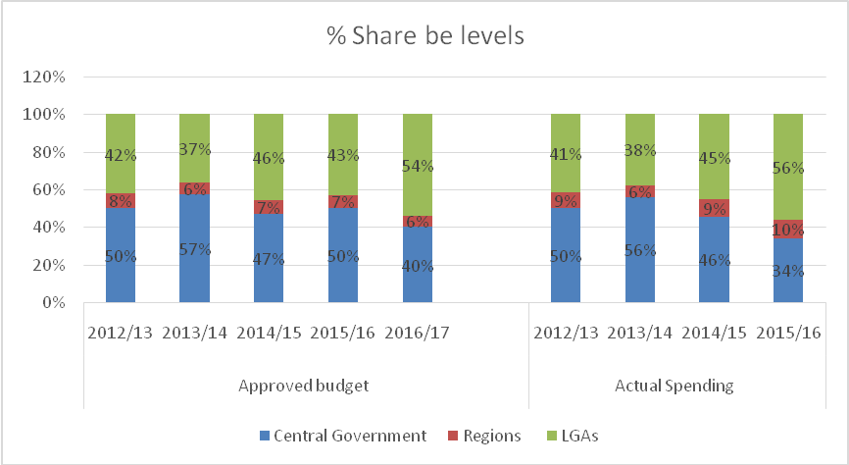

4.0 Complementary Health Financing

4.1 Introduction

This section reviews three main sources of complementary funding: Health Services Fund (HSF), the National Health Insurance Fund (NHIF), and the Community Health Fund (CHF). HSF is basically the user fees paid by patients at the point of health service delivery. NHIF mobilizes funds from employees and employers to finance health care services for its members. The contribution rate is provided in the Act establishing the Fund as 6% of the employee’s gross monthly salary (met equally by both employer and employee – 3% each). CHF is a rural health insurance mechanism whereby districts set their own payment premium and the number of beneficiaries per CHF card as directed by the CHF Act of 2001.

The availability of budget and expenditure data in the complementary financing has been a challenge mostly because the Epicor system is not linked to health facilities where user fee and CHF are collected and spent at the point of collection. This pose a challenge on having accurate data on the complementary financing.

4.2 Health Services Fund

The HSF continues to be an important source of funding for health facilities especially for operations and maintenance.

Table 4.1: HSF Revenues and Expenditures, FY2012/13 – FY2015/16
FY | Balance Brought Forward | Receipts | Payments | Closing Balance
2012/13 | 405.00 | 10.49 | 14.08 | (4.00)
2014/15 | (8,003.16) | 6,662.91 | 5,881.07 | (8,296.90)
2014/15 | (8,003.16) | 25,271.29 | 17,268.13 | (5,154.96)

4.3 The National Health Insurance Fund

4.3.1 Membership and Utilization of Health Services
Membership of the NHIF grew by 9.7% for principal members (from 640,341 in 2014/15 to 702,598 in 2015/16) which is an improvement when compared to only 6% growth experienced from 2013/14 to 2014/15 (increase from 602,955 to 640,341). The total number of beneficiaries increased slightly by 4% from 3,237,434 in 2014/15 to 3,377,023 in 2015/16. The ratio of members to beneficiaries declined from 5.52 in 2012/13 to 4.81 in 2015/16 (Table 4.2) which would mean that the number of beneficiaries had declined relative to the principal members. This can be explained by the current initiatives by NSSF to enroll students from various higher learning institutions and children. Visits by members and beneficiaries almost doubled; there is an increase from 5.6 million visits in 2014/15 to 6.5 million in 2015/16 (95% growth). This has resulted to an increase in the mean contacts per beneficiary from 1.0 to 1.9.
Table 4.2: Basic Data on NHIF Membership and Utilization of Health Services, FY2012/13 – FY2015/16
 | 2012/13 | 2013/14 | 2014/15 | 2015/16
Number of Members | 536,829 | 602,955 | 640,341 | 702,598
Number of Beneficiaries | 2,963,296 | 3,328,312 | 3,237,434 | 3,377,023
Ratio of Beneficiaries to Members | 5.52 | 5.52 | 5.06 | 4.81
Visits by Members/Beneficiaries | 3,904,863 | 3,334,137 | 5,636,373 | 6,506,492
utilization rate per beneficiary/member | 1.3 | 1.0 | 1.7 | 1.9
Sources: NHIF data submitted for PER FY2015/16.

4.3.2 Income and Expenditure
A comparison of figures from 2012/13 and 2015/16 indicates an increase in the total revenue from TZS 266,533 million to TZS 453,997 million which is a 70% increase. The NHIF surplus declined from 50% in 2012/13 to 37% in 2015/16. Previous PERs noted concerns on huge unspent balance. This significant decline in surplus despite increase in the revenue is commendable. The increase in the contribution and decline in the surplus signify the contribution NHIF is making in financing health services.

Table 4.3: Basic Data on NHIF Income and Expenditure, FY2012/13 – 2015/16, (MN TZS)
Description | 2012/13 | 2013/14 | 2014/15 | 2015/16
Income from contributions | 207,502 | 245,176 | 286,702 | 352,763
Total revenue | 266,533 | 318,066 | 370,476 | 453,997
Value of claims paid | 97,925 | 132,034 | 156,710 | 220,088
Total expenditures | 132,652 | 182,185 | 224,915 | 286,971
Surplus (revenues less expenditures) before tax | 133,881 | 135,881 | 145,561 | 167,026
Surplus as % of total revenue | 50% | 43% | 39% | 37%
Sources: NHIF data submitted for PER FY2015/16.

4.3.3 NHIF Spending by Ownership of Facilities
Faith-based organizations received highest shares of the funds paid out as claims by NHIF in FY 2012/13 and FY 2013/14 (36% and 39% respectively) but this trend was reversed in FY 2014/15 and FY 2015/16 where private facilities received the highest share (36% in each year). Faith-based health facilities are important actors in health service delivery, especially in marginalized areas. The share going to public facilities has remained largely constant, at between 28% and 30% per year. Growth of the share going to the private for-profit health facilities is worrisome given that these facilities charge higher prices compared to public and faith based health facilities. This jeopardises access to health services by majority since huge amount of money could be paid for few services. Figure 4.1 shows the relative shares of the three main ownership groups.

Further, the fact that government facilities are receiving low and constant total reimbursement is a concern given that these facilities provide more services than faith-based and private for-profit health facilities. The reimbursement is according to fees for service. It is understandable that the government facilities receive less given their lower charges, but this would effectively mean that the government is subsidizing the NHIF.

Figure 4.1: NHIF Payments by Facility Ownership Type, FY 2012/13 – 2015/16
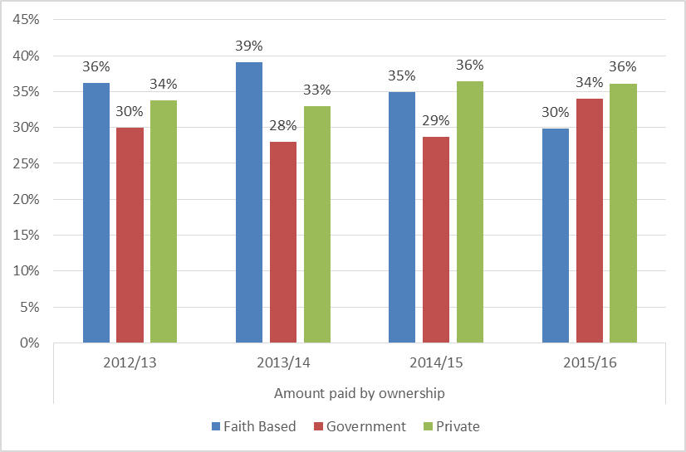

4.3.4 NHIF Spending by Levels of Health System

Figure 4.2 shows the distribution of FY 2015/16 claims payments by type of facility, or level of the health system, whereby referral hospitals received over half of NHIF payments, at 56%. The addition of regional hospitals results in 68% of claims payments going to higher level hospital facilities. Regional hospitals, district hospitals and pharmacies each received around 9-12% of the payments. The Figure shows further that only 19% of NHIF claims payments go to the primary lower level health facilities (district hospitals, health centers and dispensaries). Over half of the budget and spending is going to referral hospitals as shown in Figure 4.2. There are many factors involved in this, including the following:
- Most of the services provided at the referral level are very expensive compared to lower levels.
- Prices per service are higher at the referral level and most referral hospitals have reviewed their fee schedules.
- Most of the NHIF “Green Card” members are found at the urban centers compared to rural areas.

Payments to pharmacies alone accounted for 10% of the total disbursements. This is an important entity in addressing the problem of access to medicines. However, disbursement to Accredited Drug Dispensing Outlets (ADDOs) is negligible, which is partly a reflection of the size of these entities countrywide. However, the ADDOs are key conduits for making medicine accessible to rural marginalized areas and more efforts should be made to collaborate with these entities. This is also an area where the CHF funds could be used effectively.

Figure 4.2: NHIF Spending by Type of Facility, 2014/15
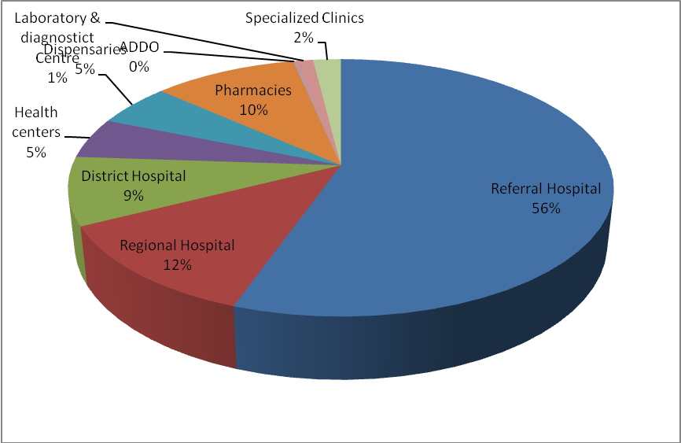
Source: NHIF Data submitted for 2015/16 PER.

4.3.5 NHIF Spending by Regions
The geographical distribution of claims payments continues to be very skewed towards the more urban areas, in large part due to the concentration of both higher level government facilities and private facilities in those regions. Table 4.4 shows the claims made by various regions, the value of the claims, and the percentage cost that was commanded by each region. Dar es Salaam region has the highest value of claims and the value of such claims was 59% of the total claims. Dar es Salaam region is followed by Mbeya region which commanded 6% of the total cost. Other regions such as . Lindi, Rukwa Geita, Njombe and Katavi few number of claims this is highly attributed by the level and type of facilities avail in these regions. (Figure 4.3).

Table 4.4: NHIF Claims by Region, 2015/16
 | No of Claims | Value of Claims | Claims | value cost
Arusha | 277,103 | 7,455,849,542 | 4.26% | 3.56%
Dar es salaam | 2,062,368 | 124,504,430,731 | 31.70% | 59.38%
Dodoma | 257,270 | 4,297,652,657 | 3.95% | 2.05%
Geita | 55,817 | 739,173,179 | 0.86% | 0.35%
Iringa | 199,406 | 3,750,383,226 | 3.07% | 1.79%
Kagera | 169,809 | 3,209,818,471 | 2.61% | 1.53%
Kaskazini Pemba | 2,451 | 26,546,839 | 0.04% | 0.01%
Katavi | 23,442 | 280,187,784 | 0.36% | 0.13%
Kigoma | 122,147 | 1,486,425,655 | 1.88% | 0.71%
Kilimanjaro | 411,031 | 11,012,500,956 | 6.32% | 5.25%
Kusini Pemba | 4,466 | 67,183,842 | 0.07% | 0.03%
Lindi | 78,757 | 897,500,892 | 1.21% | 0.43%
Manyara | 84,963 | 1,323,975,481 | 1.31% | 0.63%
Mara | 150,569 | 1,802,515,408 | 2.31% | 0.86%
Mbeya | 455,768 | 13,438,667,870 | 7.01% | 6.41%
Morogoro | 271,284 | 3,845,480,421 | 4.17% | 1.83%
Mtwara | 116,160 | 1,123,131,300 | 1.79% | 0.54%
Mwanza | 350,507 | 9,819,194,794 | 5.39% | 4.68%
Njombe | 53,961 | 646,863,561 | 0.83% | 0.31%
Pwani | 142,575 | 1,841,259,216 | 2.19% | 0.88%
Rukwa | 60,077 | 759,795,972 | 0.92% | 0.36%
Ruvuma | 165,949 | 2,081,940,738 | 2.55% | 0.99%
Shinyanga | 123,006 | 1,174,923,108 | 1.89% | 0.56%
Singida | 136,039 | 1,825,640,028 | 2.09% | 0.87%
Songwe | 133,961 | 2,195,773,025 | 2.06% | 1.05%
Tabora | 163,126 | 1,994,695,139 | 2.51% | 0.95%
Tanga | 333,433 | 5,164,393,362 | 5.13% | 2.46%
Unguja | 99,973 | 2,891,255,030 | 1.54% | 1.38%

Figure 4.3: NHIF Value Cost by Region, 2015/16
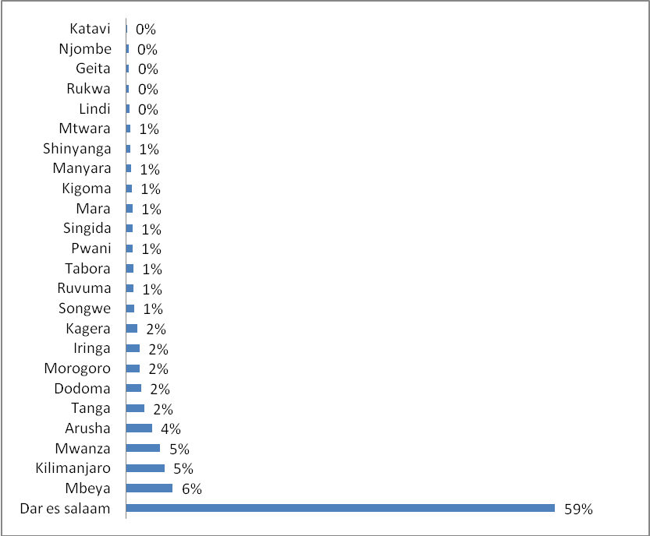

4.4 Community Health Fund

Progress in expansion of the Community Health Fund (CHF) continued in 2015/16. There is improvement in estimated population coverage from 7% in 2012/13 to 14% in 2014/15 and 18% in 2015/16 as shown in Figure 4.4. The number of member households almost tripled from 543,621 in 2012/13 to 1,452,855 in 2015/16.

Figure 4.4: CHF Coverage and Membership, 2012/13 – 2015/16
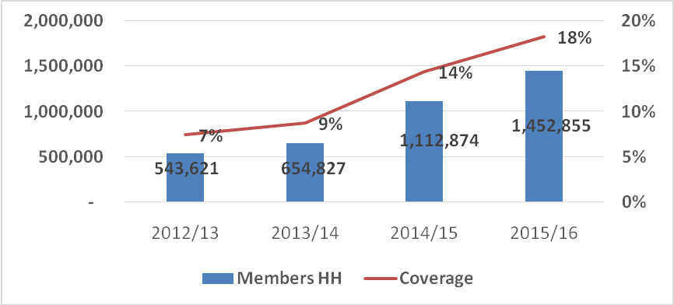
Source: NHIF Data submitted for 2015/16 PER.
Figure 4.5 shows the variation in CHF coverage by regions in FY 2015/16. The numbers are based on an estimated six persons per household, although this is not always the case – there are variations per district. Accurate population coverage is not yet available, except in Dodoma, Morogoro and Shinyanga regions where detailed membership databases have been established under the Health Promotion and Systems Strengthening (HPSS) project. Singida region has the highest CHF enrollment followed by Tanga and Mbeya regions. The low figures for Dodoma, Morogoro, and Shinyanga are surprising given the presence of HPSS project. Dar es Salaam region reports zero enrollment because TIKKA, an adapted urban based CHF is not fully functional.

Figure 4.5: Estimated CHF Coverage by Regions, 2015/16
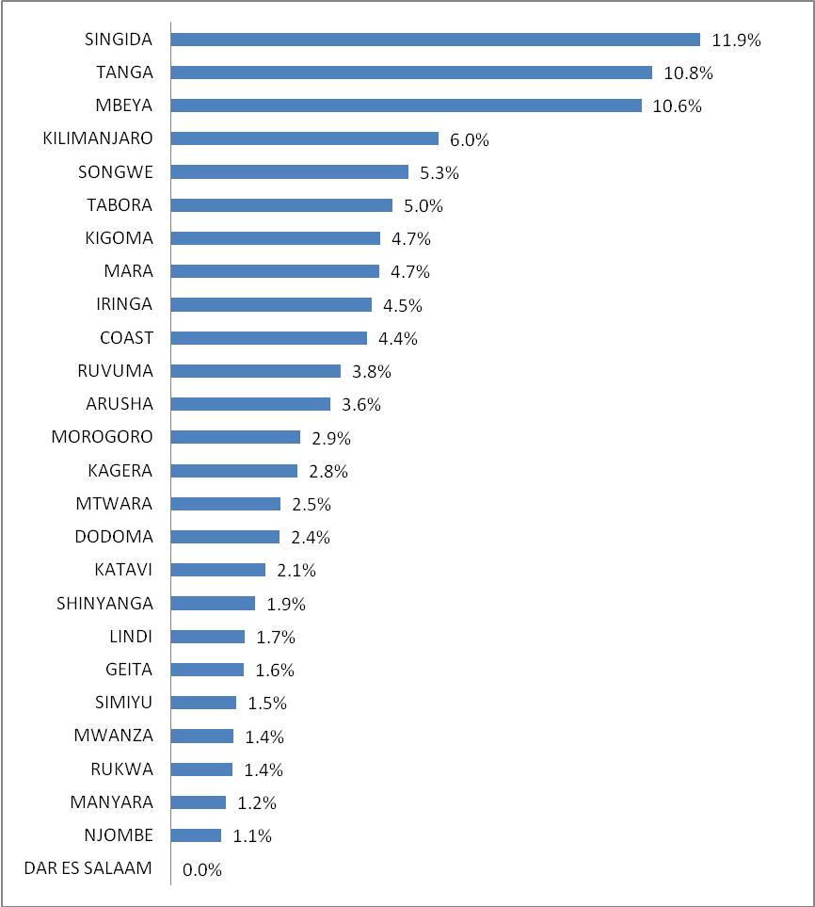
Source: NHIF Data submitted for 2015/16 PER.

4.5 CHF Revenues and Matching Funds

NHIF data for 2013/14 indicate that the CHF premium were generally low. Of the 159 LGAs for which data were available, 89 (56%) were charging TZS 10,000 while 19% were charging only TZS 5,000 per household. The status was the same in 2015/16 with only few LGAs charging between TZS 25,000 to TZS 30,000 per year.

CHF membership revenues are intended to be matched by central Government in recognition of the fact that CHF cannot be self-financing given the limited ability of the majority of the informal sector to pay full cost, and the government’s role in financing essential services. The Memorandum of Understanding between Ministry of Health, the then PMO-RALG, and NHIF was renewed after its lapse in June 2009, and the responsibility for channeling matching funds lies with NHIF. Table 4.4 below presents NHIF-reported revenues and expenditure on matching grants between 2012/13 and 2015/16. Figures in Table 4.5 show a decline in the funds received from the Ministry of Health and the total payments to LGAs in 2015/16 compared to 2014/15. The reasons for this decline have to be identified and addressed. It is important to note that due to delays in the processing of matching grants, payments made do not necessarily relate to the CHF revenues raised in a given financial year. Further work to assess and address such delays is warranted.

Table 4.5: NHIF Data on Matching Grant Funding Received and Paid Out, 2012/13 – 2015/16
Year | Brought Forward | Received from MoHCDGEC | Paid to LGAs | Carried Forward
2012/13 | 2,421,655,680 | 1,900,000,000 | - | 4,321,655,680
2013/14 | 4,321,655,680 | 1,900,000,000 | 752,352,500 | 5,469,303,180
2014/15 | 5,469,303,180 | 1,400,000,000 | 1,053,983,820 | 5,815,319,360
2015/16 | 5,815,319,360 | 1,000,000,000 | 3,307,265,150 | 3,508,054,210
Source: NHIF Data submitted for 2015/16 PER.

5.0 Local Government Health Sector Spending

5.1 Introduction

This chapter presents information on the financing of Local Government Authorities (LGAs), covering sources of funding, breakdown by cost centers, and budget performance. LGAs are responsible for the delivery of primary health care services which, as stated in thePrimary Health Services Development Program (MMAM) 2007 – 2017, HSSP III & IV, and National Five Year Development Plan 2016/17-2020/21 remains the priority for the Government as the most cost-effective and equitable level of the health system. It is therefore useful to examine both the level and composition of financing at this level. Data inconsistencies regarding LGA funding are substantial, with variation between MOFP data, PO-RALG data, and data from the LGA Epicor system and as reported in the CCHP implementation reports. CCHPs capture direct funding to LGAs which is not always reflected in central government data sources. The findings in this section are not necessarily consistent. However, the picture is slowly improving, in particular as efforts are made to better link Epicor outputs with the PlanRep system.

5.2 LGAs Budget and Expenditure by Source of Funds

There are various sources of funds in health sector in LGAs, namely budgetary allocations from the government, external financing through either the health basket or non-basket mechanisms, funds from councils own sources, and complementary sources which include fees and subscriptions from various schemes. Each financing source has its modality for raising and managing its own collection for the aim of financing the health sector in Tanzania.

Table 5.1 and Figure 5.1 below present the budgeted funds and expenditures for LGAs over the past four years as reported in Epicor. The block grant which covers both Personal Emoluments (PE) and Other Charges (OC) continues to be the major source of funds at council level. As a share of reported funds, it has increased from 66% of the budget in 2012/13 to 75% in 2015/16. A decline is observed in the 2016/17 budget – 62%. The share of health basket funds budget has declined from 17% in 2012/13 to 8% in 2016/17. In terms of actual spending, the share of block grant increased from 70% in 2012/13 to 74% in 2015/16 while the basket fund expenditure decreased from 20% in 2012/13 to 14% in 2015/16. Expenditures from Council Own Source are broadly similar across years, at 3% - 4% of the total expenditure.

Source | Budget Estimate |  |  |  |  | Actual Expenditure
Source | 2012/13 | 2013/14 | 2014/15 | 2015/16 | 2016/17 | 2012/13 | 2013/14 | 2014/15 | 2015/16
Government | 408,529 | 513,472 | 481,911 | 523,517 | 778,840 | 223,637 | 265,518 | 390,764 | 436,412
Health Sector Basket Fund-HSBF | 105,909 | 103,553 | 89,132 | 64,759 | 106,611 | 64,164 | 75,799 | 80,311 | 80,167
Own Source | 26,105 | 25,790 | 34,808 | 50,516 | 27,027 | 12,463 | 9,792 | 15,839 | 15,452
Community Contribution/user fee | 493 | 243 | 62 | 192 | 33,894 | 128 | 123 | - | -
Community Health Fund | 21,475 | 9,007 | 10,552 | 17,301 | 23,449 | 3,320 | 2,065 | 1,851 | 1,933
NHIF |  |  |  |  | 20,097
Others donors | 60,869 | 40,314 | 35,439 | 39,794 | 274,158 | 15,087 | 15,533 | 52,559 | 52,504
Grand Total | 623,381 | 692,377 | 651,904 | 696,078 | 1,264,076 | 318,799 | 368,830 | 541,324 | 586,468
Table 5.1: LGA Budget and Expenditure by Source (MN TZS)
Source: LGA Epicor System.

Figure 5.1: LGA Budget and Expenditure by Source

Source: LGA Epicor System.

5.3 Recurrent and Development Spending at LGA

Analysis of expenditure by recurrent (PE and OC) and development categories was done as shown in Table 5.2 and Figure 5.2. PE as the share of total spending has increased from 55% in 2012/13 to 68% in 2016/17. Development expenditure is the least – ranged from 9% - 12% during the review period. Increase in PE expenditures reflects the increase in the Human Resource for Health (HRH) and remuneration for the same. Low allocation to the development expenditure is a concern given the status of some health facilities in the rural areas. Some are dilapidated and they need major repair.

Table 5.2: Government Recurrent and Development Budget and Expenditures at LGAs, FY 2014/15
 |  | Development | OC | PE | Total
2012/13 | Budget | 99,954 | 217,197 | 304,125 | 621,276
2012/13 | Allocations | 39,285 | 138,131 | 181,397 | 358,814
2012/13 | Expenditure | 29,092 | 113,766 | 174,766 | 317,624
2013/14 | Budget | 56,130 | 96,371 | 223,136 | 375,637
2013/14 | Allocations | 22,868 | 75,476 | 130,458 | 228,802
2013/14 | Expenditure | 19,306 | 65,526 | 121,894 | 206,727
2014/15 | Budget | 85,399 | 181,046 | 385,459 | 651,904
2014/15 | Expenditure | 64,124 | 122,779 | 354,421 | 541,324
2015/16 | Budget | 76,630 | 178,278 | 441,170 | 696,078
2015/16 | Expenditure | 63,670 | 122,537 | 400,261 | 586,468
Source: LGA Epicor System.

Figure 5.2: Government Recurrent and Development Spending at LGA

Source: LGA Epicor System.

5.4 Budget and Expenditure by LGAs Sub-Votes

Expenditures by Sub-votes increased from TZS 317,624 Million in 2012/13 to TZS 586,468 Million in 2015/16. For the 2012/13 and 2013/14 financial years, Sub-vote 508E (Dispensaries) had the highest expenditures followed by Sub-vote 508A (CHMT). This trend was reversed in the 2014/15 and 2015/16 financial years with CHMT having higher expenditures than Dispensaries. This is a concern given the need to channel resources at the health services delivery points .

Table 5.3: Budget and Expenditure by LGAs Sub-Votes
Sub vote | 2012/13 |  | 2013/14 |  | 2014/15 |  | 2015/16
Sub vote | Budget | Exp. | Budget | Exp. | Budget | Exp. | Budget | Exp.
508A | 133,853 | 82,260 | 170,690 | 98,032 | 207,933 | 179,133 | 221,819 | 184,749
508B | 120,390 | 58,988 | 113,881 | 58,614 | 98,377 | 108,932 | 111,160 | 110,231
508C | 12,908 | 6,643 | 4,010 | 3,237 | 4,252 | 3,072 | 3,613 | 3,052
508D | 135,087 | 65,187 | 167,921 | 87,144 | 145,714 | 109,824 | 154,355 | 119,849
508E | 178,589 | 87,497 | 225,504 | 116,739 | 195,627 | 140,364 | 198,141 | 157,557
508F | 35,998 | 15,587 | 9,125 | 4,507 | 10,629 | 9743 | 6,474 | 10,650
508G | 4,449 | 1,462 | 1,247 | 557 | 351 | 379 | 517 | 379
508H | 2.59 | - | - | - | - | - | - | -
Grand Total | 621,276 | 317,624 | 692,377 | 368,830 | 662,883 | 551,446 | 696,078 | 586,468
Source: LGA Epicor System

6.0 Conclusions and Recommendations

6.1 Health Financing

General trend in health financing
The total public health budget in nominal and real terms increased significantly from Tanzanian Shillings (TZS) 1.270 trillion and 715 billion in 2012/13 to TZS 1.821 trillion and 876 billion respectively in 2015/16. The budget was projected to increase further to TZS 2.465 trillion in nominal terms and 1.196 trillion in real terms in 2016/17. This means that, between 2012/13 and 2016/17 there has been a 94.1% increase in the public health budget in nominal terms, and a 67.3% increase in real terms. In terms of actual health spending, it increased from TZS 1.055 trillion in 2012/13 to TZS 1.446 trillion in 2015/16 which is a 37.1% increase, while actual public health spending in real terms increased by 17% - an increase from TZS 594 billion in 2012/13 to TZS 695 billion in 2015/16.

The share of public health budget in total government budget, excluding CFS, was 9.3% in 2012/13 and it increased to 10.1% in 2015/16. With the CFS included, the share of health budget actually fell from 9.4% in 2012/13 to a mere 8.1% in 2015/16. Similarly, the share of actual health spending in total government spending (excluding CFS) declined from 9.2% in 2012/13 to 7.3% in 2015/16, while with CFS included the decline in the share of health spending was from 8.7% in 2012/13 to 8.0 in 2015/16. Based on these figures, we conclude that the share of government actual spending to the health sector has not kept pace with general government spending between 2012/13 and 2015/16 – it has declined with and without CFS.

Per capital expenditures
In real terms, there is an upward trend for both per capital budget allocation and actual expenditure – increase from TZS 16,228 (USD 10.27) in 2012/13 to TZS 18,315 (USD 10.59) in 2015/16 and TZS 13,480 (USD 8.53) in 2012/13 to TZS 14,540 (USD 8.41) in 2015/16 respectively. Because of domestic inflation and depreciation of the shilling, the estimated per capita health expenditures in real terms have consistently remained below USD 10 throughout the review period which is shot of USD 54 recommended by the World Health Organization (WHO). We conclude that despite the increase in the public health spending overtime, it has not kept pace with the population growth thus leaving only a modest amount to be spent per capita.

Sources of financing
Government funding remains the dominant source of public health financing. The actual government spending increased from TZS 765.3 billion in 2012/13 to TZS 1,343 billion in 2015/16 which is a 75.5% increase. The actual expenditure for foreign funds declined from TZS 289.9 billion in 2012/13 to TZS 169 billion in 2015/16 which is a 71.6% decline. The expenditure from health basket in particular, declined by 44.7% from TZS 142.8 billion in 2012/13 to TZS 79 billion in 2015/16. Comparing the non-basket funds approved estimates for 2015/16 with the actual expenditure there is a significant difference – TZS 407 billion, meaning that only 18% of the approved estimate was released. The overall decrease for the foreign funds is contributed by some donors dropping from the basket and decrease in Global Fund. Given the unpredictability of donor funding, the government is urged to develop sustainable health financing strategies to curb future unexpected budget deficits.

Recurrent and development expenditures
Following faster growth in the recurrent budget and expenditures relative to development budget and expenditures, the share of the recurrent budget increased significantly from 63% in 2012/13 to 70% in 2014/15 but declined to 62% in 2016/17. Also, the share of actual recurrent expenditure increased significantly from 64% in 2012/13 to 87% in 2015/16. Dwindling development expenditure is a concern given the need to improve health facility infrastructure especially in the rural areas.

Budget performance
Overall, the execution of the total budget was consistently high (above 80%) from 2011/12 but it experienced a significant decline in 2015/16; declined to 70%. The performance of the basket fund is consistently high – above 89% for each year in the review period. Execution of non-basked funding is the lowest. Although the performance was 82% in 2013/14 it declined to 41% in 2014/15 and as low as 18% in 2015/16. This inconsistency in budget performance is detrimental to service delivery.

Budget and expenditure by levels of Government
There is a significant change of shares of resources among levels of government during the 2015/16 and 2016/17 budget cycle. The share of centrally controlled budgeted resources (MoHCDGEC, PO-RALG, and the NHIF) declined from 50% in 2012/13 to 42% in 2015/16. The actual expenditure also decreased from 50% in 2012/13 to 29% in 2015/16. The share of resources going to LGAs increased from 42% of the budget in 2012/13 to 58% in 2016/17 while the actual spending increased from 41% in 2012/13 to 49% 2016/17. This increase reflects the efforts of the current Government to channel resources to the local level where poverty levels are high.

Complementary financing
The complimentary a funding continues to be an important source of funding for health facilities especially for operations and maintenance although its contribution to the health budget is still very minimal.

A comparison of figures from 2012/13 and 2015/16 indicates an increase in the total NHIF revenue from TZS 266,533 million to TZS 453,997 million which is a 70% increase. The NHIF surplus declined from 50% in 2012/13 to 37% in 2015/16. Previous PERs noted concerns on huge unspent balance. This significant decline in surplus despite increase in the revenue is commendable. The increase in the contribution and decline in the surplus signify the contribution NHIF is making in financing health services. However, Government facilities are receiving low and constant total reimbursement is cause for concern given the fact that they provide more services than faith-based and private for-profit health facilities. The reimbursement is according to fees for service. It is understandable that the government facilities receive less given their lower charges, but this would effectively mean that the government is subsidizing the NHIF.

Dar es Salaam region has the highest value of claims from NHIF and the value of such claims was 59% of the total claims. Dar es Salaam region is followed by Mbeya region which commanded 6% of the total cost. Some regions such as Lindi, Rukwa Geita, Njombe and Katavi have very low claims , these are some of the remote and marginalized regions.

Progress in expansion of CHF continued in 2015/16. There is improvement in estimated population coverage from 7% in 2012/13 to 14% in 2014/15 and 18% in 2015/16. However, this low coverage has left huge population in rural areas unprotected meaning that the country is very far away from reaching the Universal Health Coverage goals. Singida region has the highest CHF enrollment followed by Tanga and Mbeya regions. The low figures for Dodoma, Morogoro, and Shinyanga are surprising given the presence of HPSS Project.

Sources of financing at LGAs
Block grant continues to be the major source of funds at Council level. In terms of actual spending, the share of block grant increased from 70% in 2012/13 to 74% in 2015/16 while the basket fund expenditure decreased from 20% in 2012/13 to 14% in 2015/16. Expenditures from Council Own Source are broadly similar across years, at 3% - 4% of the total expenditure. Expenditures from own sources may decrease even further in the future given the current move of moving some of the revenue sources to the central level. This implies that the block grant has to increase even further to cover the gap left by declining own resource revenue.

Budget and expenditure at LGAs by sub-votes
Expenditures by Sub-votes increased from TZS 317,624 Million in 2012/13 to TZS 586,468 Million in 2015/16. For the 2012/13 and 2013/14 financial years, Sub-vote 508E (Dispensaries) had the highest expenditures followed by Sub-vote 508A (CHMT). This trend was reversed in the 2014/15 and 2015/16 financial years with CHMT having higher expenditures than Dispensaries. This is a concern given the need to channel resources at the health services delivery points.

Budget performance at LGAs level
The average budget performance at LGAs level ranged from 53% to 65%. The performance of the basket fund is fairly good and in 2014/15 the basket fund was fully released. The performance of the block grant was above 65% in the three years. Other sources of funding (except MMAM in 2012/13) have consistently performed poorly.

6.2 Recommendations

- The Government funding remains the dominant source for the health sector. Given the unpredictability of donor funding, the government is urged to develop sustainable health financing strategies to curb the unexpected future budget deficits.
- It is important to note that due to delays in the processing of matching grants, payments made do not necessarily relate to the CHF revenues raised in a given financial year. NHIF should commission a study that will provide an analysis of the factors responsible for the delays in disbursement of matching fund
- In improving the feedback mechanism for the unpaid claims and matching fund, NHIF has established e-claim system which has been installed in some of the health facilities. This system should be installed in all health facilities in order to smoothen the claiming and process. Further, NHIF should clarify how does the e-claim solved the claiming problems.
- Given the importance of Accredited Drug Dispensing Outlets (ADDOs) in reaching the poor and marginalized communities, NHIF should explore mechanisms to use ADDOs to supply pharmaceuticals using contributions from CHF.
- There is a decline in the matching funds received from the Ministry of Health and the total payments to LGAs in 2015/16 compared to 2014/15. The reasons for this decline have to be identified and addressed.
- Data inconsistencies regarding LGAs funding are substantial, with variation between the MoFP data, PO-RALG data, and data from the LGAs Epicor system and as reported in the CCHP implementation reports. CCHPs capture direct funding to LGAs which is not always reflected in central. Efforts should be made to link Plan Rep and Epicor and ensure that all Budget and expenditure data are captured in the Epicor System.
ANNEXES
Annex A: Aggregate Data Used For Analysis (Tzs Million)

Majority of teachers and nurses reside in rural areas and they are all members of NHIF. However, these are the members with brown cards not green cards which allows access to limited number of services. Contrary, those in urban areas some have big salaries and thus qualify for green card. With green card, they consume more advanced services.
The National Five Year Development Plan 2016/17 – 2020/21 stresses the need to strengthen health systems (primary and referral) and equipping district, regional and referral hospitals with modern equipment.
508A - Council Health Management Team (CHMT); 508B - Council Hospital;508C - Voluntary Agency Hospital;508D-HealthCentres;508E-Dispensaries;508F-Community Health Initiatives/Promotion;508G - Projects

