REPUBLIC OF KENYA

MINISTRY OF HEALTH



MONITORING AND EVALUATION FRAMEWORK FOR UNIVERSAL HEALTH COVERAGE IN KENYA


2018.
mINISTRY OF HEALTH, aFYA HOUSE

Contents
SECTION 1: INTRODUCTION AND BACKGROUND 0
1.1 Overview of the Sustainable Development Goals 1
1.2 Positioning Universal Health Coverage within the SDGs 1
1.3. What Universal Health Coverage entails 3
1.3 Universal Health Coverage and Funding Mechanism 6
1.3.1 Revenue Mobilization 6
1.3.2 Revenue Pooling and Management 7
1.3.3. From passive to strategic purchasing 7
1.4 Purpose of the Monitoring & Evaluation Plan 8
1.5. Goals and Objectives of the M&E Plan 10
1.5.1. Goal of the UHC M&E Plan 11
1.5.2 Objectives of the UHC M&E Plan 11
1.5.3 Outputs of the M & E Framework 11
1.5.4. Implications for M & E 11
1.5.5. Alignment of the M & E framework with existing legal framework and polices 12
1.5.6. Organization of the M&E framework 12
1.5.7. The process of developing the M&E Framework 12
1.5.8. Monitoring and Evaluation Team 12
1.5.9. Current status of Health information systems 15
2.0 Program Description and Frameworks: Positioning of UHC in the Nexus of the Big4 Agenda 19
2.2 Program Strategies and Activities (including Geographic Scope and Target Population) 27
2.3 UHC Results Framework 0
2.6 Critical Assumptions 3
3.0 Monitoring Plan 4
3.1. UHC Performance Monitoring and Evaluation Matrix 1
SECTION 4: MONITORING PLAN FOR UHC IN KENYA 1
4.2. GOALS AND OBJECTIVES OF THE M & E FRAMEWORK 1
Outputs of the M & E Framework 2
Implications for M & E 2
4.2. Framework of actions domains and dimensions 3
4.3. Generation & collection of data 5
4.4. Information generation 5
4.5. Criteria for assessing UHC performance 5
4.6. Knowledge generation 6
Knowledge Use 7
Review and feedback 7
Indicators for Monitoring universal Health Coverage 7
4.1 Tools for Monitoring and Evaluation of UHC 18
4.2 Data quality plan for UHC 18
4.3 Information dissemination and use 18
SECTION 6: EVALUATING UNIVERSAL HEALTH COVERAGE 18
6.1 Why the evaluation 18
6.2 Evaluation Objectives 19
6.3 Evaluation Questions 20
6.4 Evaluation framework 21
6.4. Evaluation Methodology 22
SECTION 7: TOOLS FOR MONITORING AND EVALUATION OF UHC 25
SECTION 8: CAPACITY BUILDING FOR UNIVERSAL HEALTH COVERAGE M&E 26
M&E Budget 26
Appendices 27
Appendix 1: Indicators for each domain and dimension of the actions framework 28
Appendix 2: Format for policy briefs 32

SECTION 1: INTRODUCTION AND BACKGROUND

INTRODUCTION

The government has prioritized the achievement of Universal health coverage (UHC) as one of the four flagship projects under the Big Four Agenda that runs between 2018-2022. UHC has been defined as the desired outcome of health system performance whereby all people who need health services (promotion, prevention, treatment, rehabilitation, and palliation) receive them, without undue financial hardship. UHC has interrelated components equally important dimensions, which need to be attained for UHC progress to be real and sustained: the full spectrum of good-quality, essential health services according to need, and protection of all populations from financial hardship, including possible impoverishment, due to out-of-pocket payments for health services (service coverage). Both components should benefit the entire population (population coverage).” (Boerma et al) Progress in reaching these targets need to be measured but which indicators or measurement methods should be used or whether to use a single index that combines all the UHC dimensions, the data collection frequency and source(s), remains a matter of discussion.

Figure 1: Dimensions of Universal Health Coverage

- Making essential services available calls for identification of which services are essential for different population groups, and actively plan and monitor their availability. Identifying needed services needs to be based on the health and wellbeing challenges faced at each life cohort and informed from engagements with the respective life cohort members. This represents a shift away from a focus on a basic set of cost effective services, which was technically, and cost defined.

- Equitable utilization of the essential services calls for Kenya to put in place service delivery mechanisms that ensure that service utilization across all beneficiaries is fair. Wherever, and whoever a beneficiary is, they should have the same utilization capacity as any other beneficiary. This represents a shift away from a focus on maximizing utilization across the whole population, to a focus on identifying and increasing utilization for the most marginalized populations in the country (e.g. immunization coverage – both overall and for hard to reach populations).
- Financial risk protection during utilization of essential services which calls for Kenya to limit financial barriers faced by the population during the process of accessing essential services. These financial barriers at the point of use are a recognized hindrance to utilization of essential services.

Table XX below highlights the critical shifts that must be made to realize each of the three UHC dimensions discussed above.

Table xx: Key shifts with Universal Health Coverage
Critical UHC Driver | From | To
Availability of essential services | Provision of basic cost-effective services for those in most need | Provision of essential services needed for all life cohorts
Coverage of essential interventions | Maximizing overall coverage of the population with interventions | Maximizing coverage for identified hard to reach populations with interventions
Financial risk protection | Maximizing all resources including during the care process | Maximizing all resources, but delinking funding from care utilization for equity considerations

Positioning UHC within the Global SDG agenda
Kenya is a signatory to the sustainable development goals (SDG) agenda and has committed to put in place appropriate measures and investments needed to realize the targets set under SDG 3. This goal seeks to ensure healthy lives and promotion of wellbeing for all, at all ages. Similarly, the achievement of UHC expressed under target 3.8, is deemed as critical to the realization of other health-related targets and indicators within the SDGs. In order to achieve the SDG targets for universal health coverage, counties need to ensure that, whatever measures they have will indeed lead to good health and wellbeing for all, at all ages. Both national and county governments will be expected to take concerted measures to ensure:
- Maximization of healthy lives for their people – efforts at disease control should not just focus on the disease
- Wellbeing – a reflection of the populations level of satisfaction with their health – is taken into consideration, and
- Healthy lives are maximized for all age groups – from children to elderly persons

To ensure appropriate movement towards health and wellbeing as envisioned in SDG 3, Kenya will focus on information and knowledge around three key areas:
- The 3 outcomes that define Universal Health Coverage, and
- The 6 health & related service outcomes areas key for attaining SDG 3;
- The 4 outputs that define performance of the health systems

The framework for health systems evolution that will be required to support the realization of UHC goals in the context of SDGs is elaborated by WHO/AFRO and presented in Figure 3 below:

Figure 2: WHO/AFRO framework for Health Systems Development for UHC in the context of SDGs

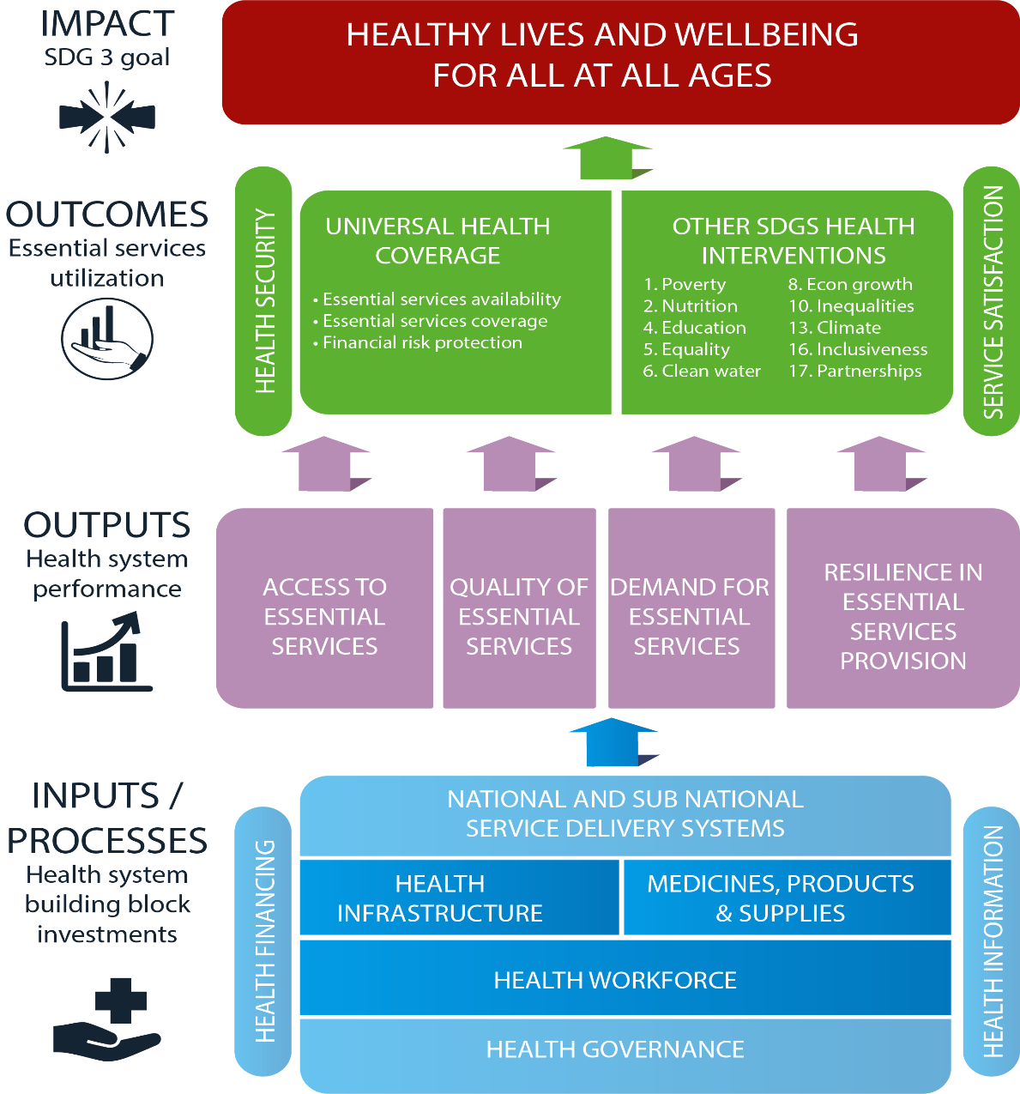
GUIDING PRINCIPLES OF Efficiency, Equity, Effectiveness

Universal Health Coverage in Kenya
The Kenya UHC Roadmap 2018-22, has set out the Governments goal of achieving UHC by the year 2022 with strategies outlined to ensure that Kenyans receive quality, promotive, preventive, and curative and rehabilitation health services without suffering financial hardship. The broad objectives towards UHC in Kenya include;
- Expansion of the population under Universal Health Insurance coverage (100% coverage with health Insurance )
- Ensuring that Kenyans have access to an explicit unified progressive Health benefit package
- Increasing the availability and coverage of quality essential interventions ; that all people who need services should be able to utilize them
- Ensuring financial risk protection for Kenyans and with a special focus for the poor and the Vulnerable groups
- Ensuring adequacy of Health resources /Ensure that resource base is appropriate for delivery of health services
- Promote efficiency in allocation and use of existing resources
- Equity in distribution of services and resources.
- Regulation of medical Health insurance sector and development of collaborative engagements with private medical insurance companies with a focus on Universal Health coverage
- Strengthening leadership and Governance within the Health sector for UHC

The roadmap also affirms the health sector’s commitment to put in place a consolidated and harmonized planning, monitoring and evaluation (M&E) platform that informs strategic decision making. This will however be anchored within the Health Sector Monitoring and Evaluation systems.

Rationale for an M&E framework for Universal Health Coverage

1.4.1 Purpose of the M&E Framework
The Kenya UHC Road Map 2018-22 elaborates the investments needed to strengthen the health system and scale up coverage of interventions leading to the achievement of UHC goals. In line with this, an M&E plan has been developed to track sector performance as well as serve as an accountability framework for stakeholders in the health sector working to achieve UHC goals. The framework articulates a strong and harmonized monitoring and evaluation of critical UHC domains, as well as health system actions. It serves as a mechanism for County, national and global reporting; aligning partners at country and global levels around a common approach to country support and reporting requirements. The M&E plan also provides an investment framework for strengthening M&E functions and processes by all health sector stakeholders at national and county level.

This plan provides a single country-led platform for tracking the implementation roadmap. More specifically it will track the range of investments and interventions implemented in phase 1 counties of Machakos, Nyeri, Kisumu and Isiolo. The relevant data sources and institutions for data generation, compilation, analysis, synthesis and dissemination form an integral part of the single platform. The UHC Country review and policy dialogue processes will make use of the platform’s evidence base as an anchor for planning and decision-making.

Strategies articulated in this M&E will leverage ongoing country effort and accelerate the current initiatives to ensure the generation of good quality, and policy relevant evidence in a timely manner. The evidence generated will inform planning, resource allocation, decision making and adaptive management as well as real time monitoring of the UHC actions in the four counties. In addition, the Kenya has signed up to international commitments including Sustainable Development Goals (SDGs), Universal Health Coverage (UHC) as well Regional commitments including the African Union (AU) Africa Health Strategy 2016 – 2020 among others. This M&E framework will facilitate fulfilment of reporting obligations on the global and regional commitments. Furthermore, this plan will facilitate monitoring of inequalities, which is central to attainment of universal health coverage (UHC) and, ensuring functional surveillance systems which is key for building health security.

1.4.2 Expected outputs of the M & E Framework for UHC
When fully operational, it is expected that this framework will drive the health sector towards full implementation of the UHC Roadmap and in particular contribute to the realization of:
- Robust health information systems generating good quality data in a timely manner
- Real time monitoring and evaluation reports for Phase I UHC implementation
- Enriched evidence-based health policy dialogue and decision making
- Effective dissemination of health information to stakeholders stimulating action
- Strengthened analytical capacity at the different levels of the health system
- Improved efficiency in data collection and storage
- Continued learning for better performance, adaptive management in line with evidence
- Forging joint solutions through peer learning

The responsibility for strengthening health sector M&E is a shared responsibility and within this arrangement, required investments and activities to be undertaken need to be agreed, and roles and responsibilities assigned. Evidence generated must be used to guide further improvements in sector performance, quality improvements and health service delivery. Institutionalised platforms that ensure a transparent and participatory process are crucial for realising actors buy in and, implementation of agreed action

1.4.3 Specific Objectives of the UHC M&E Plan

- Provide an investment framework to align stakeholders’ resources and action to strengthen UHC M&E in the health sector;
- provide a framework for documenting lessons learnt in UHC implementation to promote learning and insitutional memory
- Provide a framework for Monitoring and evaluation of Phase I and other control counties implementation of UHC upto 2022 ;
- Ensure continued progress through regularly and systematically tracking the progress of implementation of the UHC in the Country;
- Ensure alignment of stakeholders to the objectives of the UHC through provision of good quality strategic information.;
- Strengthen partnerships in the health sector through enabling constructive evidence-based policy dialogue;.
- Promote evidence-based decision making through ensuring timely availability of good quality evidence that is effectively disseminated.
- Strengthened operational research capacity to generate evidence to inform decision making

1.5 Organization of the M&E framework

The M & E plan is organized in xx chapters, namely: -

1.6 The process of developing the M&E Framework

The development of the UHC Monitoring and evaluation framework was initiated when the Ministry of Health (MoH) formed a national taskforce that would develop both the UHC Roadmap and an M&E framework that would enable effective tracking of progress towards the achievement of Kenya’s UHC goals. The taskforce developed a conceptual framework and a zero draft of the guidelines during a workshop held in June 2018. The workshop was led by the UHC Taskforce and brought together representatives drawn from M&E focal points in key health programs, counties and development partners working in the health sector. This draft was subjected to internal review by various MOH user departments. Their feedback was incorporated and presented as second draft during the Naivasha Workshop held on 23-27 July 2018. This draft was circulated to stakeholders within the health sector and their input was consolidated both before and during the workshop. The Document
The revised draft of the documents was then circulated simultaneously to key stakeholders, including MoH departments and health programs, health institutions, county departments of health and both development and implementing partners working to strengthen M&E systems in the health sector. Input from these sources was collated and a comprehensive

1.5.8. Key actors in implementing the UHC M&E Framework
Figure 2: National and County M&E Organogram

National Level
At the national government departments and SAGAS M&E units report to the National M&E unit which reports to both Health Information and Research Inter agency coordination Committee (ICC) and National Health Sector coordinating Committee which includes: National MOH, Civil Society Organizations (HENNET), DPHK, Kenya Private Sector Alliance (KPSA), professional Association and County Health departments. The national M&E unit also becomes a secretariat to the Health sector M&E Coordinating committee.

County Level
The county M&E Units should work in close collaboration and in mutual relationships with the national M&E unit with similar reporting channel channels at the county department of health, at county level all departments/directorates of health and non-state actors shall report to county M&E unit. The county M&E unit shall in turn report to both Health information ICC and County stakeholders forum
Both National and County levels shall establish Health M&E units functions as: providing a forum for joint planning, coordination and monitoring of specific investments in the sector; bring all key sub-sector partners together for joint planning, oversight and decision making in M&E; enable partners to become jointly responsible for planning, monitoring, performance reviews, reporting and dissemination; hold all sector partners jointly accountable for achieving results, harmonise the number of separate meetings with individual partners; enable harmonization of inputs and better coordination of investments in the sector partnership for more effective use of all available resources to support M&E functions-reduce duplication of efforts and critical gaps; and providing easy access to coordinated Technical Assistance, Joint reviews, joint monitoring and support for priority actions

Identify members of your Monitoring and Evaluation Team and explain their roles and responsibilities.

Figure 3: Planning framework for the Health Sector

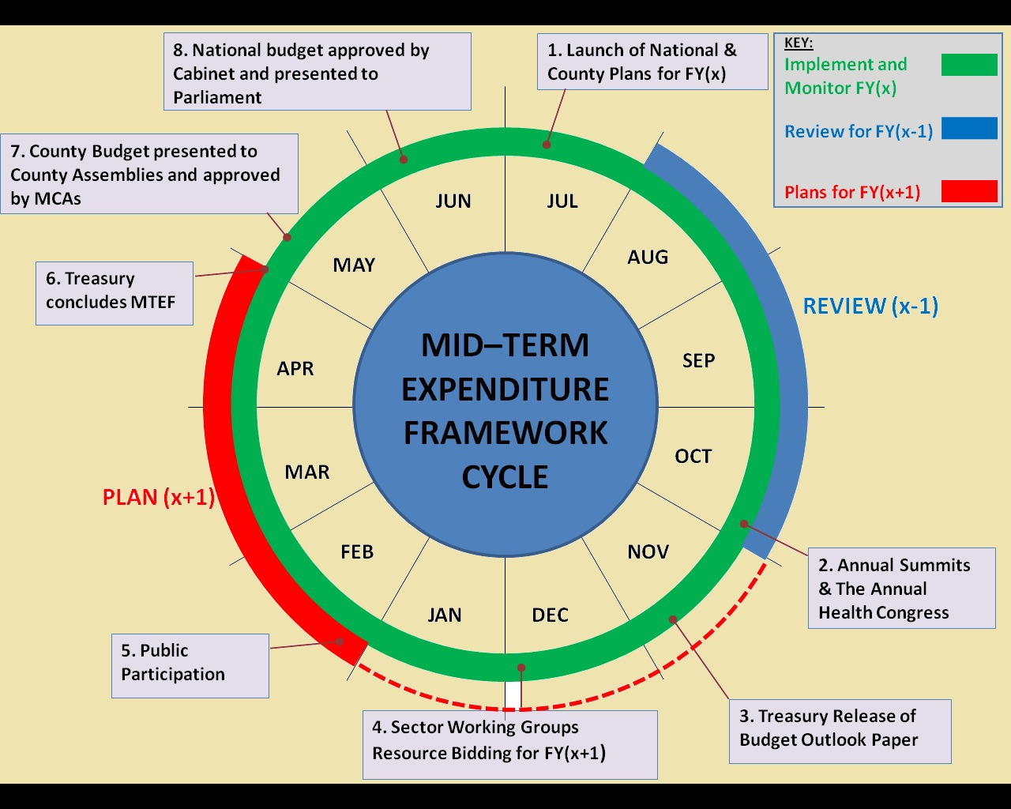

The processes of an effective M& system starts with a development and dissemination of a clear accountability calendar and tools (formats) for national and county governments and stakeholders performance reviews of their performance. The MoH M&E Unit is strengthened to oversee various aspects of health sector accountability and county level M&E capacity development for UHC and reporting. Using the standard format, develop the report, share with the stakeholders including the public participation and identify priorities for the next planning period. Following the budgeting calendar use the available measurements to project for the next planning period. Strengthen links between health sector performance reviews and the Performance contracting processes and priority setting for the next planning period (X+1) informed by X-1 performance. This is also prepared as a cyclic . See figure XXX for detailed information.

Figure XX Cyclical Process of Reporting, Review and Planning

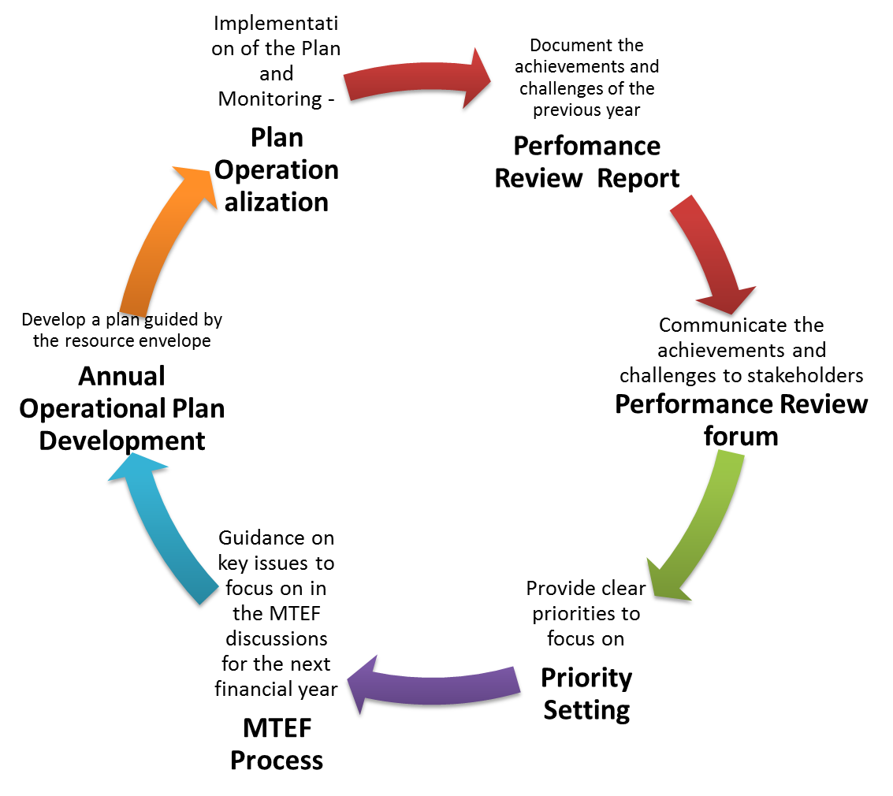

This M&E framework articulates a strong and harmonized M&E component of the UHC domains, as well as health system actions. It serves as a mechanism for County, National and Global reporting; aligning partners at country , regional and global levels around a common approach to country support and reporting requirements. The M&E plan also provides an investment framework for strengthening M&E functions and processes by all health sector stakeholders in the Country.

This plan further serves as a single country-led M&E platform bringing together all the elements related to monitoring, evaluation and review of the UHC roadmap and specifically monitoring and evaluating the implementation of UHC actions in the 4 phase I pilot participating counties (Machakos, Nyeri, Kisumu and Isiolo). The relevant data sources and institutions for data generation, compilation, analysis, synthesis and dissemination form an integral part of the single platform. The UHC Country review and policy dialogue processes will make use of the platform’s evidence base as an anchor for planning and decision-making.

This framework articulates the strategies to ensure a sound M&E platform which seeks to ensure generation of good quality, and policy relevant evidence in a timely manner. The evidence generated will inform planning, resource allocation, decision making and adaptive management as well as real time monitoring of the UHC actions in the four counties. In addition, Kenya has signed up to international commitments including Sustainable Development Goals (SDGs), Universal Health Coverage (UHC) as well Regional commitments including the African Union (AU) Africa Health Strategy 2016 – 2020 among others. This M&E framework will facilitate fulfilment of reporting obligations on the global and regional commitments. Furthermore, this plan will facilitate monitoring of inequalities, which is central to attainment of universal health coverage (UHC) and, ensuring functional surveillance systems which is key for building health security.

1.5.9. Current status of Health information systems

Health management information system (HMIS):
The role of the Health Information System (HIS) is collection of routine of health service data, collation, conveyance, management of the data to information for decision making. This information is only useful when it is reliable and timely. HIS has in the past several years undertaken serious improvements including the deployment of District Health Information Software (DHIS-2) and this has led to an increase in the volume of data collected and reporting rates from 65% to 85%. To support health information systems strengthening, the MOH has developed various policy documents and guidelines including:
• Revised HIS policy 2014-2030, • HIS strategic plan 2014-2018,
• eHealth strategy, and eHealth policy 2016-2030
• Health sector indicator’s and SOPs manual,
• EMR standards and guidelines,
• mHealth guidelines and System interoperability guidelines.
The KHSSP outlined that main priority in health information system is to invest on innovative approaches that can ensure comprehensive and effective health information to inform and guide decision making.

Health facility assessments:
The World Health Organization indicates that Service Availability and Readiness Assessment (SARA) as a health facility assessment tool designed to assess and monitor the service availability and readiness of the health sector and to generate evidence to support the planning and managing of a health system. The current SARA is designed as a systematic survey to generate a set of tracer indicators of service availability and readiness. The survey objective is to generate reliable and regular information on service delivery (such as the availability of key human and infrastructure resources), on the availability of basic equipment, basic amenities, essential medicines, and diagnostic capacities, and on the readiness of health facilities to provide basic health-care interventions relating to family planning, child health services, basic and comprehensive emergency obstetric care, HIV, TB, malaria, and non-communicable With the increased demand for accountability and the need to demonstrate results at country and county levels, information is needed to track how health systems would respond to increased inputs and improved processes over time and the impact such inputs and processes have on improved health outcomes and better health status. The provision of the defined Health and related services is a function of:
- Availability of the inputs needed to provide the service
- Health Worker Knowledge on the methods of provision of the service, and
- The ability to appropriately mix the required inputs to deliver the service
The SARAM focuses on providing comprehensive information on Health Access, as defined in the Kenya Policy documents. It provides a mapping of:
- Status of KEPH provision across the Country, counties (health outcomes),
- Capacity to provide services, looking at
  - Availability of critical inputs needed for provision of services
  - Functionality of critical inputs needed for provision of services
- Readiness of critical inputs needed for provision of services
It therefore provides information to decision makers and managers on the existing capacity for Service Provision. Availability of inputs is assessed through a mapping of existing Human Resources (numbers, and basic skills), Infrastructure (including physical infrastructure, equipment, transport, and ICT), and Health Products. Health worker knowledge and ability to mix inputs is assessed through mapping of service readiness (leadership, and organizational capacity).

Tracking health expenditures:
Household Health expenditure and Utilization Survey - The Kenya Household Expenditure and Utilization Survey is an elaborate NHA framework comprising the household and institutional Surveys. The goal of the survey is to provide essential data describing the use of health care services, choice of providers, spending on health care and the demographic and social-economic determinants of health care use. The survey primarily looks at:
The estimation of the utilization rates of health care services by those reporting illness by specific subgroups in the population;
- Analysis of the pattern and choice of providers used for outpatient and in-patient health care by various socioeconomic
- and demographic variables;
- Estimation of the amount spent on health care services at the per capita levels;
- The perceptions of quality of care for different types of providers and
- The extent of health insurance coverage in the population. The survey is conducted by the Ministry of Health in collaboration with the KNBS but Coordination is by MOH

Integrated disease surveillance and response (IDSR):

Population based surveys:

National research system:

National Health Accounts (NHA)
Kenya National Health Accounts Survey - National Health Accounts (NHA) has become a feasible and useful approach for understanding many health care financing issues. National Health Accounts is a tool for health sector management and policy development that measures total public and private (including households) health expenditure. It tracks all expenditure flow across a health system and links the sources of funds to service providers and to ultimate use of the funds. Thus, NHA answers the questions: who pays? How much? For what? The overall objective of the NHA study is to comprehend the total resource envelope for the Kenyan health sector with a view of obtaining data that will inform future policy development and planning. The Kenya NHA estimation describes expenditure in the form of a matrix structure which distinguishes between the source and final use of funds.

Civil registration and vital statistics (CRVS):
A vital statistics unit within MOH has been established and is working to improve the quality of information generated. Information policy and strategy has been developed and is being implemented. Although people are yet to be trained and implement it, a data warehouse has been developed.

Common data architecture (enterprise architecture, infrastructure)

UHC readiness assessment
In order for the UHC delivery unit to initiate the process of developing the UHC roadmap and phase I pilot document, the unit conducted a readiness assessment in the 47 Counties to establish the critical Gaps and planned on how to fill the gaps. The results were as follows:

Figure 2. Major Gap at 50% for Community units

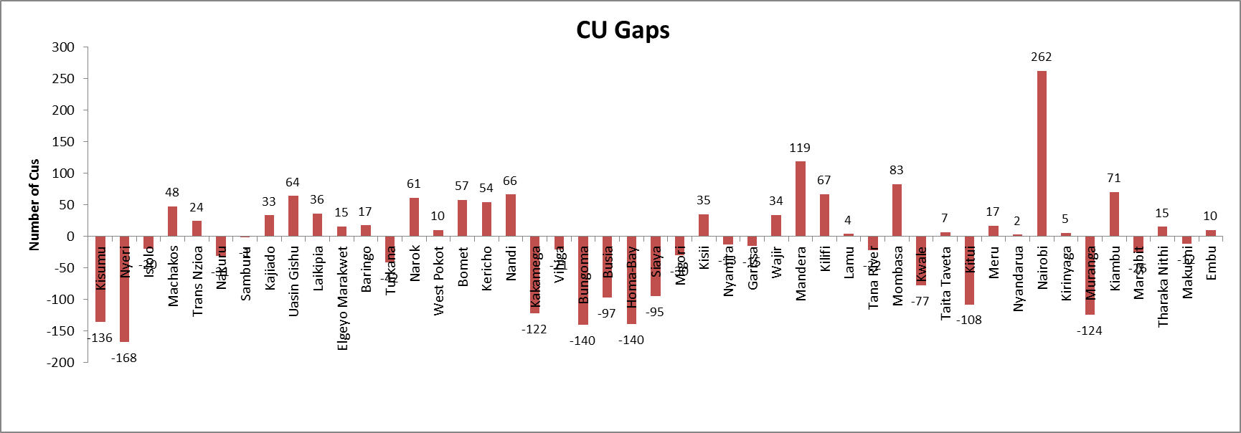

Similarly, on health infrastructure, a significant number of health facility infrastructures exists with 14 out of 47 counties below the threshold of 2 health facilities per 10,000 pop. Two thirds of the counties have adequate numbers of the health facilities though not operating optimally.
Health facility density by county /10,000 population in 2018
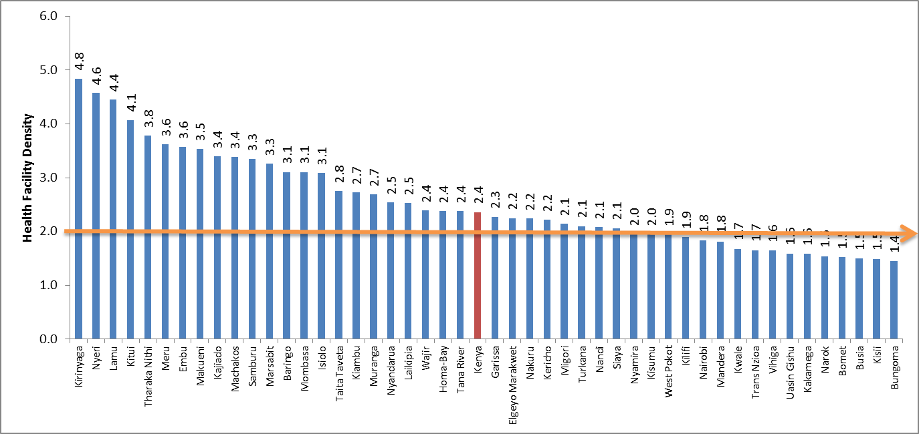
On the other hand, 12/47 Counties had above the recommended standard of 18 beds per 10,000 population while three quarters of the counties had below the average recommended Health facility bed density/ 10,000 population by county.
Health facility bed density/ 10,000 population by county
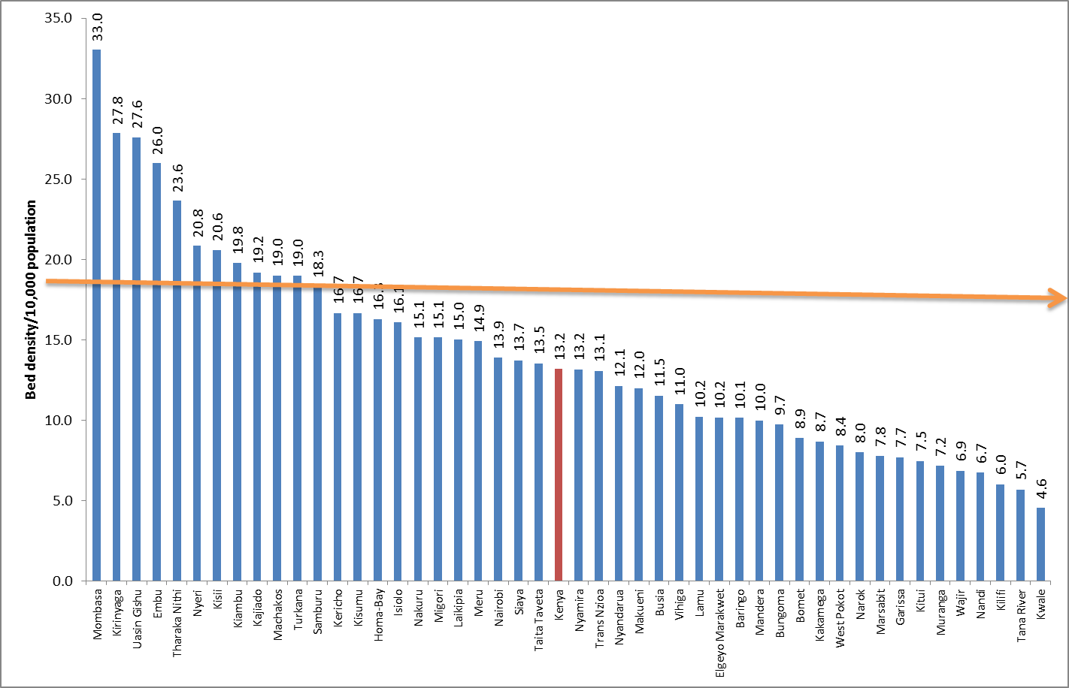

Availability of Major equipment

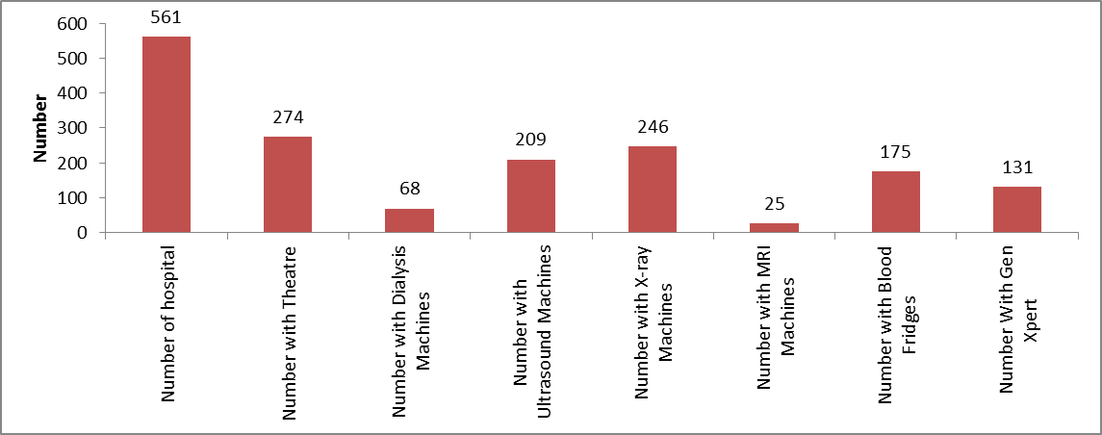

Analysis, dissemination and use of evidence

2.0 Program Description and Frameworks: Positioning of UHC in the Nexus of the Big4 Agenda

Briefly give an overview of the Pilot/ project (usually the summary from the project proposal is sufficient). Give the reader an indication of why the UHC is relevant to your organisation and the community at large by relating the project to your organisation’s vision.

The following principles have been identified to guide action in prioritizing and implementing HSS:
- Leaving no one behind: a commitment to equity, non-discrimination and a human rights-based approach
- Transparency and accountability for results
- Evidence-based national health strategies and leadership
- Making health systems everybody’s business with engagement of citizens, communities, civil society and private sector
- International cooperation based on mutual learning across countries and development effectiveness principles.

HSS for UHC is designed to focus on five dimensions of health system performance: (i) equity; (ii) quality; (iii) responsiveness; (iv) efficiency; and (v) resilience. Kenya has made significant strides in implementation of priorities towards UHC. The main progress and challenges thereof are outlined below.
Equitable access: Whilst Kenya has made substantial progress towards meeting the health Millennium Development Goals (MDGs), this progress has been uneven across specific goals and within the country. Several other programs have been initiated to ensure equity in availability of health services. These include establishment of health facilities in informal settlement, Free Maternity Services among others. This M&E Framework will focus more on tracking the socio-economic equity of benefits in order to make sure that Kenya delivers on its SDG agenda to leave no-one-behind. Approximately 36% of Kenya have a form of Health Insurance offering financial protection. As a result, approximately 1 million Kenyans fall into poverty every year due to catastrophic health expenditures. Increased healthcare financing will be required to ensure all Kenyans can benefit from UHC.
Education is a social vaccine and is associated with positive health outcomes. Studies have consistently shown that education attainment has a strong effect on health behaviors and attitudes. Accordingly, teenage girls with no education or those with primary education only, are more likely to begin childbearing compared to those with secondary education and above. The KDHS (2014) indicates that 33% of teenage girls (15-19 years) with no education had begun child bearing compared to 12% of girls with secondary or higher education. Furthermore, teenagers from the poorest households were more likely to experience teenage pregnancy and motherhood (26%) compared to teenagers from wealthiest backgrounds (10%). Moreover, also between Counties significant inequalities prevail in health outcomes.
According to the Mid-term review report of the Kenya Health Sector Strategic plan (KHSSP 2014-2018), on average, HIV and malaria prevalence were 4 times higher than the national average in 4 counties bordering Lake Victoria: Migori, Kisumu, Siaya and Homa Bay. Urban areas had a substantially higher prevalence of TB compared to rural areas. Four counties: Turkana, Isiolo, Garissa and Kisumu have institutional maternal mortality over 200 per 100,000 deliveries while two counties: Elgeyo-Marakwet and Nyamira have institutional MMR less than 50 per 100,000 deliveries; Basic vaccination stands at 36% coverage in West Pokot to over 95% in Nyamira, Nandi, Kiambu, Kirinyaga & Tharaka-Nithi; regarding non-communicable diseases; the data from the STEPS 2015 show that the prevalence of overweight and obesity have increased, and are reaching epidemic proportions especially among women, with 38% of the women in Kenya either overweight or obese. County differences in overweight and obesity among women were quite large, with for instance 45% of women in counties in the central region and cities overweight or obese compared to 15% in counties in the arid regions.
Health system efficiency: The mission of the MOH is to deliberately build progressive, responsive and sustainable technologically-driven, evidence-based and client-centered health system for accelerated attainment of highest standard of health to all Kenyans. The vision is to contribute to being a globally competitive, healthy and productive nation. The mandate of the health sector is to promote and participate in the provision of integrated and high-quality curative, preventive and rehabilitative services that is equitable, responsive, accessible and accountable to Kenyans.
Over recent years and under the leadership of the MOH, the Health Sector has made important strides towards attaining its mission, but various challenges remain regarding optimization of efficiencies within its health system. The minimum benefit package that should drive the UHC agenda is yet to be defined which makes sufficient costing and planning for efficient delivery of care very challenging.
In leadership, each County has developed its structures based on what it thought was best without guidance on structural and organizational arrangements, resulting in very different organizational structures among counties. There is no agreed partnership framework at the national and county levels among different stakeholders (government-MOH and counties, Development and implementing partners). Due to this, it is not clear how external resources mobilized from partners are equitably distributed among priorities and counties. There are no systematic resource tracking mechanisms at sector-wide level or even for government health spending at county level. All is hampering health system efficiency. Moreover, the health sector is underfinanced as compared to international benchmarks, which is well reflected in poor performance of PHC, especially prevention, the community strategy, NCDs and curative care. External funding is poorly aligned and harmonized because of the weak coordination, absence of joint annual planning and poor resource mapping. The funds remain largely off-budget (96% of total external resources).
With increasing numbers of conditional grants going to counties (Free maternity, user fees, HSSF, NHIF), the fragmentation is high and hence the risk of inefficiency. The MOH was able to only spend 68% of the total allocated budget (52% development and 86% recurrent) in the last three years.
Furthermore, Kenya has only been able to fill in 15% the approved positions in all health facilities; the gap is much worse in primary care facilities (13%) than in tertiary ones (30%). There is inequity in the distribution of workforce: urban–rural, regions with high and low socioeconomic development. Moreover, specialized medical care is mostly available in urban areas. Delayed promotions, issues around non-practice and call allowance, unpaid salaries, non-payment of school fees, non-remittance of NHIF salary deductions resulting in salary discrepancies especially between former local government and MOH staff, together are the major challenges in the management of the human resources. These challenges are causing industrial unrest in some counties.
There is a high level of absenteeism of human resources as shown by recent studies, which show high efficiency gap.
In health infrastructure, the average population living within 5 Km from the health facility (the norm) is about 62%. There has been concerted efforts by both National and county Governments toward equipping health facilities. Despite the efforts, gaps remain with facilities having inadequate and dilapidated equipment and with some not meeting the required norms and standards.
In health policy and systems research, understaffing of the unit and inadequate capacity to undertake policy relevant and demand driven research as well as packaging the findings to meet policy makers’ interests remain major gaps.
Quality of health care: This is the degree to which health services for individuals and populations increase the likelihood of desired health outcomes and are consistent with current professional knowledge. Shortfalls in quality result in avoidable risks for patients and under-performance of health systems relative to what can be achieved with available resources.
Under health leadership, investment is taking place at both levels of the government to improve stewardship, implementation of appropriate system of health governance and consolidating health partnership arrangements. The 2017 Health Act and Kenya Health Policy (2014-2030), and norms and standards (e.g. HRH, and Health Infrastructure, HPT) are offering overall guidance to the health sector in the delivery of quality care. Counties established their health service management structures. In addition, more specific service delivery related policies, strategies and guidelines that translated the overall health policy and strategy into action are being developed.
In human resources, devolution created an enabling environment for counties to employ more staff which enhanced the health worker population ratio especially in hard to reach areas. Kenya has 14 doctors per 100,000 populations and only 42 nurses per 100,000 respectively in 2016. Some counties have also started to work on motivation and retention mechanisms. For example, Garissa County has upgraded health worker’s salaries by two job groups and developed a retention package for its workers.
With regards to Health Infrastructure Systems Strengthening, the Managed Equipment Supply (MES) programme helped to embark on a comprehensive programme to upgrade 98 hospitals, 2 in each of the 47 Counties and in the 4 National hospitals. There is also an effort to upgrade slum clinics. Counties have started to improve their infrastructure as can be seen throughout the Country.
In health products and technology, the ability of KEMSA to respond to requests improved, with its fill rate increased from 50% in 2013/14 to 85% in 2015/16. Training of over 3,000 health workers on the Logistics Management Information System (LMIS) has improved turnaround time of medical commodities. It has reduced from 12 days in 2013/14, to 10 days in 2014/15 and to 9 days in 2015/16. The development and functioning of the LMIS and the use of WhatsApp to follow-up stock levels have helped to monitor and reduce stock-outs. All have contributed to increased availability of essential medicine and supplies at all service delivery levels which again enables timely provision of quality care.
However, and nevertheless the improvements described above, there are also gaps in improving the quality of care. These include inadequate numbers of Human Resources for Health, and capacity of staff at national and county levels in the area of standards and quality assurance; bottlenecks in supply chain management systems for health commodities and supplies; insufficient planning, maintenance, and quality control over infrastructure and equipment; and insufficient inter-operationality between and capacities within the existing health management information systems to facilitate solid evidence based decision making.
Responsiveness: The concept of responsiveness refers to the extent to which a health system meets people’s expectations and preferences concerning non-health matters, including the importance of respecting people’s dignity, socio-cultural beliefs and preferences, autonomy and the confidentiality of information, besides responding to the needs and demand of patients.
Resilience: Although resilience lacks a formally accepted definition, within the context of Kenyan UHC Roadmap, Resilience is referred to here as “the capacity of health actors, institutions, and populations to prepare for and effectively respond to crises; maintain core functions when a crisis hits; and, informed by lessons learned during the crisis, reorganize if conditions require it.”
In order to progressively move towards achieving Universal Health Coverage, the Government has committed to implement various interventions that will facilitate the achievement of the above objectives. These include the scaling up of NHIF coverage to 100 per cent of the population; improving systems at NHIF; aligning the NHIF Act to UHC and allowing Public Private Partnership in Insurance; mobilizing additional funding to the health sector and implementing various programs and projects that are meant to improve access and quality of healthcare services across the country. These interventions the Government is undertaking are in line with the current global health agenda and the SDGs 3 goal (specifically target 3.8) under the 2030 agenda that is increasingly focusing on the goal of achieving universal coverage in health as well as the national policies, including the Kenya Vision 2030 and the Kenya Health Policy, 2014-2030.
Further, it is recognized that the role of the county governments, other government ministries, departments and agencies and other stakeholders including partners, private sector, and civil society will be critical in moving towards Universal Health Coverage.

2.1 Program Goals and Objectives (rework/ realign and harmonise the programme thematic areas and strategic objectives- see summary table on objectives and expected)
The Government is committed to implementing Universal Health Coverage as one of the big Four Government Agenda. Universal Health coverage is an integral part of the country’s efforts to attain the desired status of health as elaborated in Kenya Health Policy. Universal Health coverage will ensure that Kenyans receive quality, promotive, preventive, and curative and rehabilitation health services without suffering financial hardship. As such the following table summarizes the UHC Thematic programming Thrust Areas (Critical Drivers) , the identified strategic objectives and expected deliverables

Table 1: The objectives and expected outputs of UHC in Kenya.

SNo. | UHC Thematic Areas/ Critical Drivers | Strategic Objectives | Expected Outputs
1 | Access to Essential Services (Health Services Coverage) | SO1: To increase population covered by defined essential health package by Dec 2022 | - Increased proportion (%) of Immunizing Public Health Facilities  - uninterrupted availability of high quality Routine and Emergency Strategic Vaccines  - New vaccines Introduced  - Increased awareness of NCDs  - NCD Screening programs in place  - School health program expanded  - Stand alone and hospital base palliative care units established  - Increased number of community health workers
 |  | SO2: To increase the population having access to a defined essential health service package by Dec 2022 | - NHIF Benefit Package Reviewed  - Kenya Essential Package for Health Reviewed  - Linda Mama program expanded  - Adopt low cost service delivery models  - Increase in the ratio of health worker per 10,000 population  - Increase the number of health workers trained  - CT-Scan equipment for 37 hospitals availed  - Expansion of MES (21 Additional hospitals and increase capacity in other hospitals; with Surgical theatres, ICU, CSSD and dialysis equipment  - Capacity building of counties using KQMH done  - Institutionalization of focused joint inspection  - Grading of health facilities piloted  - Expansion of MES (21 Additional hospitals and increase capacity in other hospitals; with Surgical theatres, ICU, CSSD and dialysis equipment  - Install 3 additional ICUs (Two new in Narok and Meru and Increase capacity in MTRH  - Fully equip an additional 11 Dialysis centers (4 new and increase capacity in 7 high volume hospitals)  - Fully equip 28 additional theatres (8 in new hospitals and increasing capacity in the 20)  - Full equip additional 24 hospitals with CSSD (21 New and additional capacity in 3 hospitals)  - Primary care facilities with cold-chain equipment
2 | Access to Quality Essential Services | SO1: To increase availability of quality people centered essential interventions/services so that Kenyans access and receive quality health services by Dec 2022. | - Improved quality of services and patient safety  - Strengthened networks of close to client Primary care organized as dispensaries/L3 or health centers /L3with the backup of specialized and hospital services responsible for defined populations (Primary Care Networks/PCNs)  - Investment in community and primary Health care services/ Invest in preventive and promotive services and social determinants of Health (water, sanitation, nutrition).  - Equipping health facilities including with specialized equipment;  - Key focus on critical basic equipment for primary care facilities  - Infrastructure development  - Investment in Human resource for Health; (  - Increased Human resources for health (50% Increase in ratio of health worker to 10,000 people (from 9: 10,000 population to 14: 10,000 population); skill development  - Investment in health Commodities and Technologies (e.g. increased financing informed by demand, targeted improvement in data collection, strategic purchasing of health commodities, supply chain strengthening)
2 | Access to Quality Essential Services | SO2: Strengthen Leadership, Governance and Management through establishments of Legal and Institutional framework for successful coordination of the implementation of UHC for Kenya by Dec 2022. | - Necessary legislations, policies, strategies and plans are in place to guide UHC implementation  - Mechanisms for intersectoral collaboration strengthened (working with the other enablers  - Strengthen health sector partnership towards UHC  - Improvement of health information system including establishment of a unified national database on patient activity  - Establishment of clear monitoring and reporting system towards UHC at both national and county levels  - Organizational structure to lead the implementation of UHC established and operationalized  - The Second Kenya Health sector strategic plan (KHSSP) developed  - Kenya Health Financing strategy finalized  - Partnership and coordination framework finalized  - Health Law Implemented  - Health sector coordination strengthened  - IRA and RBA acts reviewed to increase uptake of private Health Insurance to cushion NHIF  - CARA amended to ring fence health funds at county level (changes to PFM act)
 |  | SO4: To ensure availability of Health Products & Technologies to meet UHC needs using projected coverage by end of Dec 2022 | - Expanded access to HPT by increasing the capacity of the market to offer a continuous supply good quality health product  - Increased KEMSA capacity for supply of essential medicines  - Expanded EMMS lists (incorporate new products e.g. products for chronic diseases like cancer chemotherapy medicines, protective wear for chemotherapy, dialysis products, laboratory screening products, implants etc) in line with reviewed KEPH  - Cost reduction in prices of medicines and other health products realized through expansion of access program  - Price control for health products and technologies secured  - increased access to medicines and health products by making use of WHO Intellectual property (TRIPS) provisions under the Industrial Property Act to health commodity funds at county level through legislation ring fenced (e.g. PFM Act 2012 review)  - Quality of all health products assured through Intensifying combating of counterfeits  - GMP inspections for manufacturing sites, both local and external conducted  - Quality assurance testing conducted for all health products and technologies in the country (i.e. Drugs, gloves, syringes, condoms, herbal preparations etc.)  - A databank on the quality of health products and technologies in the country created  - An ultra-modern laboratory put- up  - Pharmacovigilance (Active reporting of poor quality health products and adverse reactions to drugs enhanced/ Intensified  - Post market surveillance for selected lifesaving health products conducted on a regular basis  - End user storage capacities to support product quality through enhancing storage infrastructure e.g. cold chain for vaccines; fridges, storage buildings;  - Safety in Commodity use ensured through support for rational use of products  - Support on Prudent management of Health products intensified to minimize wastage e.g. (through pilferage and expiries)  - Healthcare Supply Chain Automated
3 | Demand for essential services | SO1: Strengthen demand for essential health services by Dec 2022 | - Increased awareness of NCDs
 |  | SO2: To Increase population accessing UHC related information by Dec 2022 | - Improve Communication and advocacy for UHC  - Stakeholder engagement on UHC done
4 | Financial Protection | SO1: To strengthen financial risk protection in health  through increased population covered by health insurance from 36% in 2017 to 100% by Dec 2022 (i.e. 16,538,982 persons to 56,740,788 persons) | - A Unified, Explicit Benefit package developed and operationalized that progressively consolidate the targeted health insurance programs  - Increased health insurance coverage through NHIF  - That resources will be prioritized to provide the essential health services that people of Kenya need.  - Increase government spending on health; increased domestic resource mobilization  - Mandatory contributions for financial sustainability, mitigate adverse selection  - Use of budget resources to reduce financial barrier to access health care and make services affordable to everyone  - Targeted external resources that are predictable and guided to specific interventions.  - To maximize Efficiency and value for money in the management and utilization of available health resources  - Moving from passive to “strategic purchasing” to drive performance and contain cost increase Effective Governance and accountability and transparency
 |  | SO2: To increase the total health expenditure on health as a % of GDP from 2.5% to XX by Dec 2022 | - increased budgetary allocation to health  - increased private sector investment  - Alternative financing models in health developed and implemented  - Implementation of existing Financing programs continued  - Increased efficiency in health financing
4 | Resilience in essential service provision | SO1: To ensure equity in distribution of services and resources. | - Targeting the marginalized and the vulnerable groups/ Effective safety nets for the poor and vulnerable; This will include expanding service delivery to the marginalized groups; implementing pro-poor interventions; Reaching the informal sector.  - Compliance of HFs in offering insured services (Benefit package)  - Financial risk protection for all Kenyans  - Fairness in distribution of health sector resources at all levels of the health system

In order to progressively move towards achieving Universal Health Coverage, the Government has committed to implement various interventions that will facilitate the achievement of the above objectives. These include the scaling up of NHIF coverage to 100 per cent of the population; improving systems at NHIF; aligning the NHIF Act to UHC and allowing Public Private Partnership in Insurance; mobilizing additional funding to the health sector and implementing various programs and projects that are meant to improve access and quality of healthcare services across the country. These interventions the Government is undertaking are in line with the current global health agenda and the SDGs 3 goal (specifically target 3.8) under the 2030 agenda that is increasingly focusing on the goal of achieving universal coverage in health as well as the national policies, including the Kenya Vision 2030 and the Kenya Health Policy, 2014-2030.
Further, it is recognized that the role of the county governments, other government ministries, departments and agencies and other stakeholders including partners, private sector, and civil society will be critical in moving towards Universal Health Coverage. The next chapters in this roadmap spells out the key focus areas, the targets as well as the resource requirements for implementation in-order to achieve the desired outputs for UHC in Kenya.

2.2 Program Strategies and Activities (including Geographic Scope and Target Population)

The Ministry has defined priorities with targets to be implemented in the next four years (2018-2022). The priorities range from increasing the population covered by health insurance, legal reforms, increasing the range of health services, investments in health commodities, ensuring the necessary infrastructure and equipment and that human resource for health are availed for efficient service delivery. Additionally, the priorities also include increasing financing to the health sector, supervision, monitoring and evaluation as well as communication and advocacy for UHC. The table 4 here below spells out some of the strategies that shall be employed in each of the priority areas in-order to progressively move towards achieving the aspirations of UHC

Figure 4: Summary of Strategies for Achieving the Aspirations (Need to be further unbundled based on identified priority interventions)
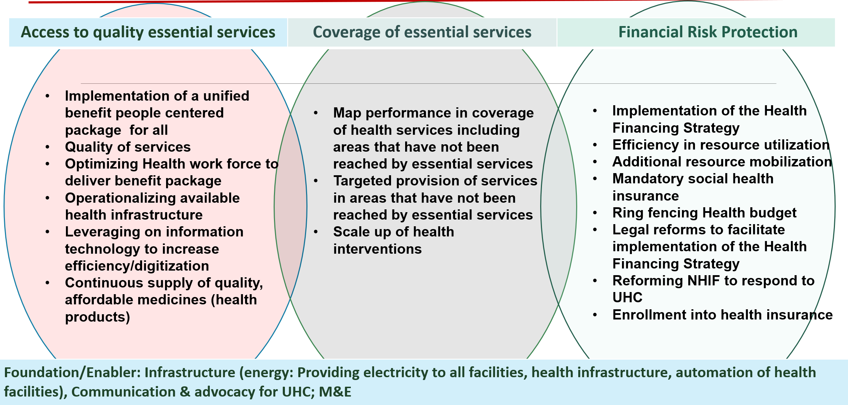

2.3 Conceptual Framework (Embed under the section on Background Information/contextual analysis of UHC)
Briefly give an overview of your project (from your situational analysis) and a conceptual model showing the known or hypothesised associations (or cause effect relationships) among the various factors in question. (You may include references to support your documentation). Include the areas which are your core concern. Summarize this section by providing the goals and objectives of your program/project.

2.3 UHC Results Framework

Strategic Objective 1: Increase population covered by defined essential health package
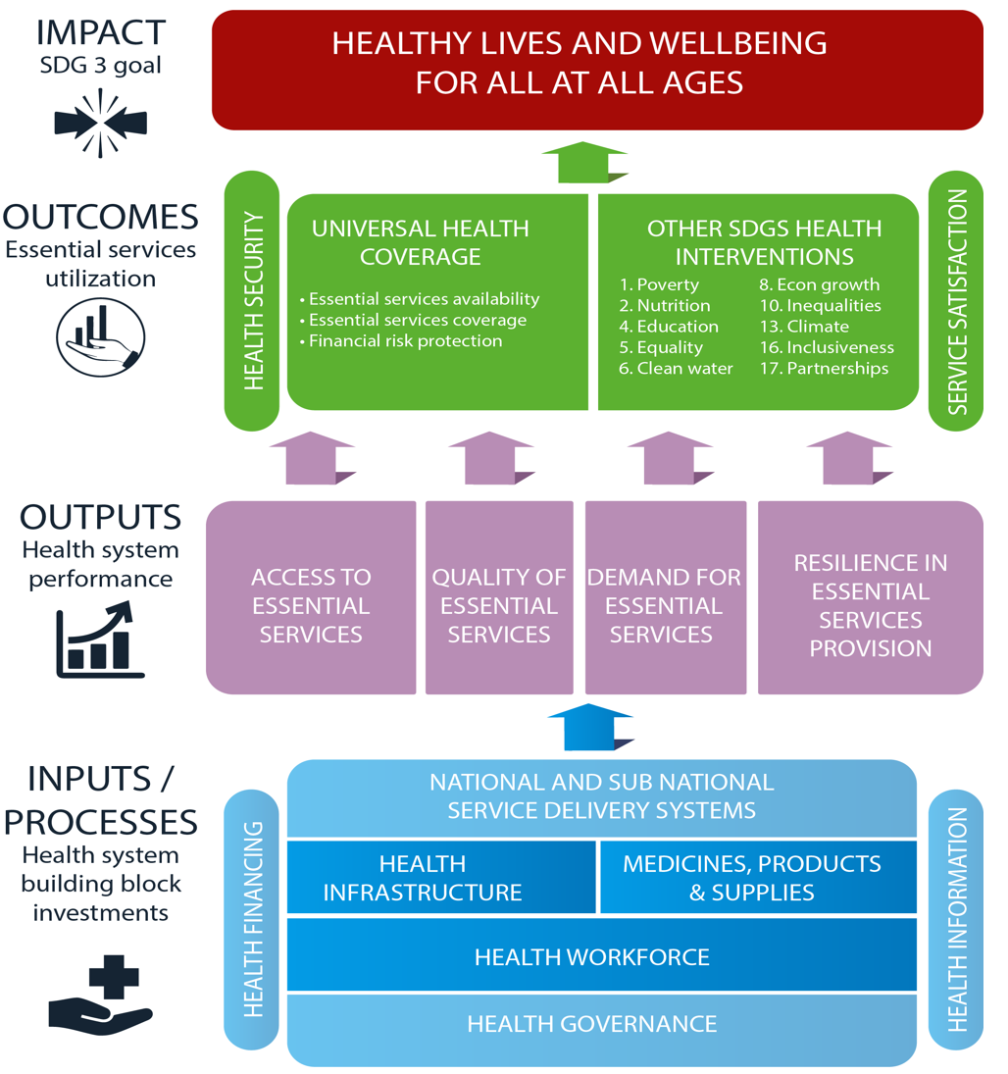
Figure 5: Results framework: Monitoring progress towards UHC
Health Impact

Level and distribution

Health Outcomes

Status and distribution of indicator targets across 6 outcome areas

System Performance
Status and distribution of indicator targets across 4 performance areas

Health Investments
Status of indicators across 7 investment areas
Progress of actions across 7 investment areas

Health Sector Performance
Efficiency across logical chain
Equity across logical chain

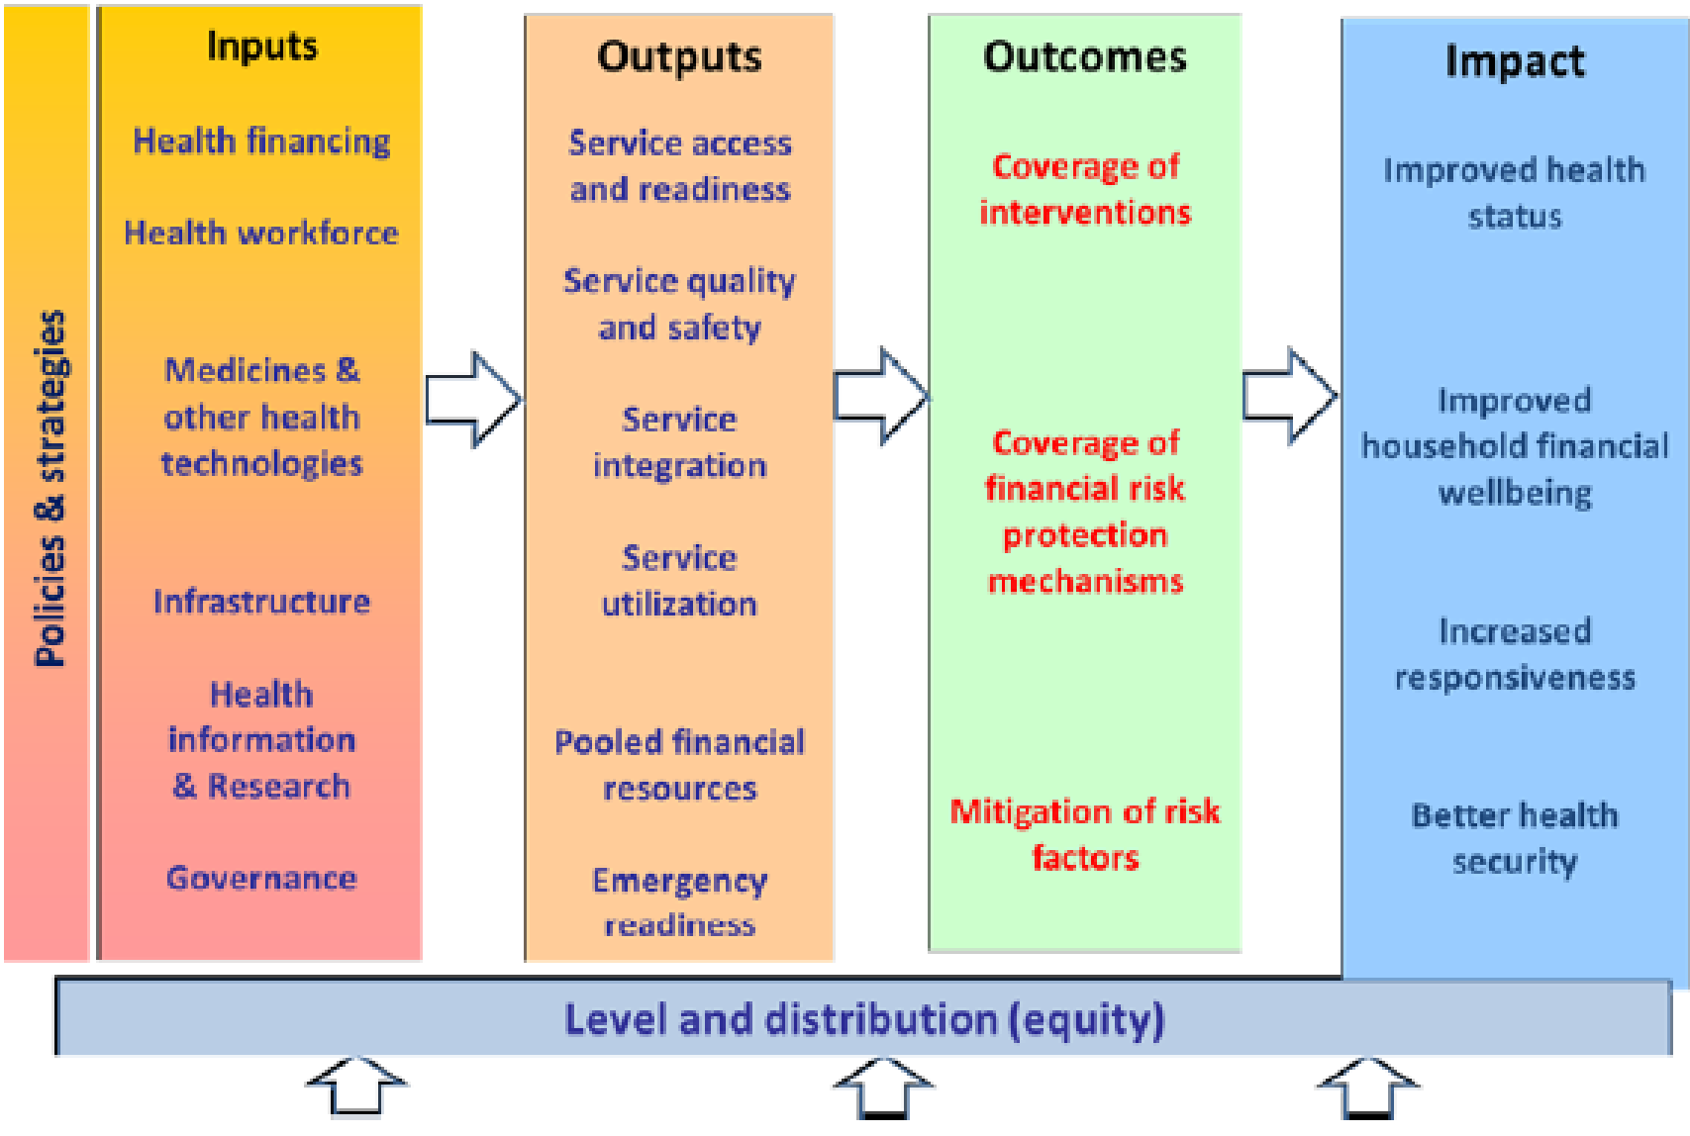
Figure 6: Results framework: monitoring progress towards UHC

2.4 Logic Model (or Logical Framework)
Provide a logic model for your project/programme indicating the problem statement (from your situation analysis), the objectives and how these objectives are to be achieved through the necessary inputs and activities, which will lead to expected outputs, which in turn should translate into expected outcomes, and finally, how the outcomes will result into the expected impact on the general population.

Inputs | Activities | Outputs | Outcomes | Impact
What goes in…  What you budget for... | What you do to reach your goal…  Each activity may have its own framework | What you get from your activity… more immediate  Relate to your project OBJECTIVES | What you get… down the road and involves some sort of change in behaviour, knowledge, attitude, ……….  Relate to your project GOALS | How the whole programme affects the general population – this is a long-term result  Relates to Mission / Vision

2.6 Critical Assumptions

3.0 Monitoring Plan
Include a monitoring plan including tools (see the template below) that you will be using to track the progress of your project. Remember these are not the tools for collecting data but are related to monitoring the organisational and operational aspects of the rollout of the project. These tools include things like benchmark calendars, budget sheets, GANNT charts, etc. It is important to state how often the information captured in the tools will be updated. Remember that these must inform operational issues and thus must be updated as often as the information would be useful for management of the project. Do not waste time, money and level of effort using tools that have no operational impact when their content is reviewed.

3.1. UHC Performance Monitoring and Evaluation Matrix
(This is a matrix that provides a snap shot of the M&E system, what data will be collected, the frequency, the people responsible and how the results will be used at the various levels, and also when the evaluations will be conducted)

Result Area
Intermediate Result
Expected Outcomes
Activities | Output | Indicator | Targets |  |  |  |  |  |  |  | Data source |  | Frequency of data collection |  | Party responsible
Activities | Output | Indicator | Base  line | Year1 | Year2 | Year3 | Year4 | Year5 | Total
Address population issues at beginning of year (identify eligible, baseline and target population).

Priority Initiatives |  | Key Output | Output Indicator |  |  | Key Activities | Sub-activities | Timelines |  |  |  |  |  |  |  | Responsibility | Budget
 |  |  |  | Baseline (2017) | Target (2018) |  |  | Q 1 |  |  | Q 2 |  | Q 3 |  | Q 4
UHC Critical Driver: Insurance Coverage
Strategic Objective 1: Increase population covered by health insurance from 36% in 2017 to 100% by 2022 (16,538,982 persons to 56,740,788 persons);

Key Outcome 1: Increased financial risk protection in health
Increase NHIF uptake |  | Increased health insurance coverage through NHIF | Number of Persons contributing to health insurance | 7.16 M - (Formal; 3.8), (Informal; 3.1), (Indigents; 181k), (Older Persons; 42k), (Linda mama;1.2) | 9.9 M - (Formal; 3.8), (Informal; 4.7), (Indigents; 350k), (Older Persons; 1.04M), (Linda mama 1.23) | Enlist 37,000 banking sector agent network; 4 banks, 3 mobile Telkom networks 2) - Ajira agents 3) -Self-help groups | Develop a concept note | x |  |  |  |  |  |  |  | NHIF
 |  |  |  |  |  |  | Mobilize and sensitize potential agents/self-help groups | x |  |  |  |  |  |  |  | NHIF
 |  |  |  |  |  |  | Carry out Registration of agents (banking and Ajira) and the self-help groups | x |  |  | x |  | x |  | x | NHIF
 |  |  |  |  |  |  | Sensitization of agents/self-help groups and continuous recruitment of members through the agents /self-help groups |  |  |  | x |  | x |  | x | NHIF
 |  |  |  |  |  | Advocate through religious organizations | Hold advocacy meetings with religious groups | x |  |  | x |  | x |  | x | NHIF
 |  |  |  |  |  | Enlist 100,000 community health volunteers to recruit 20 households per CHV | Sensitize the community & CHVs | x |  |  |  |  | x |  |  | NHIF
 |  |  |  |  |  |  | Register the CHVS | x |  |  | x |  |  |  |  | NHIF
 |  |  |  |  |  |  | Continuous recruitment of members | x |  |  | x |  | x |  | x | NHIF
 |  |  |  |  |  | Digitization of NHIF | Carry out an ICT audit | x |  |  |  |  |  |  |  | NHIF
 |  |  |  |  |  |  | Implementation the recommendations from the audit |  |  |  | x |  | x |  | x | NHIF
Strategic Objective 2: To reduce the out-of-pocket expenditure from 26% in 2017 to 12% by 2022
 |  | Reduction of out of pocket expenditure (50% Reduction in out of pocket medical expenses by 2022)
UHC Critical Driver: Health services coverage
Strategic Objective 1: Increase population covered by defined essential health package
Key Outcome: Reduced morbidity and mortality
Increase availability of Immunization services |  | Increased Proportion (%) of Immunizing Public Health Facilities | Proportion of Health Facilities Offering Immunization Services | 65% | 100% | Procure vaccine storage equipment for all Health Facilities to ensure universal access to immunization | Conduct a National Inventory of Cold Chain equipment | x |  |  | x |  |  |  |  | MOH/Preventive/promotive dept
 |  |  |  |  |  |  | Conduct an Assessment to determine vaccine storage capacity needs for all levels | x |  |  | x |  |  |  |  | MOH/Preventive/promotive dept
 |  |  |  |  |  |  | Procure Cold Chain Equipment |  |  |  | x |  |  |  |  | MOH/procurement
 |  |  |  |  |  |  | Distribute and Install cold chain equipment |  |  |  | x |  | x |  | x | MOH/Preventive/ promotive dept
 |  | uninterrupted availability of high quality Routine and Emergency Strategic Vaccines | Proportion of Sub-counties reporting vaccine stock outs in a year | 5% | 0% | Procure and distribute Routine and Emergency Strategic Vaccines to all Counties | Conduct a National and County Vaccine forecasting | x |  |  |  |  |  |  |  | MOH/Preventive/promotive dept
 |  |  |  |  |  |  | Procure Routine and Emergency Strategic Vaccines for all Counties | x |  |  |  |  |  |  |  | MOH/Preventive/ promotive dept/ procurement
 |  |  |  |  |  |  | Distribute all Routine and Emergency Strategic Vaccines to all Counties | x |  |  | x |  | x |  | x | MOH/Preventive/promotive dept
 |  |  |  |  |  |  | Monitor utilization of the vaccines (Coverage) appropriately | x |  |  | x |  | x |  | x | MOH/Preventive/promotive dept
 |  |  |  |  |  | Support vaccine clearance and operationalization (O&M) of the Regional Vaccine depots and distribution | Procure vaccine clearance and Distribution services | x |  |  |  |  |  |  |  | MOH/Preventive/promotive dept
 |  |  |  |  |  |  | Secure financial allocation for O&M and daily running of Regional vaccine depots | x |  |  |  |  |  |  |  | MOH/Preventive/promotive dept
 |  |  |  |  |  |  | Monitor utilization of the vaccines (Coverage) appropriately | x |  |  | x |  | x |  | x | MOH/Preventive/promotive dept
Reduce morbidity and Mortality from vaccine preventable diseases (HPV) |  | New vaccines Introduced. | No. of new vaccines introduced | 1 | 1 | Plan for and Procure new vaccines | Set up planning committees for new vaccine introduction | x |  |  |  |  |  |  |  | MOH/Preventive/promotive dept
 |  |  |  |  |  |  | Procure and Distribute new vaccines (HPV) |  |  |  |  |  | x
 |  |  |  |  |  |  | Train National, County and Operational staff on the new vaccine |  |  |  |  |  | x
 |  |  |  |  |  |  | Develop and disseminate messages on the new vaccines to drive uptake |  |  |  |  |  | x |  | x
 |  |  |  |  |  |  | Monitor utilization of the new vaccines (Coverage) appropriately |  |  |  |  |  | x |  | x
Raise awareness on NCD risk factors for prevention and control |  | Increased awareness of NCDs | Proportion of people with information on NCD risk factors and prevention | xx | xx |  | Hold meetings, barazas; use of media to Raise awareness on healthy diets; physical activity, Tobacco and substance abuse; exposure to harmful environmental contaminants and products among other risk factors | x |  |  | x |  | x |  | x | MOH/Preventive/promotive dept
Intensify NCD screening services |  | NCD Screening programs in place | Number of individuals screened for priority NCDs | xx | xx |  | VIA/VILI and cryotherapy capacity strengthened | x |  |  | x |  | x |  | x | MOH/Preventive/promotive dept
 |  |  |  |  |  |  | Screening for Diabetes done as routine and opportunistically by CHW | x |  |  | x |  | x |  | x
 |  |  |  |  |  |  | Screening for Hypertension done as routine and opportunistically by CHW | x |  |  | x |  | x |  | x
School health |  | School health program expanded | Proportion of school going children aware of healthy living and wellness | xx | 50% | Increase NCD awareness content in the program  -capacity building for teachers on NCD prevention and control | Review content of the school health program | x |  |  |  |  |  |  |  | MOH/MOEST
 |  |  |  |  |  |  | Train teachers on prevention NCDs (e.g. diabetes, hypertension and priority cancers) | x
 |  |  |  |  |  |  | Training of students | x |  |  | x |  | x |  | x
Intensify Rehabilitation and palliative care |  | Stand alone and hospital base palliative care units established | Institution based, and home based palliative care done | xx (get baseline from KEHPCA) | 100 |  | Continuous Institution based, and home based palliative care | x |  |  | x |  | x |  | x
Expand/ set up new community units by recruiting additional community Health Workers |  | Increased number of community health workers | Number of recruited community health workers | xx | 100,000 | Recruit and train CHVs | Plan for and allocate resources to recruit CHVs | x
 |  |  |  |  |  |  | Conduct a mapping exercise to determine the distribution of CHVs | x |  |  |  |  |  |  |  | MOH
 |  |  |  |  |  |  | Recruit and deploy CHVs |  |  |  | x |  |  |  |  | MOH
 |  |  |  |  |  |  | Train the CHVs to deliver on the Health Objectives |  |  |  | x |  | x |  | x | MOH
UHC Critical Driver 2: Access to services
Strategic Objective 2: To increase the population having access to a defined essential health service package
Key Outcome 2: Reduced morbidity and mortality due to ill health
Health systems strengthening for Universal Health coverage
Service delivery reforms | NHIF Benefit Package Reviewed |  | Number of NHIF benefit packages available to the public | 2 Packages | 3 Packages (Gold Platinum & Bronze) | Develop a segregated Multi-tiered package | Develop a concept note |  | x
 |  |  |  |  |  |  | Stakeholders engagement |  | x
 |  |  |  |  |  |  | Launch of the package |  | x
 |  |  |  |  |  |  | Implementation |  | x |  | x |  | x |  | x
 |  |  |  |  |  |  | Monitoring and Review |  | x |  | x |  | x |  | x
Service delivery reforms | Kenya Essential Package for Health Reviewed |  | Number of KEPH | 1 | 1 | Review of the KEPH | Develop a concept note
 |  |  |  |  |  |  | Form the TWGs |  | x |  |  |  |  |  |  | MOH
 |  |  |  |  |  |  | Develop draft KEPH |  | x |  |  |  |  |  |  | MOH
 |  |  |  |  |  |  | Stakeholder Consultations (Counties, partners, line Ministries) |  |  |  | x |  |  |  |  | MOH
 |  |  |  |  |  |  | Finalize KEPH Review and launch |  |  |  |  |  | x |  |  | MOH
Service delivery reforms | Linda Mama program expanded |  | Expanded Linda Mama Package | 0 | 1 | Expand Linda Mama to include post-natal care, infants care and complications in the package | Definition of the expanded package |  | x |  |  |  |  |  |  | MOH/NHIF
 |  |  |  |  |  | Scale up the Linda Mama cover to private care provider | Registration of private care providers |  | x |  | x |  | x |  | x | NHIF
Service delivery reforms | Adopt low cost service delivery models |  | Leverage on Health care ICT (HCIT) | 0 | 2 | Develop a National Data Centre (NDC) and a reporting Hub | Construction of data Centre and reporting hub in KNH (ongoing) |  | x |  |  |  |  |  |  | MOH/Curative and rehab department
 |  |  |  |  |  |  | Equipping of the center |  | x |  | x
 |  |  |  |  |  |  | Training of the health staff (users) |  | x |  | x
 |  |  |  |  |  | Network 98 hospitals equipped under MES With the KNH data center | Site preparation, installation and commissioning of equipment in the facilities;  Training of Health care workers |  | x |  | x |  | x |  | x
Increased investment in human capita | Increase in the ratio of health worker per 10,000 population |  | No of staff recruited | 35,000 | 40,500 | Human resources for Health recruitment and Development | Develop a recruitment plan |  | x |  | x |  |  |  |  | MOH (/HR dept); Counties
 |  |  |  |  |  |  | Advertise for the posts |  |  |  | x
 |  |  |  |  |  |  | shortlist and conduct interviews |  |  |  | x
 |  |  |  |  |  |  | Induction and Deployment of the staff |  |  |  |  |  | x |  | x
 |  |  |  |  |  |  | Develop and attract expertise in Key areas
Increased investment in human capita | Increase the number of health workers trained |  | Number of apprentice/interns |  | 2,200 | Training of HR for Health | Offer apprentice/internship positions |  | x |  | x |  | x |  | x | MOH
Increased investment in human capita |  |  | Number of Specialists trained |  | 30 | Training of HR for Health | Train oncologists |  | x |  | x |  | x |  | x | MOH
Increased investment in human capita |  |  | Number of other staff trained |  |  | Training of HR for Health | ▪ |  | x |  | x |  | x |  | x | MOH
Ensure availability of medical equipment | CT-Scan equipment for 37 hospitals availed |  | Number of hospitals with CT-Scan equipment | 17 (5 to be replaced Machakos, Voi, coast General, Kenyatta and MTRH) | 49 | Provide CT scan Equipment for 37 hospitals | Install and commission the CT scans |  |  |  | x |  | x |  | x | MOH/Curative and Rehab dept
 |  |  |  |  |  |  | Train health workers (radio imaging staff) on operationalization of the equipment |  |  |  | x |  | x |  | x
Ensure availability of medical equipment | Expansion of MES (21 Additional hospitals and increase capacity in other hospitals; with Surgical theatres, ICU, CSSD and dialysis equipment |  | number of hospitals equipped with Surgical theatres, ICU, CSSD and dialysis equipment | As per different lots (below) | As per different lots (below) | Equip 21 additional hospitals with Surgical theatres, radiology and dialysis equipment | • Preparation of site |  | x |  |  |  |  |  |  | MOH/Curative and Rehab department
 |  |  |  |  |  |  | • Install and commission the equipment |  | x |  | x |  |  |  |  | MOH/Curative and Rehab department
 |  |  |  |  |  |  | • Train health workers on operationalization of the equipment |  | x |  | x |  |  |  |  | MOH/Curative and Rehab department
Ensure availability of medical equipment | Install 3 additional ICUs (Two new in Narok and Meru and Increase capacity in MTRH |  | Number of hospitals with ICUs. | 11 | 13 | Install ICUS in MTRH, Meru and Narok hospitals | -Preparation of site  -Install and commission the equipment  -Train health workers on operationalization of the equipment |  | x |  |  |  |  |  |  | MOH/Curative and Rehab department
Ensure availability of medical equipment | Fully equip an additional 11 Dialysis centers (4 new and increase capacity in 7 high volume hospitals) |  | Number of hospitals with dialysis centers | 49 (one per county and KNH and MTRH | 53 | Install dialysis centers in MTRH, KNH, JOOOTRH, Coast General, Moyale | Preparation of site  -Install and commission the equipment  -Train health workers on operationalization of the equipment |  | x |  |  |  |  |  |  | MOH/Curative and Rehab department
 |  |  |  |  |  | Install dialysis Centers in Nakuru, Kisii, Meru, Machakos, Naivasha and Gatundu | Preparation of site  -Install and commission the equipment  -Train health workers on operationalization of the equipment |  |  |  | x |  |  |  |  | MOH/Curative and Rehab department
Ensure availability of medical equipment | Fully equip 28 additional theatres (8 in new hospitals and increasing capacity in the 20) |  | Number of theatres that are fully equipped through MES program | 183 theaters in 96 Hospitals | 211 theaters in 104 hospitals | Fully equip 14 theatres; (2 each in MTRH; KNH, JOOOTRH, Coast General, Nakuru and Kisii; and 1 each in Moyale and Kigumo hospitals | Preparation of site  -Install and commission the equipment  -Train health workers on operationalization of the equipment |  | x |  |  |  |  |  |  | MOH/Curative and Rehab department
 |  |  |  |  |  | Fully equip 14 theatres; (1 each in Nyamache, Yala, Molo, Londiani, Mwala, Kanyakine, Embu, Garissa and 2 each in Thika, Kakamega and Nyeri) | Preparation of site  -Install and commission the equipment  -Train health workers on operationalization of the equipment  Preparation of site |  |  |  | x |  |  |  |  | MOH/Curative and Rehab department
Ensure availability of medical equipment | Full equip additional 24 hospitals with CSSD (21 New and additional capacity in 3 hospitals) |  | Number of hospitals with CSSDs through MES program | 96 | 117 | Equip (1 in each; MTRH, Moyale, KNH, Kigumo, Nyamache, Yala, Molo, Londiani, Mwala, Kanyakine, Thika, Kimbimbi, | Preparation of site  -Install and commission the equipment  -Train health workers on operationalization of the equipment |  | x |  |  |  |  |  |  | MOH/Curative and Rehab department
 |  |  |  |  |  | Equip (1 in Magutuni, Gesima, Takaba, Manga, Mpeketoni, Naivasha, Kiambu, Narok, Naitiri, Eldas, Bura, Port Reitz, Wesu, Suguta Marmar, Kamwosor | Preparation of site  -Install and commission the equipment  -Train health workers on operationalization of the equipment |  |  |  | x |  |  |  |  | MOH/Curative and Rehab department
Ensure availability of medical equipment | Primary care facilities with cold-chain equipment |  | Number of Primary care facilities equipped with cold-chain equipment | x | x+750 | Equip 750 health facilities with cold chain equipment | Procurement of the equipment |  | x |  |  |  |  |  |  | MOH/Dept of Preventive/Promotive services /procurement
 |  |  |  |  |  |  | Distribution of equipment |  |  |  | x |  | x |  | x | MOH/preventive/promotive dept
Enhance availability of medical Commodities | Commodities available at health facilities |  | Proportion of facilities with tracer commodities | xx | xx | Procurement of necessary commodities by KEMSA | Quantification, place order, procurement |  | x
 |  |  |  |  |  | Avail medical commodities in health facilities | Continuous distribution of commodities as per the orders from counties and referral facilities |  | x |  | x |  | x |  | x | KEMSA
Availability of medical infrastructure for specialized services | 10 additional referral hospitals established  (For year one—carry out the necessary preparatory measures) |  | Bill and Cabinet memo | 0 | Bill on establishment of the hospital in place and feasibility study done  10 | Establish 10 referral hospitals | Cabinet Memo on establishment of centers of excellence |  |  |  |  |  |  |  |  | MOH/Curative and Rehab department
 |  |  |  |  |  |  | Cabinet memo on creation of National Referral Hospital Authority of Kenya
 |  |  |  |  |  |  | Write bill on creation of National Referral Hospital Authority of Kenya
 |  |  |  |  |  |  | Conduct feasibility study on establishment of centers of excellence in 10 sites
 | 4 new comprehensive cancer centers established |  | the number of new comprehensive cancer centers | 0 | 4 | Establish 4 new comprehensive cancer centers | Conduct Stakeholders engagement (visits to the 4 sites and hold county stakeholders meetings) |  | x |  |  |  |  |  |  | MOH/Cancer program.
 |  |  |  |  |  |  | Preparation of project documents including drawings |  | x |  |  |  |  |  |  | MOH/Cancer program.
 |  |  |  |  |  |  | Operationalize two chemotherapy centers by;
 |  |  |  |  |  |  | o Procure chemotherapy equipment |  |  |  |  |  | x
 |  |  |  |  |  |  | o Refurbish the identified space |  |  |  |  |  | x |  | x
 |  |  |  |  |  |  | o Conduct trainings for the health workers |  |  |  |  |  |  |  | x
 | Chemotherapy centers established as spokes of the comprehensive cancer centers |  | Number of chemotherapy centers established | 0 | 8 | Establishment of chemotherapy centers in Kisumu, Embu, Meru, Garissa, Machakos, Kakamega, Kitale, Malindi | Identification and restructuring (refurbishment) of chemo sites |  | x |  | x
 |  |  |  |  |  |  | Installation of mixing hoods and chemo chairs |  |  |  |  |  | x
 |  |  |  |  |  |  | Linkages with comprehensive cancer centers for capacity building and streamlining of referral  Production of treatment algorithms and training on use |  |  |  |  |  |  |  | x
 |  |  |  |  |  |  | Administration of chemo operational |  |  |  |  |  |  |  | x
 | One center of excellence for kidney Health established |  | % of completion of Kidney Institute | 0 | 1 | Establish one center of excellence for kidney Health | Develop the scheme design and Bill of Quantities for the Institute |  | x |  |  |  |  |  |  | MOH/Curative and Rehab.
 |  |  |  |  |  |  | Advertise for Expression of Interest (EOI) for construction |  | x
 |  |  |  |  |  |  | Evaluation of the tenders and award the contract |  | x
 |  |  |  |  |  |  | Construction of the institute (site preparation, construction of superstructure, and finishes, fittings and fixtures, electrical works) |  | x |  | x |  | x |  | x
 |  |  |  |  |  |  | Procurement of biomedical engineers |  | x
 |  |  |  |  |  |  | Preparation of International equipment specifications and advertisement for tender |  |  |  | x
Improve Quality of care | Capacity building of counties using KQMH done |  | Number of counties trained using KQMH | 42 | 47 | Capacity building of counties using KQMH | Finalize and launch the updated KQMH |  | x |  |  |  |  |  |  | HSQR/MOH
 |  |  |  |  |  |  | Training of counties on KQMH |  | x |  | x |  | x |  | x
 |  |  |  |  |  |  | Conduct mentorship programs with the counties |  |  |  | x |  | x |  | x
 |  |  |  |  |  |  | carry out integrated supportive supervision |  |  |  | x |  | x |  | x
Improve Quality of care | Institutionalization of focused joint inspection |  | Quarterly Joint inspection | 4 | 4 | Institutionalize focused joint inspection | Updating training manual |  | x |  |  |  |  |  |  | HSQR/MOH
 |  |  |  |  |  |  | Develop a web-based monitoring system |  | x |  | x
 |  |  |  |  |  |  | Train county coordinators and Health facility inspectors |  |  |  | x |  | x |  | x
 |  |  |  |  |  |  | Joint inspections by counties |  |  |  | x |  | x |  | x
Improve Quality of care | Grading of health facilities piloted |  | Number of health facilities graded/rated | 0 | 5 | Rating/grading of Health facilities | Develop an award system |  | x |  |  |  |  |  |  | MOH
 |  |  |  |  |  |  | Conduct external inspections of the health facilities in selected counties |  |  |  | x
 |  |  |  |  |  |  | Award Best performing facilities |  |  |  |  |  | x
UHC Critical driver 3: Health Financing
Strategic Objective 3: To increase the total health expenditure on health as a % of GDP from 2.5% to X
Key Outcome 3: Increased financial resources for health
Increased financing to health |  | budgetary allocation to health increased | Proportion of government health expenditure as a function of Total Government expenditure | 7% | 8% | Increased budgetary allocation to health | Advocacy/lobby for increased budgetary allocation |  |  |  | x |  | x |  | x | MOH
 |  |  |  |  |  |  | Gradual increment in the budgetary allocation to health | x |  |  | x |  | x |  | x | National Treasury
 |  | increased private sector investment | Proportion of private sector investment in health as a function of Total health expenditure |  |  | Attract private sector Investment | Promote PPP in health /enter into PPP arrangements with relevant stakeholders in implementation of the priority areas | x |  |  | x |  | x |  | x
 |  | Alternative financing models in health developed and implemented | Number of alternative financing models in the health sector | 0 | 1 | Implement alternative financing models | Dedicate a proportion of excise duty and Sin tax to health |  |  |  | x |  |  |  |  | National Treasury
 |  |  |  |  |  |  | Explore opportunities for introduction of Robin hood taxes |  |  |  |  |  | x |  | x | National Treasury
 |  | Implementation of existing Financing programs continued | Per capita OPD utilization in primary health facilities | x | xx | Reimbursement for foregone user fee | Reimbursement of Primary care facilities for the foregone user fee | x |  |  | x |  | x |  | x | MOH
 |  | Increased efficiency in health financing | National Level staff trained on performance-based budgeting and resource tracking | x | xx | Develop the capacity for performance-based budgeting and resource tracking in the health sector | Train national health staff on performance-based budgeting and resource tracking |  |  |  | x |  | x |  | x | MOH
 |  | Increased efficiency in health financing | number of counties trained on performance-based budgeting and resource tracking | 12 | 20 |  | Train counties on performance-based budgeting and resource tracking |  |  |  |  |  | x |  | x
 |  | Increased efficiency in health financing | Counties implementing Results Based Financing Project | 21 | 21 |  | Implementation of RBF Projects | x |  |  | x |  | x |  | x
 |  | Increased efficiency in health financing | Resource tracking dashboard developed | 0 | 1 |  | Development of resource tracking dashboard | x |  |  | x |  | x |  | x
UHC Critical Driver 4: Leadership and Governance
Strategic Objective 4:
Key Outcome 4: Enhanced Health Sector Governance and Leadership
Policy and strategic reforms |  | The Second Kenya Health sector strategic plan developed | Number of documents | 1 | 1 | Developing of the Second Kenya Health sector strategic plan | Development and endorsement of the concept note | x
 |  |  |  |  |  |  | Develop draft plan | x
 |  |  |  |  |  |  | Stakeholders engagement (internal review, county reviews, intergovernmental forum, external review) | x |  |  | x
 |  |  |  |  |  |  | Finalization and launch for implementation |  |  |  | x
 |  | Kenya Health Financing strategy finalized | Number of strategies | 0 | 1 | Finalization of the Kenya Health Financing Strategy | Hold MOH internal review meetings for inputs and comments to the draft | x |  |  |  |  |  |  |  | MOH/Dept of policy planning
 |  |  |  |  |  |  | Review meeting with the UHC-Steering committee to validate | x
 |  |  |  |  |  |  | Review meeting with the health financing ICC to validate the draft | x
 |  |  |  |  |  |  | Hold validation meeting with the Health Sector Intergovernmental forum | x
 |  |  |  |  |  |  | Health sector stakeholders validation meeting
 |  |  |  |  |  |  | Develop and submit to cabinet a cabinet memo on Health financing strategy | x
 |  |  |  |  |  |  | Draft legal instruments (sessional paper, bills) |  |  |  | x
 |  |  |  |  |  |  | Dissemination of the financing strategy for implementation |  |  |  | x
 |  | Partnership and coordination framework finalized | Partnership frameworks | 0 | 1 | Finalization of the Partnership and coordination framework | Hold MoH internal review meeting for inputs to the existing drat |  |  |  |  |  |  |  |  | MOH/Policy planning dept
 |  |  |  |  |  |  | Health sector stakeholders review meeting | x
 |  |  |  |  |  |  | Launch and dissemination of the framework for implementation | x
 |  | Health Law Implemented | Number of requisite legislation reviewed/developed | xx | xx | Implementation of the Health Law | Development /review of the requisite legislations based on the health law | x |  |  | x
 |  | Health Law Implemented | MOH Organizational structure | 1 | 1 | Implementation of the Health Law | Review the organization structure of MOH in line with the health law |  |  |  |  |  | x
 |  | Health sector coordination strengthened | number of quarterly health sector Inter governmental forums held | 4 | 4 | Coordination of the health sector stakeholders | Hold quarterly health sector Inter governmental forums | x |  |  | x |  | x |  | x | MOH/Counties
 |  | Health sector coordination strengthened | Number of Inter-Agency Coordination Committees (ICCs) | xx | xx | Coordination of the health sector stakeholders | Hold relevant Inter-Agency Coordination Committees (ICCS) e.g. financing ICC, HR ICC | x |  |  | x |  | x |  | x | MOH
 |  | NHIF Act aligned to UHC | Amended NHIF Act | - | 1 | Align NHIF Act to UHC | Propose amendments | x |  |  |  |  |  |  |  | NHIF
 |  |  |  |  |  |  | Stakeholders engagement |  |  |  | x |  | x
 |  |  |  |  |  |  | Develop a sessional paper and present to cabinet |  |  |  |  |  |  |  | x
 |  | IRA and RBA acts reviewed to increase uptake of private Health Insurance to cushion NHIF | Reviewed IRA and RBA acts | - | 2 | Review IRA and RBA act to increase uptake of private Health Insurance to cushion NHIF | Propose amendments and present them to treasury | x |  |  |  |  |  |  |  | MOH/NHIF
 |  | CARA amended to ring fence health funds at county level (changes to PFM act) | Amended CARA | - | 1 | Amend CARA to ring fence health funds at county level (changes to PFM act) | Propose amendments and present them to treasury | x
UHC Driver 5: Communication and Advocacy
Strategic Objective 5: Increase population accessing UHC related information
Key Outcome 5: Improved communication for UHC
Improve Communication and advocacy for UHC |  | Guidelines for UHC Developed | UHC Guidelines | 0 | 1 | Development of guidelines on UHC | Development of concept note | x |  |  |  |  |  |  |  | MOH/UHC steering committee
 |  |  |  |  |  |  | Development of the draft guidelines | x
 |  |  |  |  |  |  | Stakeholders consultations | x
 |  |  |  |  |  |  | Finalization of the draft | x
 |  |  |  |  |  |  | Dissemination for implementation | x
 |  | Stakeholder engagement on UHC done | Number of stakeholder engagements |  |  | Conducting the stakeholder engagements | Stakeholders engagement including; |  |  |  |  |  |  |  |  | NHIF
 |  |  |  |  |  |  | • County governors | x
 |  |  |  |  |  |  | • National Assembly | x
 |  |  |  |  |  |  | • Partners (funding and implementing partners) | x
 |  |  |  |  |  |  | High level publicity/advocacy | x
 |  |  |  |  |  |  | Engage H.E the first lady/and county first ladies | x |  | x |  | x |  | x
 |  |  |  |  |  |  | Media campaigns
 |  |  |  |  |  |  | Radio shows | x |  | x |  | x |  | x
 |  |  |  |  |  |  | Print media | x |  | x |  | x |  | x
 |  |  |  |  |  |  | Bulk SMS | x |  | x |  | x |  | x
 |  |  |  |  |  |  | Use social media platforms e.g. Twitter, Facebook, WhatsApp etc. | x |  | x |  | x |  | x
UHC Critical driver 6: Supervision, Monitoring and Evaluation
Strategic Objective 6: To carry out continuous monitoring and Evaluation on UHC
Key Outcome 6: Robust design and implementation of UHC
Leverage on ICT to Improve the data platforms |  | integrated health data platform developed | Health Data Platform | 0 | 1 | Develop an integrated health data platform | Develop an Integrated data platform (Kenya Health Observatory platform) |  |  |  |  |  |  |  |  | MOH/Strategic Information Division
 |  | integrated health data platform developed |  |  |  | Develop an integrated health data platform | -
Enhanced performance monitoring and review for UHC |  | Performance monitoring and review done | number of 100-day RRIs | xx | xx | Implement 100-day RRIs | Develop RRI Templates | x
 |  |  |  |  |  |  | Develop key priority RRI plans | x
 |  |  |  |  |  |  | Implementation of the RRIs | x
 |  |  |  |  |  |  | 50th day review of the RRIs | x
 |  |  |  |  |  |  | 100-day RRIs review |  |  |  | x
 |  |  | Monthly performance review meetings held | 12 | 12 |  | Carry out monthly meetings to review progress in implementation | x |  |  | x |  | x |  | x | MOH/ME
 |  |  | End year review | - | 1 |  | Mid -year review of progress |  |  |  |  |  | x
 |  |  | Mid- year review | - | 1 |  | End year review of progress (Including Development of reports that are also aligned to the SDGs report for Kenya.) |  |  |  |  |  |  |  | x

SECTION 4: MONITORING PLAN FOR UHC IN KENYA

Monitoring Implementation of UHC in Kenya in a manner to guide action goes beyond just generating statistics for the UHC monitoring indicators. The approach proposed recognizes the need to generate data, analyze this and produce appropriate health intelligence needed to guide decision making in a real time basis in particular in the phase 1 pilot Counties. This need is reflected across the framework of action domains and their dimensions.

Figure xx: Process for monitoring UHC in Kenya

4.2. GOALS AND OBJECTIVES OF THE M & E FRAMEWORK

In line with one of the goals of UHC road map and centred around putting in place a consolidated and harmonized planning, monitoring and evaluation process that informs strategic decision making, the M & E framework seeks to fulfil the following goal and strategic objectives:
Goal
Strengthened sector wide UHC monitoring and evaluation for evidence informed decision making, planning, resource allocation, continued learning and mutual accountability.

Objectives
- Provide an investment framework to align stakeholders’ resources and action to strengthen UHC M&E in the health sector
- Provide a framework for Monitoring and evaluation of Phase I and other 43 counties in implementation of UHC by 2022
- provide a framework for documenting lessons learnt in UHC implementation to promote learning and insitutional memory
- Ensure continued progress through regularly and systematically tracking the progress of implementation of the UHC in the Country
- Ensure alignment of stakeholders to the objectives of the UHC through provision of good quality strategic information.
- Strengthen partnerships in the health sector through enabling constructive evidence based policy dialogue.
- Promote evidence based decision making through ensuring timely availability of good quality evidence that is effectively disseminated.
- Strengthened operational research capacity to generate evidence to inform decision making

Outputs of the M & E Framework

- Robust health information systems generating good quality data in a timely manner
- Real time monitoring and evaluation reports for Phase I UHC implementation
- Enriched evidence based health policy dialogue and decision making
- Effective dissemination of health information to stakeholders stimulating action
- Strengthened analytical capacity at the different levels of the health system
- Improved efficiency in data collection and storage
- Continued learning for better performance, adaptive management in line with evidence
- Forging joint solutions through peer learning

Implications for M & E
Monitoring progress made in implementation of UHC actions will require use of data from multiple data sources, strong multi-sectoral collaboration more so in reference to the social determinants of health, collaboration with research institutions and the KNBS who collect data of relevance to health; as well a strong institutional and political support for strengthening M & E. Appropriate indicators need to be defined and participatory performance assessment mechanisms institutionalised.
The responsibility for strengthening health sector M&E is a shared responsibility and within this arrangement, required investments and activities to be undertaken need to be agreed, and roles and responsibilities assigned. Evidence generated must be used to guide further improvements in sector performance, quality improvements and health service delivery. Institutionalised platforms that ensure a transparent and participatory process are crucial for realising actors buy in and, implementation of agreed actions.

4.2. Framework of actions domains and dimensions

Table 2: Framework of actions domains and dimensions
Domain | Dimensions
Health impact: State of health and wellbeing | - Impoverishing health expenditure  - Reduced Morbidity and mortality  - Under-5 mortality rate  - Maternal mortality ratio  - HIV incidence  - Tuberculosis cure rate  - Malaria mortality rate  - cancer, diabetes, or chronic respiratory disease between 30 and 70  - Road traffic deaths
Health outcomes: Population benefit from essential health and related services | - Availability of essential services, across the life course
 | - Coverage of essential interventions, across the public health functions
 | - Population level of financial risk protection
 | - Population levels of health security
 | - Population levels of satisfaction with essential services
 | - Coverage of essential social, economic, environmental and political determinants for health
Health outputs: Health system performance and functionality | - Access to essential services
Health outputs: Health system performance and functionality | - Quality of care during provision of essential services
Health outputs: Health system performance and functionality | - Effective demand for essential services
Health outputs: Health system performance and functionality | - Resilience of the system for sustained provision of essential services
Health inputs / processes: Investments made across the system | - Health workforce
 | - Health infrastructure
 | - Health products, including vaccines and technologies
 | - Health governance processes
 | - Service delivery processes
 | - Health information systems
 | - Health financing systems

Statistics, information and knowledge shall be produced across all dimensions and domains. Through this, actions at county level shall be evidence based, and lead to the desired improvements across all the indicators for the UHC targets.

Monitoring in the 4 pilot counties
Comparisons will be done among the comparable pilot counties as well as pilot versus non pilot comparable counties.
The monitoring process will be more emphasized in the 4 pilot counties, building on the existing M&E systems.
The major components of the monitoring process will entail the following;

- Generation & collection of statistics/data
- Information generation
- Knowledge generation
- Knowledge Use
- Review and feedback

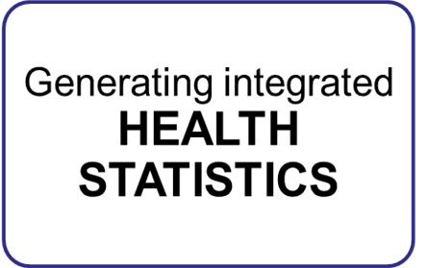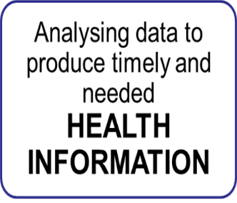
Evidence and
Knowledge to action

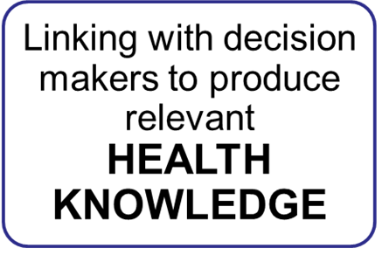

4.3. Generation & collection of data
For effective monitoring of UHC actions being implemented in the country, the following set of steps will be followed in the generation of data.

The types of data that will be used to track UHC implementation include service delivery data from health facilities, claims data, NHIF operational data, community health data, and administrative data among others. These data are collected through routine methods, surveys, sentinel surveillance and periodic assessments among others.

Routine data will be generated using the existing mechanisms. For service delivery data, these data are collected using mostly manual forms and uploaded to the DHIS2 monthly, while claims and NHIF operational data are collected real time.
Surveys will be used to collect data that cannot be collected using routine systems, while assessments will be used for close monitoring and support.
Sentinel surveillance will be used to track indictors in populations of interest such ante natal mothers.
New tools will be developed for new indicators while existing tools may also be revised to accommodate these indicators.

4.4. Information generation
This step ensures that there will be transformation of data into information which can be used for action at the health facility, sub-county, county and national level. This transformation will be done internally by the health information systems through pre-determined analytical process or by technical staff analyzing the data following pre-determined criteria.

Analysis will focus on generating indices for each dimension and domain for monitoring UHC. The indices consolidate information across the statistics relating to the dimension, into a single value. The index value is within a range of 0 to 1, with 1 being the best possible value. Where there is no data, the data point is ignored in deriving the average (index score) and so it doesn’t contribute in weighting of the index.

4.5. Criteria for assessing UHC performance
Trends over time will be compared by tracking of the index over time. The trend in the index will be plotted over at least 3 data points to discern trends in its value.

Forecasting of performance will be explored by extrapolating the trend line to the year 2022, to assess whether the index will reach at least 0.8 / 1.
- If above 0.8 at 2022, then the improvement trajectory dimension is on track
- If between 0.5 to 0.8 at 2022, then efforts need to be accelerated in the dimension
- If under 0.5 by 2022, then critical actions are needed, including change in focus

Compare distribution of the index current value. The distribution is looked at by
- Arranging the current County, Sub-county unit index values from lowest to highest
- Averaging the index values for the County, Sub-county units making up each quintile
- Deriving the percentage difference of average index values for highest and lowest quintiles
Contextualizing the index value. The level and distribution of the index value will be compared against key contextual factors, such as GDP, poverty levels, employment status, levels of security.

The information arising from this analysis will be consolidated into a write up on each UHC dimension, and domain.

Figure xx: Criteria for assessing UHC performance

4.6. Knowledge generation
This stage involves the transformation of the information generated in the previous stage into knowledge or health intelligence which would be required for action at all stages of the health system.
Knowledge can be generated internally by health information systems or by a dedicated technical team.
In either case, the following systematic steps will be implemented.
- Identification of knowledge consumers. The end users will include high level policy makers, implementers and clients/ community. Each of these audience require targeted information products.
- For each dimension of UHC, there will be not more than 3 key issues for which summaries will be made to guide decision making. This will range from indicators such as assessing service coverage interventions e.g. what is the improvement in health expected from introducing a vaccine, to service delivery system input dimension e.g. what is the most effective service delivery approach for taking services to a nomadic population.
- For each issue, information will be sought, with input from the research institute. This involves a structured search for information to be completed within a 2-week period on the dimensions of:
- Reviewing observatory information reports for the specific dimension, plus all investment dimensions
- Conducting a published literature search for existing published information on the issue – including Cochrane, and other meta review processes
- Conducting a grey literature search for existing reports on the issue
- Exploring amongst knowledge management team for country information on the issue
- Consolidate the emerging information into a 2-page policy brief, based on the format in appendix 2. The brief should be available within 3 weeks of agreement on the issue
- Conduct regular formal meetings of the knowledge management team. These are important to:
- Discuss emerging policy briefs and their implications on sector actions,
- Agree emerging research agenda, derived from pending questions arising during the intelligence generation process

Figure xx: Process of knowledge generation for monitoring of SDGs in health

Based on these principles, a more detailed process for elaboration of statistics and information for specific sector issues is now presented. These sector issues include:
- Universal health coverage progress and priority identification
- Overall health and related services progress and priority identification
- Health system performance progress and priority identification

Knowledge Use

Review and feedback

- Annual and Quarterly verification process should be carried out, to review the data across all the indicators. This verification process will;
- Involve high level decision makers in the sector
- Review and agree values for all the indicators, and make decisions for controversial indicators
- Assessment of attributes for the indicators that require scores (see Appendix 1).

Indicators for Monitoring universal Health Coverage
This Monitoring framework is accompanied by a reference list of core indicators. The list includes proposed tracer indicators to measure the process, the level of coverage of health interventions and financial risk protection. The focus of monitoring progress toward UHC as outlined in the Kenya Health policy 2014- 2030. Also included are proposed tracer indicators for health system inputs, processes, outputs, and health attributes that are required during phase I implementation.

Data for these important measurements have been linked on health service output/outcomes and financial risk protection coverage. Additionally, population health will allow assessment of the overall performance of the health system and will guide health system strengthening efforts. On multi-sectoral approach for UHC, a number of Tracer indicators are also identified for health-related initiatives from other sectors (e.g., Agriculture, social services, education, water, and sanitation) and social determinants of health, as well as for lifestyle factors and practices, as these measurements significantly contribute to health service intervention utilization and coverage and the impact of population health.

The proposed reference list of indicators is aligned to the latest guidance on SDG targets and indicators, the WHO Global Reference List of 100 Core Health Indicators and to the Kenyan 3rd edition reference list of health sector indicators and standard operating procedures manual available in existing country M&E systems. The proposed indicators and their data requirements have been grouped into the following domain areas of the results chain.
- Inputs /process
- Outputs
- Outcomes
- Impact

OUTPUTS
OUTCOMES
IMPACTT
INPUTS
Planned work
Intended results

Figure…: A logic model
The critical elements to be monitored are alongside: Resources (inputs); Service statistics; Service coverage/Outcomes; Client/Patient outcomes (behavior change, morbidity); Investment output targets; Access to services; and impact assessment.

Figure….: The expected areas of population health outcomes

Result Framework

Results Framework (if applicable)

Health Impact

Level and distribution

Health Outcomes

Status and distribution of indicator targets across 6 outcome areas

Figure 7: Results framework: Monitoring progress towards UHC

System Performance
Status and distribution of indicator targets across 4 performance areas

Health Investments
Status of indicators across 7 investment areas
Progress of actions across 7 investment areas

Health Sector Performance
Efficiency across logical chain
Equity across logical chain

Core Universal Health Coverage tracer Indicators for the Kenya Based on the Health-Related Sustainable Development Goals
INPUTS AND PROCESSES OUTPUTS OUTCOMES IMPACTS

DTP = diphtheria, tetanus, and pertussis (whooping cough); IHR = International Health Regulations; SDG = Sustainable

Development Goal.

Note: Total of 34 indicators, updated June 2016 Included in (a) the Global Reference List of 100 Core Health Indicators (25). (b) Indicators where stratified equity analysis is recommended (partial list).

Sources: World Health Organization Regional Office for the Western Pacific and Asian Development Bank
Indicator that are not monitored routinely will be collected via
- For each dimension, a minimum of 4 indicators will be selected for information and intelligence purposes. There is no maximum – the more the indicators, the more sensitive will the monitoring process be. The indicators should be selected, where applicable, from
- SDG monitoring indicators for the domain level
- 100 core indicators for monitoring health
- Kenya Indicator reference sheet
- Phase 1 Pilot Counties project document
- UHC roadmap in proposed
- For each indicator, the most pragmatic source of the data will be identified. The data can come from multiple sources. Sources of data can be prioritized based on their ability to provide
- Disaggregated data where feasible – by sex, and sub national unit (County, sub county, Ward, Health Facility)
- Data over several years in the recent past
- Collate the available data for the selected indicators. Data required includes:
- Most recent value
- Value for the past 2 years (where feasible)
- Values for the County, sub county, Ward, Health Facility

Indicator matrices

Goal/Objective | Indicator | Baseline | Target | Data source | Frequency | Responsible
Impact | Under Five Mortality Rate | 52 |  | KDHS | 5 years | MOH/KNBS
Impact | Infant Mortality Rate | 39 |  | KDHS | 5 years | MOH/KNBS
Impact | Maternal Mortality Rate | 362 |  | KDHS | 5 years | MOH/KNBS
Impact | Malaria mortality rate
Impact | Prevalence of undernourished population (stunting) | 26 |  | KDHS | 5 years | MOH/KNBS
Impact | Percentage of Deaths from NCD'c(Cardiovascular,Cancer,Diabetes ,Chronic respiratory Diseases | 55% |  | STEPS | 5 Years | MOH/KNBS/WHO
Impact | Diabetes disease death Rate
Impact | Cancer disease death Rate
Impact | Death rate due to road traffic injuries (per 100,000 population)
Improve Reproductive, Maternal Newborn and Child
Outcome | Percentage of women of reproductive age (15−49 years) who have their need for family planning satisfied with modern methods.
Outcome | Percentage of Pregnant women aged 15-49 years (with a live birth in a given time period) who received antenatal care four or more times | 40% |  | DHIS 2 | Monthly | MOH
Outcome | Percentage of skilled Deliveries conducted in Health facilities | 59% |  | DHIS 2 | Monthly | MOH
Outcome | Percentage of infants receiving three doses of diphtheria-tetanus-pertussis containing vaccine (HIB/Hib/DPT3 | 80% |  | DHIS 2 | Monthly | MOH
Outcome | Percentage of Children Fully immunized | 74% |  | DHIS 2 | Monthly | MOH
Outcome | Proportion of Under 5 treatment for Pneumonia | 22% |  | DHIS 2 | Monthly | MOH
Output | Percentage of children under 5 years of age with suspected pneumonia (cough and difficult breathing NOT due to a problem in the chest and a blocked nose) in the two weeks preceding the survey taken to an appropriate health facility or provider.
Eliminate communicable conditions/ infectious disease control
Outcome | Percentage of TB cases successfully treated (cured plus treatment completed) among TB cases notified to the national health authorities (TB treatment Success Rate (TSR)) | 90% |  | TIBU | Cohort | MOH
Outcome | Malaria Prevalence rate | 8% |  | Malaria Indicator Survey(2015) |  | KNBS
Outcome | Percentage of Pregnant women who are currently on ART | 94% |  | DHIS 2 | Monthly | MOH
Outcome | Antiretroviral therapy (adult + children) coverage
Output | The number of new and relapse TB cases diagnosed and treated in national TB control programmes and notified to WHO in a given year (TB Case detection Rate) | 53% |  | TIBU | YEARLY | MOH
Output | Number of adults and children who are currently receiving ART at the end of the reporting period
Output | Number of Infants (people) in malaria-endemic areas who slept under an ITN. | 56% |  | KMIS | 5 years | MOH/KNBS
Output | Number of Women (people) in malaria-endemic areas who slept under an ITN. | 58% |  | KMIS | 5 years | MOH/KNBS
Halt and reverse the burden of Non- communicable conditions
Outcome | Age-standardized prevalence of raised blood pressure among adults aged 18+ (Hypertension) | 23.8 |  | STEPS | 5 Years | MOH/KNBS/WHO
Outcome | Age-standardized mean fasting plasma glucose for adults aged 25 years and older (Diabetes)
Outcome | Percentage of women aged 15−49 years (who report ever screened) found with cervical cancer receiving treatment
Outcome | Number of people managed with lifestyle diseases (Renal, Cancer, Diabetes and Cardiovascular Diseases)
Outcome | Age-standardized prevalence of adults >=18 years smoking tobacco in last 30 days | 13.30% |  | STEPS | 5 Years | MOH/KNBS/WHO
Output | Hypertension treatment Coverage | 22.30% |  | STEPS | 5 Years | MOH/KNBS/WHO
Output | Diabetes treatment coverage (percetage of respondant currently taking medication among those previous diagnosed | 40.10% |  | STEPS | 5 Years | MOH/KNBS/WHO
Output | Percentage of women aged 15−49 years (who report ever having been) screened for cervical cancer
Improve service capacity and access
Outcome | Service Availability and Readiness
Outcome | OPD per capita utilisation rate | 1.4 |  | DHIS 2 | Monthly | MOH
Outcome | Children<5 stunted | 2.5 |  | DHIS 2 | Monthly | MOH
Outcome | % bed occupancy rate
Output | Health professionals (physicians, psychiatrists, Nurse, and surgeons) per capita, relative to maximum thresholds for each cadre (per 10,000 population)
Output | Hospital beds per capita, relative to a maximum threshold of 18 per 10,000 population
Output | Number of Doctors per population ratio (per 10,000 population) | 1.5 |  | Emory Report(rHRIS)2015 |  | MOH/CDC/Emory
Output | Number of Nurses per population ratio (per 10,000 population) | 8.3 |  | Emory Report(rHRIS)2015 |  | MOH/CDC/Emory
Output | Health Worker density per 10,000 Population | 16 |  | Emory Report(rHRIS)2015 |  | MOH/CDC/Emory
Output | Proportion Quarterly of Community units conducting Dialogue days | 2 days |  | DHIS 2 | Monthly | MOH
Output | Proportion of Cus conduct action days held
Output | Average distance to Nearest Health Facility
Output | Percentage of health facilities with essential medicines
Output | # of clients seen in OPD | 70,432,271 |  | DHIS 2 | Monthly | MOH
Output | # of beneficiaries referred in/out for specialized services
Output | # of beneficiaries received in-patient services
Output | Access to specialized health care in management of lifestyle diseases (Renal, Cancer, Diabetes and Cardiovascular Diseases)
Output | Timelyness of reports | 74% |  | DHIS 2 | Monthly | MOH
Output | Completeness of reports | 81% |  | DHIS 2 | Monthly | MOH
Improve financing and financial Risk protection
Outcome | % of population incurring catastrophic health expenditures | 26
Outcome | Public per capita health spending (US$)
Outcome | Per capita spending on health (THE in $)
Outcome | Out of pocket expenditure as % of total health expenditure
Outcome | Health Insurance Coverage
Outcome | Proportion of health budget as a percentage of Total budget (National + County)
Outcome | Government spending on health as % of Total Health Expenditure (THE)
Outcome | Public spending on health as percentage of GDP
Outcome | Health Insurance coverage for (Elderly and Persons With Disability (EPWD) |  |  | NHIF | Quarterly | NHIF
Outcome | Health Insurance coverage – Linda Mama |  |  | NHIF | Quarterly | NHIF
Outcome | Health Insurance coverage – (Secondary school) | N/A |  | NHIF | Quarterly | NHIF
Outcome | Health insurance coverage for Inua Jamii (70yrs +) | N/A |  | NHIF | Quarterly | NHIF
Output | Government spending on health as % of total government spending
Output | Government spending on health as % of total government spending (Absolute KShs Billions)
Output | Public spending on health as percentage of GDP (Absolute values) KSh billions.
Output | % of total health expenditure that is pooled (government and insurance)
Output | % of population covered under mandatory prepayment schemes
Output | % of population needing subsidies covered under mandatory insurance
Output | % of total health expenditure contributed to by donor projects / programs
Output | % of total health expenditure contributed to by voluntary pre-payment schemes
Output | People covered by Health Insurance (NHIF) Supa cover Benefits Formal | 4,038,379 |  | NHIF | Quartely | NHIF
Output | People covered by Health Insurance (NHIF) Supa cover Benefits Informal | 3,619,084 |  | NHIF | Quartely | NHIF
Output | People covered by Health Insurance (NHIF) UHC-EBP | N/A |  | Ministry of Interior/ NHIF | Quartely | Ministry of Interior/ NHIF
Output | # of people identified for special programme (HISP, ; EPWDs Innua Jamiis) | 223,415 |  | Social Protection Sectcretariat | Annually | Social Protection Sectcretariat
Output | # of people identified for special programme - Innua Jamii | N/A |  | Social Protection Sectcretariat | Annually | Social Protection Sectcretariat
Output | # of people identified for Secondary students programme | N/A |  | Ministry of Education | Quartely | Ministry of Education
Output | # of expectant mothers registered under the linda mama programme | N/A |  | NHIF | Quartely | NHIF
Output | Total amount capitated | N/A |  | NHIF | Quartely | NHIF
Output | # of HFs received Timely disbursments ( within 14 working days from the date the HFs submt the claim) |  |  | MOH | Quartely | MOH
Output | # of claims submitted for reimbursement | N/A |  | NHIF | Quartely | NHIF
Output | Total funds reimbursed (NHIF) | N/A |  | NHIF | Quartely | NHIF
Output | Total amount received from FIF (cash) |  |  | MOH | Quartely | MOH
Output | Total Amount of claims not reimbursed |  |  | MOH | Quartely | MOH
Output | Total amount collected from FIF + cash |  |  | MOH | Quartely | MOH
Improve Health Related interventions and social determinants
SOCIAL DETERMINANTS
Outcome | Percentage of households using improved sanitation facilities
Outcome | Percentage of households using improved safe water facilities
Outputs
Increase Demand and quality of care
Outcome | Client satisfaction
Outcome | Outpatient per capita utilisation Rate | 1.4 |  | DHIS 2 | Monthly | MOH
Outcome | TB treatment cure rate | 81% |  |  | YEARLY | MOH
Outcome | Fresh still birth rate | 1.2 |  | DHIS 2 | Monthly | MOH
Outcome | Client, employee satisfaction and work environment survey (index)
Outcome | Level of knowledge on UHC for general public
Outcome | Level of knowledge on UHC for healthcare workers
Outcome | Average Length of stay (ALOS) | 7 days |  | DHIS 2 | Monthly | MOH
Outcome | percentage of Neonatal deaths Audited
Outcome | Precentage of Maternal deaths Audited | 80.4 |  | DHIS 2 | Monthly | MOH
Outputs | # of quarterly Joint implementation support visits
Outputs | # of functional QITs
Outputs | # of stakeholders sensitized
Outputs | Estimated # of HHs Registered by NHIF |  |  | NHIF | Quartely | NHIF
Outputs | Estimated # of beneficiaries |  |  | NHIF | Quartely | NHIF
Outputs | # contributing to the scheme
Outputs | # of HFs gazzetted
Outputs | # of HFs on accredited
Outputs | # of HFs signed Contracts | 7,584 |  | NHIF | Quartely | NHIF
Outputs | # of HFs capitated | N/A |  | NHIF |  | NHIF
Service Capacity and Access (IHR-core capacity index)
Outcome | International Health Regulation (IHR) index
Output | Capacity attained for National legislation, policy and financing;
Output | Capacity attained for Coordination and National Focal Point communications;
Output | Capacity attained in Surveillance;
Output | Capacity attained in Response;
Output | Capacity attained in Preparedness;
Output | Capacity attained for Risk communication;
Output | Capacity done Human resources for Health;
Output | Capacity attained in Laboratory;
Output | Capacity in Points of entry;
Output | Capacity achieved in Zoonotic events;
Output | Capacity attained in Food safety;
Output | Access to specialized health care in management of lifestyle diseases (Renal, Cancer, Diabetes and Cardiovascular Diseases)

Tools for Monitoring and Evaluation of UHC

Data quality plan for UHC

Information dissemination and use

SECTION 6: EVALUATING UNIVERSAL HEALTH COVERAGE

Why the evaluation
Implementation of UHC in Kenya is intended to improve access to quality health services to the population without suffering financial catastrophe. It is anticipated that there will be improvements in health outcomes. This evaluation is intended to determine whether or not the changes envisioned are actually achieved. This evaluation is designed to assess whether the implementation of UHC would have achieved the intended goals of improving health and well-being of the population. This evaluation is intended to provide evidence based policy making relating to the scale up on UHC interventions across the Country by ensuring that there is robust and credible evidence on performance and document what worked and what did not work.
This evaluation is intended to assess the changes in the health outcomes that can be attributed to the implementation of UHC at the County level. Beyond answering the evaluation questions, it will be used to test the effectiveness of UHC implementation alternatives at the county level.
The UHC Phase I is a time-bound intervention in four counties with different epidemiological or geographical challenges. Several policy, managerial, administrative changes will be instituted during Phase I period, to test their effectiveness to improve the situation. The phase I evaluation framework is developed based on the scenarios (hypothesis) and expected actions to solve the problems identified as bottlenecks. The collected data/information will be analyzed to test the hypothesis.
The evaluation is also useful for “reality check” of the existing system/governance to achieve the goals for UHC needs to be assessed and compared with other alternative options so that Kenya is confident that the reforms are leading the country to the right direction.
The evaluation findings will be converted into actionable. Even if the intended changes do not happen, having collected sufficient data/info should allow an analysis of what went wrong (could it be hypothesis, timeframe, inputs, external factors, etc.).

Evaluation Objectives
Overarching Objective
To test the effect of full health insurance subsidies on UHC goals in 4 pilot counties, and to examine the implementation experience of the pilot and other parallel UHC reforms in Kenya.
Specific Objectives
- To measure the effect of full health insurance subsidies on the level of out-of-pocket payments by households in the 4 pilot counties
- To measure the effect of full health insurance subsidies on utilization of primary and secondary healthcare services in the 4 pilot counties
- To measure the effect of full health insurance subsidies on effective service coverage with priority interventions in the four pilot counties with a focus on primary healthcare services
- To examine the cost of providing full health insurance subsidies, the feasibility of scale up, and model the financial requirements for national scale up that ensures sustainability
- To examine how existing health system capacity influences the implementation and outcomes of the pilot intervention as well as parallel UHC reforms in non-pilot counties
- To examine how purchasing arrangements, governance, and funding flow arrangements influences the implementation of the pilot intervention as well as parallel UHC reforms in non-pilot counties
- To examine the implementation experience in the pilot intervention as well as other UHC reforms in non-pilot counties

Evaluation Questions
To carry out an effective evaluation, there is need that clear evaluation question are elaborated to ensure that they answer/respond to the appropriate policy questions. To establish the type of questions, theory of change has been developed as outlined below describing the results chain, for formulating hypotheses to be tested by the evaluation, and selecting performance indicators. The proposed evaluation questions are as indicated below;
- Is the UHC implementation in the selected County effective compared to the non-focus county?
  - Process evaluation – funds flow, HR, HPTs supply, Access to Insurance,
  - Outcome evaluation – Immunizations, SBAs, Coverage, Utilization
  - Impact Evaluation – Changes within the population
- Has the Health Benefit Package (HBP) improved the people’s access to quality services?
  - Utilization of Health services
  - Awareness of the entitlements
- Primary health care network can improve access to care with an impact to the high level referral health facilities
  - Refer to the referral system and indicators
  - Defined health package for the different services
- Efficiency can be gained by setting up an independent medical claims review function (screening) before sending to NHIF for reimbursement
  - Set up of an independent claims oversight department
  - Strategic purchasing for services
- Is there any change in quality of health care by investments in HRH, infrastructure, Equipment, commodities, HIS..?
  - Domains of the Quality of Care – Timely, Safe, Efficient, Effective, Patient-Centred, and Equitable
  - Technical and Allocative efficiencies
- How many people are covered by health insurance?
  - Households covered with health insurance
  - The percentage of population covered
- How many people are covered by health insurance and are able to pay?
  - Social Economic Status Data
  - The amount of subsidization by the governments
- What lessons can be learned from the pilot counties for mutual learning and accountability?
  - Budget Allocations
  - Social Accountability Mechanisms
  - Networking of facilities
- Are there any lessons learnt from other counties?
  - Other UHC focus counties – Laikipia, Makueni, Siaya,
  - Budget Allocations
  - Social Accountability Mechanisms
  - Networking of facilities
- Is having an ear-marked county health pool lead to increased expenditures (absorption rate)? - disaggregate by funding sources
  - Management processes of Health Facilities
  - Available Health pools in the county
  - Budget allocation process to the facilities
- Resource Allocation (Financial, HRH, HPTs)
  - Funds flow
  - Out of Pocket Expenditure
  - Supply Chain
  - Health Workforce

Evaluation framework

This one also, want to have a consensus on the framework format first.
The proposed framework that will be used for this evaluation will be the results chain framework, where the process evaluation will focus on the inputs and outputs, outcome evaluation on the intended outcomes and Impact evaluation on the intended Impact of UHC Implementation.
Figure 8: Proposed UHC Monitoring framework

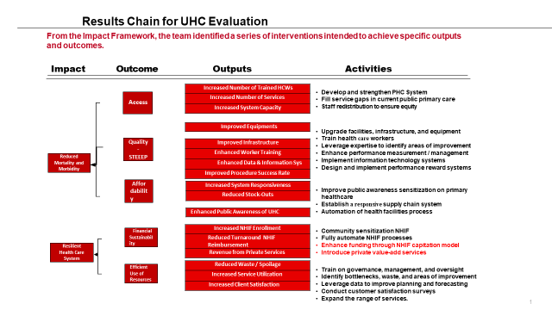
**** The highlighted activities to be relooked

The evaluation is focused on the measurement of the impact for Universal Health Coverage (UHC) in counties and their contributions in achieving the health agenda for 100% UHC by 2022. The overall evaluation will focus on qualitative and quantitative evidence generated from multi-sectoral sources around Health Systems strengthening, provision of quality health care to Kenyans, improved health lives and measurements that may drive the economic growth to 10% by 2022.
The impact evaluation in phase I implementation emphasizes the need to test the effect of delivery of the Health Benefit Package (HBP) as an affordable health care package to Kenyans.

Evaluation Methodology
We propose to employ a mixed methods study approach that combines a quantitative quasi-experimental (before and after with controls) study design with qualitative case studies. Table 2 outlines the study approach matched with study objectives and data collection method.

Table 2: study approach and objectives
Study objective | Study approach | Data collection methods
- To measure the effect of full health insurance subsidies on the level of out-of-pocket payments by households in the 4 pilot counties | Before and after study with controls | Household quantitative survey
- To measure the effect of full health insurance subsidies on the utilization of healthcare services in Kenya | Before and after study with controls | Household quantitative survey
- To measure the effect of full health insurance subsidies on effective service coverage with priority interventions in the four pilot counties with a focus on primary healthcare services | Before and after study with controls | Household quantitative survey
- To examine how existing health system capacity influences the implementation and outcomes of the pilot intervention as well as parallel UHC reforms in non-pilot counties | Qualitative case studies | In depth interviews with national, county policy makers and implementers, health facility managers, frontline health workers, and members of the community
- To examine how purchasing arrangements, governance, and funding flow arrangements influences the implementation of the pilot intervention as well as parallel UHC reforms in non-pilot counties | Qualitative case studies
- To examine the implementation experience in the pilot intervention as well as other UHC reforms in non-pilot counties | Qualitative case studies
- To examine the cost of providing full health insurance subsidies, the feasibility of scale up, and model the financial requirements for national scale up that ensures sustainability | Financial modeling | Document review  Routine financial reports

- Comparison Evaluation -
- Public hospital autonomy:
- Hypothesis: Increased autonomy and authority of public sector health facilities to make decision on what to use the facility income (either capitation or user fee or NHIF reimbursement) for -> Facilities better equipped with drugs and commodities and more health workers hired -> better services (quantity - more client visits, quality – happier clients);
- Comparison groups: i) counties that allow NHIF to directly reimburse 100% of the claimed amount to public hospitals; ii) counties that receive NHIF reimbursement to CRF and transfer partially to HF’s commercial account through CRF; iii) counties that receive NHIF reimbursement to CRF, and stop there; iv) but no cash transfer), and some do not.
- MoV: Baseline/Endline; Process documentation

- Public or Private - Which are the provider of choice?
- Background: Currently, more than two thirds (67%) of NHIF reimbursement is to private health facilities. Meanwhile, the 1st phase UHC essential benefit package is likely to set the flat rebate rates for both private and public sector facilities.
- Hypothesis: The rebate rate set under UHC essential benefit package is considered to be not profitable-> private providers may opt out to contract the UHC BP package OR may seek other options (e.g. charge extra to patients) -> public sector providers will become the choice for majority of patients -> ratio of disbursed funds to private sector and public sector facilities may change over time.
- Comparison groups: i) private sector for profit; ii) private sector non-profit; iii) public sector service providers.
- MoV: Baseline/Endline; Process documentation

- Measurement to identify poor/indigents
- Hypothesis: Counties experiment different ways to identify poor and indigents over the course. MoH or M of Interior can provide a few ideas.
- MoV: documentation of each county
- Centralized one national insurer who also has purchaser function, or decentralized insurers with an independent (3rd party) claims processing function:
Comparison of 42 counties (except Makueni, since they are the outlier) and of 4 pilot counties. MoH will review the Makueni info separately). (incl. their management cost - administrative cost

SECTION 7: TOOLS FOR MONITORING AND EVALUATION OF UHC

SECTION 8: CAPACITY BUILDING FOR UNIVERSAL HEALTH COVERAGE M&E
Capacity Building for UHC M&E -Kumiko
≪National Level≫
Start with the UHC coordination mechanism, who constitutes them, what is their roles, UHC Project Delivery Unit (or UHC Coordination Dept?) of MoH will serve as the overall Secretariat for this coordination mechanism.
M&E Unit of MoH will continue tracking the routine data reported through DHIS2.
Special research to measure the changes during the Phase I implementation (incl. baseline/endline) will be commissioned to contractors through MoH M&E Unit. (is this OK, wanjala?)
≪Pilot counties and any other counties interested≫
- Pilot counties will establish County UHC coordination committee to update each others’ progress , enhance multi-sector collaboration.
- Pilot counties will assign at least 1 M&E focal person from each of information source identified in this framework: namely NHIF, Education sector, Agriculture sector, Water sector, office in charge of resident registry (which agency is in charge?)
- Pilot Counties will set up M&E unit under CHMT. National MoH will assist the set up of county M&E unit through technical assistance (as per “GUIDELINES FOR THE INSTITUTIONALIZATION OF MONITORING AND EVALUATION (M&E) IN THE HEALTH SECTOR” published by MoH in 2017)
- The county M&E Unit will be tasked to:
- conduct baseline/endline survey
- ensure regular reporting of routine health indicators and facility-based data required by MoH
- analyze DHIS2 data monthly for any policy/service delivery implications-> report to CHMT for discussion.
- analyze IHRIS system for the latest status of human resources in the county.
- consolidate the data/info/reports from the M&E focal persons in the county, and report to the County UHC coordination committee meetings.
- conduct operational research, document the process of reforms and good practices (qualitative studies) -> report/disseminate through inter-governmental forums.

M&E Budget

Appendices

Appendix 1: Indicators for each domain and dimension of the actions framework

Input/process | Output | Outcome | Impact
Service Capacity and Access | Service Capacity and Access | Service Capacity and Access | Impact
Hospital beds per capita, relative to a maximum threshold of 18 per 10,000 population | Average distance to Nearest Health Facility | Percentage of women of reproductive age (15−49 years) (who are married or in-union ) who have their need for family planning satisfied with modern methods. | Under Five Mortality Rate
Community Dialogue days | Health professionals (physicians, psychiatrists, Nurse, and surgeons) per capita, relative to maximum thresholds for each cadre (per 10,000 population) | Percentage of Pregnant women aged 15-49 years (with a live birth in a given time period) who received antenatal care four or more times | Infant Mortality Rate
Number of Doctors per population ratio (per 10,000 population) | Service Availability and Readiness | Percentage of skilled Deliveries conducted in Health facilities | Maternal Mortality Rate
Number of Nurses per population ratio (per 10,000 population) |  | Percentage of infants receiving three doses of diphtheria-tetanus-pertussis containing vaccine (HIB/Hib/DPT3 | Malaria Prevalence rate
Health Worker density per 10,000 Population |  | Percentage of Children Fully immunized | Prevalence of undernourished population (stunting)
Percentage of health facilities with essential medicines |  | OPD per capita utilisation rate | Death rate due to road traffic injuries (per 100,000 population)
Service Capacity and Access (IHR-core capacity index)
Capacity attained for National legislation, policy and financing; | Percentage of children under 5 years of age with suspected pneumonia (cough and difficult breathing NOT due to a problem in the chest and a blocked nose) in the two weeks preceding the survey taken to an appropriate health facility or provider. | Percentage of TB cases successfully treated (cured plus treatment completed) among TB cases notified to the national health authorities (TB treatment Success Rate (TSR))
Capacity attained for Coordination and National Focal Point communications; | The number of new and relapse TB cases diagnosed and treated in national TB control programmes and notified to WHO in a given year (TB Case detection Rate) | Age-standardized prevalence of non-raised blood pressure among adults aged 18+ (Hypertension)
Capacity attained in Surveillance; | Percentage of Pregnant women who are currently on ART | Age-standardized mean fasting plasma glucose for adults aged 25 years and older (Diabetes)
Capacity attained in Response; | Number of adults and children who are currently receiving ART at the end of the reporting period | Age-standardized prevalence of adults >=15 years not smoking tobacco in last 30 days
Capacity attained in Preparedness; | Number of Infants (people) in malaria-endemic areas who slept under an ITN.
Capacity attained for Risk communication; | Number of Women (people) in malaria-endemic areas who slept under an ITN.
Capacity done Human resources for Health; | Percentage of households using improved sanitation facilities
Capacity attained in Laboratory; | Percentage of households using improved safe water facilities
Capacity in Points of entry; | Percentage of women aged 15−49 years (who report ever having been) screened for cervical cancer
Capacity achieved in Zoonotic events; | Number of people managed with lifestyle diseases (Renal, Cancer, Diabetes and Cardiovascular Diseases)
Capacity attained in Food safety;
Capacity achieved in Chemical events; | Demand and Quality of Care | Demand and Quality of Care
Capacity in Radionuclear emergencies | Average Length of stay (ALOS) | Client satisfaction Index
Access to specialized health care in management of lifestyle diseases (Renal, Cancer, Diabetes and Cardiovascular Diseases) | Neonatal deaths Audit | Outpatient per capita utilisation Rate
 | Maternal deaths Audit | TB treatment cure rate
 | Fresh still births
 | Joint assessment | Joint assessment
Social Health Protection | Social Health Protection
Proportion of health budget as a percentage of Total budget (National + County) | Health Insurance Coverage
 | People covered by Health Insurance (NHIF)
 | Health Insurance coverage for (Elderly and Persons With Disability (EPWD)
 | Health Insurance coverage – Linda Mama
 | Health Insurance coverage – (Secondary school)
Gazettment , Accredited and claims
Financing | Financing
Government spending on health as % of total government spending | Public per capita health spending (US$)
Government spending on health as % of total government spending (Absolute KShs Billions) | Per capita spending on health (THE in $)
Government spending on health as % of Total Health Expenditure (THE) | % of total health expenditure that is pooled (government and insurance)
Public spending on health as percentage of GDP | % of population covered under mandatory prepayment schemes
Public spending on health as percentage of GDP (Absolute values) KSh billions. | % of population needing subsidies covered under mandatory insurance
 | % of total health expenditure contributed to by donor projects / programs
Advocacy and social mobilisation | % of total health expenditure contributed to by voluntary pre-payment schemes
 | Out of pocket expenditure as % of total health expenditure
 | % of population incurring catastrophic health expenditures

Appendix 2: Format for policy briefs
GUIDANCE NOTE NUMBER:
SUBJECT:
DATE:
BACKGROUND
SUMMARY OF GLOBALLY PUBLISHED LITERATURE RELATED TO SUBJECT
SUMMARY OF CONCHRANE REVIEWS ON SUBJECT
SUMMARY OF COUNTRY-SPECIFIC LITERATURE ON SUBJECT
AFRO SUMMARY GUIDANCE
AFRO RECOMMENDATIONS FOR FURTHER RESEARCH
LINKS TO INFORMATION ON SUBJECT

iHP+ & WHO; (2011); Monitoring, evaluation and review of national health strategies; A country-led platform for information and accountability.
iHP+ & WHO; (2011); Monitoring, evaluation and review of national health strategies; A country-led platform for information and accountability.

