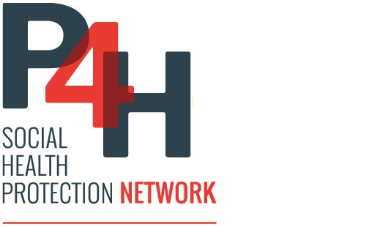
Partners’ Mailing List
P4HC⁺

(September 2019)

N° | Agency | Name | Email
1 | AFD | Anne Chapalain
  chapalaina@afd.fr
2 | BMZ | Benjamin Knödler | wz-1@phno.auswaertiges-amt.de
3 | DFAT | Sarah Wadley  Rattana Rong | sarah.wadley@dfat.gov.au  Rattana.Rong@dfat.gov.au
4 | GIZ | Bart Jacobs  Bernd Appelt  Sokunthea Koy  Kelvin Hui  Maria-Lucia Nikoloudi | Bart.jacobs@giz.de  bernd.appelt@giz.de  sokunthea.koy@giz.de  kelvin.hui@giz.de  maria-lucia.nikoloudi@giz.de
5 | ILO | Malika Ok | malika@ilo.org
6 | JICA | Sophearun In | InSophearun.CM@jica.go.jp
7 | KfW | Harald Huettenrauch  Chamna Chhorn | Harald.Huettenrauch@kfw.de  chamna.chhorn@kfw.de
8 | KOICA | Yuenji Ma  Sok Dimol | santema@koica.go.kr  dr.sokdimol@gmail.com
9 | SDC | Kouland Thin | koulandthin@hotmail.com
10 | UNAIDS | Vladanka Andreeva  Polin Ung  Khin Cho Win Htin | AndreevaV@unaids.org  UngP@unaids.org  WinhtinK@unaids.org
11 | UNFPA | Daniel Alemu  Sokun Sok  Tum May | dalemu@unfpa.org  sok@unfpa.org  may@unfpa.org
12 | UNICEF | Etienne Poirot  Khadka Suman  Rathmony Hong  Jana Nagnitschenko | epoirot@unicef.org  ksuman@unicef.org  rhong@unicef.org  jnagnitschenko@unicef.org
13 | USAID | Chantha Chak  Robert Stanley | cchak@usaid.gov  rostanley@usaid.gov
14 | WHO | Mai Mo  Erik Josephson  Kumanan Rasanathan | mom@who.int  josephsone@who.int  rasanathank@who.int
15 | World Bank | Ziauddin Hyder  Manveen Kaur Kohli  Anne - Marie Provo  Nareth Ly  Tomo Morimoto  Kayla Soo Young Song | zhyder@worldbank.org  mkohli@worldbank.org aprovo@worldbank.org  nly1@worldbank.org  tmorimoto@worldbank.org  ksong2@worldbank.org

