Tanzania Health Financing Strategy 2014-2025
On the Path towards Universal Health Coverage

November 2014

Preface

Acknowledgement

Acronyms (incomplete)
CBHI Community-based health insurance
CCHP Comprehensive Council Health Plan
CHF Community Health Fund
DHIS District Health Information System
DP Development partner(s)
FBO Faith-Based Organization(s)
GBS General Budget Support
GDP Gross Domestic Product
GOT Government of Tanzania
HBF Health Basket Fund
HFS Health Financing Strategy
HMIS Health Management information System
HSSP III Health Sector Strategic Plan III (2009-2015)
ISC Inter-ministerial Steering Committee
LGA Local Government Authority
MBP Minimum Benefit Package
MHIS Mutual Health Insurance Scheme
MOF Ministry of Finance
MOHSW Ministry of Health & Social Welfare
MTR Mid Term Review of HSSP III (2013)
NBOS National Bureau of Statistics
NHIF National Health Insurance Fund
NIDA National Identification Authority
PHI Private health insurance
PMO-RALG Prime Minister’s Office – Regional Administration & Local Government
PO-PSM President’s office – Public Service Management
RAS Regional Administrative Secretariat(s)
RITA Registration, Insolvency, and Trusteeship Agency
SHI Social Health Insurance
SHP Social Health Protection
SNHI Single National Health Insurance
SSRA Social Security Regulatory Authority
TIKA [Tiba kwa Kadi] - urban, informal sector health insurance
TIRA Tanzania Insurance Regulatory Authority
UHC Universal Health Coverage

Glossary (incomplete)

Capitation
Case-based payment
Fee For Service | Out of pocket payment mechanism, where a fee is charged for a service at the time of use. Currently used by NHIF for reimbursement to providers
Purchaser
Results-Based Financing
Social Health Insurance
Social Health Protection
Single National Health Insurance
Universal Health Coverage | Access to a defined package of essential health services for all Tanzanian residents

Table of Contents
1 Background 7
1.1 Rationale for the Health Financing Strategy 7
1.2 The Process of Developing the HFS 7
1.3 Demographic trends 9
1.4 Economic Context 9
2 Health Financing Overview 10
2.1 Governance 10
3 Health Financing System Overview and Challenges 12
3.1 Revenue collection 12
3.1.1 Government funding 12
3.1.2 Prepayment schemes 13
3.1.3 Health financing composition 14
3.2 Pooling 15
3.3 Purchasing, payment, and allocation of resources 17
3.3.1 Provider payment mechanisms and 17
3.3.2 User-Fees and Waivers/Exemptions 18
3.3.3 Service Agreements 18
4 HF Strategy 19
4.1 Vision and Mission 19
4.2 Goal 19
4.3 Objectives 19
4.4 Guiding Principles and Values 20
5 Strategic Interventions 20
5.1 Governance 23
5.1.1 Strategy 1: Provide an adequate legal and regulatory framework and institutional set up for the reformed social health protection system 23
5.2 Revenue Collection 26
5.2.1 Strategy 2: Increase revenues for health 26
Mobilise additional alternative resources for the sector 27
5.2.2 Strategy 3: Introduction of mandatory contribution system 28
5.2.3 Strategy 4: Identify and ensure coverage of the poor 28
5.3 Pooling of Funds 29
5.3.1 Strategy 5: Decrease the fragmentation of risk pools 29
5.4 Health Care Purchasing 29
5.4.1 Strategy 6: Implement a standard Minimum Benefit Package 29
5.4.2 Strategy 7: Establish effective provider payment arrangements 32
5.4.3 Strategy 8: Improve public resource allocation and expenditures 33
5.4.4 Strategy 9: Improve public financial management 34
5.4.5 Strategy10: Improve use of information for evidence-based policy 34
6 Institutional Arrangements, Roles and Responsibilities 36
6.1 Implementation Plan 36
7 Results framework: Priority Interventions, Results and Indicators 36
7.1 Governance 36
7.2 Revenue Collection 37
7.3 Pooling 38

Preface

Background

Rationale for the Health Financing Strategy
In 2007, the Government of Tanzania (GOT) adopted a Health Policy with the policy vision “to improve the health and well-being of all Tanzanians with a focus on those most at risk […]”. This vision remains valid and the GOT is committed to moving towards Universal Health Coverage (UHC) by making sure that everybody has access to needed health services of high quality and is protected against financial risks that could arise as a result of paying of health care. As part of the Health Sector Strategic Plan III (2009-2015) (HSSP III), a decision was taken to develop a Health Financing Strategy to ensure that this vision is realized.

Tanzania is entering a new phase of health financing reforms based on those undertaken since the early 1990’s. The first phase of reforms moved the Tanzanian health financing system from a purely budget-financed system to a mixed financing model with the hope of increasing availability and quality of care. In this first phase, user-fees (in 1993), Community Health Funds (CHFs – from 1996 onwards) and the National Health Insurance Fund (NHIF – in 1999) were introduced in order to leverage additional funds, build community ownership, and create stronger accountability of service providers. However, these mechanisms have largely failed to achieve significant population coverage and thus adequate social health protection.

A large body of evidence shows that spending from public sources, especially from domestic sources, is still too low to finance a package of essential health services. User-fees are still a barrier to access especially among the poor while coverage of pre-payment schemes is low, funding is not distributed equitably between and within districts, and the limited funds available are not used efficiently to achieve the maximum effect (NHA 2010). Accountability and transparency can also still be improved. The above challenges are to a large extent a result of a highly fragmented health financing system whereby a lot of small funding pools financing health care needs of different small segments of the population.

The Process of Developing the HFS
The need to develop a Health Financing Strategy was spelt out in HSSP III (p32), and the process started in 2012 with background studies, initial consultations, and efforts to learn from other countries as part of capacity building (Figure 1). In order to ensure high level, multi-sectoral Government ownership and oversight of the process, the Ministry of Health and Social Welfare (MOHSW) inaugurated an Inter-Ministerial Steering Committee (ISC) In August 2012. The ISC comprises representatives of key Ministries, Departments and agencies to ensure that proposed reforms are comprehensive, accepted and implemented by all stakeholders. Its role was to provide leadership, ensure national ownership of the process, coordinate technical level activities, provide guidance on policy direction and act as a transmission mechanism between a technical Secretariat and the high-level decision makers.

Figure 1 Process of developing the Health Financing Strategy

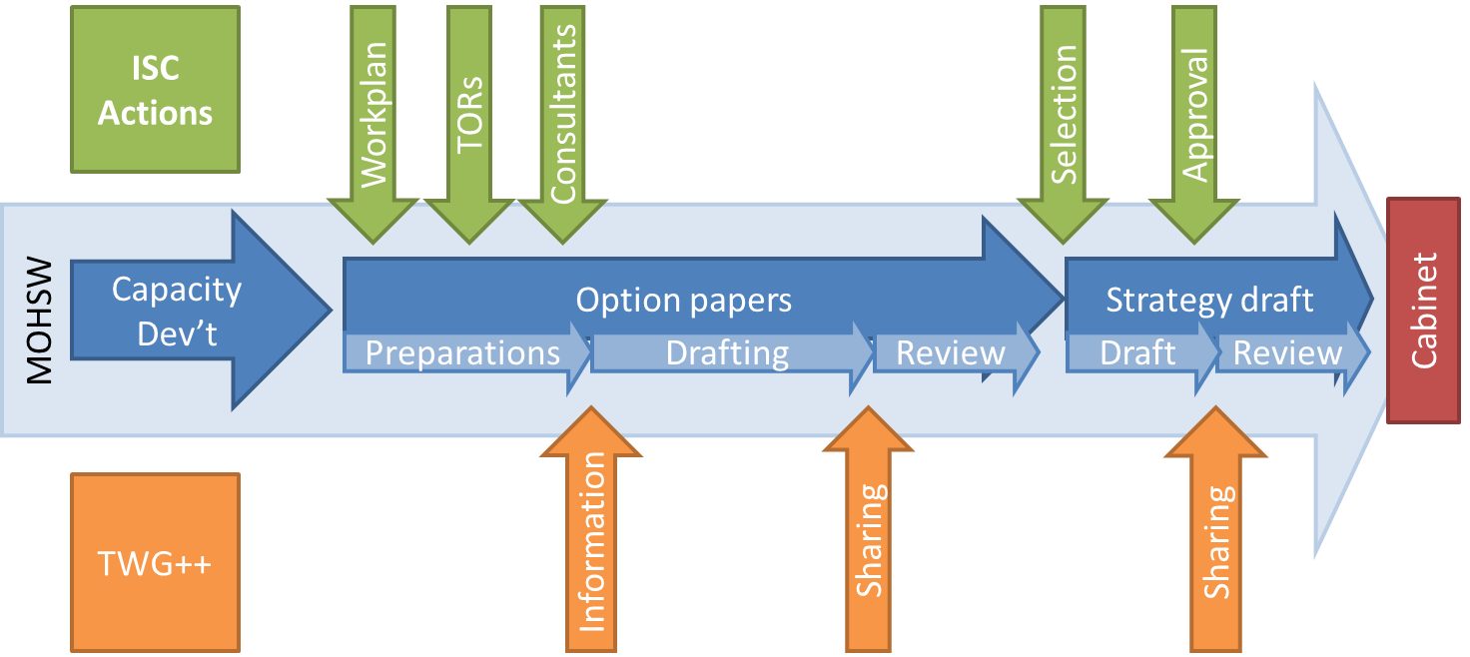

An early task of the ISC was to identify eleven reform areas and commission a number of studies and option papers in order to generate evidence to inform key decisions on these areas. These included papers outlining options for the health insurance market, CHF reform, inclusion of the poor, and the minimum benefit package, among others. Study findings were discussed and validated with national stakeholders and form the basis for choosing the proposed social health insurance structure.

The proposed social health insurance structure was again comprehensively discussed by stakeholders at the national and district levels for further inputs before coming up with a refined final structure that is presented in this strategy.

Demographic trends
According to the 2012 Tanzania Mainland where this HFS applies had a population of 43,625,434 people (NBoS 2013). This is an increase of about 30% compared to the 2002 population census. The population annual growth stand at 2.7 which is a small reduction compared to the 2.9 percent growth estimated in 2002. Average household size is about 4.8 with variations between urban (5.3) and rural (1.8). About 29.6 percent of the population lives in urban areas and 70.4 percent in rural localities. About 50.1 percent of the population is below 18 years of age, 16.2 percent of the population aged 5 or under, while 5.6 percent is aged 60 years and above. Life expectancy at birth is estimated at 61 years and increase from 51 years in 2002 (NBoS 2014).

Economic Context

GDP and Inflation
In 2013 Tanzania realized a total GDP of 33bn US dollar, an increase from 21 billion in in 2009. GDP growth in 2013 averaged at 7%. The per capita GDP increased from about $500 in 2009 to about $700 in 2013 during the same period. The growth in GDP is mainly contributed by services sector which accounted for an average of 43.5% of total GDP during 2009-2013. Agriculture and fishing is the second large contributor to the growth with an average of 27.2% during this period. Industry and construction is the third largest contributor with an average of 21.35% (Bank of Tanzania 2013).
There have been fluctuations in inflation rates over the past ten years. In 2005 inflation rate stood at 4% but this has been increasing over time with the highest inflation rate of 16% observed in 2012. In 2013 the level of inflation stood at 7.9%.

Poverty, Inequality and HDI
About 28 percent of the population lives below basic needs poverty line and 9.7 percent in extreme poverty (food poverty). There are variations in poverty incidence between urban and rural localities with more poor people located in rural areas compared to urban areas (Table 1).

Table 1 Poverty headcount rates by type of area, 2012
 | Dar es Salaam | Other urban areas | Rural areas | Tanzania mainland
Basic needs poverty | 4.2% | 21.7% | 33.3% | 28.2%
Food poverty (extreme poverty) | 1.0% | 8.7% | 11.3% | 9.7%
Source: NBoS (2013) Household Budget Survey 2011/12

There has not been significant change in income inequality in Tanzania since 1990 although the distribution shows significant inequality. The degree of income inequality observed in 2012 as measured by the GINI index was 0.34 same to the level observed in 1990 (NBoS 2013). Despite the observed inequality in income distribution the country has been experiencing and increasing trend in Human Development Index (HDI). In 2012 HDI was 0.48 which is an increase from 0.40 in 2005.

Employment
About 40 percent of Tanzania population was employed in the informal sector in 2006, an increase from 35 percent in 2001 (National Bureau of Statistics 2006). The proportion of the population working in the informal sector is higher in urban areas (66 percent) than in rural localities (27 percent). About 75 percent of the population works in agriculture sector. Only about 12 percent of the population is employed in the formal sector (National Bureau of Statistics 2006).

Health Financing Overview

Governance
The Ministry of Health and Social Welfare (MoHSW) is mandated with overall stewardship of the health sector. The Ministry is responsible for policy development, strategic planning, resource mobilization, and monitoring and evaluation for the sector as a whole. The relationship and roles of different Ministries, Departments and Agencies (MDAs) in the health sector is shown in Figure 2 below.

Figure 2: Ministries, Departments and Agencies, and their responsibility in health sector

Regional Health Management Team
National and Regional Hospitals
Departments and Agencies, Training Centers
Training of Health Staff
Support functions in the health sector
Training of Health Staff
Disbursement of funds, financial reporting
Provision of health services
Provision of primary health and hospital services
Private Health Providers
Government of Tanzania
Ministry of Education and Vocational Training
Ministry of Finance
MOHSW
Local Government Authorities
PMO-RALG
Government and Holding Accounts
Universities and Colleges

Under the GOT policy of devolution, LGAs are responsible for the operation and management of primary level health services, while regions are responsible for LGA supervision, and also management of the regional hospitals. The MoHSW plays a major role in policy development and articulating the case of health, and shares regulatory and accountability functions with other Government MDAs, especially with the Prime Minister’s Office for Regional Administration and Local Government (PMO-RALG).

At the local level, the MOHSW maintains technical relations with the Regional Health Management Team (RHMT) and the Council Health Management Team (CHMT).

All Councils produce an annual Comprehensive Council Health Plan (CCHP), which incorporates all activities related to District Health Services, and all sources of funding at the council level (government funds, locally generated funds, local donor funds, etc.).

Important in the governance structure of the health sector in Tanzania is the use of a Sector Wide Approach (SWAp) since the mid-late 1990s. The SWAp provides the framework of collaboration among stakeholders including MOHSW, PMO-RALG, Ministry of Finance (MoF), civil society, private sector and Development Partners (DPs) including United Nations (UN) agencies active in Health. It aims to coordinate financing, planning, and monitoring mechanisms.

Other key stakeholders in the health governance structure include the Tanzania Insurance Regulatory Authority (TIRA) and the Social Security Regulatory Authority (SSRA) which deals with the specifics of health insurance regulation.

NHIF was tasked in 2009 by Memorandum of Understanding (MOU), to administratively manage CHF. However, its core business focuses on its public health insurance administration.

Challenges
The reforms necessary to implement the HFS will pose serious challenges to the existing governance structures. In the area of insurance regulation, for example, SSRA and TIRA will be challenged with the regulation of a full-blown insurance covering the entire population (Mtei and Bultman 2013). With regards to the devolution of functions, there is currently a strong resistance to shifting spending powers to health facilities to improve service delivery by speeding up Decentralization by Devolution (D-by-D) to local levels.

Health Financing System Overview and Challenges

Revenue collection

Government funding
The Health sector government funding is comprised of central tax revenue is financed by GOT general tax revenue and Development Partners (DPs) support. DPs pool funding both through General Budget Support (GBS), and the Health Basket Fund (HBF), a form of Sector Budget Support.

The share of public health budget in total government budget, excluding the Consolidated Fund Services (CFS) decreased from 11.6% in FY2009/10 to 10.8% in FY2013/14. Similarly, the share of actual health spending in total government spending (excluding CFS) declined from 13.1% in 2009/10 to 11.0% in 2012/13, while with CFS included, the share of health spending declined from 9.9% in 2009/10 to 8.7% in 2012/13.

The nominal health budget and expenditures allocations per capita increased from TZS 22,655 (USD 17.92) in 2009/10 to TZS 31,715 (USD 19.20) in 2012/13. whereby actual per capita has increased from TZS 22,483 (USD 17.79) 2009/10 to TZS 24,409 (USD 15.31) in 2012/13 which is the decrease of 15% in USD terms. Nevertheless, actual per capita health expenditure in real terms decreased from TZS 12,060, in 2009/10 to 11,001 in 2012/13)

Figure 3 Health sector as a share of Total Government Budget
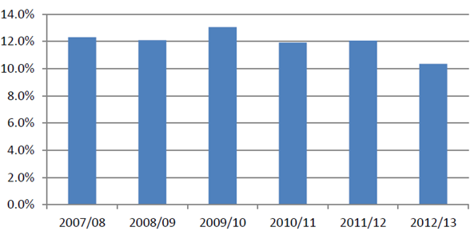
Source: MTR Financing Report 2013

Besides block grants and basket funds, other significant sources of funds at the LGA level were the Global Fund , UNICEF, health insurances (CHF and NHIF), in-kind, cost sharing, own sources and the Primary Health Services Development Program (in Swahili, acronym MMAM).

Prepayment schemes
Health insurance system in Tanzania is organized in a two tier systems, formal and informal sector insurance schemes. The NHIF is the largest formal sector schemes targeting public sector employees. Members mandatorily contribute 6% of their salary equally shared between employees and employers. The scheme was introduced under the NHIF act no. 1 of 1999. The low has recently been amended to allow contribution of premium from individuals and non public sector employees on voluntary basis. The SHIB is another form of formal sector health insurance mainly focusing on private employees, parastatals and NGOs. The SHIB is not a standing alone health insurance scheme but rather part of benefit packages provided by the NSSF. Members of NSSF mandatorily contribute 20% to the NSSF, equally shared between employees and employers. Part of these collections is used to fund health insurance benefits for NSSF members. Private for profit health insurance is a third type of health insurance targeting the formal sector. Contribution to private insurance vary across firms and in most cases it is either community rated in case when private employees negotiate for premium or risk rated incase of individual enrolment.

The Community Health Fund (CHF) is the largest informal sector insurance scheme enacted in 2001 under the CHF act no. 8 after a pilot in Igunga district conducted in 1996. The scheme mainly targets the rural population and is managed at the council level. Membership is at household level whereby households voluntarily contribute a flat rate Premium amount as decided by the district authority after consultation with the community members. Currently the level of premium contribution across councils vary from 5000 TZS per household per annum to 15,0000 TZS per household per annum. A counterpart scheme, TIKA was also introduced in 2009 (Borghi, Mtei et al. 2012) for urban informal population with the same objectives as CHF except that enrolment to TIKA is on individual basis. In addition to CHF there is a number of other Community Based Health Insurance (CBHI) schemes established to cater for health care costs across different groups in the informal sector. The commonly known schemes include VIBINDO which brings together workers in small scale industries and petty business and UMASITA which covers wider informal sector groups. It is estimated that in 2007 there were about 12 CBHI registered by the Tanzania Network of Community Health Funds (TNCHF) (PHRplus 2006). In 2010 these kind of schemes were about 43 in number (Toutant 2010).

Health financing composition
The 2011/12 National Health Account (NHA) data shows increase on donor dependence to fund health care in Tanzania. This source accounted for about 48% of total health sector resources envelop in 2011/12, an increase from 40% in 2009/10. The share of out-of-pocket is still on a higher side, accounting for about 27% of total health sector financing but there has been a decrease compared to 2009/10 share of total financing (34%). Contributions from total general tax revenue remains slow accounting about 21% of total health financing; which is a decrease compared to the 24% in 2009/10. Health insurance schemes contribution is insignificant accounting for about 3% of total health sector financing. This low contribution level of prepayment schemes is a result of limited health insurance coverage which is estimated at 19% of total population.

Table 2 Total Health Expenditures by Source (percent)
 | FY2002/03 | FY2005/06 | FY2009/10 | FY2011/12
Households | 42 % | 25 % | 32 % | 27%
DPs | 27 % | 44 % | 40 % | 47%
MOF | 25 % | 28 % | 26 % | 21%
Other | 5 % | 3 % | 2 % | 5%
TOTAL | 100 % | 100 % | 100 % | 100%
Source: NHA (2014)

Challenges
There is still a significant level of dependence on external partners to financing health care while the share of domestic tax sources is still very low. A significant proportion of donor funding support goes to vertical programs hence only a small segment of the population benefit leaving broad health system improvement with limited resources. This poses a threat to the sustainability of the system. Further the level of dependence on out-of-pocket payment is still high and it is commonly understood that high dependence on out-of-pocket payments is a major cause of inequities in access to health care and high degree of financial risk. With regards to the existing health insurance schemes, enrolment is still considerably low. Studies conducted have identified several reasons for the low enrolment including poor quality of service coupled with frequent drug stock-outs in health facilities, weak design and management, poor understanding of the concept of risk pooling, and unattractive benefits package.

Pooling
The health financing landscape in Tanzania is heavily fragmented, not only among existing health insurance funds, but also among different vertical project funds, basket funds and government budgetary funds to central and lower levels. The current funding flows are shown in Figure 4 below.

Figure 4: Current health financing structure
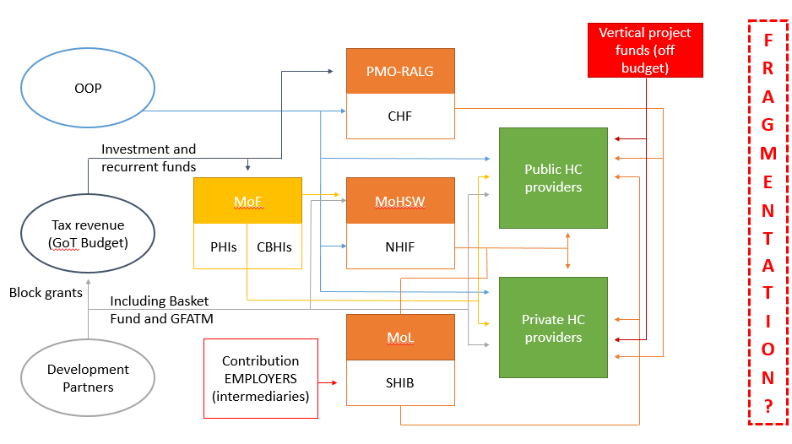
CHF premiums are collected from members at health facilities and matched 100 percent by the government (administered by NHIF). With the current fragmented district CHF pools, the richer councils receive higher matching funds (as subsidies) compared to the poor councils. Collected premiums are submitted to the LGA cost-sharing account, where they are pooled with user-fees. At the moment CHF risk pools are relatively small and cover mostly the middle-income groups – the poorer often stay out and the richer are covered by the NHIF or private insurance.

The NHIF has one nation-wide pool into which all premium revenue collected together with returns from investments are deposited. public employees mandatorily contribute pay and from which all members draw. The relatively large pool gives it financial viability. SHIB and the isolated community-based or mutual health insurance schemes (CBHI/MHIS) on the contrary have small risk pools. In the case of CBHI/MHIS, the small size of the pools makes pooling inefficient due to the low financial stability and sustainability, as well as limits equity effects through redistribution. In the case of private insurance, the risk-pool is only balancing risks partially as insurance contracts are written individually, negotiated between the company or individual seeking insurance cover.

Challenges
The main challenge observed is the fragmentation of the health insurance landscape. This fragmentation begins from the governance structures of the schemes, where different ministries are responsible for different health insurances including the MoHSW, MOF, MOL and PMO-RALG. Fragmentation within the health insurance landscape manifests itself in coordination difficulties of strategizing, resources and functions amongst the actors, duplication of activities and processes, not profiting from economies of scale, wastage of resources in the absence of an integrated approach and a strategy to achieve formulated policy goals. Another significant challenge posed by fragmentation is the lack of cross-subsidization from the wealthy to the poor.

Purchasing, payment, and allocation of resources

Provider payment mechanisms and
CHF funds flow back to health facilities through CCHP activities budgeted from cost-sharing funds. There is no clear separation between a purchaser of health care services and providers. In the majority of councils CHF cards are not portable across providers and benefit package is limited to one primary facility of household choice. In addition, the limited portability of benefits undermines the risk-pooling potential of CHF/TIKA.

There is currently no single provider payment mechanism in Tanzania and each insurance scheme has its own provider payment system. While CHF, SHIB and CBHI use capitation, NHIF and private insurance use fee-for-service. At the LGA level, budgetary transfer is used for Other Charges, the non-salary recurrent costs, and for the HBF, whereas other key flows employ other mechanisms such as user fees and NHIF reimbursements, flat rate incentive payments (RBF).

3.3.2 Resource Allocation
Resources for the HBF are allocated according to a formula based largely on population (60 percent). The formula is designed to improve equity through the inclusion of weights for factors influencing the need for funding in different geographical locations. Currently, these factors are poverty (10 percent), health need, proxied by the under-five mortality rate (10 percent), and the size of the council, to reflect cost differentials, with higher land areas or lower population density resulting in higher costs of supervision, distribution of supplies etc (20 percent). The allocation of the OC follows a broadly similar formula adjusted by other factors identified by the Ministry of Finance.

With regard to salaries, health workers based in government health facilities, and some of those in faith-based organizations, are remunerated through monthly salaries which are a separate funding stream directly from MOF. For the government sector, this is based on nationally agreed pay scales, determined under the President’s Office – Public Service Management (PO-PSM).

User-Fees and Waivers/Exemptions
In FY2010/11 user-fee revenue was reported to be TZS 10.1bn, which was about 1.1 percent of the total health budget in that year. Despite the relatively low contribution to the total resource envelope, it has repeatedly been argued that user-fees are an important source of revenue at the local level, assuring a minimum availability and quality of services and drugs.

The waiver and exemption policy was designed to provide relief for the poor and to facilitate health care seeking behavior for priority population groups and conditions. Under-fives, pregnant women and the elderly are exempt from payment, while exemptions also extend to treatment for diseases of public health importance such as tuberculosis. While exemptions, particularly for children and pregnant women, are largely respected, the implementation of the waiver scheme for the poor has failed most of those it was meant to protect. The process to obtain waivers are not always clearly outlined, criteria not always explicitly set or applied, and poor people find it difficult to make their case in front of health providers and relevant authorities. Moreover, given the nature of health services, there are no incentives for health facilities to offer the waiver/exemption because they know that people will pay for the services if they are charged, and no mechanisms exist for reimbursement of the resources expended.

Service Agreements
Where no equivalent public facility exists, LGAs may enter into a contract, known as a service agreement, with private service providers in order to deliver the priority health services. LGAs agree to pay the service provider per service provided. The price of a service is negotiated between the LGA and the provider. In exchange for the payment from public funds, the provider offers the contracted services free to the patients. Financing for this arrangement currently comes from the LGA’s HBF allocation.

Challenges
Resource allocation is hampered by a myriad of factors. One salient challenge is the ad hoc nature of the allocation of certain resources. Allocation of funds based on DP priorities further complicates the picture. There are serious delays in disbursement of government funds and health basket funds, due in part to challenges with reporting at all levels, and of CHF matching funds, due to relatively complex administrative requirements compared to staff capacity. Bottlenecks at the district as well as the national level prevent facilities from being adequately reimbursed for service delivery, particularly as regards CHF, exemption and waivers and service agreements. Furthermore, vulnerable groups are insufficiently taken care of by the current system.

NOTE: consider Cross-cutting issues in each section (as per HSSP3: equity, quality, gender, community ownership, HS planning and implementation)

HF Strategy

Vision and Mission
Cost-effective, quality health services are available to all Tanzanian residents without financial barriers at the time of need

The Mission of the Health Financing Strategy is to put in place a Social Health Protection System that will enable all Tanzanian residents to access appropriate and affordable health care in time of need

Goal
The HFS goal is to enable equitable access to affordable and cost-effective quality care and financial protection in case of ill health, according to a nationally defined essential health services package.

Objectives
The objectives of the HF Strategy are to:
- Develop a sound, responsive and adequate health financing legal and regulatory framework;
- Establishments of SHP institutional structure with clearly defined roles and responsibilities which reflects the voice of the community/ user of the health system and accommodate the reforms towards a mandatory Single National Health Insurance System;
- Develop a health financing system which is responsive to the needs of the poor, by ensure effective identification and inclusion mechanisms of the poor;
- Strengthen the revenue collection/mobilization system for the health sector;
- Improve financial and risk pooling mechanisms within the health sector;
- Ensure appropriate resources allocations and expenditures for health;
- Continuously adapt and shape the purchasing structure within the health system, placing particular focus on results-based financing for improved services delivery;
- Strengthen the overall public financial and resource data management systems within the health sector.

Guiding Principles and Values
Implementation of the Health Financing Strategy will adhere to the following principles:
- Equity
Contribution to health care financing is expected to be progressive whereby those with high income will contribute a relatively higher share of their income to fund health services compared to the poor. Similarly access to health care will be determined by the needs of the people rather than income. This means that those with similar health care need will get same opportunity to access services.
- Solidarity
Resources collection and pooling will be organized in a harmonized way to make sure that those with higher income and good health conditions cross-subsidize those with less income and poor health conditions
- Transparency and Accountability
Good governance stands at the core of the survival of this financing strategy. Organization of collection, pooling and purchasing will be done in a transparency way making sure that beneficiaries get timely knowledge of what is happening in the SNHI. Responsible stakeholders will be held accountable for all decisions made in relation to collection, pooling and purchasing of health care services.
- Sustainability
Organization of fund collection, pooling and purchasing of health care services will be done in such a way the SNHI will survive for long term. The SNHI will keep on adjusting the level of benefit package according to the ability of the fund.
- Acceptability

- Efficiency and value for money.
The Health Financing Strategy is designed with the value of health as a Human Right in mind. It will be specifically geared towards providing financial protection to the population and will focus its efforts on the inclusion of the poor into the envisaged Social Health Protection System.

Strategic Interventions
As part of reforming the health financing sector via a comprehensive Social Health Protection System, Tanzania envisages the creation of a new Social Health Insurance (SHI) System as a mandatory Single National Health Insurance (SNHI), accompanied by performance based financing mechanisms to increase quality outcomes in health services delivery. The new system will aim at reducing fragmentation in health sector resource pooling and increase the size of revenue collectively available to fund health services. It envisaged that the harmonization of health sector funding resources will help to improve efficiency in allocation and use of funds.

Figure 5 The proposed SNHI set-up

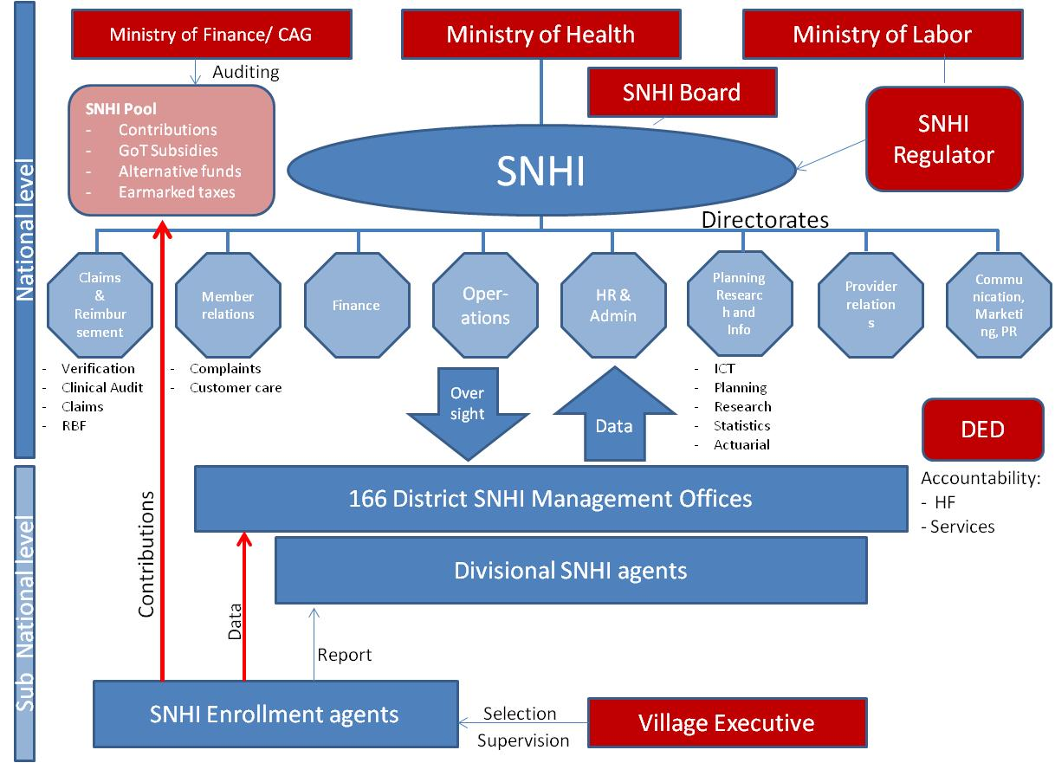

Governance

Strategy 1: Provide an adequate legal and regulatory framework and institutional set up for the reformed social health protection system
This Strategy aims at developing or adapting a legal and regulatory framework such that it improves the health financing policy landscape, ensures stakeholder participation, strengthens accountability, and provides clear and executable laws and regulations.

The legal and regulatory framework will ensure that the vision, values, guiding principles, goals and objectives outlined in the Strategy are reflected in relevant legislations and provide the needed legal tools to implement the chosen Social Health Protection Model for the Country.

New Legislation Needs
An adequate legal and regulatory framework for the creation of the mandatory SNHI will be newly developed. The legal framework will include the legal framework for Mandatory Membership to the SNHI and a Basic Minimum Benefit Package entitlement to the entire population. The existing Social Health Insurance law and acts will have to be annulled (e.g. NHIF Act, CHF Act, SHIB etc.) while other existing laws and regulations relating to insurance, social security and service delivery will have to be reviewed, adapted or changed to suite the new system The legal framework will clearly state that private health insurances will operate in duplicative and supplementary function to the SNHI and will cover non-MBP benefits.

As soon as the Strategy enters implementation and the mandatory SNHI is created, appropriate regulation has to be in place. Tanzania will move away from its fragmented health insurance legislations, and unify and harmonize its system of regulation to fit one single social health insurer.

Establishment of a mandatory Single National Health Insurance
As part of the Strategy a new mandatory SNHI will be established covering the entire population (Figure 5). The SNHI will hold the main purchasing power in the public system and be the principal actor in contracting for health services, and paying providers. There will be satellite offices to a nationally established structure, which handle health insurance management functions at regional level. Supportive and innovative structures for premium collection and membership administration of the SNHI will also be established at District/ village level. Clear complaints mechanisms will be established at every level. Building on the positive experience of the CHF Iliyoboreshwa (Mtei and Enemark 2013).

Providers of health care in the Tanzanian environment will be given increased autonomy in the public system to allow them to allocate their resources more effectively to purchase goods and services including drugs. This will facilitate competition between public and private providers and thus enhance their quality of care. The creation of primary care networks is envisaged below council level, linking any community or outreach services with dispensaries under a specific health center, with district hospitals as the apex of the primary health care system, for improved financial management and services delivery (Fuenzalida and Kuper 2013)

Policy level
The SNHI will report to the Ministry of Health & Social Welfare. Clear functional specifications and roles will be assigned to all relevant entities, the legal framework adjusted accordingly, and mechanisms for transparent reporting and coordination established. Unified command is necessary to defragment the SHI governance landscape which is currently split among a number of Ministries (MOHSW, PMORALG, MOF, Ministry of Labor etc.).

A clear purchaser-provider split will be introduced within the sector. The SNHI will become the primary purchaser of health services within the agreed Benefit Package(s), while the LGAs and referral/national hospitals will be the providers. The LGAs will be disengaged from the implementation and management of health insurance, in order to render the system more efficient, accountable and to remove an unnecessary administrative burden from health providers. The LGAs will focus their engagement on community-oriented public health, supervision and monitoring of health policy implementation, and advocacy on behalf of the citizens.

Health Insurance Regulation, Supervision and Stakeholder Engagement
An independent Health Regulatory Body will be established to ensure compliance of the single payer with the regulatory environment and thus operate efficiently and with client orientation. The regulatory body will also be responsible to control fee levels on provider side, especially pertaining to the private sector, monitor tariffs, premiums, accreditation system, and conflicts resolution and protect consumer interest in the health insurance sector.

A supervisory board will be established which features a variety of representatives including, but not limited to, MOHSW, MOF, MOL, Insurance Regulator, TASAF, Attorney providers, FBO, Unions, Academic Institution, and population or users of services (there could be more than one provider and population representative).

The essence of social solidarity is comprehensive and positive participation of all stakeholders necessary. It is important that this participation is driven from the users of the system. This strategy will ensure that health facility governing bodies are representative and multi-sectoral in nature, covering all age groups. These bodies will be involved in the identification of members, prioritization, planning and evaluation of the scheme and services provided at the facilities, thereby ensuring responsiveness to needs of the user. They will also be involved in health facility management, including recruitment of staff and their evaluation.
.
Fora for continuously listening to the views of users will be established, for example meetings between providers, purchasers and users, or use of strategically located opinion boxes. These views will be used to strengthen or change scheme services as needs arise. Participation of users in setting contribution levels and means of payment will also be ensured.

Finally, accessible information will be provided to enable the user to make decisions to promote their own health and that of the environment in which they live, as well as regularly updated information on the SNHI and how it is managed.

Results-Based Financing
As part of the Strategy a performance-based incentive mechanism will be rolled-out throughout the health delivery system. This results-based financing approach will target quality outcomes at every level of public and contracted private facilities (delivering public intervention packages) rewarding facilities and individuals for achievement of selected health priority outcome indicators. This system will start in its roll-out phase as a parallel health financing system to the social health insurance system. Once the SNHI has been established and is functioning, the RBF system will be absorbed as part of the SNHI.

Finally, accessible information will be provided to enable the user to make decisions to promote their own health and that of the environment in which they live, as well as regularly updated information on the SNHI and how it is managed.

Population involvement and the community
Involvement of the broader population will be fostered through ensuring opportunities for the community to periodically elect multi-sectoral representatives to the health facility governing bodies, and through the creation of structures for participation, linked to the formal sector.

Community resources will be mobilized for support with local infrastructure, both to assist with rehabilitation, and to foster sustainability and local ownership. Use of existing trusted social groups will be promoted in order to enhance premium collection.

Finally, investments will be made in health promotion in order to build the capacity of households and the community at large to improve their health and prevent disease in order to have positive impact on SNHI resources.

Exploiting the political constituency
Political will is necessary at all levels for the SNHI to be acceptable and for it to thrive. In this context the political constituency will be fully exploited at all levels to support the insurance scheme. Politicians’ power to influence opinion, allocate resources, and initiate new taxes will be productively directed to help establish and sustain the scheme.

Capacity development will be provided for politicians at all levels to enable them to understand the need for social protection through SNHI as a means of attaining UHC, the linkages between catastrophic expenditures and impoverishment, and to support timely implementation of SNHI and the strategy as a whole. Similarly, education will be provided on the critical role that a healthy population plays in building a healthy economy, and the link with SNHI and social protection.

Revenue Collection

Strategy 2: Increase revenues for health
Increase public revenue
Despite the commitment of the Government in increasing the health sector budget, challenge of underfunded health services remains, due to increased population, rising costs, and the double burden of communicable and non-communicable diseases, among other factors. Continued advocacy for a larger sectoral share of existing resources will be required, through demonstration of value for money and the importance of human capital. The health sector is expected to benefit from ongoing reforms to strengthen the efficiency of the tax administration system.

Additional resources for the sector will be generated by identifying politically acceptable and administratively feasible areas whereby all or part of a given tax, profit or premium can be allocated for health. These additional funds can be obtained from VAT, targeted taxes such as “sin taxes” on cigarettes and alcohol, a levy on airline tickets, or earmarking a specific proportion of particular taxes to support the SNHI. Other possibilities include a proportion of profits made by social security funds through their investments, motor vehicle insurance contributions, and industry insurance.

While not mobilizing new resources, fiscal space can also be generated through efficiency gains, e.g. through investment in primary health care (reference MMAM), effective gate-keeping mechanisms, enforcement of referral mechanisms, improved human resource distribution (reference MTR report 2013), implementation of effective and harmonized data management systems (specially related to resources management), productivity gains by means of RBF, increased external aid coordination (resource tracking, bringing DP funding increasingly on budget), enhancing Public Financial Management: ensure that full health allocations are spent and per capita allocations of resources across LGAs are improved; strengthen PFM in the transfer of funds from central to district level; improve the disbursement of funds by eliminating complicating disbursement procedures and clarifying who is accountable at all levels.

Mobilise additional alternative resources for the sector
dditional resources will be mobilized for health from alternative taxes and from the private sector, including through public-private partnerships, foundations, and corporate social responsibility.

A taxation on cigarettes and alcohol sales earmarked for health penalizes drinkers and smokers and is not paid by non-drinkers and non-smokers. As a result of the imposed tax consumption of cigarettes and alcohol might be reduced in the population and thus have some overall improvements in the health status of Tanzanians. Sustainability of this tax should be long-term as there would be little pressure to reduce taxation of alcohol or cigarettes from a social standpoint. According to the Fiscal Space Study conducted by Chris James et al. in July 2014 projections for the resources made available from alcohol tax levy alone in Tanzania could reach 256 bio Tsh a year for the next ten years. This equates to 0.2% of GDP and would cover 2.2% of the minimum financing gap of the sector, or 1.6% of the THE financing gap.
Another tax to be considered is an airline levy earmarked to health, which has been implemented by a number of European countries and a few in Africa. A levy on airline tickets is is both long-term and predictable, as air travel is growing and is expected to continue to grow in years to come. There is evidence that the price elasticity on demand for plane tickets is low and that the airline industry is not affected by this additional tax (James et al, 2014). Tourism is a large contributer to GDP in Tanzania

Airtime levy?

2.5% VAT?

Motor vehicle insurance levy? - we calculate

Strategy 3: Introduction of mandatory contribution system
Membership of the National Social Health Insurance will be mandatory for all Tanzanian residents. Based on the principle of shared contributions, for those in employment the employer contribution will not be less than that of the employee. For those identified as being without the means to pay a contribution, the SNHI premium will be fully or partially subsidized by Government and cross-subsidies within the single insurance pool. Regular actuarial studies will form the basis for setting and reviewing contribution levels.

In line with the purchaser-provider split, the mechanism for ensuring informal sector contributions to the SNHI will be established outside the council health delivery system. In order to ensure that everyone is contributing to the scheme, different contribution mechanisms will be used (involving village governments and communities) taking seasonal income into consideration.

Strategy 4: Identify and ensure coverage of the poor
UHC inherently implies (eventual) coverage of the entire population, and Tanzanian health policies and strategies emphasis inclusion of the most vulnerable, in terms of ability to pay and health need.

International and country evidence on identification of the poor suggests that a combination of methods is desirable, specifically combining geographical targeting, community identification, and some form of proxy means testing (PMT) in order to have some national benchmarking (Stoermer et al 2013). This approach is cross-sectoral, and is currently being used by the Tanzanian Social Action Fund (TASAF) for the purposes of identifying beneficiaries of conditional cash transfers (CCT).

The target population of the “very poor” for the purpose of full government subsidy of health costs currently differs from that for CCTs, and will depend both on political priorities and budget constraints. The 28.2 percent of the population defined as “basic needs” poor according to the 2012 Household Budget Survey will be fully subsidized by Government. These will be identified using the combination of methods outlined above, in particular the PMT. This will require extending the TASAF approach to a larger segment of the population. To speed up the process of identification, additional agencies/ organizations will be required to undertake this exercise, and it may be necessary to simplify the PMT instrument to reduce costs and facilitate wider application (TBD)

Local governments will contribute own source revenues to the SNHI pool to support the subsidies of very poor members.

Pooling of Funds

Strategy 5: Decrease the fragmentation of risk pools
The creation of a single risk pool – merging NHIF, CHF, NSSF-SHIB and others - will increase the redistributive capacity of prepaid funds and align different revenue sources to enhance cross-subsidization across beneficiaries with different risks and socio-economic status, and efficiency associated with economies of scale.

Over time, selected parallel funding flows will be integrated into the single national health insurance pool. This will include part or all of certain external funding flows which are intended to support disease-specific interventions and/or commodities which fall within the Minimum Benefit Package (eg Global Fund, Health Basket Fund).

The differential poverty rates and thus revenue-raising potential of LGAs will necessitate development of an equalization mechanism to ensure that those LGAs with a higher proportion of fully-subsidized poor SNHI beneficiaries are not unduly penalized financially. Cross-subsidization is expected both at the level of the individual and geographic area.

  - Health Care Purchasing
    - Strategy 6: Implement a standard Minimum Benefit Package
An affordable standard Minimum Benefit Package (MBP) is clearly defined to serve as a legal entitlement to the whole population.

In the short run there will be two types of MBP, standard MBP and MBP plus. The standard MBP which will be accessible to everyone will include all individualized services at dispensary, health centre and district hospital. This will exclude public health services such as water and sanitation programs and education and promotion campaigns but include child vaccination and ANC services. Services that are currently under the category of chronic illnesses such as diabetes, cancer, and mental illnesses will only be funded if public resources that are currently been used to fund such services will be pooled to the central SNHI pool. Access to district hospital will be granted upon receipt of referral letter from dispensary or health centre. Where members of SNHI walk-in to the district hospital without referral letter the person will bear full cost of health services provided. Enforcing referral system is crucial for the sustainability of the SNHI especially at the initial years of its introduction where we expected high increase in utilization of formal health care. However, the main challenge in enforcing referral system is availability of services at primary facilities (dispensaries and health centers). Without effective availability of services members will continue to bypass to higher level and the objective of financial protection will not be guaranteed as many SNHI members will be paying out-of-pocket. This HFS is written with the view that there will be an increase in investment funds through the MMAM program in order to improve service provision at primary facilities by making sure that staffs and medical supplies and equipment are available. Further with initiatives such as the Result Based Financing and Big Results Now it is expected that quality of service in primary facilities will be improved and the challenge of drug stock-out will be resolved, hence reducing unnecessary needs of bypassing to higher level facilities.

At the beginning only public and designated not public facilities will be contracted to provide the standard MBP for SNHI members. In areas where there will be no public primary facility, special arrangements will be made to enter into contract with non-government facility that will be within that area in order to guarantee availability of care to everybody in need. The SNHI card will be portable across all contracted providers within Tanzania.

MBP plus will include in addition to what is provided under standard MBP, access to regional referral, zonal referral and national hospital as is currently covered under NHIF. It is not the intention of the SNHI to reduce the size of health care benefit package that is currently consumed by the members of the NHIF. Such members together with employees in the formal non public sectors and individuals who have been identified as extremely poor, hence fully subsidized by the government will be accessing the current NHIF package (referred to as MBP plus) but this package will be ‘frozen’ until the time when the SNHI has been sustainable enough to raise the standard MBP up to the level that will be equivalent to the current NHIF package. In this case the long-term goal is to make sure that every member of the SNHI has access to the level of benefit package that is currently provided by the NHIF. This is a long term definition of the SNHI MBP. Individuals who are currently not employed in the formal sector but would wish to enjoy the MBP plus straight away can do so upon contributing additional premium top up to what has been agreed as standard premium contribution rates.

In order to avoid stigmatization of the very poor, the mechanism for their inclusion within the SHI will be through issue of the same SNHI membership card(s). This will entitle this most vulnerable group to access the same services as the rest of the population without being discriminated. In order to demonstrate its commitment to reducing poverty and embracing the role of the government in meeting the needs of the poor, this population group will immediately be eligible for the MBP plus, funded through a combination of government subsidy and cross-subsidization from the formal sector members of the SNHI. The cost of this investment in the poorest Tanzanians will be identified through an actuarial assessment.

Regarding Private Health Insurers, individuals may take out private health insurance to provide cover beyond the MBP or MBP plus (supplementary health insurance). It is also possible to take out cover that includes MBP or MBP plus, i.e. one is free to purchase additional private health insurance to cover the same services (duplicative health insurance) if not satisfied with the benefits offered by the SNHI, but the mandatory contribution must still be made.
As regards public health interventions (e.g. for water and sanitation, and for health education and promotion activities) and capital investments it is envisioned that the purchasing will initially be outside the MBP and continue to be managed directly by the LGAs.

Cost and Revenue implication of the proposed SNHI

It is anticipated revenue that

Table*** Revenue and cost per year at baseline

Revenue | Scenario 1 | Scenario 2
Members' contribution | 39,102,661,383,540 | 39,107,536,269,402
Government subsidy for the poor | 184,079,744,100 | 309,585,131,850
Total | 39,286,741,127,640 | 39,417,121,401,252
Cost | Scenario 1 | Scenario 2
Administration cost | 23,332,200,000 | 23,332,200,000
Service utilization cost
Outpatient | 2,532,076,161,436 | 900,293,746,288
Inpatient | 459,230,423,698 | 274,167,417,133
Total | 3,014,638,785,134 | 1,197,793,363,422

    - Strategy 7: Establish effective provider payment arrangements

Payment of providers
A combination of provider payment mechanisms is envisaged under the new SNHI, combining some form of capitation payment at the primary health care facility level and fee-for-service at district hospital and above. Payments will be made by the SNHI directly to the facility responsible for providing services. It is anticipated that some degree of autonomy will be introduced at all levels of health care provision in order to allow flexibility of facilities in spending their own resources for health care quality improvement, especially in primary level facilities. Flexibility will be important, and the agreed provider payment system must be flexible enough to incentivize good performance and dis-incentivize inappropriate care (ref HIM). Lessons will be learned from other countries, and a reference group established for regular review of this area.

A Results-Based Financing mechanism is currently being rolled-out nationwide (ref, design doc). Initially this will run in parallel to the SNHI but in the long run RBF indicators will be purchased by the SNHI. Selected activities within the MBP will attract incentive payments to health providers in order to stimulate increased utilization so that national targets are reached. .

The incentivized service range at dispensary and health centre level will cover both essential Maternal, Newborn, and Child Health services for which uptake remains relatively low, and also general outpatient attendance, screening for hypertension and diabetes, and priority interventions for malaria, tuberculosis and HIV & AIDS, among others, and will be subject to regular review.

The level of financial incentives for a given output will vary geographically, according to factors such as poverty levels and remoteness, in order to provide additional incentives for health workers to work in currently under-served areas.

Certain minimum conditions will be met for a health facility to participate in RBF, thereby ensuring a general improvement in effective access and quality, through eg placement of minimum qualified staff, clean water, basic equipment etc. The use of mainstream HMIS indicators, establishment of independent verification mechanisms, and harmonization with ongoing quality improvement initiatives, are jointly expected to strengthen the overall monitoring & supervisory systems.

Some input-based financing will remain in the mid-term for management and operations offered by CHMTs and RHMTs, though with an increasing share of such funding being channeled according to outputs and performance.

    - Strategy 8: Improve public resource allocation and expenditures
The move towards SNHI as the primary mechanism for funding individual health services will reduce the flow of Other Charges (OC) funding through Councils and Regional Administrations as funds will rather be channeled as reimbursement for services offered, directly to health facilities.

The role and structure of existing allocation formulae for non-salary recurrent funding of LGAs (specifically through the Health Basket Fund and the government OC block grant) will be reviewed in order to better support the revised context. Consultation with MOF and PMO-RALG will be necessary to align with the broader context of inter-governmental transfers where appropriate, while the health sector specific reforms will necessitate a particular approach. In particular, continuous adjustment will be required as population coverage with SNHI expands, and as preventive services not initially included in the MBP are incorporated. Some form of formula will continue to be required at least at the LGA/CHMT level to cover non-personal services such as public health interventions, supervision and monitoring (cross-ref to Strategy 14) and at the RHMT level also for management and support to LGAs.

Effective UHC requires access to qualified health workers throughout the country. Mechanisms for rapidly improving the distribution of health personnel both between and within districts will be developed in consultation with MOF, PMO-RALG, PO-PSM and LGAs, building on the existing pay and incentive strategies, and successful local initiatives. In addition, the potential for future channeling of additional PE funding through the RBF pool, and ultimately through the SNHI pool, will be explored with PO-PSM. This is necessary in order to reduce fragmentation of funding and to level the playing field between different providers of the SNHI benefit packages.

    - Strategy 9: Improve public financial management
Sound Public Financial Management (PFM) is an important component of the HFS. Resources need to be well managed and value for money is a priority. The focus of PFM within the context of Tanzania’s health financing strategy is to ensure that resources are both mobilized and spent efficiently and cost-effectively to maximize the provision of quality health services.

The SNHI will need strong financial management staff, systems and procedures in order to successfully manage the identification and collection of revenue from multiple sources, manage multiple provider contracts through its regional network, and to make payments down to the facility level – including payments related to activity and, potentially, performance. This will require a degree of integration between financial and non-financial information, and improved accuracy and reliability in both sets of data.

Providers will need to implement effective billing systems to ensure receipt of all funds due, and to improve the arrangements for management of those funds – possibly through use of provider networks that enable cost effective management and oversight. Rules will need to be developed to give effect to the envisaged provider autonomy in expenditure management whilst ensuring compliance with existing legislation and public financial management rules and procedures. Providers will also need to strengthen their forecasting capability to model expected future funding flows, patient demand and resource requirements.

    - Strategy10: Improve use of information for evidence-based policy

Development of a unified HMIS
Information for evidence-based policy as a strategy in the SNHI will require a redesign of the current Health Management information Systems (HMIS). The redesign process will input into the HMIS features of the Social Health Insurance. The users of the redesigned HMIS will need training to be able to use it effectively. Special attention will be given to building capacity at lower level health facilities. The redesigned HMIS will be linked to the SNHI database.

Link vital national databases to the Social Health Insurance
Linkage of key national databases to that of the SNHI is intended to encourage those who have not joined the scheme to join it, as receiving certain services will become conditional on being a member of the scheme. Important national databases that should be linked to SNHI include NIDA, RITA and Tanzania Revenue Authority. In the rural areas, where these databases are not very commonly used, enrolment in school databases will be one alternative.

Regular supportive research
Evidence-based policies are best derived from daily practice and observations. In this context information generated from supportive research is an important strategy for the social health insurance to perform better. Such research will investigate joining rates and drop-out, satisfaction with services, and required scheme improvements. Supportive research strategy will also investigate provider performance, ability to pay premiums, and conformity to essential drugs lists. Other important issues to study include equity, social inclusion, organizational performance, actuarial aspects, and alternative sources of complementary funds.

Solid social health insurance database
A solid social health insurance database is an invaluable strategic input for the scheme’s performance. This is a critical input in the day to day management of the scheme. Such database will show client behavior, premium conformity, provider needs, quality aspects and areas which need attention to sustain the scheme.

MOHSW will take lead responsibility for analysing, consolidating and distributing financial and performance reporting for the sector. The MOHSW must have good access to the SNHI datasets, as well as to provider financial report datasets, to ensure overall monitoring of health policy implementation and value for money, to develop nationally set provider tariffs, and to inform further policy development. Clear and transparent reporting of resource use will be critical to enabling the health sector to demonstrate value for money and to ensure that any additional resources can be most effectively and efficiently targeted.

PMO-RALG, Regional Administrative Secretariats, and LGAs will also require access to appropriate SNHI data sets, in order to monitor implementation of health policy in the regions/ districts, and to assist in identification and management of service delivery risks. In particular it is anticipated that RASs will need strengthened financial management capacity dedicated to the health sector.

Institutional Arrangements, Roles and Responsibilities

Implementation Plan
The purpose of this Health Financing Strategy document is to outline “WHAT” strategic interventions will be realized to strengthen the health financing system of the country. The accompanying HFS Implementation Plan will describe in more detail the planned processes and mechanisms that will ensure the vision, goals and objectives of this Strategy are met. Implementation aspects do not feature in detail in the Strategy document as they are prone to evolve according to environmental and political changes, together with challenges and experiences collected along the way. The HFS implementation plan will prioritize and sequence planned interventions, detail roles and responsibilities of each involved institution, and set out the resources needed to realize the envisaged plan.

Results framework: Priority Interventions, Results and Indicators

Governance

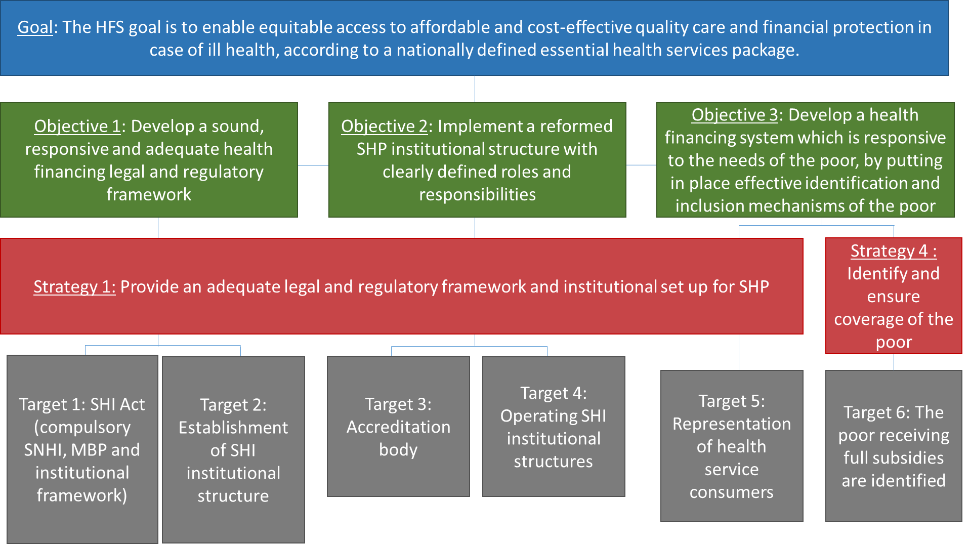

Revenue Collection

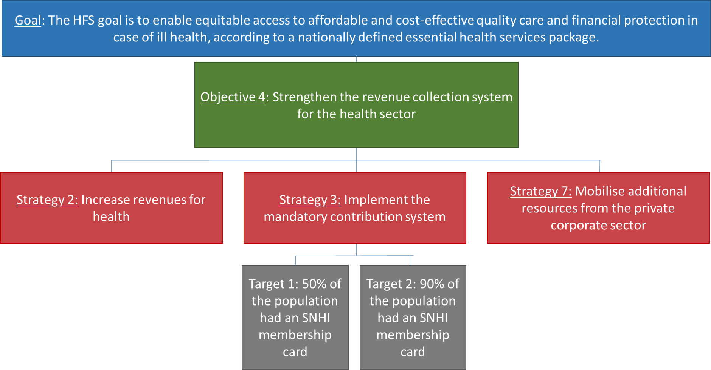
7.3 Pooling

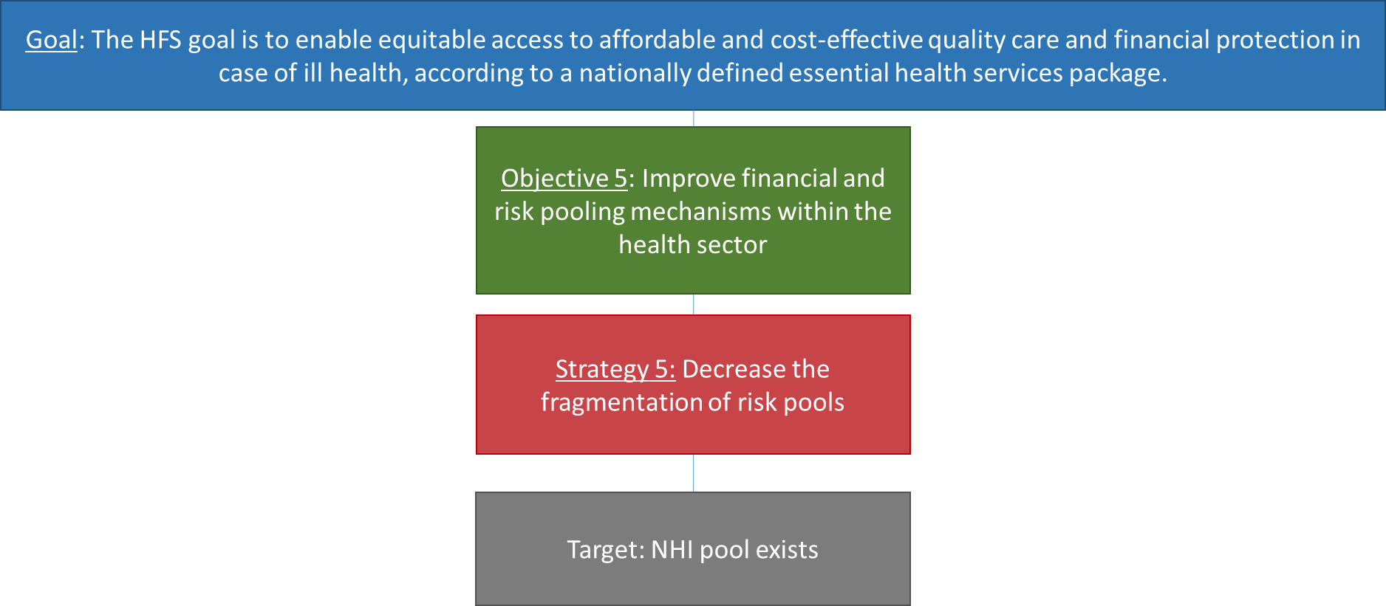

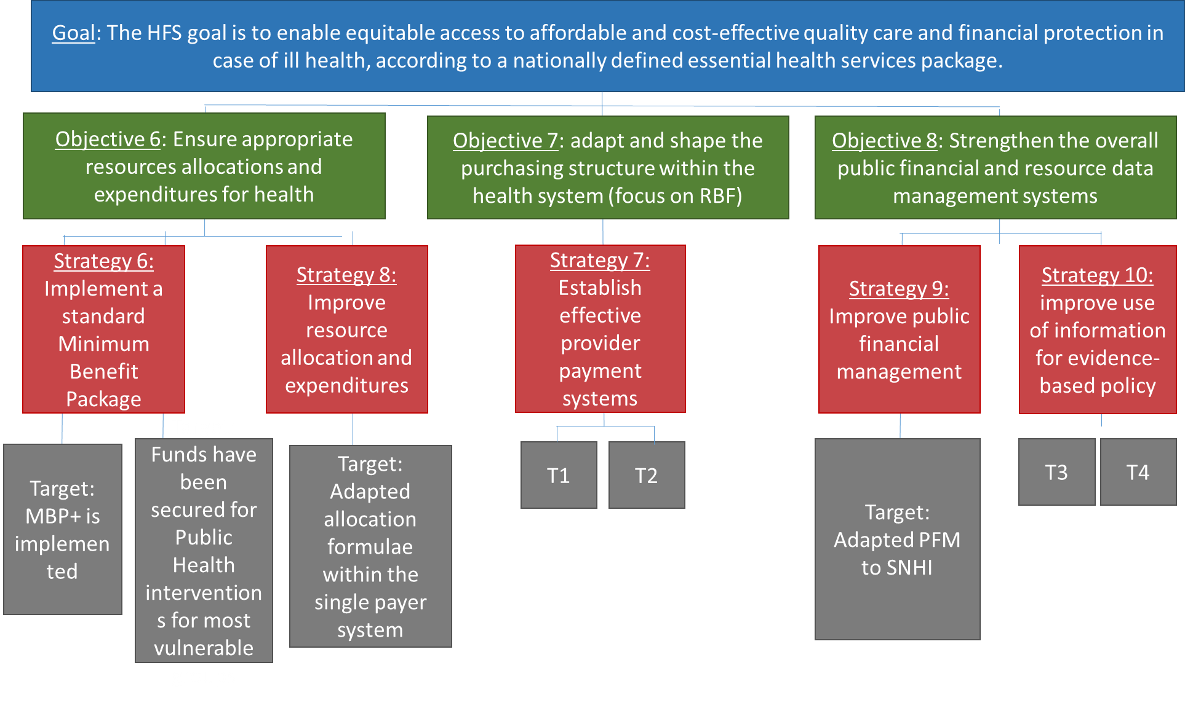
T1: Effective claim and reimbursement systems in place
T2: RBF rolled-out to all regions
T3: Accurate database systems produced
T4: Unified HMIS

References

Fuenzalida H and Kuper M (2013). Study on Provider Autonomy (Local and Primary Health Care Levels). Report prepared for the Tanzanian Health Financing Strategy. Oct/Dec 2013.
MOF (2013). Macroeconomic Policy Framework for the Five Year Development Plan/Budget 2013/14 – 2016/17. March 2013.
MOHSW (2009) Health Sector Strategic Plan III (2009 – 2015)
MOHSW (2012) National Health Accounts 2009/10
MOHSW (2013). Mid Term Review of the Health Sector Strategic Plan III 2009-2015. Main Report.
MOHSW, 2013. Mid Term Review of the Health Sector Strategic Plan III 2009 – 2015, Health Care Financing, Technical Report, Ministry of Health and Social Welfare, United Republic of Tanzania.
MOHSW (2014a). National Health Accounts FY 2011/12
MOHSW (2014b). Health Sector Public Expenditure Review FY 2012/13
Mtei G and Bultman J (2013. Tanzania Health Insurance Institutional Assessment
In support of Health Financing Strategy Development
Mtei G and Enemark U (2013). Reform options for the CHF Systems. Final Report. October 2013.
NBOS (2013a) Tanzania Population and Housing Census
NBOS (2013b) Household Budget Survey
NBoS (2013c). National Accounts
NBoS (2014). Basic Demographic and Socio-Economic Profile. Key Findings. 2012 Population and Housing Census.
Stoermer M, Kessy F, and Widmer T (2013). Inclusion of the Poor and Vulnerable into the New Health Financing Strategy. October 2013.

ISC Comprised of President Office-Public Service Management, Planning Commision, Prime Minister Office, Prime Minister Office-Local Government Authority, Ministry of finance, Ministry of Industry of Trade, TACAIDS, Ministry of Labor, E-Government, NIDA,
All commissioned studies are included in the reference section
MTR HSSP III Financing Report (2013)

