Analysis of Catastrophic health payments and
Benefit incidence of government spending for health
in Mongolia
Tsolmongerel Tsilaajav
Oyungerel Nanzad
Enkhbaatar Ichinnorov
September 2015

Contents

Acronyms 5
Introduction 6
Overview of the health system in Mongolia 7
Health service delivery and governance 7
Human resources 8
Health care financing 9
Medicine 11
Information system 11
Data description 12
Recall periods 13
Construction of key variables 13
Analysis results 18
Health service utilization 18
Out-of-pocket health expenditure 23
Catastrophic health expenditure and poverty impact 27
Benefit incidence of government spending on health 32
Discussion 39
Policy recommendations 41
At national policy making level 41
At purchaser level 44
Reference 47

Table 1: Sources of revenue as percentage of total expenditure on health, 2000-2012 9
Table 2: Recall periods of key variables 13
Table 3: Variables used for constructing health payments 16
Table 4: Variables used for constructing health services utilization 17
Table 5: Variables used for benefit incidence analysis 18
Table 6: Percentage distribution of outpatient service utilization by geographic regions, 2010-2012 20
Table 7: Percentage distribution of inpatient service utilization by geographic regions, 2010-2012 21
Table 8: Outpatient health services utilization and health seeking behavior by expenditure quintile, 2010-2012 22
Table 9: Outpatient health services utilization and health seeking behavior by geographic regions, 2010-2012 22
Table 10: Health seeking behavior and self-prescription of medicine 22
Table 11: Distribution of household out of pocket health payments in absolute terms by quintiles, (2009 base) 24
Table 12: Distribution of households out of pocket health payments in absolute terms by regions, (2009 as base) 24
Table 13: Percentage distribution of out of pocket health payments as share of total household expenditure and capacity to pay by regions 26
Table 14: Structure of out of pocket health payments by regions, 2010-2012 28
Table 15: Distribution of impoverishment by total out-of-pocket payment 30
Table 16: Catastrophic payments by types of health services and expenditure quintiles, 2010-2012 31
Table 17: Catastrophic payments by types of health services and geographic regions, 2010-2012 31
Table 18: Estimates of impoverishment by major component of out-of-pocket payments and quintiles, 2010-2012 32
Table 19: Determinants of catastrophic health payments 33
Table 20: Distribution of benefits of government expenditure on health by level of health service delivery, 2012 37
Table 21: Mean per capita benefit in health by types of health services, 2012 38
Table 22: Mean per capita benefit in health by types of health services and expenditure quintile, 2012 39

Figure 1: Percentage of outpatient and inpatient service utilization upon reported needs, 2009-2012 18
Figure 2: Percentage distribution of outpatient service utilization by expenditure quintiles, 2010-2012 19
Figure 3: Outpatient care utilization by the lowest and highest expenditure quintiles and by health facilities 20
Figure 3: Percentage distribution of inpatient service utilization by expenditure quintile 21
Figure 5: Percentage distribution of reasons for not seeking health care 23
Figure 6: Percentage distribution of out of pocket health payments as share of total household expenditure by quintiles 25
Figure 7: Percentage distribution of out of pocket health payments as share of capacity to pay by quintiles 25
Figure 8: Structure of out-of-pocket health payments 26
Figure 9: Structure of out-of-pocket health payments by expenditure quintile, 2010-2012 27
Figure 10: Distribution of households by catastrophic health payments 29
Figure 11: Geographic distribution of households by catastrophic health payments 29
Figure 12: Geographic distributions of impoverishment by total out-of-pocket payment 30
Figure 13: Estimates of catastrophic expenditure by each component of out-of-pocket payments 31
Figure 14: Estimates of impoverishment by major component of out-of-pocket payments 32
Figure 15: Percentage share of government subsidies for health by quintiles, 2012 34
Figure 16: Percentage share of government subsidy for health by urban and rural population, 2012 35
Figure 17: Percentage share of government benefits by urban and rural population and expenditure quintile, 2012 35
Figure 18: Percentage share of government benefits by geographic regions, 2012 36
Figure 19: Percentage share of government benefits by gender, 2012 36
Figure 20: Percentage share of government benefits by gender and expenditure quintile, 2012 37
Figure 19: Percentage share of government benefits by outpatient and inpatient care and expenditure quintile, 2012 38
Figure 22: Lorenz curve of government subsidy on health, 2012 39
Figure 23: Percentage distribution of need for health services and government subsidy on health, 2012 40

Acronyms

ADB | Asian Development Bank
DRGs | Diagnostically Related Groups
FGPs | Family Group Practices
HMIS | Health Management Information System
HSES | Household Socio Economic Survey
ICT | Information Communications Technology
MNT | Mongolian Tugriks
MoH | Ministry of Health
NSO | National Statistics Office
OOPs | Out of Pocket Payments
PSU | Primary Sampling Unit
SHI | Social Health Insurance
TB | Tuberculosis
THE | Total Health Expenditure
USD | US dollar
WB | World Bank
WHO | World Health Organization

Introduction

Mongolia’s rising out of pocket health expenditure is the priority concern for its government, citizens and development partners including the World Health Organization. The share of out of pocket health payments in the total health expenditure increased sharply from 12% in 2000 to 35% in 2012. The impact of these out-of-pocket payments for health care can be twofold. One is that it may negatively impact the living standards of people causing catastrophic and/or impoverishing spending. The other is that it may deter people from using services, simply because they cannot afford direct costs, such as for consultations, medicines and laboratory tests. Poor households are likely to sink even further into poverty because of the adverse effects of illness on their earnings and general welfare. In order to address the issue, the Government endorsed the health financing strategy 2010-2015 however showed flawed implementation and monitoring over the years. The contributing factors included lack of evidences and understanding by policy makers.

In cooperation with WHO, the Ministry of Health initiated the assessment of catastrophic health payments in Mongolia using datasets of the Household Socio Economic Survey conducted in 2009. This study informed the policy makers and partners to inform the development and implementation of more equitable health policies and regulations and also contributed to the formulation of the Social health insurance law with one of the focus is to reduce out of pocket health payments by the population.

Further assessment and evidences on the catastrophic and impoverishing health payments and the benefit incidence of government spending on health will be an important effort to maintain overall policy objectives of ensuring access to health services without financial catastrophe and also targeted to reducing associated burden to affected people including the poor and vulnerable. Therefore, this report presents the results of health services utilization, catastrophic health expenditure, impoverishing health expenditure and benefit incidence of government health spending in Mongolia based on national Household Socio-Economic surveys conducted in 2010, 2011 and 2012. The report will also use HSES 2009 results to provide some comparative overview over time.

The analytical methodology is the WHO developed approach that is published in “Distribution of health payments and catastrophic expenditures”, 2005. For estimation of benefit incidence of government health subsidy we used EQUITAP guide developed using the “Analysing health equity using household survey data”, the approach developed and published by the World Bank in 2008.
This report is structured as follows: 1) overview of the health system over the last ten years, 2) survey design, data description and construction of key variables, 3) results of analysis, and 4) discussion and policy recommendations.

Overview of the health system in Mongolia

Health service delivery and governance

The Mongolian health system is organized to provide nationwide service delivery through primary health care facilities down to the lowest administrative unit, a large hospital sector in urban areas and growing private care providers mainly in aimag centers and the capital city.

Throughout the last 15 years, more efforts have been made to strengthen the primary health care providers. During late 1990s, the government rationalized the health care facilities and established privately run Family group practices building on family care delivery system of the previous system. Rural hospitals were restructured and reconstructed into health centers and there are three categories of soum health centers depending on the size of catchment population. In 2003 and 2013, policy documents to improve primary health care facilities have been approved and national standards and by laws have been revised. The latter revision of policies and standards aimed to redirect the operation focus of these health facilities from curative to more preventive care.

Since 2000s, public private partnership has received much attention and the Government made attempts to rationalize the hospital sector by contracting out the management function to private sector however most of which led to eventual privatization of government hospitals. Assessment showed that these arrangements failed to ensure adequate access and quality of health services to users. The Policy on Public and Private Partnership in health sector” was developed in 2011, providing a legal framework for engagement of not only the private providers but also civil society organizations in delivery of health care and health promotion functions of the government.

Until 2010 and 2011, Mongolia has made limited progress towards modernizing its hospitals and health technologies. Most hospital facilities have been in poor or very poor conditions and their design and maintenance does not meet modern requirements for a quality and risk free environment for care. In Ulaanbaatar, most district hospitals provide inpatient services with only limited specialty areas i.e. mainly internal medicine and neurology services. The new Health act (2011) reorganized district outpatient clinics and hospitals into district public health centers and general hospitals in Ulaanbaatar. In addition, all general hospitals should provide 7 major medical services including internal medicine, pediatrics, surgery, obstetrics and gynecology, neurology, infectious disease and dental care from previous three disciplines (internal, neurological medical and services).

On the other hand, the new Health act also brought changes in the hospital governance where there is newly established governing boards of the state central hospitals, specialized centers and regional diagnostic and treatment centers aimed to provide elements of health care organizational autonomy in management and decision making. However, actual implementations of the Health act have not been effective and been erratic due to limitations by other legal environment including civil service and public finance and also capacity constraints at national and local levels.

Moreover, the MoH approved (2014) the development strategy for hospital care sector in the country and is aiming to reorganize the public hospitals into geographically aligned network systems where general hospitals are established to provide multi disciplinary hospital services in cooperation with other types of health facilities such as private sanatoria and hospitals in Ulaanbaatar. The policy aimed to promote high technology and complex care at the tertiary level care providers and secondary hospitals to deliver the general hospital care to the population.

Human resources

Since 1990, the number of doctors per 1000 population has remained steady but the supply of nurses and other allied staff significantly decreased. In order to increase the number of nurses, the MOH has also taken numerous steps to address poor working conditions by establishing the Inter-sectoral Committee on Health sector human resources chaired by the Prime Minister, introducing incentive packages for health workers in remote areas, approving the Housing Programme for Health workers and increasing overall salaries. However the ratio of doctor to nurse remains low at 1:1.13 in 2012.

There are more doctors per 1000 population in Ulaanbaatar and most of them are specialists providing services at the secondary or tertiary facilities. At the primary care level, Ulaanbaatar has the half the number of doctors compared to soums. On the other hand, there are significantly more doctors providing secondary care in Ulaanbaatar than in aimags.

Doctors, nurses, paramedics at government hospitals are civil servants and salaried according to civil servant salary schedule which vary in accordance with employment duration, seniority and professional degree. Most non-medical staff such as cleaners and/or maintenance people is contract workers or no longer civil servants from 2005. The significant strides in the salary increases for civil servants in recent years have made the average wage in the public sector outpace the average private sector wage (WB 2009). However, health care personnel are still underpaid and face hard working conditions.

Health care financing

Since 2000s, the health care financing in Mongolia shifted from largely publicly funded system to increasing out of pocket payment for health care. WHO data on the share of OOPs in Total Health Expenditure (THE) shows a sharp rise from 12.1% in 2000 to 35% in 2012. This type of outcome is highly undesirable for a country with traditional socially equitable values and principles and the strong public financing system.

Increases in per capita health spending over the past decade has been found with government health expenditures increasing from MNT40597 in 2005 to MNT197778 in the year 2012 in absolute terms. However it has not kept pace with the significant increases of Gross domestic product (GDP) and total government expenditure over the same period as the percentage of total government health expenditures in total government expenditure decreased from 13% in 2005 to 9% in 2012. Total government health expenditures as a proportion to GDP remained constant at about 3.7% during last ten years.

Table 1: Sources of revenue as percentage of total expenditure on health, 2000-2012
Sources of revenue | 2000 | 2001 | 2002 | 2003 | 2004 | 2005 | 2006 | 2007 | 2008 | 2009 | 2010 | 2011 | 2012
Government expenditure | 62 | 58 | 50 | 43 | 44 | 44 | 46 | 50 | 49 | 46 | 47 | 50 | 49
Social health insurance | 20 | 27 | 29 | 12 | 12 | 12 | 12 | 10 | 13 | 14 | 15 | 14 | 13
OOP expenditure | 12 | 10 | 17 | 42 | 41 | 41 | 39 | 38 | 35 | 37 | 35 | 34 | 35
Other private expenditure | 6 | 5 | 4 | 3 | 3 | 3 | 3 | 3 | 3 | 3 | 3 | 3 | 3
Source: WHO (2015). National Health Accounts data, (http://www.who.int/nha/en/)

The social health insurance (SHI) population coverage has been decreasing from 95.3% in 1998 to 82.6% of the total population in 2010 when students and herders were removed from the populations being subsidized by the state. In 2011, in order to help the ruling political party to deliver on its political promises, the Human Development Fund helped to subsidize the uninsured groups and coverage reached 98.6%. However, this arrangement is no longer supported and students will be in charge of their own contribution and as result the SHI coverage went down to 90.4% in 2012.

The SHI contribution rate for salaried workers was 6% of salary but it has been reduced to 4% in 2008 as part of the policy decisions to reduce contribution burden of overall social security system on employers. A flat rate contribution applied for state subsidized group, herders, students, and the self-employed population. Since 2008, the contribution rate for the self-employed is set at 1% of (reported) monthly income, revised from the previous flat rate of 800 MNT per month or 0.7 USD.

The majority of SHI revenue is generated from payroll-tax contributions from formal sector employees; it was 66.3% of total revenue in 2000 and 88% by 2013. In addition, the government subsidy for the vulnerable groups decreased from 27.4% of total revenue in 2000 to 6.6% in 2013. This group is subsidized at a very low level, US$ 4-5 per capita per annum.

The SHI mainly has been covering inpatient care however the benefit package was expanded in 2006 to include diagnostics, outpatient visits and daycare. On the other hand, the state budget funds services including primary care, maternity, child health, infectious diseases, cancer and mental health. This fragmented package of services by state budget and health insurance subsequently fragmented the payment system for health care providers.

Since 2007, hospitals are funded by DRG system with 115 DRG groups. However, in reality, their funding is decided using the previous year’s spending as baseline and adjusted by a percentage increase, which is then classified or divided into 115 DRG cases to define the respective contributions of the government budget and health insurance fund. The state budget share of the funding to hospitals is paid or transferred by line item expenses.

Since 2000s, Family group practices are paid on the basis of capitation payment. This method is evolving to suit the Mongolian context in terms of determining catchment population and their health risks as well as conditions where facilities operate. The original FGP payment model had weightings for 10 different types of clients, classified by five age groups and poor/non-poor. In 2006, it was decided that the determination of poverty classes was ineffective, and from 2007 the socioeconomic adjustment was made according to places of residence: ger district or apartment district. It was changed in 2008 and revised again in December 2010. As of 2012, the FGP risk-adjusted capitation model with ten categories is set at 7 USD for a person in a ger district and 6 USD per capita in an apartment district.

User charges have not been regulated in Mongolia for sometime. However, in 2006, the MoH approved the list of services where user charges can be applied at government health facilities. Hospital managers are free to set prices for these services in consultation with the MoH. This policy is seen as a way to monitor and decrease informal payment, which makes a big share of out of pocket health payments. The list of user charged services was revised and expanded in 2014.

In 2015, after more than six years of debates at technical and political levels, the Mongolian parliament finally made a decision to move to a pooled purchaser of health services under the social insurance scheme. The new law on health insurance established a separate social health insurance institution as the government implementing agency attached to the Ministry of Population Development and Social Protection. In 2012, the Government promulgated the long-term development strategy for social health insurance. This strategy defines objectives for benefits, contribution, coverage, and institutional development as well as role of private health insurance.

The Integrated budget law (2012) embedded reforms in public finance system, strengthened the decentralization process in Mongolia by enabling local government administration to have power over allocation of budgets for every primary health care facility in their constituency as central government gives them special purpose transfer for primary health education services. The law also enabled more flexibility in spending of the line item budgets and gave more power to health care managers to shift expenses between previously defined line items.

Medicine

Pharmaceutical services are provided through 1200 or more private pharmacies in Mongolia. All pharmacy outlets are privately owned and the Government maintains only inpatient pharmacy departments in public hospitals. There are excessive numbers of pharmacies especially in urban settings leading to unregulated use of self-medication practice among the population. Mongolia has a National Policy on Medicine and approved the second State policy on medicine that has been promulgated by the Parliament in 2014. The policy sets strategies to ensure safe, good quality medicines at affordable prices. It emphasizes centralized procurement system of medicine for government facilities, prioritization of public resources to needy and vulnerable and promoting use of generic drugs.

Essential drugs of 134 generic and 339 brand names are reimbursable by health insurance for selected pharmacies at a discounted rate (28.6%-93% of reference prices are reimbursed), but only when prescribed by primary health care providers. In addition, drugs to treat government budget-funded services such as diabetes, TB and cancer are provided by line item expenses within approved budgets. However, both hospitals and patients complain that government funding does not cover such expenses and thus patients face out of pocket payments. These have been largely to do with the lack of an effective purchasing mechanism, because the reimbursement rates are followed only for SHI services but not for government budget funded services. The new health insurance law (2015), that enhances institutional capacity of social insurance as a purchaser, expands the benefits to cover medicines prescribed by medical doctors in secondary hospitals.

Information system

Since 2005, Mongolian health sector has been making efforts to implement the health management information system strategy. Ministry of Health uses Health-info software for collecting, integrating and processing the routine health statistics. Most tertiary and secondary hospitals use Hospital information systems, however hospitals have to keep paper records as the legal framework for electronic record keeping has not been fully instituted and regulated effectively. For example, linkage to social health insurance is still stumbling, as there is lack of electronic exchange of information between health care providers and health insurance. Use of information technology (IT) at the primary care level is limited to basic word-processing and the use of spreadsheets. Information on ICT in private sector is limited though newly established private health care providers use the latest developments of hospital information system.

Data description

We used the data sets of Household Socio-Economic Surveys (HSES) for 2010-2012 to analyze the catastrophic and impoverishing health payments and benefit and incidence of public subsidy for health in Mongolia. This is a nationally representative survey whose main objective is to evaluate and monitor the income and expenditure profiles of households and the population poverty. The HSES is a permanent survey carried out by the National Statistics Office (NSO) every year. There has been detailed or summarized versions of the study depending on the scale of analysis. The detailed version of HSES is conducted every three years. The detailed HSES was organized in 2012 as for years covered in this analysis. In 2012, 15 modules were studied through HSES.

The sample size has been 11232 households that nationally representative and sampled through stratified sampling approach. The design of the survey recognizes three explicit strata: Ulaanbaatar, aimag centers, and rural areas and small towns. In addition, the sample was implicitly allocated by districts and khoroos in Ulaanbaatar, and by aimags in rural areas. Each aimag center was an explicit sub-stratum. This design technique has been maintained for all 3 years. However for 2012, in order to estimate poverty level at aimag level, sample sizes in 5 aimags have been increased. Thus the sample size was 12840 households in 2012 instead of 11232.

The selection strategy was different in each stratum: a two-stage process in urban areas and a three-stage process in rural areas. The primary sampling unit (PSU) is the location or unit counted by 1 enumerator in Ulaanbaatar and aimag center and bagh in rural area. In Ulaanbaatar, first 360 khesegs were selected, and then 10 households in each kheseg. In aimag centers, first 12 or 24 PSUs were selected, and then 10 households in each unit. Since second quarter of 2012, however 84 PSUs were added. In rural areas, first 52 soums were selected, then 12 baghs in each soum and finally 8 households in each bag. Again, 96 PSUs were added from 2nd quarter of 2012. All 1248 primary sampling units or clusters (khesegs, bags or soums) were selected with probability proportional to size and were randomly selected and 180 PSUs in addition. Thus the survey visited a random sub-sample of 104 clusters each month and throughout 12 months. In order to obtain representative statistics for each stratum and for the whole country sampling weights were used. These weights are applied to each household and correspond to the inverse of the probability of selection, calculated taking into account the sampling strategy.

The sample of 12840 (2012) was allocated as follows: 3600 in Ulaanbaatar, 3480 in aimag centers, and 5760 in rural areas and small towns. However, the actual used for this report is slightly lower: 3578 households in Ulaanbaatar, 3473 in aimag centers, and 5760 in rural areas and small towns. The difference corresponds to 29 households that were excluded because they did not have complete information.

Recall periods

In order to ensure comparability over time HSES uses same recall periods in all three years.

Table 2: Recall periods of key variables
Variables | Recall periods
food | In the capital and in aimag centers, information is captured through a diary, which is compiled by an enumerator every ten days or three times during a month. In soum centers and in the countryside, a recall period for the last week is employed.
non-durable goods | Last month
durable goods | Last 12 months
Out-of-pocket health payments:
Outpatient care | Last 1 month
Medicine | Last 1 month
Inpatient care | Last 12 months
Ancillary services | Last 1 month
Dental services | Last 1 month

Construction of key variables

The HSES contains 15 major modules on different consumption and expenditure profiles and behavior of Mongolian households. Key variables to estimate catastrophic health payments, impoverishing health payments and benefit incidence of public spending are described below.

- Total household consumption expenditures
- Total household food expenditures
- Total household non-food expenditures
- Total household out-of-pocket expenditures
- Total government subsidy/spending to health sector
- Health services utilization
- Socio economic variables including age, sex, education, urban/rural location, household size, household sampling weight

Consumption expenditure

Consumption aggregate comprised of five main components: food, non-food, housing, durable goods and energy.

Food

The food variable was constructed by adding up all consumption per food item, previously normalized to uniform reference period, and then aggregating all food items per household. HSES records information on food consumption at the household level for 122-123 items, organized in 12-13 categories. The reference period is 1 month. A few general principles are applied in the construction of this component. First, all possible sources of consumption are included. This means that the food component comprises not only expenditures on purchases in the market or on meals eaten away from home but also food that was own produced and also received as a gift. Second, only food that was actually consumed, as opposed to total food purchases or total home-produced food enters in the consumption aggregate. Third, non-purchased food items need to be valued and included. The HSES collects average prices for food purchases, whereas for all other sources only quantities are recorded. These average prices were used to estimate the monetary value of non-purchased items.

Non-food

As in the case of food, non-food consumption is a simple and straightforward calculation. Again, all possible sources of consumption is included and normalized to a common reference period. Data on an extensive range of non-food items are available, 371 items arranged in 38 different groups such as clothing and footwear for men, women and children, jewelry and souvenirs, clothing materials, education, health, recreation, beauty and toilet articles and services, cultural expenses, household goods, housing expenditures, transportation, communication, insurance and taxes. With the exception of durable goods, housing and energy, which will be dealt with later, this subsection covers the consumption of all the other non-food items. It also includes non-food items that was own produced and also received as a gifts and given by others for free.
With regards to inclusion criteria only items that contribute to the consumption are to be included. For instance, clothing, footwear, beauty articles and recreation are included. Others such as taxes are commonly excluded because they are not linked to higher levels of consumption; households paying more taxes are not likely to receive better public services. Capital transactions like purchases of financial assets, debt and interest payments should also be excluded. Finally, remittances given to other households are better excluded.
In terms of recall period for a consumption item, the information was taken from the last month if available, and if the household did not purchase anything in the last 30 days, information from the last year is taken.

Durable goods
The estimation of this component involved three steps. First, a selection of durable goods was done. The HSES supplies data on 44 durable goods, ranging from home appliances to furniture. However, a third of them were excluded because they were goods used for household businesses or fell under jewelry, dwelling or residual categories. Second, to calculate implicit depreciation rates a median regression for each of the remaining goods was run with the current unit value as the dependent variable on a constant and the age of the durable. This technique provides more robust estimates for the depreciation rates because they will be less affected by extreme values. Finally, the stream of consumption is computed by multiplying the estimated value of the good a year ago times its depreciation rate, and aggregating these amounts by household.

Housing

As in the case of durable goods, the objective is to try to measure the flow of services received by the household from occupying their dwelling. When a household rents its dwelling, and provided rental markets function well, that value would be the actual rent paid. In Mongolia, the housing value for households who own their dwelling cannot be determined based upon on information from renters because very few cases reported renting their dwellings. Yet the HSES asks households for estimates of how much their dwelling could be rented for and also how much their dwelling could be sold for. Implicit rental values can in principle be used in the consumption aggregate whenever actual rents are not reported, but they are a hypothetical concept and the estimates may not always be credible or usable. An additional complication is that almost half of the population lives in gers, for which establishing a rental value appears to be even more difficult.

The HSES analysis by National Statistics Office involved running Hedonic housing regressions with the imputed value of the dwelling as the dependent variable. The set of independent variables included characteristics of the dwelling such as main type of floor, walls and roof, number of rooms, access to water, electricity, heating, location, etc. This exercise was conducted separately for gers, houses and apartments. Results show that the value of the dwelling has a strong correlation with its characteristics and this may be intuitively explained by the fact that even though households do not rent dwellings, they do buy and build them, so they report more accurately the overall value of the dwelling rather than a hypothetical rent. However, the use of property values requires an additional assumption to arrive to an estimation of the services provided from housing and that is either the depreciation rate or the remaining lifespan of the dwelling. It was assumed that houses and apartments still have a lifespan of 33 years and gers of 17 years. Therefore for the consumption aggregate, the estimated imputed rents derived from the self-reported or imputed property values were used as estimates for the flow of services from housing, except when actual rents were available.

Energy

The final non-food component that justified special attention was energy, meaning basically expenditures on heating and electricity. Mongolia is a country that endures extreme weather conditions. While summer may pose fewer inconveniences, winter is indeed a serious matter. Winters are long, they last on average 6 months and with usual below zero temperatures. This means that heating becomes a basic and essential necessity for households all over the country, and in some cases it could be a very significant and important component of their consumption. The HSES collects information only on purchases and self-reported valuations of goods and services obtained for free.

Out-of pocket health expenditures
Out-of-pocket health expenditure variable is constructed by adding up payments paid by individuals at the time of accessing health services for outpatient consultations, dental care, purchases of medicines and drugs, hospital inpatient, ancillary services to support inpatient and ambulatory care and the other medical services. The out of pocket health payments variables are constructed based on expenses reported in the non-food module of the survey.

Table 3: Variables used for constructing health payments
Variable name | Variable description
oop_med | OOP on medicines (drugs, medicines, vitamins, medical supplies including condoms, thermometer, syringe IVUs, wound lent etc.)
oop_disp | OOP on consultations
oop_dent | OOP on dental care
oop_hosp | OOP on hospitalization
oop_ancil | OOP on ancillary services (injection, diagnostic imaging, laboratory tests etc.)
oop_othheal | OOP on other medical services (optic glass, lens, hearing aid, orthopedics etc.)

Health services utilization

The construction of health services utilization variable involved using the Health module of the HSESs. The survey instruments show that health services utilization of outpatient health services and inpatient stays were captured in the household survey. The household survey lacks service utilization information on other health services such as diagnostics and medicine.

The utilization variables are based on self-reported uses of health care services due to reported illness by household members. It does not capture other types of health services utilization including scheduled antenatal care and home visits by primary health care practitioners to households.

Table 4: Variables used for constructing health services utilization
Variable name | Variable description
illness | reported health problem during past month
use | reported outpatient care utilization
provider | health facility where outpatient care is used
hospitalization | reported inpatient care utilization
hospital | health facility where inpatient care is provided

Government subsidy for health

We used the same methodology to estimate the benefit and incidences of public subsidy in order to ensure comparability with baseline estimates of the 2007/2008 household survey. In this case, the term public subsidy or government subsidy or spending will refer to net subsidy made to health facilities by the State budget. The government or state budget subsidy to social health insurance was also included to estimate the total net subsidy figures. The amount paid in official user charges was subtracted from the government subsidy expenditures to arrive at the net subsidy received for health. Government spending data on recurrent spending for health was obtained from budget execution data as reported by the Ministry of Finance.

The budgetary data provided estimates of total expenditures at the health facility level, but did not separate for inpatient and outpatient services. Therefore, the hospital services costing studies of previous years were used to estimate the shares of funds allocated to outpatient and inpatient services.

Mongolia conducted several health services costing studies in the past. The recent such study was organized in 2012. Except for the latest survey, the most used top-down allocation methods. The costing studies provided shares of the total hospital expenditure allocated or spend for major types of health services such as outpatient care, inpatient care, emergency and ancillary services.

Table 5: Variables used for benefit incidence analysis
Variable name | Variable description
pub_op | outpatient visits at public health facility
pub_ip | inpatient bed days at public health facility
pub_oppc | per capita government subsidy to outpatient care
pub_ippc | per capita government subsidy to inpatient care
pub_totpc | per capita total government subsidy to health
provider_opd | public health facility provided outpatient admissions
provider_ipd | public health facility provided inpatient admissions
gender | gender
urban | urban and rural
peqcons | per capita equivalent expenditure
hhw | household weight

Analysis results

Results of the analysis of 2010-2012 Household Socio Economic Survey data cover:

- Health services utilization
- Catastrophic health payments
- Impoverishing health payments
- Benefit and incidences of government subsidy for health

In order to compare the results over time we also referred back to HSES 2009 outputs where appropriate.

Health service utilization

The health services utilization rates are estimated based on percentages of population accessed outpatient and inpatient health services when reported their illness or need for health services. Overtime, the health service utilization by Mongolian people has shown moderate but increasing trend during 2010-2012 and compared to 2009. The outpatient service utilization reached 80% of those reported being sick in 2012 in comparison to 77% in the early analysis of HSES 2009. Similarly, more people accessed inpatient care (11% in 2012) than in 2009 (9% in 2009).

Figure 1: Percentage of outpatient and inpatient service utilization upon reported needs, 2009-2012

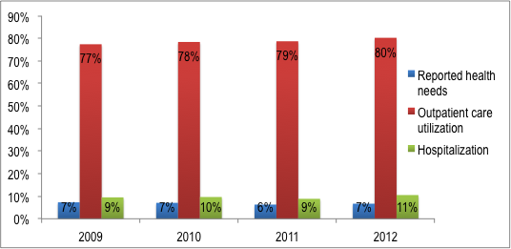
Source: Mongolia Household Socio-Economic Surveys, 2009-2012

- Distribution of utilization among different socio-economic groups

Analyses of the utilization patterns across expenditure quintiles show that outpatient and inpatient utilization rates increase the higher the expenditure quintile (Figure 2 and 4). The lowest expenditure quintile had the lowest utilization rate for outpatient services at 69% compared to the highest expenditure quintile that had the highest utilization rate at 83% in 2009 and 77% and 84% in 2012 respectively. However, access to outpatient services by poor people increased at faster rate than the richest quintile.

Figure 2: Percentage distribution of outpatient service utilization by expenditure quintiles, 2010-2012
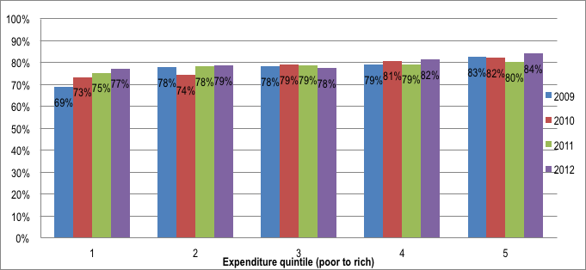
Source: Mongolia Household Socio-Economic Surveys, 2010-2012

Moreover, the utilization of outpatient care in highlands and central regions increased but for other parts of Mongolia it has dropped. In western region, 82% of people reported being ill used outpatient care in 2010 but it fell sharply to 75% in 2011 and 76% in 2012 (Table 6). When compared to 2009 data, outpatient care utilization grew in all geographic areas except Ulaanbaatar.

Table 6: Percentage distribution of outpatient service utilization by geographic regions, 2010-2012
Geographic regions | 2009 | 2010 | 2011 | 2012
West | 70% | 82% | 75% | 76%
Highlands | 69% | 65% | 75% | 76%
Central | 84% | 84% | 81% | 88%
East | 81% | 85% | 89% | 84%
Ulaanbaatar | 83% | 80% | 77% | 77%
Total | 78% | 78% | 79% | 80%
Source: Mongolia Household Socio-Economic Surveys, 2010-2012

The Figure 3 depicts outpatient care utilization patterns of the lowest and highest expenditure quintiles. The poorest of poor use mostly primary health care facilities rather than the specialized centers and clinical hospitals of tertiary care level. Despite being relatively limited, the use of private health facilities increased for the poorest population in Mongolia. They attend Soum and Family health centers twice more than the richest people and 5-10 times less the private hospitals. The richest people accessed health services at central clinical hospitals and specialised centers 2-3 times more than the poorest people.

Both poorest and richest expenditure quintiles had fairly equal access to the secondary level care providers such as aimag and district general hospitals.

Figure 3: Outpatient care utilization by the lowest and highest expenditure quintiles and by health facilities

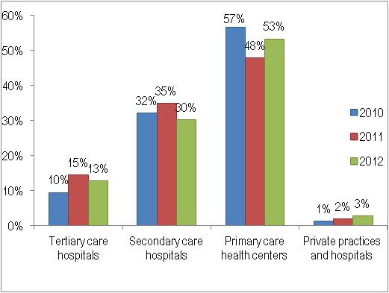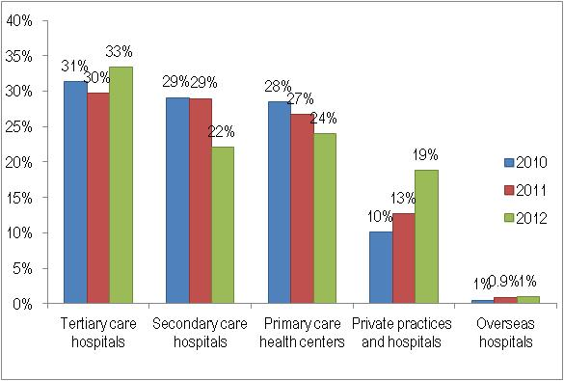
Source: Mongolia Household Socio-Economic Surveys, 2010-2012

The utilization of inpatient care increased as expenditure quintiles go up. However, inpatient service utilization fluctuated for all expenditure quintiles over time. For example, the utilization by the lowest expenditure quintile increased from 7% in 2009 to 8.4% in 2010 but dropped back to 7.2% in 2012 (Figure 4).

Figure 4: Percentage distribution of inpatient service utilization by expenditure quintile
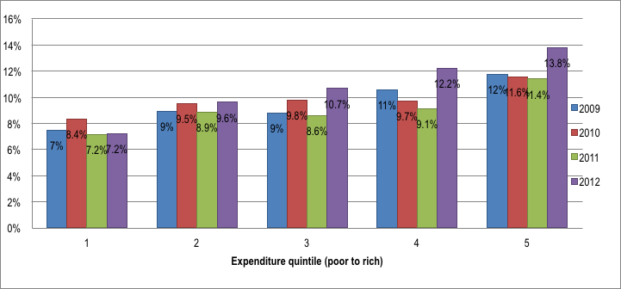
Source: Mongolia Household Socio-Economic Surveys, 2009-2012

Access to inpatient care increased in all regions in Mongolia except in highlands region (Table 7).
Table 7: Percentage distribution of inpatient service utilization by geographic regions, 2010-2012
Geographic regions | 2009 | 2010 | 2011 | 2012
West | 9% | 10% | 11% | 14%
Highlands | 10% | 11% | 8% | 8%
Central | 11% | 10% | 10% | 11%
East | 11% | 11% | 12% | 14%
Ulaanbaatar | 8% | 8% | 7% | 9%
Total | 9% | 10% | 9% | 11%
Source: Mongolia Household Socio-Economic Surveys, 2010-2012

- Utilization patterns and health seeking behaviour

Poor people are two or more times less likely to report about their need to seek health services than the richest quintile. About 80% of the total population reporting illness in the past four weeks had sought health care in 2010-2012 (Table 8).

Table 8: Outpatient health services utilization and health seeking behavior by expenditure quintile, 2010-2012
Expenditure  quintile | 2010 |  | 2011 |  | 2012
Expenditure  quintile | reported illness | Use | reported illness | Use | reported illness | Use
1 | 5% | 73% | 4% | 75% | 4% | 77%
2 | 6% | 74% | 5% | 78% | 6% | 79%
3 | 7% | 79% | 6% | 79% | 7% | 78%
4 | 8% | 81% | 7% | 79% | 8% | 82%
5 | 10% | 82% | 10% | 80% | 9% | 84%
Total | 7% | 78% | 6% | 79% | 7% | 80%
Source: Mongolia Household Socio-Economic Surveys, 2010-2012

Overtime, there are slight decreases of the health seeking behaviour in highlands, central, and in the eastern regions and more people reported being sick in the west (Table 9).

Table 9: Outpatient health services utilization and health seeking behavior by geographic regions, 2010-2012
Geographic regions | 2010 |  | 2011 |  | 2012
 | reported  illness | utilization | reported illness | utilization | reported illness | utilization
West | 5% | 82% | 5% | 75% | 6% | 76%
Highlands | 7% | 65% | 6% | 75% | 5% | 76%
Central | 9% | 84% | 8% | 81% | 7% | 88%
East | 9% | 85% | 8% | 89% | 8% | 84%
Ulaanbaatar | 7% | 80% | 6% | 77% | 7% | 77%
Total | 7% | 78% | 6% | 79% | 7% | 80%
Source: Mongolia Household Socio-Economic Surveys, 2009-2012

As shown in the Table below, the health seeking behavior and purchase of self-prescribed medicines increases from poor to rich people and over time.

Table 10: Health seeking behavior and self-prescription of medicine
Expenditure quintile | 2010 |  | 2011 |  | 2012
Expenditure quintile | reported  illness | self-prescription  of medicine | reported illness | self-prescription  of medicine | reported illness | self-prescription  of medicine
1 | 5% | 7% | 4% | 5% | 4% | 6%
2 | 6% | 8% | 5% | 8% | 6% | 9%
3 | 7% | 9% | 6% | 9% | 7% | 10%
4 | 8% | 10% | 7% | 8% | 8% | 13%
5 | 10% | 12% | 10% | 11% | 9% | 17%
Total | 7% | 9% | 6% | 8% | 7% | 11%
Source: Mongolia Household Socio-Economic Surveys, 2010-2012

- Determinants of utilization, including reasons for not seeking health services

In Mongolia, the perceived seriousness of illness (46% in 2012) and self-treatment (40.5% in 2012) constitute the highest portions of the reasons for not seeking health services among the population (Figure 5). Furthermore, financial constraints, distance and transportation to health care providers were important barriers to access health services.

Figure 5: Percentage distribution of reasons for not seeking health care

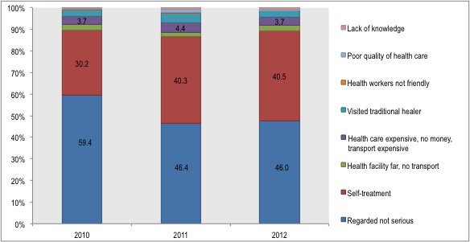
Source: Mongolia Household Socio-Economic Surveys, 2010-2012

Out-of-pocket health expenditure

- Distribution of out-of-pocket health payments in absolute terms and as a share of total household expenditure and capacity to pay across quintiles

After adjusting for inflation, out of pocket health payments rose from the poorest to richest expenditure quintile and the over time. In absolute terms, the poor households spent 10-15 times less than the highest expenditure quintile over the years analysed. On average, Mongolian households spent per capita 9231 MNT in 2009, 15072 MNT in 2010, 15275 MNT in 2011 and 18164 MNT in 2012. The average amount of households OOPs in 2012 doubled its value of 2009 (Table 11). It is notable that the highest income households have been spending almost three times the average as they have sought health services at tertiary care hospitals, private and overseas hospitals more (Figure 3).

Table 11: Distribution of household out of pocket health payments in absolute terms by quintiles, (2009 base)
Expenditure quintile | 2009  base | 2010 | 2011 | 2012
1 | 1,356 | 3,207 | 4,099 | 3,284
2 | 3,026 | 5,597 | 6,687 | 6,870
3 | 3,977 | 8,502 | 9,381 | 10,436
4 | 6,415 | 14,939 | 13,699 | 19,363
5 | 28,381 | 43,138 | 42,516 | 50,872
Total | 9,231 | 15,072 | 15,275 | 18,164
Source: Mongolia Household Socio-Economic Surveys, 2009-2012

On average, household out of pocket payments in geographical regions increased almost twice in real terms compared to 2009. The OOPs increased the highest in eastern and western regions (Table 12).
Table 12: Distribution of households out of pocket health payments in absolute terms by regions, (2009 as base)
Geographical regions | 2009  base | 2010 | 2011 | 2012
West | 6,430 | 8,385 | 10,196 | 14,718
Highlands | 8,145 | 13,174 | 12,057 | 14,473
Central | 10,385 | 20,163 | 20,955 | 17,859
East | 5,711 | 15,439 | 13,549 | 16,253
Ulaanbaatar | 11,443 | 15,926 | 16,379 | 21,242
Total | 9,231 | 15,072 | 15,275 | 18,164
Source: Mongolia Household Socio-Economic Surveys, 2009-2012

Nationally, the shares of out of pocket health payments in both total household expenditure and in the capacity to pay decreased from 2009 to 2012 (Figure 6). For example, the share of out of pocket health payments in total household expenditure was 3.2% in 2009 and 2.8% in 2012 respectively. Further, the share of OOPs in capacity to pay was 5.5% in 2009 and fell to 3.7% in 2012 (Figure 7).

The overall declines in the shares of out of pocket health payments in both total household expenditure and in the capacity to pay have been largely due to higher decreases in respective shares of richest quintile from 2009 to 2012. For all other wealth quintiles, there is moderate decreasing trend in shares of out of pocket health payments in both total household expenditure and in the capacity to pay.

Figure 6: Percentage distribution of out of pocket health payments as share of total household expenditure by quintiles
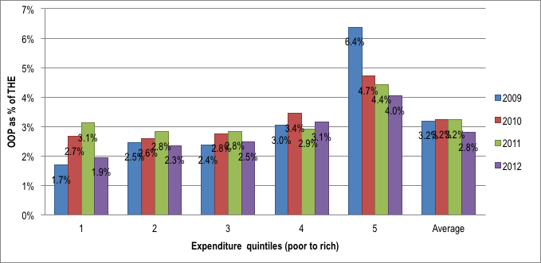
Source: Mongolia Household Socio-Economic Surveys, 2010-2012

Out-of-pocket health expenditure as a share of total expenditure for the highest expenditure quintile was 4% in 2012 that is double the share of the lowest quintile (1.9%).

Figure 7: Percentage distribution of out of pocket health payments as share of capacity to pay by quintiles
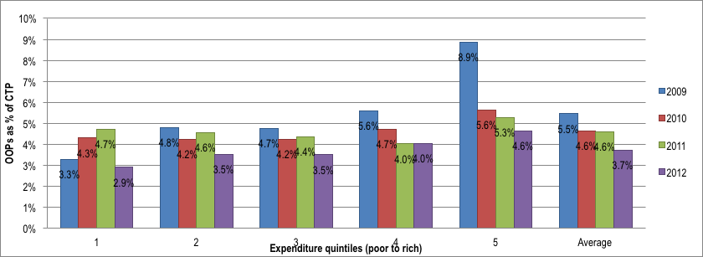
Source: Mongolia Household Socio-Economic Surveys, 2010-2012

The shares of out of pocket health payments in total household expenditure and capacity to pay have declined in all regions except Ulaanbaatar (Table 13).

Table 13: Percentage distribution of out of pocket health payments as share of total household expenditure and capacity to pay by regions

Geographical | 2010 |  | 2011 |  | 2012
regions | % of TE | % of CTP | % of TE | % of CTP | % of TE | % of CTP
West | 3.0% | 4.5% | 3.5% | 5.3% | 2.8% | 3.8%
Highlands | 3.8% | 5.4% | 3.5% | 5.0% | 3.0% | 3.9%
Central | 3.9% | 5.5% | 4.0% | 5.6% | 2.9% | 3.8%
East | 3.9% | 5.7% | 3.5% | 4.7% | 2.9% | 3.9%
Ulaanbaatar | 2.6% | 3.8% | 2.7% | 3.8% | 2.6% | 3.6%
Total | 3.2% | 4.6% | 3.2% | 4.6% | 2.8% | 3.7%
Source: Mongolia Household Socio-Economic Surveys, 2010-2012
TE=total household expenditure, CTP=capacity to pay

- Structure of out-of-pocket health payments and its distribution

The medicine and medical supplies remain to take the largest share in monthly household out of pocket payments. However, as shown in the Figure 8, there is a significant decline of out of pocket payments for medicines and supplies from 75% in 2009 to about 60% in 2012 in the household total OOPs.

The next major payment for health is for accessing inpatient care (28% in 2010 and 2012) at health facilities and from 17.5% of total household health payment in 2009.

Ancillary services such as diagnostic imaging and laboratory tests constitute about 6%-10% of total OOPs.

Figure 8: Structure of out-of-pocket health payments

Source: Mongolia Household Socio-Economic Surveys, 2009-2012

The structure of out pocket health payments across population wealth quintiles is shown in Figure 9.

Figure 9: Structure of out-of-pocket health payments by expenditure quintile, 2010-2012
Purchase of medicines and medical supplies remained the largest share of out of pocket expenditure among all expenditure quintiles and increased as quintiles go down (Figure 9). The households in lowest expenditure quintile spend 81% of OOPs for medicine in 2010, 73% in 2011 and 76% in 2012 respectively. The highest expenditure quintiles spent 50% in 2010, 49% in 2011 and 53% in 2012 of their total health payments for purchasing medicines.
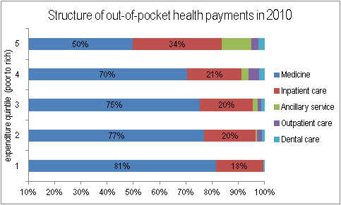
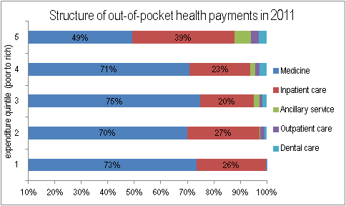
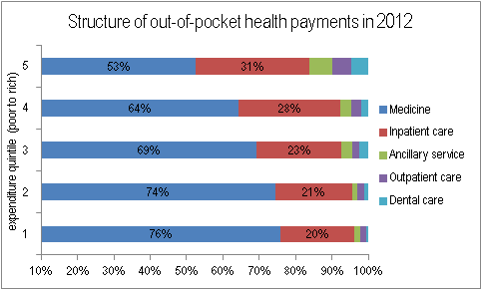
On the contrary, among all five expenditure quintiles, the richest paid highest share of their OOPs for inpatient care and ancillary services indicating increased utilization.

Source: Mongolia Household Socio-Economic Surveys, 2010-2012

In all regions, there are substantial increases of out of pocket payments for medicine, ancillary and dental services while sharp declines occurred for health expenditure for outpatient care (Table 14).

Table 14: Structure of out of pocket health payments by regions, 2010-2012
Geographic region | Medicine |  |  | Inpatient |  |  | Oupatient |  |  | Ancillary |  |  | Dental
 | 2010 | 2011 | 2012 | 2010 | 2011 | 2012 | 2010 | 2011 | 2012 | 2010 | 2011 | 2012 | 2010 | 2011 | 2012
West | 61% | 60% | 72% | 32% | 37% | 23% | 6% | 1.2% | 0.6% | 0.6% | 1.5% | 3.1% | 0.5% | 0.6% | 1.0%
Highlands | 39% | 51% | 74% | 21% | 31% | 23% | 4% | 1.0% | 0.6% | 0.4% | 1.2% | 3.2% | 0.3% | 0.5% | 1.0%
Central | 25% | 29% | 60% | 13% | 18% | 19% | 2% | 0.6% | 0.5% | 0.3% | 0.7% | 2.6% | 0.2% | 0.3% | 0.8%
East | 33% | 45% | 66% | 18% | 28% | 21% | 3% | 0.9% | 0.5% | 0.3% | 1.1% | 2.8% | 0.3% | 0.4% | 0.9%
Ulaanbaatar | 32% | 37% | 50% | 17% | 23% | 16% | 3% | 0.8% | 0.4% | 0.3% | 0.9% | 2.2% | 0.2% | 0.4% | 0.7%
Total | 34% | 40% | 59% | 18% | 25% | 19% | 3% | 0.8% | 0.5% | 0.3% | 1.0% | 2.5% | 0.3% | 0.4% | 0.8%
Source: Mongolia Household Socio-Economic Surveys, 2010-2012

Catastrophic health expenditure and poverty impact

    - Estimates of catastrophic health expenditure and impoverishment

Catastrophic health expenditure occurs when households spend 40% or more of their capacity to pay to access health services. The percentages of households incurring catastrophic health payments in Mongolia were estimated at 1.5% or 10778 households in 2010, 1.8% or 13602 households in 2011 and 0.9% or 6683 households in 2012 respectively. The time trend compared to HSES 2009 results has shown significant decline in the number of households experienced catastrophic health payments. The share of households with catastrophic health expenditures was 3.83% or 27442 households in 2009. There was an increase by 16% from 2010 to 2011 and mainly due to growing catastrophic spending by lower and middle-income quintiles.

Generally, the shares of households with catastrophic health expenditures increase as quintiles go up (Figure 10). The number of richest households experienced catastrophic health payments is 5 times higher than the poorest in 2009 and 10 times more in 2012.

Figure 10: Distribution of households by catastrophic health payments

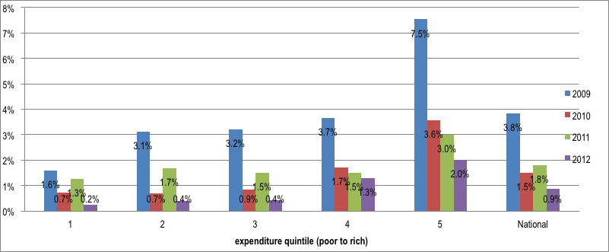`
Source: Mongolia Household Socio-Economic Surveys, 2009-2012

About 70% of the households experienced catastrophic health payments live in highlands, central and eastern regions (Figure 11).

Figure 11: Geographic distribution of households by catastrophic health payments
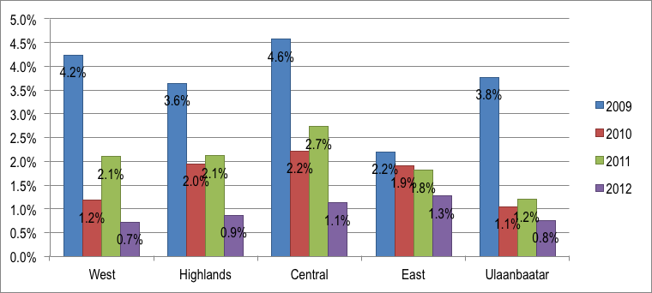
Source: Mongolia Household Socio-Economic Surveys, 2010-2012

Out of total households, 1.1% in 2010, 1.2% in 2011 and 0.6% in 2012 have been pushed below the poverty line due to health payments. This accounted for 7602 Mongolian households in 2010 and decreased to 4685 households in 2012. Compared to 2009, the number of households impoverished due to health payments decreased by almost 40% in 2012 (Table 15).

Table 15: Distribution of impoverishment by total out-of-pocket payment
Expenditure quintile | 2009 | 2010 | 2011 | 2012
1 | 0.0% | 4.0% | 4.1% | 2.7%
2 | 7.0% | 0.3% | 0.7% | 0.1%
3 | 1.1% | 0.1% | 0.1% | -
4 | 0.5% | - | - | -
5 | 0.4% | - | - | -
Total | 1.8% | 1.1% | 1.2% | 0.6%
Source: Mongolia Household Socio-Economic Surveys, 2009-2012

In addition, only households in lower expenditure quintiles impoverished due to health payments and 80% of them live in western, eastern and highlands regions. Only 3% of total households impoverished due to health out of pocket payments is in Ulaanbaatar (2011 and 2012).

Figure 12: Geographic distributions of impoverishment by total out-of-pocket payment
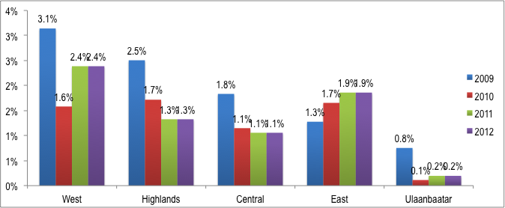

Households experienced catastrophic health payments due to higher out of pocket spending on purchase of medicine and also inpatient services in Mongolia. This means that about 80% in 2010 and 60% in 2012 of households experienced catastrophic health payments as results of OOPs on medicine and inpatient care. The shares of households decreased substantially from 2010 to 2012 for both medicines and inpatient services. In particular, the percentage of households experiencing catastrophic expenditure due to medicine declined by 2.7 times or from 0.8% in 2010 to 0.3% in 2012 (Figure 11).

Figure 13: Estimates of catastrophic expenditure by each component of out-of-pocket payments
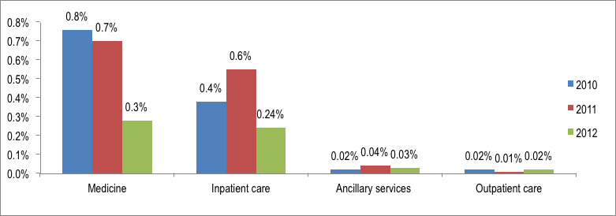
Source: Mongolia Household Socio-Economic Surveys, 2010-2012

Declines in percentages of households experienced catastrophic health payments due to purchase of medicines have been observed for all wealth quintiles from 2010 to 2012 (Table 16).

Table 16: Catastrophic payments by types of health services and expenditure quintiles, 2010-2012
Expenditure quintile | Medicine |  |  | Inpatient care |  |  | Ancillary services |  |  | Outpatient care
Expenditure quintile | 2010 | 2011 | 2012 | 2010 | 2011 | 2012 | 2010 | 2011 | 2012 | 2010 | 2011 | 2012
1 | 0.4% | 0.64% | 0.08% | 0.2% | 0.4% | 0.1% | - | - | - | - | - | 0.04%
2 | 0.5% | 0.6% | 0.2% | 0.1% | 0.5% | - | - | - | - | - | 0.03% | -
3 | 0.3% | 0.6% | 0.2% | 0.3% | 0.2% | 0.1% | 0.03% | - | - | 0.03% | - | 0.04%
4 | 1.0% | 0.8% | 0.4% | 0.2% | 0.4% | 0.4% | - | 0.1% | 0.04% | 0.1% | 0.01% | -
5 | 1.7% | 0.8% | 0.5% | 1.1% | 1.3% | 0.7% | 0.1% | 0.1% | 0.1% | - | - | 0.02%
Total | 0.8% | 0.7% | 0.3% | 0.4% | 0.6% | 0.24% | 0.02% | 0.04% | 0.03% | 0.02% | 0.01% | 0.02%
Source: Mongolia Household Socio-Economic Surveys, 2010-2012

Except for western part of the country, the number of households with catastrophic health payments due to medicine decreased in all regions in Mongolia, 2010-2012.

Table 17: Catastrophic payments by types of health services and geographic regions, 2010-2012
Geographic region | Medicine |  |  | Inpatient |  |  | Outpatient |  |  | Ancillary
Geographic region | 2010 | 2011 | 2012 | 2010 | 2011 | 2012 | 2010 | 2011 | 2012 | 2010 | 2011 | 2012
West | 0.4% | 0.3% | 0.4% | 0.4% | 1.2% | 0.1% | 0.1% | - | - | - | - | -
Highlands | 1.1% | 1.4% | 0.2% | 0.5% | 0.3% | 0.3% | - | - | 0.1% | - | 0.1% | -
Central | 1.3% | 1.0% | 0.5% | 0.5% | 0.9% | 0.2% | - | 0.1% | 0.1% | - | 0.2% | -
East | 1.0% | 0.6% | 0.4% | 0.4% | 0.3% | 0.7% | - | - | - | - | 0.1% | 0.1%
Ulaanbaatar | 0.4% | 0.4% | 0.2% | 0.3% | 0.4% | 0.2% | - | - | - | - | 0.1% | -
Total | 0.8% | 0.7% | 0.3% | 0.4% | 0.6% | 0.2% | 0.0% | 0.0% | 0.0% | 0.0% | 0.1% | 0.0%
Source: Mongolia Household Socio-Economic Surveys, 2010-2012
Evidently, the majority of impoverishment was due to out of pocket payment of medicine and medical supplies (Figure 14).

Figure 14: Estimates of impoverishment by major component of out-of-pocket payments
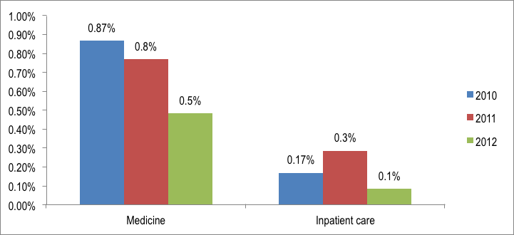
Source: Mongolia Household Socio-Economic Surveys, 2010-2012

As estimated in the table below, the poor people have impoverished due to out of pocket payments on medicines and inpatient care (Table 18).

Table 18: Estimates of impoverishment by major component of out-of-pocket payments and quintiles, 2010-2012

Expenditure quintile | 2010 |  | 2011 |  | 2012
Expenditure quintile | Medicine | Inpatient care | Medicine | Inpatient care | Medicine | Inpatient care
1 | 3.35% | 0.63% | 2.95% | 1.0% | 2.1% | 0.4%
2 | 0.17% | 0.04% | 0.3% | 0.2% | 0.1% | -
3 | 0.09% | 0.05% | 0.05% | 0.05% | - | -
4 | - | - | - | - | - | -
5 | - | - | - | - | - | -
Total | 0.87% | 0.2% | 0.8% | 0.3% | 0.5% | 0.1%
Source: Mongolia Household Socio-Economic Surveys, 2010-2012

- Determinants of catastrophic expenditure

Results of logistic regression model show factors that are significant to the likelihood of suffering from catastrophic health expenditures (Table 19). The odds ratio of incurring catastrophic health expenditures increased significantly as household expenditure quintile increased indicating that households of higher expenditure quintiles experience a higher likelihood of catastrophic expenditure in Mongolia In addition, factors including household size, living in an urban area, and having a household member over the age of 60 also significantly increased the odds ratio of catastrophic health expenditures. Having a household member under the age of five and a male household head significantly decreased the odds ratio of catastrophic health payments.

Table 19: Determinants of catastrophic health payments

 | 2010 |  |  | 2011 |  |  | 2012
Dependent variable: Household catastrophic health expenditure | Odds Ratio | P>z | [95% Conf. | Odds Ratio | P>z | [95% Conf. | Odds Ratio | P>z | [95% Conf.
Household size | 1.838 | 0.000 | 1.425 | 1.420 | 0.002 | 1.132 | 1.845 | 0.000 | 1.355
Urban | 3.261 | 0.000 | 2.331 | 1.974 | 0.000 | 1.453 | 2.517 | 0.000 | 1.744
Children | 1.237 | 0.197 | 0.896 | 0.655 | 0.026 | 0.451 | 0.564 | 0.013 | 0.360
Elderly | 0.463 | 0.000 | 0.372 | 0.556 | 0.000 | 0.461 | 0.530 | 0.000 | 0.409
Household head male | 0.616 | 0.008 | 0.430 | 0.882 | 0.447 | 0.639 | 0.576 | 0.011 | 0.377
Quintile 2 | 1.325 | 0.392 | 0.695 | 1.394 | 0.144 | 0.892 | 1.951 | 0.162 | 0.764
Quintile 3 | 1.873 | 0.056 | 0.984 | 1.322 | 0.252 | 0.820 | 2.516 | 0.052 | 0.994
Quintile 4 | 5.288 | 0.000 | 3.023 | 1.532 | 0.084 | 0.944 | 8.744 | 0.000 | 3.851
Quintile 5 | 10.464 | 0.000 | 6.122 | 3.071 | 0.000 | 1.971 | 15.969 | 0.000 | 7.108
Source: Mongolia Household Socio-Economic Surveys, 2010-2012

Benefit incidence of government spending on health

Benefit and incidence analysis describes the distribution of health sector subsidies across individuals ranked by their living standards. Consequently, we examined the distribution of those health services that are subsidized from public finances.

    - Description of benefits of state budget and health insurance.

The government including public social health insurance pays the majority of expenditures of government owned health facilities in Mongolia. In addition to paying for mainly public health services including primary health care, maternal and child health and communicable disease, the government budget also gives a subsidy to social health insurance as contribution for vulnerable groups of population. In this study we took the total government subsidy for health and showed its distributional impacts across expenditure quintiles, and other socio-economic indicators. The benefit to health sector was estimated as follows:

First, we assembled the data on overall government subsidy expenditures by all types of government health care providers in each of five geographic regions. Then the amounts paid in official user charges were subtracted from the total government subsidy expenditures of each facility to arrive at the net subsidy received. The total government subsidy net of official user charges was then allocated into inpatient and outpatient services based on ratios obtained from costing studies. Then we estimated the proportion of all visits and inpatient days reported in the survey in a particular region accounted for by each individual. The total national or regional subsidy expenditures for each type of service can be then allocated to each individual according to their specific share of the overall number of visits and inpatient days. Next, the overall subsidy received by each individual in the survey for each type of service is estimated by summing the subsidies associated with each type of healthcare facility. Having categorized individuals by their living standards and calculated the value of the health sector subsidy received by each individual, the distribution is estimated for the subsidy in relation to living standards.

- Benefit and incidences of government subsidy by income groups

As estimated in the figure below, the distribution of government expenditure on health is regressive, benefiting the rich more than the poor.

Figure 15: Percentage share of government subsidies for health by quintiles, 2012
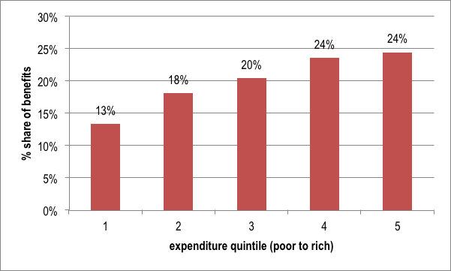
Source: Mongolia Household Socio-Economic Survey, 2012

The poorest 20% of Mongolian people received only 13% of the government resources spent on health, while the richest 20% received 24% of government spending for the sector. Hence, the richer populations benefited more from government subsidy than the poor as percentage share of benefits increase from lowest to highest wealth quintile.

- Benefit incidences of government subsidy by rural and urban areas

People in urban settings used two-thirds of total benefits for health as well as outpatient and inpatient subsidies in 2012 (Figure 16). The resource allocation for urban population is largely driven by the higher portion of the total health subsidy used by the people in Ulaanbaatar (Figure 18).
Figure 16: Percentage share of government subsidy for health by urban and rural population, 2012
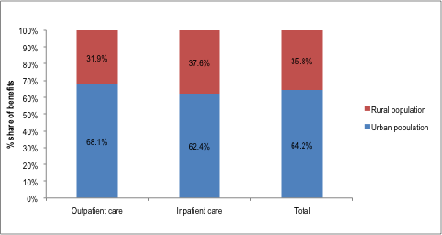
Source: Mongolia Household Socio-Economic Survey, 2012

However, the shares of benefits decreased from lowest to highest wealth quintile among rural population. This is an indication of wealthier people in rural settings seek care in more costly health facilities such as hospitals in Ulaanbaatar (Figure 17).

Figure 17: Percentage share of government benefits by urban and rural population and expenditure quintile, 2012
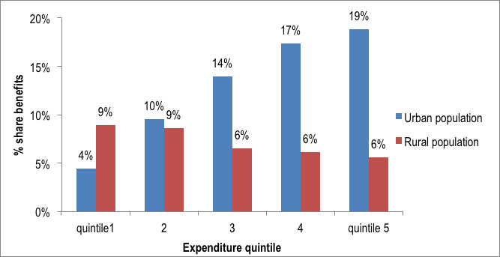
Source: Mongolia Household Socio-Economic Survey, 2012

- Benefit incidences of government subsidy by geographic regions

Figure 18: Percentage share of government benefits by geographic regions, 2012

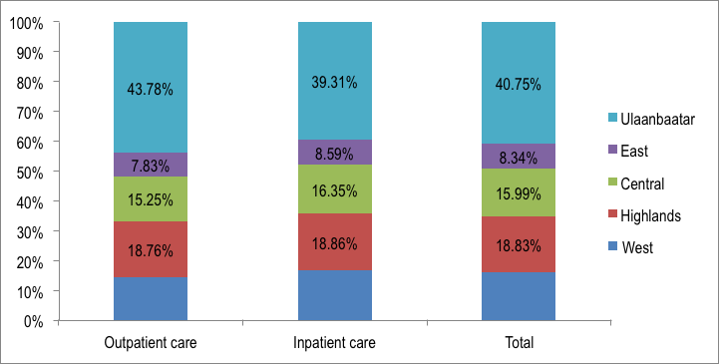
Source: Mongolia Household Socio-Economic Survey, 2012

- Benefit incidences of government subsidy by gender

The male population benefited from government subsidy slightly less than the female population (Figure 19).

Figure 19: Percentage share of government benefits by gender, 2012
Source: Mongolia Household Socio-Economic Survey, 2012

For both male and female population, the shares of government subsidy increase as expenditure quintiles go up.

Figure 20: Percentage share of government benefits by gender and expenditure quintile, 2012
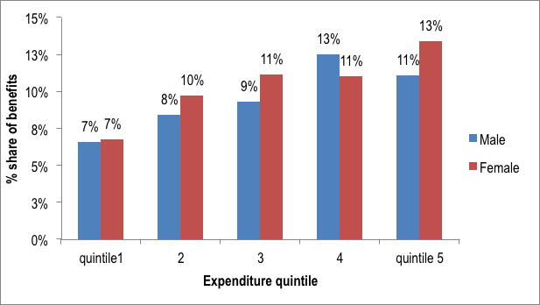
Source: Mongolia Household Socio-Economic Survey, 2012

- State budget benefit incidences by level of health facility

Table 20 presents the findings of a benefit-incidence analysis on health in 2012. Spending on primary health care facilities benefits the poor more than spending on tertiary hospitals as lowest and highest income groups received same share of government subsidy.

Table 20: Distribution of benefits of government expenditure on health by level of health service delivery, 2012
Expenditure  quintile | Clinical hospitals and specialty centers | Aimag and district general hospitals | Primary health  care facilities
1 | 1.8% | 4.3% | 7.4%
2 | 4.4% | 5.4% | 7.4%
3 | 4.8% | 7.7% | 7.8%
4 | 7.0% | 7.5% | 8.7%
5 | 11.4% | 6.9% | 7.5%
Total | 29.4% | 31.7% | 38.9%
Source: Mongolia Household Socio-Economic Survey, 2012

On the other hand, wealthy people benefit from clinical hospitals and specialty centers that provide tertiary level of health care by 6.3 times more than the lowest expenditure quintile.

- Benefit and incidences of government expenditure on health by types of services

The benefits from government spending in outpatient and inpatient care increased as expenditure quintiles go up (Figure 19).

Figure 21: Percentage share of government benefits by outpatient and inpatient care and expenditure quintile, 2012
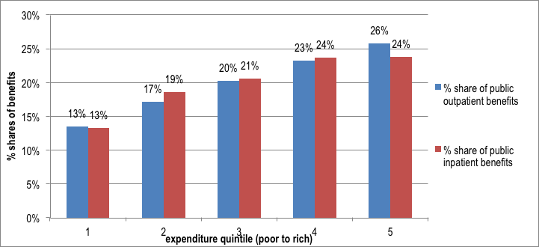
Source: Mongolia Household Socio-Economic Survey, 2012

- Estimation of distribution of benefits.

On average, per capita government subsidy was 6157 MNT in 2012. One third of total per capita subsidy spent for outpatient care and the rest for inpatient care. The costing studies do not provide disaggregation of data for ancillary and other services such as medicine (Table 21).

Table 21: Mean per capita benefit in health by types of health services, 2012
 |  | Linearized
 | Mean | Std. Err. | [95% Conf. | Interval]
Outpatient care | 1986 | 44 | 1899 | 2073
Inpatient care | 4171 | 106 | 3964 | 4379
Total subsidy | 6157 | 124 | 5915 | 6400
Source: Mongolia Household Socio-Economic Survey, 2012

Table 22: Mean per capita benefit in health by types of health services and expenditure quintile, 2012

 | Public subsidy for outpatient care |  |  |  | Public subsidy for inpatient care
Wealth quintile | Mean | Std. Err. | [95% Conf. | Interval] | Mean | Std. Err. | [95% Conf. | Interval]
1 | 1338 | 76 | 1189 | 1486 | 2771 | 136 | 2504 | 3038
2 | 1710 | 88 | 1537 | 1883 | 3884 | 230 | 3434 | 4335
3 | 2015 | 100 | 1818 | 2211 | 4291 | 215 | 3870 | 4712
4 | 2309 | 109 | 2096 | 2523 | 4944 | 324 | 4308 | 5579
5 | 2566 | 117 | 2338 | 2795 | 4967 | 239 | 4499 | 5436
Source: Mongolia Household Socio-Economic Survey, 2012

The highest income quintile benefited from public subsidy for health care twice as much as the lowest group.

Figure 22 plots in the horizontal axis the cumulative share of the population ranked by their per capita expenditure level and in the vertical axis, the cumulative distribution of the health subsidy they received in 2012. Further Figure 23 showed that poor reported less than the rich of their illness and benefited from government subsidy also at lower rates. It can be observed, that government expenditure on health is slightly regressive in Mongolia.

Figure 22: Lorenz curve of government subsidy on health, 2012

Source: Mongolia Household Socio-Economic Survey, 2012

Figure 23: Percentage distribution of need for health services and government subsidy on health, 2012

Source: Mongolia Household Socio-Economic Survey, 2012

Discussion

The report laid out the data from Mongolia’s Household Socio Economic Surveys conducted over three years 2010-2012 and provided analysis of patterns of health services utilization and catastrophic health payments and impoverishment. The results were also compared with HSES 2009 outputs. In addition, attempts were made to reveal the benefit incidence of government health budget in Mongolia. Before discussing the issues identified limitations related to survey data and methodology should be stated.

Overall, as noted in the national survey reports the HSES data quality is to be considered of good standard as every stages of the survey work both local and international experts followed and advised the NSO. However, the NSO noted about some understandable concerns related to specifically non-sampling or survey design and administration related bias envisaged because of the large amounts of information that the HSES collects from households.

Next, the recall periods of inpatient out of pocket payment variables in both health and non-food sections of the survey appear to differ. In the health section health spending of the last 12 months were asked whereas in the non-food module of survey used recall periods of both last month and last 12 months. Such difference of recall periods of variables even in the same module will cause measurement errors. However since we applied same data source and methodology, such errors considered to be of insignificant when compared across time and within Mongolia.

Health service utilization is based on self-reported need that may result from different expectations and norms for health as well as biases by age, sex, health system indicators and other characteristics. In addition, health service utilization estimates use only self-reported services and excludes supply side initiated services such as preventative visits.

Some of the key issues identified in this report include:

There is a clear evidence of issues of health services accessibility by poor people in Mongolia compared to the rich and they benefit less from public spending for health. Outpatient health service utilization was lower for the poor than the rich over time. Inpatient service utilization decreased for poor quintiles while the access to same services increased for wealthy quintiles. For various reasons the poor are less likely to report about their illness than the richest quintile when the poor have greater health needs. Likewise the rich, the significant reasons of poor who do not seek care include perceiving the illness to be less serious and try to self medicate. In general, self-medication is a major health system problem in Mongolia and we provide some points of discussion later.

But further, the analysis of reasons of not seeking health care suggest that lower quintile groups forgo health care due to financial burden of accessing health services and distance of health facility and the lack of transport.

Therefore, the poor access to mainly primary health care for their health needs while the rich use tertiary care centers and private hospitals. Primary health care is provided through family and soum health centers and they located are closer to households and also funded by the government budget. Despite copayment for essential medicines, the primary health care is free.

Nationally, the shares of out of pocket health payments decreased from 2010 to 2012 largely due to increasing shares of capacity to pay in the total household expenditure. In addition, changes in some areas of health care financing policy could also explain the part of this positive outcome. For example, the MoH uses the 115 groups of DRGs to pay hospital inpatient care and diagnostic and palliative care from social health insurance since 2010. Over three years there have also been increases in payment rates for social health insurance covered services to increase the cost coverage accordingly. The most importantly, essential medicines are made more accessible by increased numbers of private pharmacies contracted by social health insurance have increased and accordingly the SHI payment allocation for essential medicines grew by 60% in 2012 compared to 2010 expenditure.

However, purchases of medicine and drugs remain the largest share of out of pocket health expenditure among all expenditure quintiles and increasingly for the poorer quintiles. The poor people have most likely been practicing self-medications as perhaps an alternative to having limited access to services at health facilities. However, it is necessary to note that there is a general pattern of high level utilization of medicine among all population, which might be due at least two main reasons. The outpatient drugs and medicines prescribed by hospitals have not been covered by health insurance until 2015. There are some medicines for health conditions such as TB, late stages of cancer, mental disorder and diabetes are fully covered by government budget. However such fragmentation of medicine coverage has lead to ambiguity between covered and non-covered medicines hence room for provider gaming behavior in the absence of strong purchaser system. Second, a mechanism to contain or regulate drug prices charged by private pharmacies is weak in Mongolia due to mainly poor coordination among government regulatory and inspection institutions. This issue has been studied by the ADB project and the proposal to establish a drug regulatory body has been recommended however the decision is pending at political level. In addition, there are also cultural issues related to Soviet time where the perception of good quality care among population was related to as much as possible prescription of medications and injections and patients shown increasing preferences for utilization of medicines.

The payment for inpatient care takes next big item in the household out of pocket health payment. This result may be explained by two factors. In the case of poor, despite a policy to exempt so called vulnerable people such as children and elderly from any types of copayments, the real poor still incur out of pocket health payments. Second, one of the main health system concern in Mongolia is the extent of unregulated informal payments in the health sector. Recent study (2011) by the Mongolian public health professionals’ association revealed that about 60% of OOPs were informal and majority of which are paid for surgical, cancer and maternity conditions. Technically, the health services for these cases are covered either by government budget or the social health insurance.

Mongolia’s average proportion of households incurring catastrophic health expenditure and impoverishment ranks low at 1.5% in 2010, 1.8% in 2011 and 0.9% in 2012 compared to many other countries in the Western Pacific region. However, it should be noted that such declining trend over three years could be unreliable as the share increased in 2011 and decreased again in 2012. Overall, the decline of catastrophic health expenditures and impoverishment due to health expenditures because of increased capacity to pay. Moreover, the declined trend of catastrophic health expenditure and impoverishment is linked also to decreased out-of pocket payments for medicine and inpatient care.

Households of higher expenditure quintiles experience a higher likelihood of catastrophic expenditure in Mongolia probably due to tendency to go to tertiary, private or overseas hospitals. Although it might not be realistic to place restrictions to those people who travel abroad seeking health services, the government can work on improvement of quality of health services domestically to gain some of the lost confidences in the health system. The reasons of not going to access to outpatient services indicated issues concerning quality of health services as well.

It is essential to note that only households of lower expenditure quintiles impoverished due to health payments in 2011 and 2012. Furthermore, the poor people in eastern and highlands regions experienced catastrophic health payments and impoverished due to health out of pocket payments. This means that poor people spend much less than the middle-income and richer people and pushed below poverty line as result of out of pocket payments for medicine and inpatient services.

Policy recommendations

Based on findings of the analysis of HSESs in 2010-2012, the following key policy interventions are recommended. Policy recommendations are organized for purposes of national policy making by the government and the Ministry of Health and also for the recently approved health insurance organization as the main purchaser of health services. Below policy recommendations will require short to long-term implementation efforts.

At national policy making level

- Develop policy and legal environment for universal health coverage as an explicit objective of the health system

Assessment and revision of Mongolia’s health financing strategy is essential step to design and implement a policy to achieve the objective of universal health coverage where people have access to needed health services without incurring financial catastrophe. Mongolia’s health financing strategy was approved in 2010 for period of implementation until 2015. The policy envisages that out of pocket health expenditure would be dropped to 25% of the THE and people shall be ensured with good quality needed health services on equitable basis and they will be financially protected from incurring catastrophic and impoverishing health payments. However, the strategy lacked implementation efforts despite having approved plan. Therefore it is ripe time to revisit the health financing strategy and develop policies and strategies to implement interventions that are based on evidences of out of pocket and catastrophic and impoverishing health payments in Mongolia.

      - Improve availability and utilization of data on health expenditure and out of pocket health payments

Further, Mongolia has good system with ample of data about population health outcomes. This means that health data related to population morbidity and mortality is well collected and reported at national and sub-national levels and by types of health facilities. However the health expenditure data is fairly limited to statistics about public finances. Therefore it needs to improve availability of health expenditure data to track the extent of health payments paid by private people to ensure health system objective of population financial protection is achieved. Fortunately, Household Socio-Economic Surveys provide good source of data for this purposes but analysis and utilization should be improved by the health sector. In addition, the Center for health development is working to produce national health accounts estimates that was missing since 2005.

      - Enhance understanding of policy makers about health disparity

Despite policy commitment by the MoHS, past efforts to allocate resources for health to improve access to health services by the poor and vulnerable and to promote health equity have not been successful in Mongolia. Support of policy makers including health and finance ministries and the parliament is critical to make decisions to prioritize health in the government budget. In this regard, advocacy and other efforts from research communities, NGOs and international bodies are essential to raise awareness of policy makers about the needs and problems of the poor and disadvantaged people to enable targeted approaches and strategies.

      - Continue making efforts to strengthen purchaser capacity of the Social Health Insurance organization

Purchasing of health services is relatively new notion in Mongolia as in the past all services were provided by the government through government health facilities. In 1995, when Mongolia introduced social health insurance, attempts have been made to purchase health services out of money contributed by insured population. However pretty much like the previous system, the SHI money went to health care providers without strategic purchasing and rather passive funding or paying the bills manner. Purchasing is very important policy instrument to monitor and control out of pocket health payments imposed by health care providers. Therefore, recent effort in the new Health insurance law to improve social insurance purchaser capacity was crucial step and the law should be thoroughly implemented. The law allows the separate health insurance organization and increasing and enhancing quality and quantity of personnel and backing this up with adequate level of operational resources. New health insurance organization will have more leverage over hospital behavior and thus playing important role to reduce formal and informal health payments by users. Strengthened SHI will have evidences about important health objectives like out of pocket payment and will be able to influence government ministries to design better policies.

      - Mobilize increased resources for health from the government budget

The Mongolia spends a fair share of the GDP for health. However, a substantial share of the total health expenditure comes from privately paid out of pocket payments. Therefore, the government contribution to health system needs to be increased as it has been remained at constant level over the years. This will provide enhanced leverage for the purchaser to cover more services as well as provide cost coverage to existing benefit package under the government budget and health insurance.

      - Reduce existing inefficiencies in Mongolian health sector in order to make most of the limited resources

Major sources of inefficiencies in the state health facilities include staffing and procurement of medicine. The procurement of medicine is inefficient due to fragmentation where health facilities organize procurement of medicine and medical supplies through 37 separate efforts. According to MoH report, for example same medicine was purchased at 16 different prices and also local prices differed by 2.5-7 times higher than the international reference price. Therefore, the MoH approved second State Medicine Policy and plans to implement centralized procurement system for the medicines and supplies purchased by the public funds.

More importantly, in order to reduce the self-medication practices of population and associated inefficiencies, three types of policy interventions should be implemented. First, a tighter regulation of private pharmacies should be implemented to reduce direct sales of non-prescribed medicines by pharmacies. Second, medicine-prescribing practices and utilization of prescription slips of medical doctors should be enforced with tougher sanctions and also with incentive systems. Third, population oriented health education and awareness raising programs and activities should be implemented to help population in rational use of medicine.

In terms of inefficiency related to the health human resource and the ways of improvement, there have been many discussions about giving incentives or autonomy to hospital managers about deciding on staffing and other resources within the cap. Such reform should be implemented on a pilot basis with lessons learnt from other countries.

At purchaser level

- Harmonize the benefit package of government budget and the health insurance scheme to improve effectiveness of the service coverage

The benefit packages covered by the public statutory schemes are fragmented between state budget and social health insurance. Therefore many services that ought to be covered by one or other payer are left out of attention of purchaser and government. For example, services such as diabetes, STIs, maternal care are covered by the state budget however hospitals and patients complain about lack of funds to purchase medicines. Such outcome can perhaps be explained by a lack of purchasing for state budget package.

In order to eliminate potential and existing fragmentation of services, the current effort of step by step channeling of government budget resources to social health insurance as the pooled purchaser should be continued. In addition, the provider payment system for government budget covered services should be clarified to reduce potential gaming behaviors of health care providers. Currently, some inpatient cases such as cancer and infectious diseases are directly paid by the government budget via line item expenses, while social health insurance uses DRGs system.

- Expand benefit package to increase the coverage of medicine costs

Population in all income groups experienced high out of pocket payments for medicines in Mongolia. Previously, the social health insurance scheme reimbursed only medicines prescribed by family and soum health centers or primary health care providers. The new health insurance law (2015) effective as of July 2015 offers expansion of medicine benefits to hospitals namely the secondary care providers i.e. district and aimag general hospitals. This will certainly reduce the out of pocket payment for medicine. However, before undertaking such expansion policy, regulatory actions to improve efficiency in the use of medicine usage need to be implemented. The recommendations to regulate pharmaceutical sector are discussed above.

Many countries, even developed ones, apply copayments to medicines when reimbursed by the social health insurance. In these instances, the poor and vulnerable are usually exempted. However, attempts to implement exemption policy have not been effective in Mongolia largely due to poor understanding and capacity of policy makers to allocate resources to cover the costs of exempted services. For example, the ADB supported project attempted to implement the safety net system to cover medicine costs of poorest people from the government budget however failed due to have the required budget approved at the ministry of finance.

- Increase spending on primary health care facilities for the benefit of the poor

The poor people twice as the richest have utilized primary health care services in Mongolia. Therefore improvement of quality of primary health services is crucial to improve access to needed health services. Until now for example, FGPs have not been resourced to perform basic diagnostic and laboratory tests, however the situation will be changed due to investment in recent years. Moreover, the new law on health insurance expands its benefit package to cover some of the key services including home care and diagnostics.

In addition, FGP staffs appear not to be paid at the same level as other health personnel. For FGPs in peri-urban areas to operate effectively and to meet the rising expectations of the population, funding should be increased to cover not only operational costs but also additional costs associated with home visits, remoteness of patients and fuel for their vehicles. Specific allowances and overall increases in FGP funding must be accompanied with targets to increase services to the poor and vulnerable. More specifically, existing capitation funding could be supplemented with fee for service payments for doctors and nurses for outreach services to the poor and vulnerable households to raise their health service utilization. For example, it has been suggested that an initial budget of around MNT 505,400 or $361 per capita, not including salaries and other variable costs, is needed to ensure effective operations of FGPs.

- Revise the hospital payment system in line with equity objectives

The recent a comprehensive assessment of all payments system recommended implementation of a Road map to improve existing payment system in Mongolia. These specific recommendations should be part of the next health financing strategy and a thorough monitoring is needed to ensure effectiveness. Some of the key concerns identified in the assessment are related to line item payment system and DRGs in Mongolia.

The mix of payment systems received by an individual provider varies widely, even within one provider category. This creates mixed signals to providers and sometimes contradictory to health objectives. For example, movement between line items is reported to be difficult, with burdensome approval requirements. A number of providers reported having savings in one line item but not being able to move funds to cover deficits in others. In fact, the lack of flexibility to allocate spending was noted as a problem more frequently than the inadequate amount of the budget. Therefore, efforts to moving away from line item payment to DRGs payment system should be sustained and intensified.

On the other hand, although DRGs are linked to health services and also used by the health insurance agency there are apparent shortcomings in design and implementation of this payment system. For example, the payment for private hospitals is at 50% of the DRG tariffs paid to public sector facilities. The basis for this payment differentiation is not clear. In addition, the main shortcoming providers raised about the design of the DRG-based payment system is that it does not account for co-morbidities, so cases within a DRG are paid the same regardless of whether the patient has complications or any additional diagnoses. There is also no mechanism to pay for outliers (particularly high-cost cases in a DRG). Several providers specifically noted that while maternal care is paid for through the budget, they do not receive DRG-based payments for services related to complications and co-morbidities of pregnant women.

- Establish SHI contracted pharmacies at places where mostly poor and disadvantaged live

There is limited number of pharmacies in the remote khoroos that sell medicines at discounted prices. Therefore, poor citizens who do not have access to needed medications resort to traditional medicine, such as urine therapy, herb and cranberry potions etc to treat themselves. This situation should be improved and more pharmacies should be located within accessible reach to the poor and vulnerable. In this regard, social insurance organization that contract pharmacies can play an important role by providing a favorable environment for these facilities to open pharmacies in areas where the poor and vulnerable live. This effort will involve not only making the contracting process more flexible for pharmacies but also providing information to users and training of FGP doctors.

      - Promote service utilization by the poor at government hospitals.

Barriers to utilization of health services by the poor at health facilities are explained by many factors including financial hardships due to health payments, responsiveness of health care providers, and distance and transport related hurdles. Copayments are currently applied to essential drugs prescribed by FGPs, outpatient diagnosis and tests and in-patient admissions at hospitals. Exemption policies are used in many countries to protect the poor from catastrophic health payments and impoverishment. Interventions in this regard include continue subsidizing the hospital service utilization of poor people through improved system of targeting the budget and social health insurance funds and effective exemption policy for user fees. In relation to the latter there is a need to assess the exemption policy for poor and vulnerable.

Reference

Cashin, Cheryl; Somanathan, Aparnaa. 2015. Assessment of systems for paying health care providers in Mongolia : implications for equity, efficiency and universal health coverage. Washington, D.C. : World Bank Group.

Designing health financing systems to reduce catastrophic health expenditure, Technical policy brief for policy makers #2, WHO 2005

O’Donnel, O., van Doorslaer., et al, Analyzing Health Equity Using Household Survey Data: A Guide to Techniques and Their Implementation. The World Bank, 2007. ISBN-13: 978-0-8213-6933-3

Informal payments in health sector in Mongolia, Mongolian Public Health Professionals Association. 2011.

Poverty profile 2012, National Statistics Office of Mongolia 2013, Ulaanbaatar

Tsolmongerel Ts, et al “Mongolia Health System Review”, Health systems in transition. Vol.3 No.2 2013, Asia Pacific Observatory on Health Systems and Policies.

Tsolmongerel T, Chimeddagva D, Erdenechimeg E, and Ulzii-Orshikh. Distribution of health payments and catastrophic expenditure in Mongolia. Report and policy brief.

Designing health financing systems to reduce catastrophic health expenditure, Technical policy brief for policy makers #2, WHO 2005
O’Donnel, O., van Doorslaer., et al, Analyzing Health Equity Using Household Survey Data: A Guide to Techniques and Their Implementation. The World Bank, 2007. ISBN-13: 978-0-8213-6933-3
Informal payments in health sector in Mongolia, Mongolian Public Health Professionals Association. 2011. The study revealed that about 60% of OOPs were informally paid.
The West is comprised of the aimags of Bayan-Olgii, Govi-Altai, Zavkhan, Uvs and Khovd; the Highlands Arkhangai, Bayankhongor, Bulgan, Ovorkhangai, Khovsgol and Orkhon; the Central Dornogovi, Dundgovi, Omnogovi, Govisumber, Selenge, Tov and Darkhan-Uul; and the East Dornod, Sukhbaatar; and Khentii.
A completely equal distribution of expenditure is represented by the 45 degree line where the 20 percent poorest individuals receive 20 percent of the subsidy.
World Bank. 2010. Managing urban expansion in Mongolia: best practices in scenario based urban planning. Washington, DC
Provider payment assessment, Ministry of Health. World Health Orgnization and World Bank, 2015
The medicines included in the national essential list of drugs are covered by the Mongolian Social Health Insurance with copayment by the insured when prescribed by primary health care doctors. This arrangement is called the health insurance drug price discount system. Currently, 339 drugs of 134 types are included under the drug price discount system.

