TanzaniA P4P ASsessment Report
P4P Assessment Team
10/18/2013

ABBREVIATIONS AND ACRONYMS
CCHPs | Council Comprehensive Health Plans
CHAI | Clinton Health Access Initiative
CHMTs | Council Health Management Team
CSSC | Christian Social Services Commission
EAPHLNP | East Africa Public Health Laboratory Network Project
DED | Council Executive Director
DHIS | District Health Information Systems
GFATM | Global Fund to Fight AIDS, Tuberculosis and Malaria
HFGC | Health Facility Governing Committee (HFGC)
HMIS | Health Management Information System
MOHSW | Ministry of Health and Social Welfare
MSD | Medical Stores Department
PEPFAR | President’s Emergency Program for AIDS Relief
NHIF | National Health Insurance Fund
NMB | National Microfinance Bank
P4P | Pay for Performance
PMT | Pilot Management Team
PMO-RALG | Prime Minister’s Office – Regional Administration and Local Government
PMTCT | Prevention of Mother to Child Transmission
RAS | Regional Administrative Secretary
RCH | Reproductive and Child Health
RHMTs | Regional Health Management Teams
USAID | United States Agency for International Development
ZHRC | Zonal Health Resource Centre

TABLE OF CONTENTS

Executive summary v
Introduction 1
Purpose and Objectives 2
P4P in Tanzania: Past, Present and Future 2
Methodology of the Assessment 12
Reviewed P4P schemes in Tanzania and selected countries with potential lessons to inform the Tanzania model. 12
Developed structured interview instruments 12
Team composition, where we went, and who was interviewed 13
Findings from review of experiences with P4P in Tanzania 14
The National P4P Programme established a strong foundation 15
National understanding of both the health system strengthening and health objectives of P4P is good and even better in Pwani 15
Non-Pwani respondents learned about P4P through CCHP guidelines and some direct training and Pwani respondents were trained alongside HMIS training 16
Respondents shared that P4P is motivating staff, strengthening the health information system, improving accountability, and increasing efficiency. 16
Strengths of P4P reported to include: more motivated and accountable health workers, better team work, improved service delivery, better quality, strengthened supervision, improved HMIS, innovations to increase demand, and reduced maternal and child mortality 17
Challenges were caused both by weaknesses in the health system and by how P4P was introduced and implemented 18
Respondents recommend phase in of a robust P4P model informed by the Pwani experience that considers revisions to the training process and model details. Respondents also shared suggestions for national implementation arrangements and options for financial sustainability 20
Assessment of Institutional potential to support, assess and revise, and administer P4P 21

Assessment team conclusions 28
Linkages between P4P and other Health Financing Strategy priorities …………………....28
Refinements to the P4P model 31
Build on existing Government of Tanzania Structures 33
Proposed phased scale up of the enhanced P4P model …………………………………….37
Preconditions for Introducing P4P …………………………………………………………37
Cost Projections 38
Sustainability options 43
Challenges, risks and strategies for mitigation 47
Final Observations 49

Annex 1: Matrix of Tanzania P4P experiences
Annex 2: Matrix of International P4P experiences
Argentina 66
Burundi 74
Egypt 82
India 90
Kenya 98
Rwanda 109
Turkey 121
Zambia 128
Annex 3: Pwani results: time series of reported results………………………………….....136
Annex 4: Interview instruments
Annex 5: Matrix of field interview findings
Annex 6: Assessment team field visit schedule
Annex 7: People interviewed …….………………………………………………………… 163
Annex 8: PowerPoint to P4P Task force and HF working group on field findings……... 171

Executive summary
In 2008, to help accelerate improvements in maternal, infant and child morbidity and mortality, the Government of Tanzania (GOT) introduced a system that provides rewards to health facilities and their supervisors for attaining population coverage targets for maternal and child health interventions. The national model was partially informed by the experiences of a Pay-for-Performance (P4P) program that was implemented by Christian Social Services Commission (CSSC) between 2006 and 2008 in five Dioceses and by experiences from other countries. After introduction of the national P4P program, an intensive pilot was implemented in the Pwani region to inform details of the national model and implementation arrangements. The Ministry of Health and Social Welfare (MOHSW), through the P4P Task Force, requested an assessment of the experience to date. This assessment was carried out in April 2013 by representatives from the MOHSW, PMO-RALG, USAID, DANIDA and the World Bank, and was designed to review strengths and weaknesses of experience to date, to suggest options for national design and scale up, and to suggest structures to administer the revised national program. A second visit was made in July 2013 to address remaining gaps. The approach used by the assessment team was to review documents on national and international experiences, request information on P4P initiatives from local P4P program directors using a structured instrument, and conduct field visits to interview health workers, local and regional administrators, community members, and representatives of potential support organizations using structured interview instruments as guides. Results of the assessment are documented in this report, which has undergone several revisions in response to feedback from the Task Force and other stakeholders.
P4P was introduced nationwide in Tanzania in 2008 through inclusion in Comprehensive Council Health Plans (CCHP). Challenges with the design and implementation arrangements and a lack of external funding for the performance payments caused the GOT to pilot a revised model in the Pwani region with the aim of informing how to strengthen this national model and to generate evidence on its impact. The assessment found that the initiation of P4P as a national program established a strong foundation of understanding and interest in P4P nationwide. While we found only two councils outside of the Pwani region which had paid performance bonuses, respondents were able to explain the health and health systems strengthening potential of P4P. They were able to explain how P4P could contribute to achieving MDG 4 and 5 and how it could strengthen the health workforce through motivating and empowering health workers, retaining health workers, and strengthening supervision. They also mentioned benefits such as strengthening the management information system and enhancing accountability for results at all levels.
In the Pwani region, as expected, respondents had a more in-depth understanding and more informed opinions of P4P and suggestions for how to strengthen it. As with respondents in non-Pwani areas, respondents in the Pwani region focused on how P4P strengthened the health system: staff is more motivated; facilities are more proactive at solving challenges, including improving the availability of medicines; supervision is more strategic; distribution of staff and retention has improved; the health management information system is working well; accountability has increased at multiple levels; and overall efficiency has improved. In response to questions about challenges and implementation difficulties, respondents shared challenges that came from the broader system, as well as direct challenges that came from the way P4P was introduced and supported.
- System challenges include shortages of medicines and supplies from the MSD; shortages of skilled RCH staff and irregular supervision; unreliable funding; shortages of HMIS tools and problems with tool design.
- Challenges specific to the program include ineffective training provided to only a few health workers per facility, and their failure to fully communicate to their subordinates; excessive focus on data and data verification, at the expense of supportive supervision; and inadequate orientation of Health Facility Governing Committees.
- Recommendations focused on implementation arrangements through Tanzanian institutions, suggestions to enhance training and sensitization, concerns about sustainable funding,, details of the model, and elements of the health system that need strengthening.
In spite of challenges, respondents recommended that a phased in model that draws on the experience in Pwani be implemented through and, in turn, strengthen the national health system structure, with roles for the National Ministry of Health and Social Welfare (MOHSW), the Zonal Health Resource Centres (ZHRCs), the RHMTs and the CHMTs. Phased implementation was recommended. Respondents recommended enhanced training and sensitization, extended to a wide group of stakeholders, and focused on how to achieve performance results as a complement to the current training that focuses on data management and reporting. Respondents also recommended revisiting the way bonuses are allocated among facility staff. Other recommendations concerned the system challenges, including strengthening the supply system, assuring a reliable supply of HMIS register books and improved tally sheets, and providing reliable resources to enable supportive supervision.
The assessment team meetings with support organizations for scale up of a national P4P model resulted in identification of candidates for each support function. With substantial capacity building and mentoring, a logical choice for supporting the training function is the existing network of zonal health resource centers (ZHRC), complemented by external training resources. The assessment team recognized critical role of the MOHSW in P4P as technical standard-setter, and confirmed that the P4P unit in the MOHSW has a small but active team that can be developed to adjust indicators, targets and payment rules, to formulate central guidance for contracts between parties involved, and to monitor implementation and results at the national level to inform refinements. Given the key role of health information in implementing P4P, the national HMIS system is critical and must function well. The schedule for implementing the DHIS coincides with – and in fact precedes -- the potential plans for phase in of an enhanced P4P model. For internal verification, the basic design of the Pwani pilot, which relies on the existing CHMT and RHMT structure, appeared sound to the assessment team. It also appears that the HMIS system has the capability to be enhanced to flag outliers that require additional investigation/verification. For external verification, the assessment team found the ZHRCs suited for providing this function but was sensitive to the difficulty of developing a strong and independent verification system and therefore the need for thorough orientation and capacity development of the ZHRCs, or any other verification institutions selected to provide this function in the eventual national scale up. In July 2013 the assessment team was able to meet with the NHIF at the central level and they are interested in exploring the resources the feasibility of performing the verification function. In contrast to the 10% fee charged by the NHIF in the Pwani pilot, the team found the National Microfinance Bank receptive to negotiating a low cost arrangement to provide payment services for a national P4P. However, the team also suggested that this be tested on a pilot basis in Pwani during one or more of the remaining payment cycles to ensure that the NMB is capable of providing this service as required.
The assessment team was struck by the general consensus throughout the country regarding the actual and/or potential power of P4P to strengthen health services and the health system and concurs with stakeholders’ recommendation for a phased scale up of P4P in Tanzania. The team recommends some refinements to the P4P model, national implementation arrangements, and financing and payment flows (such as modification of hospital indicators, broadening indicators beyond MNCH, simplification of the payment model, re-examination of bonus allocation rules). The team also concluded that the national model must be built on existing government structures, in order to ensure ownership, cost-effectiveness and institutional sustainability. Based on this principle, and on the team’s findings from the pilot experiences and assessment interviews and observations, the report recommends options for support of the various P4P functions. The team recommends a 4-year phase-in schedule, adding 2 regions in Year 1, 4 in Year 2, 8 in Year 3, and 10 in Year 4.
The costing model shows the total costs of the scaled up program rising from about $3.2 million in FY14 to a steady state of around $20.7 million in FY18. The cost over the five-year period is estimated to be around $60.7 million. Of that total steady state amount, roughly 65 percent would go towards incentives, 21 percent for feedback provision and training, and 14 percent for other management costs. On a per capita basis, the steady state total would be around $0.44. This cost is somewhat lower than that in other countries, but this level appears to have achieved results in the Pwani pilot, so a substantial general increase in funding levels does not appear to be warranted at this time. This clearly needs to be monitored during the scale-up process. However, based on the discussion on the implementation of P4P at the hospital level, some adjustment may be needed in this area to support a different incentive structure and new indicators. Accordingly, another version of the model was produced which doubled the hospital allocation, allowing both new indicators and quality assessment measures to be implemented. This option would see “steady state” costs rise to almost $23.3 million and the total cost increase to $67.2 million. Here the steady state amount going towards incentive payments would increase to 69 percent and other costs would decline slightly. It is clear from these results that the hospital portion of the incentive allocation is not the major cost driver.
The assessment team recognized the importance of sustainable systems to enable the national P4P program, while recognizing the potential of the P4P program itself to enhance the sustainability of these various systems. The team therefore concluded that basic minimum levels of functioning of supply, HMIS, human resources and other systems will be required for phase-in of new regions, but that scale up of the national program should not be delayed due to imperfections in these systems. Institutional sustainability can best be achieved by building the program design around existing governmental or parastatal organizations as noted in the team’s observations and conclusions related to support structures. The one sustainability element that the team believes is a precondition for scaling up P4P is the need for a sustainable financing system. The team therefore recommends design of, and agreement on, a possible incremental model for moving from central to local (council) funding of the program.
The report enumerates a number of challenges and risks associated with implementing a scaled up national P4P program in Tanzania and proposes strategies for mitigation based on national experience and context, as well as on lessons learned from international experience. The report concludes with final observations on elements to be taken into consideration in the detailed design of the national scale-up, based on recommendations of the assessment team. Specifically, while the report lays out the basic elements of the design of a national program, including modifications of the existing models and suggestions for structures and arrangements for institutional support, it is not a design document. Prior to scale-up, there is a need for much more careful and detailed program design, based on these recommendations and inputs from the Task Force, and leadership from the government (both MOHSW and PMO-RALG). This design should be based on thorough institutional assessment of organizations ultimately chosen to implement various functions; detailed training needs assessment and planning for capacity development at all levels, including HFGCs; special focus on design of the external verification processes; and design of a financial sustainability plan in keeping with the Health Financing Strategy currently under development. This design should:
- continue to using existing structures and organizations in scaling up the P4P approach, keeping in mind the pre-eminence of the local government system of Tanzania;
- build on and strengthen the governance of the system, particularly HFGCs which are currently quite weak.
- take into account the risks and mitigation measures highlighted throughout this report.
Finally, the assessment team believes that while there is risk inherent in taking action to scale up the P4P program, there is also risk of NOT taking action. The risk of not moving forward is that “business as usual” will continue, resulting in a system that doesn’t deliver the expected health results. While not a magic bullet with solutions to all health systems challenges, P4P catalyzes many health systems actors to work hard and solve systemic problems and, in the process, elements of the health system are strengthened. The risk of not moving forward with P4P, given the evidence, is far greater than the risks involved in moving judiciously to national scale-up.

Introduction
Due to concern about slow progress in reducing maternal, infant and child mortality despite many interventions and efforts (see table below), in 2008 The Government of Tanzania made the decision to introduce a system that provides rewards to health facilities and their supervisors for attaining population coverage targets for maternal and child health interventions. This initiative, called “Pay for Performance” or “P4P”, was expected to strengthen the health system by motivating health workers to devote additional effort to overcome systemic challenges and to reach more of the population with high quality priority services. Implementation was thwarted due to lack of funding, however, which resulted in the subsequent decision to conduct a two year pilot test a refined approach in the Pwani region. This pilot has ended (although it is being maintained pending a scale-up decision) and the Government of Tanzania is now learning from this and other experiences with P4P in order to inform the Ministry of Health and Social Welfare on the way forward that will guide phasing in a refined model of P4P nationwide.
Health Indicators | 2005 | Latest Value | Latest Year | 2015 MDG target
Infant mortality rate (1,000 live births) | 62 | 45.4 | 2011 | 36
Child (<5) mortality rate(1,000) (MDG 4) | 98.1 | 67.6 | 2011 | 64
Maternal mortality rate (100,000) (MDG 5)ª | 610 | 460 | 2010 | 133
Source: World Bank World Development Indicators database and Health Nutrition and Population Statistics; Demographic and Health Survey.
Note: a. Maternal mortality rate is modeled estimate. National estimates are 578 (2005) and 450 (2010).

This assessment report is the product of an effort led by the MOHSW, guided by the P4P Task Force, and with participation from PMO-RALG, the World Bank, USAID and DANIDA. It is intended to provide options and a process for refining the national P4P approach and to contribute to the National Health Financing Strategy.
This document begins with a description of the objectives of this P4P assessment. It then sets the stage with a discussion of Tanzania’s experiences with P4P in the health sector, shares some health results from the pilot in the Pwani region, and presents a brief canvas of other P4P initiatives that are in the planning stage. The methodology applied by the assessment team is then described, followed by detailed results from field visits with RHMTs, CHMTs, and health workers in selected facilities and health facility governing committees in councils in the Pwani region and in other parts of Tanzania. These results present a picture of a strong foundation of understanding of P4P in the country on which to build implementation of a refined P4P approach. Also included are challenges and recommendations from stakeholders who have day-to-day experience of P4P to inform the national scale up of a refined approach. Following the summaries of field visits with recipients of performance payments, we present the results of assessments of the potential capacity of a range of Tanzanian entities to assume functions needed to administer and oversee P4P nation-wide. Following this, we share the recommendations of the assessment team about the way forward, proposed phased implementation, projected costs, and challenges, risks and strategies for mitigation.

Purpose and Objectives
The Tanzania P4P Assessment (April 2013) was undertaken to fulfill in part the Terms of Reference for the “Review of P4P in Tanzania to Inform Scale-up.” The purpose and objectives of the review include:
Purpose
The purpose of this review is to explore lessons learned (including efficiency gains) from existing and possible future P4P models (supply and demand) to improve the design of the national program, minimize the common pitfalls of P4P schemes, and inform other ongoing relevant efforts such as the mid-term review of the HSSP III (e.g. review the success of P4P as a strategy to enhance the productivity and motivation of health care workers) and the development of the country’s first ever health care financing strategy.
With respect to the HCFS, this review will serve as a key option paper for the inter-ministerial steering committee that will draft the strategy. The results of this review will also guide stakeholders’ engagement with national processes relating to P4P in Tanzania and help inform the level of engagement by donor partners in a future P4P model.
Objectives
The objectives of this review are to:
- Identify the relevant strengths and weaknesses of existing P4P initiatives - will draw on ongoing assessments of individual P4P initiatives (including that being conducted in the Pwani region).
- Suggest sustainable, costed options for the national design and scale up; i.e. indicators, training, management considerations, potential expansion of programmatic scope, and
- Suggest national structure(s) to administer the various components of a national P4P scheme.

P4P in Tanzania: Past, Present and Future
The Government of Tanzania has been committed to incorporating P4P as part of a strategy to accelerate the reduction of maternal, newborn and child morbidities and mortalities since 2008. Evidence of this commitment can be seen by: inclusion of P4P in CCHPs since 2008/09; inclusion as an approach to strengthen quality in The National Road Map Strategic Plan To Accelerate Reduction of Maternal, Newborn and Child Deaths in Tanzania 2008 – 2015/One Plan; and inclusion as a strategy to motivate staff at the council level in Health Sector Strategic Plan III. It has continued to be incorporated into CCHPs, and two Councils are known to have found their own sources of funds to implement a modified P4P program. Councils report on indicators and targets each year, and the national P4P program has created a strong foundation of understanding of P4P throughout the country. However, specific sources of funding were not made available and the program was never fully implemented.
What is P4P and how might it strengthen the health system and reduce maternal and child mortality?
Pay for Performance (P4P) schemes are rapidly gaining traction throughout developing world health systems as an approach to tackle both demand and supply-side obstacles to achieving health and health system goals that include universal health coverage. A formal definition of P4P is the “transfer of money or material goods conditional on taking a measurable health- related action or achieving a predetermined performance target.” In practice, P4P means linking a payment (whether to a potential service recipient, such as a pregnant woman, a health provider, or both) to the achievement of predefined and agreed-upon results. Incentives can be given to patients when they take health-related actions (such as having their children immunized); to health facility teams when they achieve performance targets (such as immunizing a certain percentage of children in a given area); or to health managers at the district, provincial and national level, conditional on such things as timely and accurate reporting, or the performance of the facilities they are responsible for. In Tanzania, the government has chosen to concentrate on performance incentives on the “supply side” of the system, for health facilities and their supervisors (CHMTs and RHMTs), in the belief is that the delivery system needs to be strengthened before incentivizing increased demand from households.

Other terms that are often synonymous with P4P include: “Performance Based Incentives (PBI)” and “Results Based Financing (RBF)”. The term “Performance Based Financing (PBF)” has come to be known as the specific form of supply side incentive scheme that has been implemented in Rwanda. “Performance Based Contracting (PBC)” most often refers to contracts with NGOs or private providers that hold back a portion of payment until pre-defined results have been verified to have been achieved.

A critical feature of P4P is that the payment or reward is conditional on achieving the agreed performance measures. This implies that the payment is only received if performance is achieved; in stark contrast with the notion of “salary top ups” which are provided to everyone regardless of performance. Salary top ups are entitlements, while performance payments are conditional and only earned if performance measures are achieved.
People are, of course, motivated by both internal and external factors. Health workers may be motivated by professional pride, social prestige, and the desire to treat people and improve health; parents want their children to be healthy, and individuals want to enhance their own wellbeing. Insofar as people are internally motivated, P4P aims to reward and enable people to act on the intrinsic motivation they already have. People are also motivated by external factors. Parents may want to be seen as good parents and helpful members of their families and communities. Health workers may want recognition from colleagues, awards and rewards. Insofar as people are motivated by external factors, P4P provides modest financial incentives and related recognition.
P4P also aims to tackle the disincentives in health systems for people to take actions that would lead to better health. At the facility level, low, fixed salaries with raises that are not tied to performance may lead to low productivity, absenteeism, poor quality, or lack of innovation. Introducing modest financial incentives that reward performance on high impact health interventions may be the catalyst to stimulate health workers and their supervisors to work hard, be more responsive to the population, and to find innovative ways to overcome constraints.
P4P is much more than a financing strategy. By specifying the health results that are expected, such as making sure that pregnant women receive 2 doses of malaria prophylaxis, health workers, their supervisors, and the community members who participate on health facility governing committees are clear about the performance that is expected and how they will be held accountable for achieving results. Rewards for performance that are managed at the facility level, with funds coming to facility bank accounts, provide the autonomy to health facilities and their communities to solve bottlenecks at the community level and the incentives to devote the extra effort needed to reach the hardest to reach populations. By being held accountable for accurate and timely reporting on health information, the HMIS system is strengthened. By rewarding council and regional health management teams for performance of the facilities in the geographic area they support, they also have incentives to solve system bottlenecks such as effective allocation of health workers and shortages of health commodities. There are therefore potential system strengthening benefits of P4P that affect every health system building block.
The government of Tanzania decided to implement a form of P4P in 2008 to inspire the many health workers and supervisors in the health system to work harder at overcoming obstacles and to enhance performance of the health system so that the country would achieve the 2015 health Millennium Development Goals focused on maternal and child health. While the country has made progress, the goals of reducing maternal and child mortality remain and P4P to improve the performance of the health system is one of the national strategies to achieve these most important goals.

Tanzania National P4P Program
In 2008, the Government of Tanzania approved a national P4P strategy and plan that aimed to accelerate progress toward achieving the health MDGs. The national P4P strategy integrated performance bonuses and reporting on five P4P indicators into every Council Comprehensive Health Plan (CCHP) in the Tanzania mainland. The design was developed through an inclusive process that included a team from the Government of Tanzania, Ifakara Health Institute, Cordaid, Norway, and consultants. The MOHSW revised the design proposed by the design team and mandated that Councils incorporate P4P into CCHPs beginning in fiscal year 2008/2009. A line item for P4P was added to CCHP budgets and this was intended to be funded by the Health Basket Fund. The plan was to move forward with the initial design and to monitor the process to guide revisions to the model and to the implementation arrangements.
However, during the first year of implementation the health basket partners questioned the design and implementation of the program, and they indicated that they were not prepared to approve use of basket funds for this strategy until their concerns were addressed. Accordingly, in the middle of the first implementation year, Councils were told to reallocate the funds initially budgeted for performance payments to purchase medicines. After some discussions with basket partners on how the approach might be changed to address concerns, the MOHSW indicated that it would implement the national P4P program with its own funds. However, specific sources of funding were not made available and the program was never fully implemented.
In spite of absence of funding for performance payments, P4P has continued to be incorporated into budgets and annual reporting in CCHPs. The assessment team visited two innovative Councils that found other sources of funds to pay some performance payments, but the majority of Councils were not able to make such payments. However, the institutionalization of planning, budgeting, tracking and reporting on P4P in CCHPs has created a strong foundation of understanding of P4P throughout the country.
In 2011, the MOHSW began a pilot of a model of P4P in the Pwani Region that aimed to work out design and implementation arrangements that could inform ways to strengthen the national model and to address basket partner concerns. The model in Pwani worked on training, funds flow, information reporting, verification, and administrative arrangements that were not as clear in the 2008 national program. This assessment draws from the experience in Pwani to inform scale up of elements that work and to suggest alternative approaches to address weaknesses or that are more feasible in a fully national approach.
The majority of the results from this assessment report are qualitative as they come from interviews with many stakeholders in the country. This qualitative information will be complemented with quantitative information from the impact evaluation being managed by the Ifakara Health Institute.
What follows are details about the national program, brief descriptions of other P4P experiences that have either been implemented or are in the planning stages.
The Government of Tanzania Payment for Performance Strategy 2008-2015 describes the elements of the model, implementation arrangements for the national program, and risks and challenges. Initial indicators were designed to be relatively simple to monitor and to reach the priority populations of: pregnant women, newborns, and children under 5 years of age, and were drawn from the HMIS. Uniform targets were established for each indicator as presented in Table 1. Health facilities of a given type could earn a ceiling bonus amount for achieving the targets. To complement this and to strengthen the system to enable front line service providers to improve maternal, newborn and child health service performance, the CHMTs and RHMTs were also provided the opportunity to earn bonuses if the facilities in their areas performed. Roles and responsibilities were specified in the P4P Implementation Guidelines, and remain largely relevant today. See Table 1 below for a summary of the P4P implementation guidelines and indicators and targets.
Table 1: Summary of Guidelines issued for the Tanzania National P4P program in December 2008
- Provided MOHSW rationale for using P4P as one of several means to improve MNCH and to achieve MDGs 4 and 5
- Specified the use of basket funds initially, while exploring other funding mechanisms to sustain the program
- Program meant to cover all health facilities in mainland Tanzania
- Payment to be based on achievement of indicators, as follows:
Dispensaries | Immunization - DTPHb 3 equal or above 80%  Immunization - OPV 0 equal or above 60%  Deliveries in health facilities equal or above 60%  IPT 2 for pregnant women equal or above 60%  Quarterly MTUHA report timely, complete and accurate 100%
Health Centres | As for dispensaries
Hospitals | As for dispensaries
CHMTs and coopted members | Aggregate performance of council on facility indicators
RHMTs and coopted members | Aggregate performance of council on facility indicators
- Data to come from routine HMIS following routine reporting lines and procedure
- Internal verification prescribed at each level; external verification to be done by a technical audit agency to be identified
- Maximum payments for each facility level were specified for the first year: T.Shs 1million/dispensary; 3m/health center; 9m/district hospital; 10m/regional hospital; 3m/CHMT;3m/RHMT
- Performance payments to be shared equally among facility/health team members
- Performance assessment and payment annually
- Unspent bonus funds to be spent on system improvements (medicines, supplies, equipment, etc.) according to reasons for lack of performance
- Roles specified for MOHSW, PMO-RALG, RS/RHMT, CHMT, facility management, HFGC

Catholic Social Services Commission (CSSC)/Cordaid P4P Initiative (s)
Between 2006 and 2008, CSSC implemented a first phase of P4P in Tanzania in five Catholic Dioceses: Arusha, Sumbawanga, Kigoma, Rulenge, Bukoba covering 13 hospitals, 12 hospitals and 39 dispensaries. Lessons from this experience contributed to the design of the National P4P Program. The catchment area served has the potential to reach approximately 2 million people. Facilities were rewarded for five indicators (with up to 75% of the payment used for facility improvements): outpatient visits, deliveries, VCT, First ANC visit, and no stock outs of essential drugs. In 2009-2010 a similar model was implemented. However, the payment structure changed from rewarding attainment of targets to paying a fee per case. CSSC evaluated their schemes and found that staff was more motivated, community participation had improved, essential drugs were more available, and treatment fees were reduced, which increased access and may have resulted in the observed increase in utilization. However, long term sustainability was a challenge. CSSC suggests that Service Agreements have the potential to be the source of P4P funds. Annex 1 presents the details of this scheme.
Pwani P4P Pilot
In 2011, the MOHSW decided to pilot a refined approach to paying for performance in the Pwani region as a way to refine and test the model and implementation arrangements to further inform how to strengthen the national P4P program. Indicators, targets and implementation arrangements were refined. In addition, introduction of this P4P pilot in Pwani occurred alongside implementation of the newly strengthened HMIS system. Table 2 presents indicators and entities accountable for achieving performance on each indicator. This model was designed to strengthen the regional and council level health system by holding RHMTs and CHMTs accountable for the performance of the facilities in their areas and by providing incentives to facilities, CHMTs and RHMTs to focus on improving maternal, newborn and child health and on the reporting system.
Implementation of this pilot was complemented by a rigorous impact evaluation led by the Ifakara Health Institute. Because results of this impact evaluation will be available in late 2013, this report will only present a snapshot of results achieved and a basic description of the indicators and recipient incentive amounts used in the pilot. For more detailed information about the pilot design and implementation arrangements please refer to the design document. These model elements will be followed by a presentation of the timeline of rewarded results in the region to provide readers with a sense of what has been achieved.
Table 2 presents the indicators and the recipients held accountable for achieving results on each indicator in the Pwani pilot. Indicators include reproductive health, family planning, and child health. Immunization coverage is rewarded and malaria prophylaxis for pregnant women is rewarded. Quality indicators focus on partographs to manage labor and delivery, and the requirement that maternal and newborn deaths be audited following national guidelines.

Table 2: Pwani P4P Pilot Indicators
Service Category | Indicator | Hosp | HC | D  i  s  p | RHMT | CHMT
Family Planning, Healthy Timing and Spacing of Pregnancy | Couple Year Protection Rate (CYP) - Proxy for MDG indicator "Contraceptive Prevalence Rate" | Y | Y | Y
Focused Antenatal Care | % of ANC clients who received IPT2 (Malaria prophylaxis coverage) | Y | Y | Y
PMTCT | % HIV positive ANC clients/pregnant women receiving ARV for prophylaxis | Y | Y | (Y)
Labor and delivery | % of facility based deliveries |  | Y | (Y)
Labor and delivery | % of completely and properly filled partographs | Y
Newborn Care | % of newborns received OPV0 in the first two weeks of life | Y | Y | (Y)
Postpartum Care | % newly delivered mothers attended postnatal clinic in a facility within 7 days after delivery | Y | Y | Y
Child Health | % Children < 1 year who received Penta3 | Y | Y | Y
Child Health | % Children < 1 year who received measles vaccination | Y | Y | Y
Maternal and Newborn Fatalities | % of maternal and newborn deaths that are appropriately audited on time |  |  |  | Y | Y
Systems strengthening | % of facilities reported stock out of either one or more of the tracer medicines in a specified period |  |  |  |  | Y
HMIS strengthening | HMIS monthly reports correctly filled and delivered on time to CHMT (by 7th of following month) | Y | Y | Y
HMIS strengthening | % of facilities included in the HMIS monthly reports exported through DHIS to RHMT in timely manner(by 14th of following month) |  |  |  |  | Y
HMIS strengthening | % of councils included in the HMIS monthly reports exported through DHIS to MOHSW on time (by 21st of following month) |  |  |  | Y
Management | Submission to MoHSW of a Semi-Annual Regional Health Profile report, based on DHIS |  |  |  | Y
Management | % of facilities having received a copy of a Quarterly Council Health Profile report, based on DHIS |  |  |  |  | Y
Overall | Overall performance along P4P facility-based indicators |  |  |  | Y | Y

Table 3 below below shows the maximum potential payment a facility or team of each type of recipient could earn each six months in the Pwani pilot.

Table 3: Pwani P4P Pilot Payment Parameters

Recipient type | Facility operations | Staff | Maximum semi-annual performance incentive (Tsh)
Hospital | 10% | 60% RCH  30% non-RCH | Regional Hospital – 12,500,000  District Hospital – 10,600,000
Health Centre | 25% | 75% | Upgraded – 6,800,000  Not upgraded – 5,000,000
Dispensary | 25% | 75% | 1,300,000
RHMT | 0 | 100% | 4,400,000
CHMT | 0 | 100% | 4,700,000

The Pwani P4P model emphasizes improving the quality of care as well as the numbers of pregnant and postpartum women, newborns and children receiving rewarded services. As shown in the charts below, the pilot began with very few deliveries accompanied by a partograph that was at least 80% complete. At baseline, roughly 12% of deliveries in the Pwani region used this valuable tool to monitor labor and delivery and to identify emergencies. By cycle 4, the proportion of deliveries accompanied by partographs that were at least 80% complete grew to reach 69%.
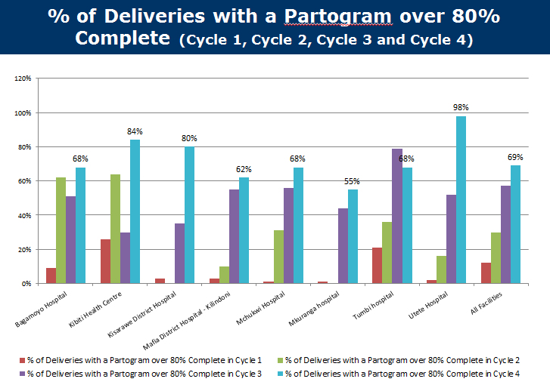

The following chart shows a time series of the performance on quantitative indicators for the entire region. While the overall trend is positive, uniform increases are not seen. As expected, performance flattens out as it approaches full population coverage. It should be noted that some targets reached over 100%, mostly driven by performance of the regional hospital that draws populations from beyond the Pwani region which results in a numerator that is larger than the denominator. The PMTCT indicator shows a downward trend due to the continuous shortage of reagents for HIV testing, which has made it difficult or impossible to reach this target. Annex 3 presents performance for each indicator by council and aggregated for the Pwani region.
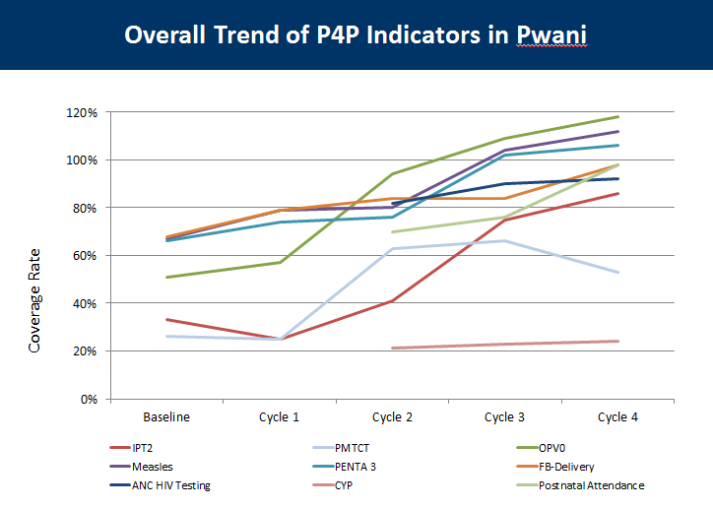
The assessment described in section 5 of this report is intended to provide a picture of how the participants in the Pwani P4P pilot understand P4P, their experience with strengths and challenges, and their recommendations to inform strengthening of the national P4P program. Detailed results from the Ifakara impact evaluation will be available in late 2013.
PSI’s P4P for tracking and managing stocks
In October 2012, PSI introduced a P4P scheme in Morogoro and Dodoma that aims to improve availability of private sector outlets by rewarding wholesalers, pharmacies and ADDOs with mobile phone minutes for reporting on stocks by SMS. This initiative provides lessons that may be applied to improving the availability of medicines and supplies. Annex 1 provides more details.
Future P4P Initiatives
At the time of writing this report, several P4P initiatives are under discussion. One initiative under the East Africa Public Health Laboratory Network Project (EAPHLNP) aims to strengthen the performance of Tanzania’s laboratory system. In another initiative, the GFATM may provide performance payments to national ministry level leaders. Also, the Elizabeth Glazer Pediatric Aids Foundation is exploring whether it would be possible to incorporate HIV/AIDS indicators into a P4P initiative and to utilize PEPFAR funds to strengthen the system to implement P4P. While each of these initiatives hold promise, it will be essential to consider how they interact with and potentially enhance the performance of the national model. A harmonized approach led by the MOHSW would be the most effective way forward if at all possible.

Methodology of the Assessment

Reviewed P4P schemes in Tanzania and selected countries with potential lessons to inform the Tanzania model.
To help Tanzania make the many decisions needed to phase in an enhanced P4P approach, the assessment team examined features of both P4P initiatives within Tanzania and selected global experiences. To enable comparisons across multiple initiatives, we developed a matrix of key categories that describe the many attributes of P4P schemes (see Annex 1). Implementers of health P4P schemes known to have been implemented in Tanzania were identified through consultations with the Ministry of Health, the National P4P Task Force, and by participants at a P4P Stakeholders Meeting that was held in Dar es Salaam in January 2013. Contact people were emailed and asked to complete the matrix of information in Annex 1 and respondents were followed up with phone conversations. The assessment team used field visits in April 2013 to address the remaining gaps. Annex 1 presents the responses received to requests to complete this matrix.
In addition, 8 countries (Argentina, Burundi, Egypt, India, Kenya, Rwanda, Turkey and Zambia) were identified as having P4P initiatives with the potential to provide lessons for Tanzania. This list of countries was decided jointly with Norway, the World Bank and USAID. A World Bank consultant was contracted to complete the same information as presented in the matrix in Annex 1 for each country experience. Annex 2 presents these findings.

Developed structured interview instruments
To achieve the first objective of the assessment, we developed two sets of structured interview instruments to guide discussions. The first set was used in interviews with key participants in various P4P initiatives within Tanzania and the second set was used to guide discussions with potential Tanzanian entities anticipated to either currently have the capacity or the potential to develop the capacity to assume the functions required to implement a P4P initiative at full national scale.
In advance of field work, structured questionnaires were prepared to guide interviews with key informants at the RHMT, CHMT, health facility, and Health Facility Governing Committee (HFGC) levels that were designed to assess:
- Respondents’ understanding of P4P
- How respondents learned about P4P
- Perception of the strengths of the P4P system respondents operate within
- Respondents’ assessment of how the P4P system they operate within is currently working
- Respondents’ opinions on the potential as well as actual strengths of P4P
- Challenges and implementation difficulties that were experienced
- Recommendations for phasing in an enhanced national P4P model nationwide
Draft interview instruments were shared with the field assessment team and donor representatives from USAID, Norway and the World Bank in advance of field work for comments and were revised accordingly.
To assess current or potential capacity to assume implementation functions, a structured instrument was developed to guide exploration of institutional capacity to assume functions such as establishing indicators and targets, training, external verification, and funds transfer. The categories that were explored mirror the categories featured in the Matrix used to describe the features of Tanzanian and international experiences with P4P in the health sector. We took the opportunity to visit regional entities such as Zonal Health Resource Centers and regional offices of the National Health Insurance Fund located in the same regions as the visited P4P initiatives.
The interview instruments are attached in Annex 4.

Team composition, where we went, and who was interviewed
The assessment team was divided into two teams to carry out the in-country assessment from April 9 to April 19, 2013. Team A consisted of Dr. Rosina Lipyoga, Pwani P4P pilot coodinator MOHSW; Dr. Emmanuel Malangalila, Broad Branch Associates consultant funded by USAID; and Dr. Nancy Pielemeier, World Bank consultant. Team B consisted of Dr. Fatuma Mganga, Assistant Pwani P4P pilot coodinator MOHSW; Mr. Eliurd Mwaiteleke, Monitoring and Evaluation Officer, PMO-RALG; Dr. Rena Eichler, President, Broad Branch Associates funded by USAID; and Mr. Ibadat Dhillon, Economic Advisor, DANIDA. Mr. Dominic Haazen, Lead Health Policy Specialist with the World Bank, was due to join the in-country assessment in April, but had to cancel his participation. He was involved in the planning and subsequent analysis and joined Rena Eichler in the follow up visit in July 2013.
The teams collectively visited 6 councils, of which 2 are in the Pwani pilot region (Rufiji and Bagamoyo), and 4 are outside the Pwani region (Same, Iringa Municipal, Iringa Rural, and Mvomero) . The teams met with the Regional Health Management Teams and Council Health Management teams; hospital, health centre and dispensary staff, and facility governing committees in the 8 councils to obtain information about stakeholders’ views of the actual or potential benefit of P4P schemes. In addition, the assessment teams met with a dozen types of possible support organizations in the regions visited to determine potential to take on a variety of functions required to support the P4P scale-up. The teams conducted a total of over 30 interviews with more than 200 health sector personnel during the 2-week period. (See Annex 4 for the schedule of field visits and Annex 5 for a list of groups and individuals interviewed.)
Non-Pwani councils selected for visits included 3 councils in the central-south and 3 in the north. All of these councils had been exposed to the national P4P program, and several had successfully implemented some aspects of the program. While not randomly selected or representative of the country as a whole, these councils provided the team with a good understanding of the national program. The councils selected for visits in the Pwani region included one of the early higher performing councils and one of the initially lower performing councils. This selection also served to provide the team with a good overview of the Pwani experience, which was supplemented by review of the routine monitoring data provided by the Pilot Management Team (PMT). As noted, the full evaluation of the Pwani experience was being conducted concurrently with the assessment, so the results were not available to the assessment team.
It should be noted that a full capacity assessment of potential support organizations was not possible within the limited time available to the assessment team; however, the team was able to meet with representatives of 16 actual or potential support organizations. In addition, in meeting with 3 RHMTs and 6 CHMTs, the team was able to get a general feel for their ability to manage various required functions. Additional in-depth capacity assessments of each support organization will be required at the design and implementation stage in any anticipated scale up of the program. Following the field visits, the assessment team spent 2 days doing a preliminary analysis of information collected, summarizing the findings, and preparing a preliminary report to present to the P4P Task Force and the Health Financing Task Force. The preliminary report was presented as a PowerPoint presentation (attached as Annex 6) to the Health Financing Task Force on April 19, 2013.

Findings from review of experiences with P4P in Tanzania
The assessment team reviewed the qualitative responses received in interviews and tallied the frequency of responses to the questions in each category (see Annex 8). We present the responses from those who are participating in the Pwani pilot in a separate column from the responses from non-Pwani areas. In all cases, the tallies should be viewed as representing the response from a team (RHMT, CHMT, facility, HFGC) rather than individuals. In some cases, one response may reflect a discussion that was held with more than fifteen people and all responses reflect discussions with more than five. Readers should consider all the answers in this section as part of an integrated whole. In many interviews, it did not make sense to revert back to a question that had already been answered as part of a different part of the guided interview process. For example, the counter to a challenge is the suggestion for how to strengthen P4P. We were careful not to impose unnecessarily on facility and management teams.

The National P4P Program established a strong foundation
The initiation of P4P as a national program in 2008/2009 established a strong foundation of understanding and interest in P4P nationwide. While respondents from the Pwani region who had experience in the P4P pilot had a deeper understanding than those from other regions, the assessment team was impressed by the level of understanding of the purpose and potential benefits of P4P in all regions and among most respondents. The one exception was interviewed members of Health Facility Governing Committees who had limited or no understanding in both Pwani and non-Pwani facilities. This is clearly an area which would need to be addressed in any scale-up process.
As described above, the Government of Tanzania developed a National P4P Strategy in 2008/2009. This approach was incorporated into the guidance provided to Councils that specifies how to present Council Comprehensive Health Plans (CCHPs), and this structure continues through the present period. Every council in Tanzania presents their CCHP with a budgeted line item specified as “P4P” and reports performance on the five indicators specified in the national scheme. We found that in most councils performance payments were not realized in accordance with the vision of the national P4P program because of challenges with funding. However, we did interview respondents from two councils that were able to pay performance bonuses by using innovative approaches to attract funding and to program existing resources. Iringa Rural succeeded in attracted funding from an Italian NGO called QUAMM that provided performance payments for dispensaries and health centers but not hospitals or CHMTs. Mvomero, a new council created out of the former Morogoro council, succeeded in using “OC” funds to pay performance bonuses.

National understanding of both the health system strengthening and health objectives of P4P is good and even better in Pwani
People interviewed in both Pwani and non-Pwani provided detailed and insightful responses to the question, “Please describe in your own words the purpose of P4P”. The health system strengthening objectives as well as the health impact objectives were recognized by both groups of interviewees but, as expected, understanding was deeper among Pwani respondents with more direct experience. Respondents from Health Facility Governing Committees shared that they did not understand the purposes of P4P.
Respondents in both Pwani and non-Pwani entities shared that the purpose of P4P was to meet the 4th and 5th MDGs and/or to achieve RCH goals and to improve the quality of care.
In addition to health objectives, a number of health system strengthening objectives were described by respondents in both Pwani and non-Pwani interviews. At the level of the health work force, P4P was seen as a means to motivate health workers, empower staff and retain staff. Strengthening the quality of health information and its use was mentioned by Pwani respondents with improving data timeliness and data quality as P4P purposes. Using P4P to catalyze facilities to perform their routine activities was also mentioned and the benefits of the 25% of the earned bonus that can be used to invest in facility improvements led one Pwani respondent to mention improving facilities as an objective. Strengthening supervision was mentioned by one non-Pwani interviewed entity as an additional health system strengthening goal.

Non-Pwani respondents learned about P4P through CCHP guidelines and some direct training and Pwani respondents were trained alongside HMIS training
Pwani respondents could describe a clear progression of the training process that began with an orientation for Leaders and Council Directors, followed by training of the RHMT and CHMTs on the concept of P4P and how it functions. Following this, health workers from each facility (2 per dispensary, 5 per health center, and 10 per hospital) were invited to an HMIS training that included an add-on day for P4P. This training was conducted by the MOHSW and by CHAI. The intention was that the 2 trained facility staff would train the other facility workers on both HMIS and P4P. The tight linkage between the two types of training led to some initial confusion and the training for these two areas should be clearly separated for any future scale-up. The current timetable for the roll-out of the HMIS suggests that this will not be an issue moving forward.
Some non-Pwani respondents recalled learning about P4P from their CHMT. Others mentioned learning about it during HMIS training. Others mentioned that they received a letter in 2009 from either the MOHSW or PMO-RALG, they couldn’t precisely recall which, that instructed them to allocate money for P4P in their CCHP. They shared that they remember being later instructed to reallocate this money for medicines. One non-Pwani respondent shared that they learned about P4P through the CCHP Guidelines. The Health Facility Governing Committee members in the non-Pwani areas were not trained on P4P.

Respondents shared that P4P is motivating staff, strengthening the health information system, improving accountability, and increasing efficiency.
Because answers to questions about the strengths of the current P4P system and about how the current P4P system is working overlapped considerably, responses were combined under the category, “How is P4P working?” As expected, the majority of the feedback we received was from Pwani participants, as they have direct experience with P4P. The few responses presented from non-Pwani areas are from Iringa Rural where bonuses are funded by QUAMM and Mvomero where performance bonuses have been paid using OC funds programd in the Council’s CCHP. Eight entities that were interviewed determined that these questions were not applicable because P4P was not currently working. In addition, the Health Facility Governing Committees that were interviewed in the Pwani region reported that they were not informed about how P4P was working.
All of the responses focused on how P4P strengthened the health system. Staff report that they are more motivated and appreciate the bonuses and health workers monitor their own performance. Facilities are more proactive at solving challenges including improving the availability of medicines. Supervision is more strategic as the RHMT is providing targeted support to underperforming facilities. Distribution of staff has improved as the RHMT is experiencing requests from staff to be transferred to remote areas, likely because of the potential to earn a higher proportion of the facility bonus, and health worker retention has improved. The health management information system is strengthened as data is recorded and reported on time by facilities and collected by CHMTs each month. Accountability has improved at multiple levels. An overall benefit is an increase in efficiency which respondents attribute to the fact that if results aren’t achieved the money doesn’t follow.

Strengths of P4P reported to include: more motivated and accountable health workers, better team work, improved service delivery, better quality, strengthened supervision, improved HMIS, innovations to increase demand, and reduced maternal and child mortality
Respondents from non-Pwani regions were able to reflect on the potential as well as actual strengths of P4P and their opinions were consistent with responses from the more experience-based reflections of Pwani respondents. Respondents from both groups reported that health workers would be/were more motivated and the allocation and retention of health workers would be/was improved. Respondents from both the Pwani and non-Pwani regions discussed that P4P improves service delivery.
Pwani respondents also added that health workers had more job satisfaction and were more committed to quality. One example of this increased commitment to quality was described as better use of partographs to identify emergencies during labor and delivery. Pwani respondents also discussed the benefits of being able to use the 25% of the earned facility bonus to purchase medicines and supplies that were not delivered by the MSD. Stock outs were reported as a problem by many respondents and the opportunity afforded by P4P to solve gaps was appreciated. Pwani respondents also discussed other innovations that served to enhance demand such as providing small presents to traditional birth attendants for referring pregnant women, providing small presents to pregnant women when they accessed care, and purchasing and installing solar panels to improve lighting in delivery rooms. One council reported that enrollment in the CHF had increased and that P4P may have contributed to this.

Challenges were caused both by weaknesses in the health system and by how P4P was introduced and implemented
While P4P can contribute to strengthening aspects of the health system, it is also introduced within the context of the existing system with all its challenges. In response to questions about challenges and implementation difficulties, respondents shared a number of challenges that came from the broader system such as late budget disbursements and availability of medicines, as well as direct challenges that came from the way P4P was introduced and supported such as the P4P training process.
The Tanzanian health system is confronting a number of challenges that interact with the way P4P is implemented. These challenges are present whether or not P4P is being used. The performance of P4P is affected by and may also contribute to strengthening these weak elements. For example, the public medicine and supplies system managed by MSD was reported to result in shortages of sulfadoxine/pyrimethamine (S/P) and reagents. One dispensary in Pwani reported a broken refrigerator that they were not able to get repaired or replaced for six months making it challenging to store vaccines and, therefore, to achieve immunization coverage targets. The unreliable availability of medicines and supplies, as well as management support to health facilities, are challenges that the government is addressing by creating a multi-year master plan. In the meantime, P4P can supplement the supply system by providing incentives for facility staff to pressure CHMTs and RHMTs to address stock gaps, and by providing liquid cash through performance payments to purchase small amounts of medicines to assure availability when the MSD doesn’t have sufficient stocks, as we have observed in Pwani.
At the health system level where challenges are present regardless of P4P, respondents discussed shortages of skilled RCH staff as a bottleneck, though others mentioned that they have observed strong performance by medical attendants when they have been guided by supervisors. Regular supervision is a challenge in some hard-to-reach facilities and late budget disbursements to the council makes it hard to buy the fuel needed to travel for supervisory visits. However, one DMO in Pwani was motivated to raise needed funds to carry out supervision visits because of P4P and this was viewed as a P4P success.
Non-Pwani respondents shared that unreliable funding makes it challenging to pay performance payments under the national program. Many respondents mentioned the need to access OC and basket funds to support P4P, while fewer respondents recognized the possibility of accessing CHF and NHIF as financing sources.
While the health management information system has been strengthened and most respondents have been trained (with remaining training planned), they shared frustration about unreliable availability of HMIS tools. Another HMIS issue noted in Pwani is the design of current tools (especially the tally sheets), which do not provide adequate space to record the higher volume of visits achieved in the course of pilot implementation.
Training on the P4P system in Pwani was not fully effective and was described as excessively focused on data management and reporting. Respondents suggest that this confusion may have been partly caused by the fact that the P4P training was added on to the training designed to introduce the new HMIS system. The result, however, is that some Pwani respondents understand P4P to be about reporting on performance on specific indicators, although they did not all understand the relationship between the indicators and the payments being made. Some of the gaps in health worker understanding of the relationship between indicator achievement and payments is likely due to the problem of providing training to only a few health workers per facility (those in leadership positions), and their failure to fully communicate to their subordinates. Respondents from both Pwani and non Pwani regions suggest that the training could have emphasized strategies to achieve the results.
Before beginning P4P, Pwani respondents recommend that each facility should open a bank account. The reason for this was that performance payments earned by facilities without bank accounts were transferred to the council budget and these facilities have not ever received their performance payments.
Some respondents believed that there is too much emphasis on data and on data verification and that this is time consuming and, in some cases, transforms supervision visits into (sometimes authoritarian) data checking visits, rather than using the data as an opportunity to carry out supportive supervision. Some complained that the P4P score card is not displayed in a public place.
In Pwani, one facility complained that there is no process to dispute scores. In another Pwani facility, the RCH staff were concerned that they worked hard to achieve the RCH targets and that bonuses go to everyone and they were not involved in deciding how the 25% of the performance payment dedicated to facility improvements would be spent.
Health Facility Governing Committees in Pwani complained that they have been asked to sign off on expenditures using the 25% facility performance bonus without understanding how P4P worked. One HFGC would like to be compensated with P4P funds. They complained that the in-charge in one facility had not been responsive to their requests to meet with the staff. Training for HFGCs was not effective as it relied on the Committee chair to brief other members and this did not appear to be happening.
In non-Pwani areas, comments about challenges were that some of the performance targets were unrealistic and that paying performance bonuses to some and not others could potentially be demoralizing.

Respondents recommend phase in of a robust P4P model informed by the Pwani experience that considers revisions to the training process and model details. Respondents also shared suggestions for national implementation arrangements and options for financial sustainability
After determining what respondents understood, and how they had experienced P4P, a large amount of the time was spent focusing on recommendations for scale up. Recommendations focused on implementation arrangements, training and sensitization, funding and sustainability, details of the model, and elements of the health system that need strengthening.
Respondents recommended that a phased in model that draws on the experience in Pwani should be implemented through the national health system structure, with roles for the National Ministry of Health and Social Welfare (MOHSW), the Zonal Health Resource Centres (ZHRCs), the RHMTs and the CHMTs. By using these existing health system structures, they would themselves be strengthened in the process. At the national level, enhanced collaboration between the M&E Department of the MOHSW and the DHIS was recommended by the RHMT in Bagamoyo. At the zonal level, the ZHRC was recommended to assist in the verification of data. Roles for the RHMT and CHMT are recommended to continue as in Pwani with enhanced engagement with PMO-RALG. The P4P national guidelines and the CCHP guidelines will need to be revised to provide guidance on how to plan for and budget P4P in the revised P4P national approach. A phased implementation approach was also recommended, rather than a “big bang” national scale-up within a short timeframe.
Training and sensitization was recommended to be extended to a wide group of stakeholders and to be more focused on how to achieve performance results as a complement to the current training that focuses on data management and reporting. More advocacy and sensitization was recommended with Leaders and the DED and more active engagement was recommended with PMO-RALG. One facility, together with members of their HFGC, suggested that health workers and HFGC members be trained together. Another suggestion was to engage Pwani RMT members to train other regions to become trainers. One intriguing suggestion was to include CHMT participation in the selection of indicators targets; while some respondents recommended removal of the CHMT indicator that is tied to the performance of the facilities they support. There were a few suggestions about revising the potential funding that a facility could earn that included doubling the dispensary payment and basing the incentive funding envelope on the number of health workers in a facility. These suggestions were made by dispensaries that were operating like health centers but had not had their category revised. There were suggestions to also consider non-financial recognition as part of the model.
Respondents recommended revisiting the way bonuses are allocated among facility staff. Some expressed that it was not fair for the RCH staff to work hard to earn the facility bonus that is then shared with staff who may not even be present at the facility much of the time. A process to develop guidelines that represent staff beliefs about fairness and equity was recommended in interviews.
As described in the previous section, there is a need to strengthen the system that supplies medicines and supplies, assure reliable supply of HMIS register books and tally sheets, and provide reliable resources to enable purchase of fuel for supportive supervision.

Assessment of Institutional potential to support, assess and revise, and administer P4P
In April, 2013 the assessment team met with the following organizations to assess potential to carry out support functions needed to administer a scaled up enhanced P4P program:
- Zonal Health Resource Centres: CEDHA/Arusha, PHCI/Iringa, ZHRC/Morogoro
- KCMC/Moshi
- National Health Insurance Fund offices: NHIF/Arusha, NHIF/Iringa, NHIF/Dar es Salaam (visits attempted but requests denied)
- Langhe Consultants/Dar
- National Microfinance Bank (NMB)/Dar
- PO-PSM/Dar
- Wajibika Project/Dar
- Twaweza Project/Dar
- MOHSW HMIS Directorate
- MOHSW P4P leadership
- PMO-RALG/Dar and various Council representatives
- CHMTs in 8 councils
- RHMT in Pwani and Arusha
- CHAI
In July, 2013, the team met with the NHIF in Dar es Salaam and with a team at the Eastern ZHRC that had implemented the approach to verification that was discussed during the April assessment process. We include these results as part of the assessment.
Some of the institutions were selected so the team could learn from their experience in implementing similar programs. These included Langhe (experience with external verification); Wajibika (experience with training and mentoring of council councils); CHAI (experiencing supporting implementation of the pilot in Pwani), KCMC (experience with training for the Cordaid project), and Twaweza (experience piloting a P4P pilot in the education sector).
The remaining institutions were selected because they stand out as the most likely of the limited number of institutions possessing recognized ability to carry out one or more of the known functions required to support P4P. In addition, the institutions were purposively selected because they are (mainly) permanent institutions within the Tanzanian government structure which would therefore have the greatest possibility of providing institutional sustainability for a scaled up P4P program. The assessment team did not have time to do a full capacity assessment of each institution, but rather it confirmed (or not) the willingness and ability of the institutions to undertake various functions, assuming further capacity building would be needed in order to do so.
The team identified the following support functions: training, indicator selection, target setting, setting payment rules, contract development, contract management, database management, monitoring and evaluation, internal verification, external verification, payment authorization, making payment. The organizations identified are displayed against their potential functions below in Table 5. An “x” indicates those function(s) the institution is suited for and would be able to carry out with appropriate orientation and capacity development, while a “?” indicates that further analysis is needed to determine if the institution is suitable or not. The narrative following the table highlights the key findings in each of the support function areas.

Table 5: Institutional Capability

Training Function: As noted by many stakeholders, training is a key element for the optimal functioning of the P4P program, and training processes and approaches need to be standardized and strengthened. The many participants in the P4P initiative need to be clear about the things for which they will be held accountable, they need to understand their responsibilities, and they need to be stimulated to develop strategies to achieve improved performance. The approach used by KCMC to develop “entrepreneurial skills” in their training for CSSC could be considered for adaptation as part of the overall training plan.
A logical choice for undertaking this function is the existing network of zonal health resource centers (ZHRC). These centers possess an understanding of the structure of health sector and are familiar with individuals and groups of health workers and administrators in their areas; and those interviewed expressed eagerness to participate in scaling up P4P. The centers vary widely in terms of existing capability – staffing, leadership, and infrastructure – but all of those interviewed during this assessment appear to be willing to take on the new challenge of training for P4P, while recognizing fully their own need for capacity building in the subject area. The ZHRCs also offered their expertise in curriculum design but acknowledged that due to limited knowledge of P4P, they would require additional expertise in design of training packages and approaches, and in the initial stages of training.
The assessment team was impressed with the enhanced training model employed by the Wajibika project, which has demonstrated the value of enhancing training with a period of intensive on-site mentoring of selected council staff to ensure understanding of health sector-specific issues and to develop council capacity to plan and budget adequately for health sector priorities within the CCHP. This project has also created a cadre of skilled mentors which might be utilized in a scale-up process. Since P4P has not yet received priority in the council budgeting, monitoring and planning process, it appears that more intensive orientation and training would be needed to elevate the priority of P4P within councils.
Design/redesign of the model: The assessment team recognized critical role of the MOHSW in P4P as technical standard-setter, and confirmed that the P4P unit in the MOHSW has a small but active team that plays this role. This team possesses the technical understanding of epidemiological trends and priorities required, for example, to select indicators, and to adjust these indicators over time. The team understands service delivery norms and standards that are required to set ambitious but realistic targets and payment rules. In addition, this team has the understanding and experience to solicit input from health workers in the field, and based on consultation and field realities, to formulate central guidance needed to ensure that contracts developed at various levels of the system follow good standards and practices. In the early stages of any scale-up, additional assistance and resources would be needed to augment the capability of the P4P unit and to build its capacity, but over the longer term this unit could play a key role in the ongoing development and implementation of the model.
Contract Management: In the current pilot, the performance agreement template was designed by P4P stakeholders at the initiation of the P4P Pwani Pilot. Any changes to the design of the performance agreement need to be proposed to and accepted by the pilot Steering Committee. It is the assessment team’s understanding that performance agreements at the facility level are agreed and signed by the HFGCs with the CHMT. All facilities enter into agreements with their respective CHMTs. For the CHMT, the performance agreement is signed with the Council/District Executive Director (DED). For the RHMT, the performance agreement is signed with the Regional Administrative Secretary (RAS).
The key role of Health Information: All agree that a functioning health information system is a critical element for administering the P4P program, and it is equally clear that the P4P program provides good impetus for health sector actors to comply with data reporting requirements.
In this regard, it is interesting to note that Pwani has gone from one of the worst regions in terms of timeliness and completeness of HMIS data submission to one of the best. Data completeness has increased from 42% in 2011 to 89% in 2012; timeliness has improved from 46% in payment cycle 3 to 92% in cycle 4; and accuracy has also improved.
While the HMIS system (known as MUTUHA) is not completely rolled out, plans are in place through the Monitoring and Evaluation Strengthening Initiative (MESI) to complete training on the DHIS software in all regions by July 2013. Stakeholders understand that the HMIS must be functioning in order to scale up the P4P program, but it is also recognized that P4P implementation may be a key to obtaining full compliance with data reporting, as has been demonstrated in the Pwani pilot. The DHIS appears to be functioning at a level that can support gradual phase-in of additional regions as the program scales up.
Verification: In Pwani the internal verification is performed by the CHMTs and RHMTs in conjunction with routine supervision before data are approved. These management teams are expected to routinely validate over 80% of facilities per 6-month cycle. In the pilot, the Pilot Management Team performs spot checks, focusing on those with sharp changes from previous cycles. Facility staff and managers noted that in some cases the verification/supervision process was poorly executed (done in more of a punitive way than in a supportive manner), pointing to the need for better orientation and training of staff involved. Nevertheless, the basic design of the Pwani pilot internal verification system, relying on the existing CHMT and RHMT structure, appeared sound to the assessment team. It also appears that the HMIS system has the capability to serve the function of flagging outliers that require additional investigation/verification.
In the pilot, external verification was done initially by an independent verifier (contracted consulting firm, Laghe) which conducted random facility checks to assess data accuracy and conducted community level verification. The independent verifier was expected to visit at least 25% of the facilities in each council where the P4P pilot is being implemented. This system was not cost-effective or sustainable and would need to be revised for scale-up. The ZHRCs appear to be positioned to absorb the external verification process in the future. These centers are independent of the local government system and therefore would not have any institutional conflict of interest. In addition, the ZHRCs have the basic infrastructure to reach the facilities in their zones (through permanent or contracted staff) to carry out this process. The assessment team was sensitive to the difficulty of developing a strong and independent verification system and therefore the need for thorough orientation and capacity development of the ZHRCs or any other verification institutions selected in the eventual national scale up.
In late April and early May the Eastern ZHRC based in Morogoro performed an external verification of Cycles 3 and 4 in Pwani to assess whether this approach was both feasible and cost effective. They verified the reported results for all hospitals and randomly selected sample of 15% of dispensaries and health centers. The process took 2 weeks and the team was comprised of people affiliated with the ZHRC. The only additional costs associated with the verification were per diems and travel expenses. The approach was to compare data on tally sheets and registers to what was reported in the DHIS, to follow up on a small sample of children and mothers to detect ghost patients, and to review management of facility bank accounts. The costs were roughly US$15,000 for covering the entire region, which would make it very cost-effective if this approach can be used during the scale-up. Findings reported by the ZHRC were that there were some discrepancies between data in facility records and what was reporting in the DHIS, but that these discrepancies appeared to be caused by human error rather than intentional falsification of data, For example, the team found that all mothers and children interviewed received the services that were reported by facilities. Performance payments in facility bank accounts were correctly managed: government procurement practices were followed, receipts were in the records, and minutes of how the funds were allocated were on site.

The Assessment team learned in July 2013 that the NHIF is potentially interested in assuming the verification function and could be considered as an alternative to the ZHRC. They would be interested in piloting verification in a subset of Pwani districts to learn about the capacity that would be needed to performance this function nationally. They stressed that they would need to be compensated for the staff and travel costs. There are advantages and disadvantages to considering NHIF to conduct verification.
  - Advantages: NHIF has an office in every region in the country. They already need to verify claims for NHIF payment and verifying P4P results could help strengthen their claims management processes. Since virtually all facilities are NHIF accredited, facilities that would receive P4P payments would also be receiving payments from the NHIF, suggesting potential synergies. In addition, one recommendation of the assessment process is to consider changing the P4P payment approach for hospitals. One option is to adjust NHIF payments to hospitals to be conditional on overall hospital quality as measured by a tool that generates a score as well as quantity of key services. This could introduce performance incentives to improve quality into the payment mechanisms used by the NHIF in contrast to the current fee-for-service system that provides incentives to over provide and over prescribe. It could provide complementary funding to the P4P performance payments and could align incentives from payment from multiple sources.

  - Disadvantages: Based on the limited discussion during the assessment mission, it does not appear that the current NHIF claims management system and processes are robust enough to either fully adjudicate claims or deter and detect fraud. We learned that it is difficult for the claims management team to identify when there is a mismatch between diagnosis and treatments and they observe that unnecessary drugs and tests are often provided. In addition, we learned that it is not uncommon for doctors in public facilities to own private pharmacies located near the public facility and since it is a fee for service system they gain by prescribing multiple drugs. When the claims management team recalls that the invoice from a provider was significantly lower in a previous period, they will request additional checks by the medical officer. However, this process is driven by the memory and skill of the person entering the claims into the system; the system does not contain automated flags that trigger follow up on potential false claims.

The Assessment team recommends that the NHIF be invited to pilot performance verification in a subset of Pwani districts in the coming cycles to enable both them and the PMT to understand what is involved and to provide the costs of assuming this function. The Assessment team recommends that the cost effectiveness of the NHIF as external verifier be compared with the cost effectiveness of the ZHRC as verifier prior to making a final decision on this issue.

Payment: In the Pwani pilot, payment to facilities is authorized by the PMT, and payments are made by the National Health Insurance Fund. The NHIF people did not meet with the assessment team to discuss their current and potential role in P4P due to communication problems. In addition, given the 10% fee charged by the NHIF, another financial institution, the National Microfinance Bank (NMB) was identified as a potential payment agent. Since the NMB has an existing agreement to manage payment of salaries to all government employees, it may be possible to arrange payment of P4P bonuses to facilities (or directly to individuals to their bank accounts to which their salaries are already paid) for a small fee.
The Assessment Team recommends that the NMB be tried to transfer payments in a subset of Pwani districts and that the costs and performance be compared with the costs and performance of the NHIF.

Assessment team conclusions
The assessment team was struck by the general consensus throughout the people interviewed across the country regarding the actual and/or potential power of P4P to strengthen health services and the health system. Stakeholders recognized the power of this approach to improve the delivery of both the quantity and quality of services due to increased health worker motivation, enhanced teamwork, and strengthened supervision. They also identified the strong link between P4P and improved data reporting and use, improved availability of drugs and equipment (by using some of the facility level bonuses to purchase drugs), and the increased involvement of the community through the involvement of the HFGCs. In sum, stakeholders implicitly recognized that this financing intervention essentially served the function of strengthening each of the other building blocks of the health system.
The assessment team recommends phased Scale up of P4P in Tanzania. What follows are recommended refinements to the P4P model, national implementation arrangements, and financing and payment flows. (The team also noted that the P4P scale up should be linked to the broader government pay and incentives reform process and was pleased with the receptivity of the President’s Office Public Service Management team to the MOHSW’s desire to coordinate on health worker incentives.)
Linkages between P4P and other Health Financing Strategy priorities
During the time of this assessment, the Government of Tanzania had commissioned a series of papers to contribute to informing a national Health Financing Strategy. This assessment report is serving multiple purposes; one of which is to serve as the financing paper on P4P to contribute to development of this national strategy. The development of a national Health Financing Strategy is extremely valuable as it provides a compass that points the way forward with short, medium and long term goals. It won’t be practical to wait for all the elements to be in place before taking decisions to move forward and elements will be refined and strengthened as they are implemented. This P4P strategy has been in place since 2009 and the purpose of the pilot in Pwani and this assessment process is to inform how to strengthen and enhance its impact. P4P has the potential to reinforce and complement the goals of the national health financing strategy and its elements but there is no need to wait for all the elements to be in place before moving forward with P4P.
The following matrix shows the linkages between the health financing priorities and P4P. By rewarding priorities that are specified in the minimum benefits package, P4P can contribute to realizing the goal of ensuring that all Tanzanians have access to these essential services. By incorporating elements of P4P into the mechanisms used by the NHIF to pay providers, the NHIF can be strengthened, hospitals can be incentivized to improve quality and access, and private insurers will be stimulated to adopt similar payment mechanisms. Demonstrating more responsiveness to the population and enhanced service availability through P4P may encourage more households to make CHF contributions. As facilities, councils and regions achieve higher population coverage targets, more of the most vulnerable and hardest to reach segments of the population will be served. P4P rewards both public and private providers and provides incentives, through rewards for council and region wide targets, to enter into service agreements with private providers. Another PPP opportunity is to enter into regional vendor contracts to provide drugs when the MSD cannot meet demand. There is an important opportunity to incorporate a P4P element into the resource allocation formula that can provide incentives for councils to achieve performance targets in health and other sectors such as education. Providing funding for the P4P line item in council budgets will strengthen financial management by making this budget item “real” and by enhancing transparency and accountability for these funds through the links to verified performance. As P4P contributes to strengthening the health system fiscal space may increase if more households contribute to the CHF and the NHIF incorporates P4P into the way it reimburses hospitals.
Table 6: Potential Linkages between Health Financing Strategy and P4P
Health Financing Strategy Elements | P4P
Minimum Benefits Package | P4P can support the goal of enabling access to a minimum package of high priority health interventions. By rewarding attainment of population coverage targets through P4P, facilities and their supervisors will be motivated to devote effort to solving constraints such as stock outs and reaching more of the population.
Insurance Market | P4P can interact with the public and emerging private insurance market in the following ways:  - The NHIF can establish a reference tariff reimbursement structure that incorporates P4P and could be adopted/adapted by private insurers.  - Refinements to the hospital P4P payment design will likely be focused on enhancing quality in hospital wide areas such as infection prevention as well as rewarding specific outputs that many broaden beyond maternal and child health. The NHIF could use its purchasing power to condition payment to hospitals on how they perform on a score card that measures structural, process and output aspects of quality. For example, the NHIF could pay the base tariff plus x% for a hospital that scores above some threshold on a quality tool. This would serve as an incentive for hospitals to improve quality, would help the NHIF become a more strategic purchaser, and would contribute to the sustainability of P4P.
CHF Options | Collection of CHF contributions has been a challenge for a number of reasons. One reason is that the population has not always perceived the direct benefits of their contributions. Since contributing is voluntary, families that don’t perceive an immediate need are less likely to contribute than families that know they will have high user fee costs. Another challenge is that the costs of collecting contributions from community members are relatively high. It is possible that as P4P strengthens accountability to the population, it may strengthen the willingness of families to contribute and reduce the administration costs of collecting CHF contributions. For example, if P4P improves the availability of essential medicines so that families know that they will receive drugs as part of their consultation, they may be more willing to pay the CHF contribution.
Inclusion of Poor  and Vulnerable | P4P rewards facilities and their supervisors for covering a higher proportion of the catchment population each cycle. As the targets move higher, incentives are to reach the hardest to reach. Preliminary evidence from the Impact Evaluation shows that P4P has reduced out of pocket payments for deliveries which contributes to reducing financial barriers to accessing care. Since facilities are rewarded for achieving population coverage targets, they are likely to respect the policy of not imposing user fees for MCH services. The incentive to achieve the targets is expected to motivate health workers to be more responsive to the population.
PPP | P4P rewards all facilities in districts that meet the criteria established by the MOHSW for delivering the rewarded services, public and private. Since CHMTs and RHMTs are rewarded for achieving population coverage targets in the entire council or region, respectively, they have strong incentives to enter into service agreements and to support and enable private as well as public facilities to perform. The incentive to improve reliable availability of essential commodities by rewarding no stock outs of essential medicines would be expected to stimulate regions and councils to enter into agreements with private vendors who can provide essential medicines at competitive prices to address periods when the MSD is out of stock. Assistance may be needed to help structure the contracts and procurement of these contracts to facilitate a PPP with private vendors.
Allocation Formula / Equity | The allocation formula that determines how national funds are allocated to councils could be adapted to provide incentives to councils to achieve performance targets. By establishing clear goals and metrics of performance and holding councils accountable for achieving these goals, there is potential for higher transparency and accountability which could contribute to stronger results in health and in other sectors including education. Verified results at the facility and council levels (as well as regional level) provide the information needed for the national government to use to condition transfers partially based on performance. This could complement other revisions to the allocation formula that adjust for population characteristics of councils.
Public Finance Management | Since 2008/2009 councils have been budgeting for a P4P line item in their CCHPs. However, since funding never materialized the majority of councils were not able to spend against this line item or provide performance bonuses. If these funds are available and used to pay for performance, transparency and accountability will be enhanced.
Fiscal Space | By demonstrating to the population that they receive value for their CHF contributions, P4P may increase the numbers of families who choose to voluntarily contribute. By transforming the way the NHIF pays hospitals to be based on performance, NHIF funds can complement the direct P4P funds with additional resources to incentivize hospitals to improve both quality and access to live saving services.

Refinements to the P4P model
Based on a combination of what the assessment team learned through interviews and knowledge of international experiences we recommend that Tanzania consider a few changes to the model that is currently implemented in Pwani. We recommend that the MOHSW P4P team lead a consultation process to determine these changes. In each case, the MOHSW team should present the current model element, discuss the challenges, and propose one or several options for comment. The primary areas are as follows:
- Hospital indicators: The assessment team received feedback that the hospital indicators are not fully appropriate for what hospitals do. They are an adaptation of indicators that are more appropriate for health centers and dispensaries. The assessment team recommends that the MOH convene a process that considers quality assessment tools used in P4P schemes and other tools such as Standards Based Management and Recognition (SBMR) that result in scores. The quality tool in Rwanda, for example, results in a score between 0 and 100 which is used to adjust the amounts otherwise payable based simply on the volume of services provided. This could be adapted to reflect Tanzania MOHSW guidelines and priorities. SBMR, currently implemented in Tanzania, also results in a score. Some combination of current indicators around safe deliveries and some hospital wide quality indicators are worth considering.

- Engage with the NHIF to incorporate P4P into hospital payment mechanisms: To maximize the impact of incentives linked to improving quality in hospitals, the NHIF should incorporate payment linked to performance to hospitals using the same quality tool as through P4P. NHIF payments would provide an alternative and sustainable source of funding for hospitals and having the payment approach aligned with P4P will strengthen the effect on quality resulting in stronger benefits for the population.

- Broaden indicators beyond MNCH: The assessment team received feedback that it could be beneficial to considering broadening indicators to capture other priority areas such as tuberculosis and malaria. There may be strategic opportunities to incorporate indicators related to HIV/AIDS as this might enable Tanzania to build on financial support from the Global Fund and PEPFAR to strengthen the health system to deliver a broad package of services. The Global Fund welcomes proposals that integrate support for MNCH with HIV/AIDS, malaria and TB and welcomes proposals from Tanzania to incorporate performance payments at the service delivery level. However, the current model includes one malaria prophylaxis indicator (IPT2) and it includes HIV testing of pregnant women.

- Simplify the payment model: Currently, quantitative indicators have targets expressed as percentage of target population covered. It might be easier if facilities were also clear that they needed to serve a target number of people to earn the bonus for that indicator. For example, 50% of pregnant women can be transformed into the numerator that represents 50% of women in the catchment population. It may be clearer for facilities to focus on reaching out to 42 women than 50% (though the target is 50% or 42/84 potential women). However the assessment team observed that the approach that rewards improvements over the baseline (rather than models such are implemented in Rwanda and Zambia that pay a unit fee for each unit of service provided) appears to be appropriate and cost-effective in the Tanzanian context.

- Re-examine the bonus allocation rules: The current division of the performance payment that is 25% for facility investments and 75% for facility staff appears to be working. The assessment team heard concerns expressed, however, about how the 75% was allocated among staff. The MOHSW might convene a task team of health providers to have them discuss an allocation approach that would be considered fair and equitable. This approach might, for example, reduce the performance payment to a staff member who was absent during the performance period. For hospitals, changes in bonus allocation rules should be considered as part of the process for modifying hospital indicators.

Build on existing Government of Tanzania Structures
The assessment team agreed that the first principle for design of the scale up of the enhanced national P4P program should be that the model be built on existing government structures, in order to ensure ownership, cost-effectiveness and institutional sustainability. Based on this principle, and on the team’s findings from the pilot experiences and assessment interviews and observations, the team’s recommended options for support of the various P4P functions are presented below. Figure 1 shows that these functions occur in a cycle that is repeated in each performance period. A textual description of each function follows the graphic.
Figure 1: P4P Functions and Cycle
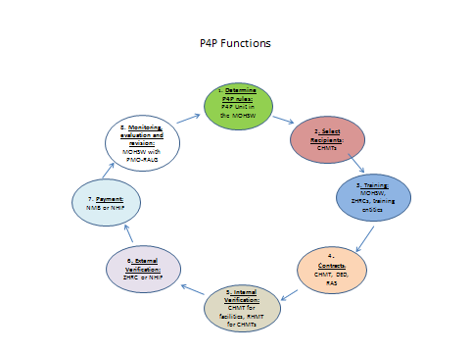

- Rules: The P4P Unit in the MOHSW will continue to lead the national process of determining the rules that guide P4P. This includes program elements such as establishing indicators, rules for setting targets, preconditions that need to be met to participate and contract templates.

- Recipient Selection: CHMTs will implement the policy established by the MOHSW that specifies the characteristics that facilities need to meet to be able to participate in the P4P initiative. Facilities that meet these conditions are considered the “recipients”. In addition, CHMTs and RHMTs are recipients.

- Training: The Zonal Health Resource Centres will be responsible for implementing a training-of trainers model that enables initial and ongoing training on P4P to be carried out at the regional and council level. The capacity of the ZHRCs will need to be complemented by private entities that develop innovative refresher training tools such as mobile videos. The assessment team recognized the need for enhanced initial orientation and training at all levels, as well as for monitoring of training results and updating and refresher training to enable scale up of an enhanced P4P program. Specific attention needs to be paid to the training of HFGC’s, which appear to have a much lower level of knowledge about P4P in both Pwani and non-Pwani facilities. Since they can/should play a key role in assuring community engagement and accountability in the P4P process, improved training of this group should be a priority. More emphasis should also be placed on developing the capacity to develop plans and innovative solutions to achieve the rewarded results, described as “entrepreneurial skills” by KCMC. Experts on training for P4P would be contracted to assist with the design of the training model, as well as of the curriculum, and to train the ZHRC trainers. Special efforts will be needed to insure that adequate training occurs at all levels of the system and adequately reaches facility health workers and HFGCs.

- Contract Management: While the contract templates with the rules for establishing targets will be set by the MOHSW, the specification of the terms of contracts with specific recipients will need to happen at the regional and local level. Facilities will enter into contracts/ performance agreements for performance with the CHMTs; CHMTs will enter into contracts/performance agreements with the District Executive Director (DED); and the RHMTS will enter into performance agreements with the Regional Administrateive Secretary (RAS).

- Internal Verification: The internal verification process piloted in Pwani should be adapted and strengthened. CHMT and RHMT members responsible for verification will need additional training and supervision to make the verification process an opportunity to strengthen supportive supervision. The MOHSW P4P team should work with the DHIS to take on the role of the current pilot PMT in flagging outliers (facilities with sharp increases or decreases). The MOHSW should then communicate with the Regional P4P Coordinator to undertake spot-checking/monitoring/re-verification where indicated.

- External Verification: The two potential entities considered by the Assessment Team to have the potential to assume the role of external verifier in a scaled up P4P system are the ZHRCs and the NHIF. The ZHRCs appear to have the capacity to harness a team and to perform this external verification function for a reasonable cost. The third and fourth cycles in Pwani were externally verified in May 2013 where the results reported by 15% of health centers and dispensaries and all hospitals were compared with facility registered and tally sheets and a small sample of women and children were visited in their homes to check for ghost patients. In the future, when outliers appear to be valid, the ZHRCs will be well placed to identify whether there are useful lessons to be learned with the potential to contribute to improving performance in other regions. In addition, the team suggests that the program develop other forms of verification, including asking Health Facility Governing Committees to perform patient spot checks in the community to detect potential ghost patients. This could have the additional benefit of enhancing the engagement of civil society in the health system and could serve to both hold facilities accountable to their communities for performance and increase appreciation for the benefits of health facilities among community members therefore enhancing demand.The NHIF is also interested in exploring the possibility of performing this external verification function. They have offices in every region of Tanzania. They are interested in trying verification in a subset of Pwani districts to better understand the effort required and the associated costs. The team recommends that this be tried to enable a comparison between the costs and the performance of the NHIF and the ZHRC.

- Payment: The assessment team suggests the following process for authorizing payment.
- Money is in Council account #6 (Health Account).
- Regional P4P Coordinator will bring verified reports to the Council Director for payment, with a copy to the Council Medical Officer.
- Council Medical Officer submits application for payment to Council Director
- Council Director authorizes payment
- Council Treasurer instructs the Bank(s) to pay the facilities.
The Pwani PMT has explored the possibility of the having the National Microfinance Bank (NMB) assume the responsibility for transferring payment and they are interested in performing this function for relatively low costs in comparison with the 10% fee charged by the NHIF to transfer payments in the Pwani pilot. The team recommends that the NMB be tried for payment on a pilot basis in a subset of Pwani councils so that both the cost and the performance of NMB can be compared with the NHIF before making a decision on this role for national scale up.
8. Monitoring, evaluation and revision: The assessment team recommends strengthening the existing P4P Team within the MOHSW to enable the unit to absorb the functions of the current pilot PMT, including managing the national data base that incorporates information from the routine DHIS, calculates targets, compares actual performance against targets, flags outliers for external verification, and approves payment. This national data base will also track progress on indicators and contribute to identifying elements that need revision (modifying indicators, targets, payment rules) over time. This unit will need the capacity to conduct qualitative research to understand whether elements of the model are working and to identify what needs to change. Stakeholder consultations with recipients at the regional, council, facility and community level will be needed. In addition, recognizing the need for regional staff to take on functions currently played by the Pwani Pilot Management Team, the assessment team recommends identifying a PMO-RALG staff member based in each Regional Secretariat, Local Government Section as phase-in occurs, to take on the role of Regional P4P Coordinator to be the eyes and ears of the P4P program to share lessons from the field with the P4P Unit at the DHSS and to provide support to RHMT and CHMTs to help them support facilities to achieve results. Technical assistance may be required to mentor the Regional P4P Coordinator and to provide mentorship support in the councils.
The central MOHSW District Health Information Systems (DHIS) has a pivotal role to play in the scaled up P4P program. The DHIS is responsible for design/redesign and maintenance of the information system, including training of key personnel at the regional and council level, and provision of templates for (and to date provision of actual forms and therefore insuring availability thereof) health facilities. The DHIS plays a key role in timely processing of data received from the councils and for calculating targets based on algorithms set for the program. DHIS persons at the Region and Council level are then responsible for ensuring that targets are received and communicated. These targets will be incorporated into performance agreements and signed as outlined in the Contract Management process below (CHMT for facilities; DED for CHMT; RAS for RHMTs). DHIS data will also generate facility scorecards that display facility performance on achieving targets and P4P payments received.

The assessment team therefore concluded that a phased scale up of an enhanced P4P model throughout Tanzania should be undertaken. Each phase should be accompanied by process learning to inform revisions in the training and administration of P4P.
Proposed phase in schedule (Each phase would take one financial year):

Phase 1: 2 regions plus Pwani (3 regions)
Phase 2: 4 regions
Phase 3: 8 regions
Phase 4: 10 regions
.
Preconditions for Introducing P4P
P4P has been effectively implemented in more fragile and challenging contexts than Tanzania such as Afghanistan, Haiti and even Rwanda in the period after the genocide, where health workers are scarce and poorly skilled, information systems are absent and supply chains are broken. In these experiences, stronger health systems are a result of P4P and not a precondition for implementation of P4P. However, in Tanzania P4P is likely to contribute to higher impact on health if elements such as the supply chain assure that essential commodities are available at the service delivery level. The following table suggests some considerations for strengthening the enabling environment to allow P4P to fully function.
Table 7: Preconditions for Introducing P4P at Regional Level
Preconditions | Explanation
Secure financing agreed | Mandatory; GoT-donor agreement on expansion with national funding initially, with agreement on process for Councils to absorb funding responsibility over a prescribed period of time (i.e., allocate required funds through CCHP process).
HMIS in place | Mandatory; DHIS training completed, data collection forms available
Training completed | Mandatory; training conducted for all participants at all levels for all institutions involved, especially for HFGC.
Supply chain functioning | Recommended to the extent possible; improvements in the functioning of the MSD are desirable for optimal functioning of P4P but beyond scope of P4P program; however, P4P can help create the demand for improvements in MSD performance and encourage performance monitoring, and P4P facility payments can be used to buy drugs to alleviate shortages in the interim.
Adequate human resources | Basic requirements should be in place, and P4P can help drive improvements in HRH distribution and productivity
Supervision and oversight | No preconditions; P4P can help drive improvements in system
M&E system | No preconditions; P4P can help drive improvements
Sustainable institutional arrangements | Selection of appropriate institutions to carry out P4P functions is an important aspect of design of the system
Verification system in place | Part of P4P system design

Cost Projections
The assessment team was able to obtain a costing tool from CHAI, which estimates the financial impact of scaling up the Pwani P4P pilot. Overall, the tool appears to be very useful, although several refinements were made to take into account the findings from the assessment:
- The sequencing and timing of the roll-out was adjusted to take into account the scale-up schedule above;
- Recognizing the role of PMO-RALG at the district level, the “temporary” MOH&SW staffing was replaced with permanent PMO-RALG staff (one per region) who would coordinate the P4P program for the districts in each region;
- Ongoing training was provided for beyond the initial roll-out trainging;
- The amount provided for technical assistance was felt to be insufficient given the scope and magnitude of the scaling up process and the limited capacity which currently exists in this area, so a higher level was included in the costing;
- While the issue of the payment agent seems to be unresolved following the assessment mission, it was felt that in any event that a payment agent fee of 10 percent would be excessive for a national implementation, so a 5 percent fee was used, recognizing economies of scale that the payment agenct should be able to achieve;
Cost projections incorporated the following key assumptions:
- 2 regions would be added in Year 1, 4 in Year 2, 8 in Year 3, and 10 in Year 4.
- The maximum amount per facility would be set per the table below:
Facility Payout | Rate Per Type
Regional Hospital | TZS 12,500,000
District Hospital | TZS 10,600,000
Up-Graded Health Centre | TZS 6,800,000
Health Centre | TZS 5,000,000
Dispensary | TZS 1,300,000
RHMT | TZS 4,400,000
CHMT | TZS 4,700,000
- The percentage payout is assumed as follows:
Payout during scale-up | 65%
Payout post scale-up | 75%

- The following standard costs were used for MOHSW managed costs:
Cost Estimates for MoHSW managed budget items | Rate in TZS
Ceiling Salary + benefits approximation for District, Regional, Zonal and Central Junior Health Staff per month | TZS 1,500,000
Ceiling Salary + benefits approximation for Central Senior Health Staff per month | TZS 3,000,000
Per diem for MoHSW, RC, RAS, DC, DED | TZS 80,000
Per diem for RHMT, CHMT, DPO, District Treasurer, District Internal Auditor | TZS 65,000
Per diem for Drivers, Facility staff and HFGC members | TZS 45,000
Transport Allowance for DC/DED/Council Chairperson to Regional Capital (round trip fuel) | TZS 200,000
Transport Reimbursement for Facility staff and HFGC members to District capital | TZS 20,000
Refreshments per person per day | TZS 15,000
Stationary Costs per person | TZS 3,000
Printing of Training Materials for Orientation Sessions per Person | TZS 5,500
Printing of Materials for Feedback Sessions per Person | TZS 1,500
Printing of Materials for Partogram and Death Audit Training per person | TZS 5,000
Venue per District/Regional Training/Meeting | TZS 150,000
Transport Allowance for RHMT to District Capital (round trip fuel) | TZS 200,000

- Costs were calculated for each region based on the number of facilities of each type and the number of districts in each region. The regional costs consisted both one-time and ongoing costs. One-time costs included: (a) P4P orientation/training of Regional/District leadership and administration; (b) P4P orientation/ training of CHMTs and cascade nodes; (c) P4P orientation of facility in-charges, RCH in-charges, and HFGC chairs; (d) partogram and death audit evaluation training of Regional and Council teams. Ongoing costs included the payments to facilities and the cost of feedback sessions and target setting for the next period.
- While detailed costs were calculated by region, the costing model uses average costs per region since the sequence of regions to be used in the roll-out is not known. While the sequence could affect the total cost of scale-up (e.g, if larger regions are rolled out first, their higher than average costs would need to be covered over a longer period during the scale-up), it would not affect the ongoing costs, since all regions would eventually be covered.
- Costs at the Zonal level included: (a) Start-up and running costs for zonal teams; (b) Training of trainers (ToT) for zonal teams and (c) P4P data verification costs for zonal teams. External verification costs were updated to reflect the Morogoro experience.
- MOH staffing included a Director, Deputy Director, Financial Manager, Data Manager and Administrator. PMO-RALG staffing included one coordinator/implementation officer per region. Central level operating costs are assumed to be $60,000 per year for the first 3 years, plus $20,000 per year per region (for travel, etc.).
- The payment agency fee was set at 5.0% – which is half of the percentage currently paid to the NHIF – on the assumption that there would be economies of scale in a national roll-out. The actual amount would be informed by the pilot use of the NMB to facilitate payments to facilities.
- TA support was estimated at $800,000 per year during scale-up and $400,000 per year for ongoing operation.
- For Option 2, all of the costs are as described above, with the exception of the maximum payments to hospitals, which were doubled to TZS 20.2 million and 25 million for district and regional hospitals respectively. Payments to up-graded health centers were alos doubled to TZS 13.6 million.
The table below shows the estimated cost of a national scale-up using the adjusted CHAI model, and the sequencing described above.

Table 8: Base Case Scenario Costing
It shows the total costs rising from about $3.2 million in FY14 to a steady state of around $20.7 million in FY18. The cost over the five-year period is estimated to be around $60.7 million. Of that total steady state amount, roughly 65 percent would go towards incentives, 21 percent for feedback provision, and 14 percent for other management costs. On a per capita basis, the steady state total would be around $0.44. It should be noted that this level of funding is somewhat lower than that in other countries where result-based approaches have been tried, but this level appears to have achieved results in the Pwani pilot, so a substantial general increase in funding levels does not appear to be warranted at this time.

Based on the discussion on the implementation of P4P at the hospital level, the assessment team felt that some adjustment may be needed in this area to support a different incentive structure and new indicators. Accordingly, another version of the model was produced which doubled the allocation for hospitals and upgraded health centers. This option would see “steady state” costs rise from $3.3 million to around $23.3 million and the total cost increase to $67.2 million. Here the steady state amount going towards incentive payments would increase to 69 percent and other costs would decline slightly. It is clear from this table that the hospital portion of the incentive allocation is not the major cost driver.
Table 9: Increased Hospital Envelope Scenario Costing

As noted above, the costing is based on the assumption that facilities would achieve 65% of their targets initially, and then 75% on an ongoing basis. Although it would be great is higher levels of achievement could be reached, the cost implications of this also need to be considered.
Accordingly, Table 10 shows a sensitivity analysis with various levels of target achievement, ranging from 75% to 95%. This table shows that the total costs of the scale-up would increase by $280,000 for each percentage point increase in achievement, and that the steady state cost would increase by $190,000 for each percentage point increase. While these costs would obviously need to be budgeted for, even a high level of achievement would not be catastrophic from a financial standpoint.
Table 10: Sensitivity Analysis
Sustainability options
As discussed throughout this report, P4P strengthens the core building blocks of the health system. The assessment team was surprised about how well these system strengthening objectives of P4P were understood by health workers and supervisors. While some question whether preconditions need to be met in the enabling environment of the health system before P4P can be effective, based on review of P4P experiences both internationally and within Tanzania, the assessment team observed that while a certain level of functioning of various components of the health system is necessary, the strong interaction of P4P with the health system creates a virtuous cycle, whereby P4P improves the other functions. A case in point is the clear improvement in data reporting and accuracy in all councils within the Pwani pilot. In the case of drugs and equipment, the experience in the pilot facilities demonstrates that P4P can help to compensate for a system that is not yet functioning optimally, by allowing facility managers the autonomy to purchase critical drugs and equipment such as solar panels and sterilizers to improve the environment and services provided, and thereby increase utilization of services by the population. The interaction between improved health worker motivation and increased service delivery was noted by many, if not most, respondents when asked how P4P is working, or to describe the strengths of the program.
In sum, the many elements that are needed for any health system to function are also needed for P4P to be effective. However, in the view of the assessment team, there is no need to wait for all of these systems to be strong before implementing P4P. Essentials include trained health workers, a reliable HMIS, a regular supply of essential medicines, and predictable funding. However, no health system in developing countries has all these elements in place. However, the experience in Pwani has shown that P4P can act as a catalyst to strengthen some parts of the existing system, such as the use of monitoring and evaluation, human resources distribution, and improved management oversight and supervision; and will also increase the demand for improving other key systems elements, such as the supply chain. As such, it will interact with other investments to strengthen the health system.
  - Institutional sustainability
Institutional sustainability is best achieved by building the program design around existing structures. The institutions recommended to take on the various support functions of a phased scale up of an enhanced P4P model include the following governmental or parastatal organizations, as discussed above:
- MOHSW P4P team (in confirmed MOHSW structure)
- MOHSW DHIS
- MOHSW Zonal Health Resource Centres
- NHIF
- CHMTs
- Council Councils
- Regional Secretariats (Local government section and RHMT)
- The National Microfinance Bank.
In order to institutionalize and sustain the required functions within these permanent structures, the design of the national scale up must have a strong focus on capacity building at each level. A brief overview of the capacity building needs of each of these institutions is provided below.
The current MOHSW P4P team leads the Pwani Pilot Management Team and has participated actively in implementing and monitoring the Pwani pilot in conjunction with the Clinton Health Access Initiative (CHAI). This unit will likely be absorbed into the MOHSW District Health Services and Systems Strengthening Unit. This team will require adequate fulltime staff to carry out the enhanced national program and will benefit from strong communication and advocacy skills, as building understanding and support for P4P will be a primary role in the first few years. In addition, this team will need to have the capacity to monitor and assess progress with the phased implementation and will need a combination of quantitative and qualitative research skills. This will involve analyzing the DHIS data, comparing performance with targets, examining trends on a sample of non-rewarding indicators to detect unintended effects (negative or positive).
To enable the unit to absorb the functions of the PMT, the additional functions need to be assessed to determine whether (and which) additional staff positions are required, and what additional capacity development is needed for current staff. Capacity development is likely to require on-the-job training by technical assistance experts/mentors.
The MOHSW DHIS currently has capacity to compile data from health facilities and to generate the information needed to initiate payments to facilities and individual personnel. Completion of HMIS training at all facilities within a council should be a precondition for the council to phase in as a P4P participant. It is the responsibility of the DHIS to provide and fund the training and to provide the data collection instruments required for councils/facilities to comply with reporting. Further assessment will be required of DHIS staff’s capability to take on the additional workload as additional councils phase into the program incrementally, followed by necessary action to train existing staff and/or hire additional staff.
Capacitation of the area’s ZHRC should be another precondition for a region/council to phase into the program. Since ZHRCs would take on critical training as well as verification functions, demonstration of mastery of both functions by ZHRC staff and consultants will be needed. As noted, experts on training for P4P would be contracted to assist with the design of the training model, as well as of the curriculum, and to train the ZHRC trainers.
CHMTs, RHMTs, Council Councils and Regional Secretariats each require initial training in program responsibilities specific to the planning and budgeting, contract management, payment and verification functions of each entity. CHMTs and RHMTs need to be trained to support the facilities in their areas to develop the skills needed to design strategies and implement plans that achieve the improved results. The initial training, as well as monitoring of training outcome, and re-training, will be undertaken by the ZHRC. As noted, additional mentoring at the regional and council levels will be provided by the proposed Regional P4P Coordinator, who him/herself will receive assistance and mentoring from technically qualified experts in P4P and program implementation.
c) Financial sustainability
A resolution of the question of financial sustainability of a national P4P program is clearly a necessary precondition for scaling up P4P in Tanzania. The assessment team’s interviews throughout the country show that while there is uniform enthusiasm across health sector stakeholders for scaling up P4P, there is simultaneous concern about financial sustainability. This is to be expected based on experience to date with the national program, which failed to attract funding at the council level (with the exception of 2 known councils) once donor basket funding was removed from consideration. Many stakeholders suggested re-institution of some sort of central funding, precisely because of the failure of this program to compete successfully for funds at the council level.
It is therefore recommended that an incremental approach be devised to move from central to council funding. Central funding would be included as part of the national budgeting process through the MTEF, following the proposed phase-in schedule (3 regions in Year 1; 7 in Year 2; 15 in Year 3; 25 in Year 4). All sources of funding would need to be considered for both the scale-up and the ongoing operation of P4P. These would include:
- Government general revenue
- Development partner funds, through the HBF and otherwise;
- User fee, NHIF and CHF revenue;
- Earmarked taxes, including possibly “sin taxes”, tourism taxes and resource revenues, either flowing directly or through the Health Trust Fund; and
- Other sources.
These arrangements would need to be further developed and included in the Health Financing Strategy, which is currently under development. In developing these arrangements, the assessment team recommends that central funds be allocated to cover incentives for new councils in the early years, with the understanding that the councils would increasingly budget for training and administration costs in subsequent years, and eventually for the cost of incentive payments. To provide a further incentive for councils to take on the costs of P4P, the central fund could provide matching funds as incentive payments to councils as they transition toward assuming budgetary responsibility for the program.
As regions and councils are phased into the enhanced national program, formal agreements would be required between the MOHSW and each region/council, in which the commitments of each party would be spelled out. In accordance with the HFS, guidelines could be developed to assist councils to plan and budget to take on P4P program costs incrementally as part of the CCHP process. Stakeholders suggested using a combination of OC funds and councils’ own funds to finance the program. In accordance with the HFS, guidelines would recommend how to estimate actual and projected service fees generated by facilities, CHF funds contributed by the community, and NHIF funds due to facilities that should be applied to improving health services, and what portion of each should be dedicated to P4P. The guidelines would provide a model to then estimate the balance that would be required from council OC funds and need to be budgeted for and funded each year. Templates would also be needed to help councils project costs each year, based on population size, baseline of services delivered, and expected increase in services year over year as the program takes hold. The proposed Regional P4P Coordinators would provide technical assistance and mentoring to councils to undertake the new P4P planning and budgeting requirements as councils phase into the program.

Challenges, risks and strategies for mitigation
Challenge/ Risk | Mitigation Strategy and/or Explanation
- Health workers will neglect non-rewarded results | To mitigate the risk that health workers may neglect services that are not rewarded with performance payments the P4P system will:  - Implement a strong monitoring system that will monitor trends in utilization of both rewarded and a sample of non-rewarded services using DHIS data. Quantitative data will be complemented by qualitative data coming from the PMO-RALG Regional P4P Coordinators. The monitoring system will be overseen by the MOHSW.  - Reward indicatorsbeyond MCH services, as recommended by some respondents in assessment interviews.  - Revise the indicators, targets, and other elements of the design based on ongoing monitoring that flags unintended negative effects.
- P4P damages intrinsic motivation | There is no documented evidence that P4P damages the intrinsic motivation of health workers. However, it is an often expressed concern. To minimize this risk:  - Rewarded P4P indicators should befully aligned with the population health objectives that intrinsically drive health workers.
- Facilities will inflate reported results so they can earn performance payments. | To mitigate against the risk of false reporting, the system will incorporate the following processes:  - Internal verification by CHMTs that provides internal checks that facility reported data reflects what it captured in facility registers. RHMTs verify data presented by CHMTs.  - DHIS system identifies performance outliers by flagging performance improvements from a previous cycle that exceed an expected range.  - Random selection of facilities, CHMTs and RHMTs for verification by the ZHRCs or by the NHIF.  - Purposeful selection of facilities, CHMTs, RHMTs based on DHIS flagged outliers for verification by the ZHRCs or NHIF.  - Community verification of a sample of patients in registers by Health Facility Governing Committees to deter listing of ghost patients.  - Penalties for evidence of falsification.
- Training will be inadequate so the system won’t work | Training is essential and the training approach will encompass the following:  - A sensitization strategy will need to be implemented to inform Leaders and the DED about P4P.  - Effective training will be critical and investing to provide a system for ongoing training will be a priority.  - Facilities, CHMTs, and RHMTs need to learn how to develop and implement strategies to achieve the results and they need to learn the processes of reporting and verifying that make the system function.  - Health Facility Governing Committee members will need adequate training and refresher training for new members.  - The ZHRCs will need to be trained to conduct verification and to train facilities, CHMTs and RHMTs in the regions they cover. This will involve developing training materials, a TOT model, and funding.  - The PMO-RALG P4P Coordinators at the regional level will need to be mentored so that they can learn how to support P4P in the region.  - The Central MOHSW unit will need to develop systems and the capacity to oversee the P4P system nationally and to manage the monitoring system that provides the information that guides refinements to the approach.  - Cost effective training strategies will be need to be developed that rely on technology such as mobile videos to provide initial and refresher training.
- Weaknesses in the Tanzanian health system don’t provide the enabling environment needed for P4P to be effective. | While this concern is often expressed when countries and donors are considering providing support to implement P4P, we would like to stress that the health system will be strengthened as a consequence of P4P. It is not necessary to wait for all systems to be in place.  - P4P has been implemented in countries with far weaker health systems than the Tanzanian health system. We have seen results improve with P4P in fragile states such as Afghanistan, Haiti and Liberia. Rwanda implemented P4P which is now scaled up nationwide within a system that had a number of weaknesses. And, in middle income countries such as Argentina, Egypt and Turkey, a number of system weaknesses were addressed alongside P4P implementation.  - P4P can strengthen health systems and, therefore, can offer important synergies that catalyze investments in improving health systems. One example is the enthusiastic endorsement from the MOHSW DHIS unit about P4P, seen as a powerful complement to the implementation of the DHIS by increasing focus on reliability of data and by incentivizing timely and complete reporting.
- The capacity to administer P4P doesn’t exist | - As with any new system, some capacities exist and others need to be enhanced. Tanzania has a strong team in the MOHSW that has experience designing and rolling out the national program as well as designing and implementing the pilot in Pwani. This team has lived through the history of implementation and understands the challenges and the task ahead. This team will need to be enhanced and the systems to administer the revised approach at scale will need to be built.  - It has been done in a number of countries with weaker capacity than in Tanzania. The assessment team has full confidence with the right resources and support that the capacity to administer the refined program will be built.
- Once the donor funds end, P4P won’t continue. | - Identifying a sustainable source of financing is a challenge for this and for any initiative. This report provides suggestions for how to phase down donor funding while successively increasing Tanzania funding at multiple levels (central government through taxes including potential sin taxes and natural resource taxes, council government, community through CHF and cost sharing, and NHIF).  - Demonstrating value for money through a monitoring system that shows improvements in health results and increased efficiency with the money spent will be a powerful tool to use to advocate with the Ministry of Finance and through the national budgeting process for continued support for P4P.
- Performance funds won’t reach health workers. They will be “captured” by facility in-charges or sub-national level supervisors. | - Each facility, CHMT and RHMT needs to have a bank account so that P4P performance payments can be transferred directly.  - Facility scorecards must be posted in a public place and must show the targets achieved and the funds earned.  - The process of distributing the earned funds needs to be public and transparent so that health works are clear about what they can expect.  - Health Facility Governing Committees will be co-signatories on how the 25% facility investment funds are used. This will be complemented with training of the committee members so they understand P4P.

Final Observations
This report documents findings of an assessment of strengths and weaknesses of the experience with P4P in Tanzania and presents recommendations on national scale-up. While the report lays out the basic elements of the design of a national program, including modifications of the existing models and suggestions for structures and arrangements for institutional support, it is not a design document. It is important to note the need for much more careful and detailed program design, based on these recommendations and inputs from the Task Force, for scale-up. This design should be based on thorough institutional assessment of organizations ultimately chosen to implement various functions; detailed training needs assessment and planning for capacity development at all levels, including HFGCs; special focus on design of the external verification processes; and design of a financial sustainability plan in keeping with the Health Financing Strategy currently under development.
The team further recommends that the design of the national scale up should:
- continue to focus on the importance of constructing the program based on existing structures and organizations, keeping in mind the pre-eminence of the local government system of Tanzania;
- build on and strengthen the governance of the system, and in particular the importance of the HFGCs.
- take into account the risks and means of mitigation of these risks highlighted throughout this report.
Finally, the assessment team believes that while there is risk inherent in taking action to scale up the P4P program, there is also risk of NOT taking action. The risk of not moving forward is that “business as usual” will continue for more years resulting in a system that doesn’t deliver health results that prevents death and disease and saves lives in Tanzania. While not a magic bullet with solutions to all health systems challenges, P4P catalyzes many health systems actors to work hard and solve systemic problems and, in the process, elements of the health system are strengthened. The assessment team suggests that the risk of not moving forward with P4P, given the evidence, is far greater than the risks involved in moving judiciously to national scale-up.
Annexes:
- Matrix of Tanzania P4P experiences
- Matrix of International P4P experiences
- Pwani results: time series of reported results
- Interview instruments
- Matrix of field interview findings
- Assessment team field visit schedule
- People interviewed
- PowerPoint to P4P Task force and HF working group on field findings

Annex 1: Matrix of Tanzania P4P experiences
OVERVIEW | CSSC/CORDAID | PSI/STOCK TRACKING | PWANI
Title of initiative  Implementing and support agencies  (include contact information) | Pay for performance (P4P)  Implemented by the Christian Social services commission, Supported by CORDAID | Stock tracking and management system  PSI - Dar es Salaam  Ph +255 222602742-4  Contact: Anya Fedorova, Technical Services Director  Niza Sikana, Head of Strategic Information Dept. | Pay for Performance (P4P) Pwani Pilot  Financed by Norwegian Ministry of Foreign Affairs, through Royal Norwegian Embassy in Tanzania  Implementation support: CHAI  Evaluation: IHI  Additional TA: Broadbranch (USAID-financed)
Statement of objectives of the initiative | The objective of P4P program in was to strengthen Diocesan Health Services, specifically to make progress in the field of:  1) Access to health services,  2) Quality of health services and  3) Organisational performance (financial management, HMIS) | The goal is:  - To improve visibility and availability of critical socially marketed health products at private sector outlets (wholesalers, pharmacies and ADDOs)  The objectives are:  - To provide up to date and simple to understand market data that will enable to design and implement better public health interventions  - To increase efficiency of trade channel operations and better logistics (order generation) in order to minimize stock outs  The products that are reported through the system are: condoms, family planning products, child health products such as zinc, ORS, water treatment, malaria drugs and test kits | - To design and test the feasibility of a results based funding approach in health in order to draw experiences for the national P4P program  - To increase the generation and use of health information for decision making leading to improved health outcomes  - To improve the efficiency and effectiveness of the health system through motivating health care workers to provide quality services  - To effectively manage, monitor and evaluate the Pwani region P4P Pilot
List types of recipients of performance payments and numbers in each category.  (e.g.: health centers [5 public, 5 private]; CHMT, pregnant women) | 5 Catholic Dioceses of (Arusha, Sumbawanga, Kigoma, Rulenge,and Bukoba), covering 13 hospitals, 12 health centers & 39 dispensaries | Wholesalers:  Morogoro – 30 Dodoma - 21  Pharmacies:  Morogoro – 6 Dodoma - 8  ADDOs:  Morogoro - 30 Dodoma – 1 | Hospitals (7)  Health Centre (19)  Dispensaries (183)  CHMTS (7)  And Pwani RHMT  - Both private and Public facilities are included in the scheme  - For Dispensaries and Health Centres rewards all health staff and non health staff  - For Hospitals, rewards only targets RCH staff and Non RCH staff
Population catchment area covered  (Nr. and % of districts and/or regions, and nr and % of the population covered) | Total population app. 2 million (based on hospital catchment) | - Morogoro (2 districts which are Kilosa and Morogoro Urban. Equivalent to 40% of pop. Source NBS 2002/2007 census)  - Dodoma (1 District which is Dodoma Urban equivalent to 19% of pop. Source NBS 2002/2007 census) | - Covers 7 districts in 1 (Pwani) region of Tanzania  with Catchment population of 1,110,917 (2012 population projection-NBS)  - 722,096, of the population in the region are women at the reproductive age and children under five and below one year
Start and end dates, any expansion that has taken place since original implementation | 2006 – 2008 first phase  2009-2010 second phase  Note: Unclear what is currently being done, because e-mail described a third? Phase starting in 2011? | Initiative was launched in Morogoro region in October 2012, since January 2013 it expanded to Dodoma urban. The decision will be taken in the end of March about potential expansion across Tanzania | 1st 2011 to 31st December 2012;  Looking into extension until scale-up begins
Current cost per capita (covered population), of which: incentive payments per capita and administrative costs per capita | Investment app. USD 0.50 per capita per year | - System development cost USD 98000 (includes features additional to stock management initiative; one off cost)  - All inclusive running costs for 6 months pilot: USD 5000 per month  - Operation stage:  - For 1000 outlets 6.85 USD per outlet (estimation of 30 sms per outlet/month). the const includes incentive of app. USD 2.5 per outlet per month.  - Cost per outlet will go down with more outlets in the system | Current Cost per Capita is ~ US $ 0.5. Preliminary costing of the model at scale puts the per capita cost is estimated to be ~ US $ 0.35 per capita

INDICATORS, TARGETS AND PAYMENT RULES | CSSC/CORDAID | PSI/STOCK TRACKING | PWANI
Target Population(s)  (e.g.: women of childbearing age, pregnant women, children under 5, etc.) | Not classified | Private sector wholesalers, pharmacies and ADDOs | - Women of Reproductive Age (15 -49 years)  - Children under five, infant and Neonatal
Indicators that are rewarded:  BE SPECIFIC and describe the indicators for each type of recipient and target population | 1. OPD util. - 0,6 visits/capita (HC/Disp)  IPD util. - 40/1000 population (Hosp)  2. Deliveries - 20/1000 pop. (HC/Disp)  Deliveries- 10/1000 pop. (Hosp)  3.VCT new clients, 10/1000 pop. (Hosp)  ANC first visit < 20 weeks – 50% (HC/Disp)  4. No Stock-out of Ess. Drugs (7) (All) | A sms with stock numbers of socially marketed products is sent on time (within 48 hours of a reminder message) and contains no errors | Please refer to table 1 at the end of this document for the list of indicators  Note: Unable to locate Table 1
Targets or Target setting rules if performance rewards are linked to achieving targets.  If fees for units of service provided, describe.  Specify rules for obtaining rewards. | - | A sms with stock numbers of socially marketed products is sent on time (within 48 hours of a reminder message) and contains no errors | Targets for indicators are set using three rules  Overall results:  For some indicators, there is a cut off performance target regardless of baseline or previous cycle performance. For others, the target is set incrementally based on the baseline or previous cycle performance  Fixed Targets :  Targets fixed throughout the course of the pilot irrespective of prior performance or the current cycle  Increase in percentage points:  The lower the baseline, the higher the increment of required percentage points is set.  Please refer to table 2 at the end of this document for target setting rule for each indicator  Note: Unable to locate Table 2
Payment mechanisms: amount for each indicator/target; frequency of payment; maximum amount for each recipient | Hospital, Tsh. 42,000,000  HC -Tsh.14,000,000  Dispensary, Tsh. 7,000,000  This was a total budget per year | Incentive is sent instantly upon sending error free sms on time. Incentive is 1000 Tsh airtime top up | - Indicators all have the same value/weight.  - Payments are made every 6 months.  - Maximum pay-out assuming all targets are fully met/single indicator value:  - Hospital: TZs 1,169,494  - Upgraded H/C : TZs 696,000  - Health Centre : TZs 554,412  - Dispensary : TZs 142,079  - CHMT : TZs1,553,571  - RHMT : TZs 2,175,000  The maximum potential payouts per facility type  - Hospital TZs 10,525,446.43  - Up graded H/C TZs 6,960,000  - Health Centre TZs 4,989,705.88  - Dispensary TZs 1,278,708.79  - RHMT TZs 4,350,000  - CHMT TZs 4,660,714.29
Payment rules: rules for distribution within recipient category.  (e.g.; 25% to facility investment and 75% to individual workers according to following rule…) | Guidelines for allocation of funding  Staff motivation max 50%  Equipment max 30%  Infrastructure max 20%  Running costs max 10%  20% for Diocesan Health Office (DHO) | Incentive is paid to the registered recipient. Owner of the outlet decides who is a recipient. 70% outlet owner, 30% shop assistant. | - For Hospital 10% to be used for facility improvement, 60% for RCH staff, 30% for non RCH staff  - For Health centre and dispensary 25% to be used for facility improvements, 75% for staff as an incentive  - For RHMT and CHMT is paid 100% as a staff incentive  - Incentive is rewarded to the facility not to an individual

REPORTING | CSSC/CORDAID | PSI/STOCK TRACKING | PWANI
Performance data reported by each recipient including: source of information, who receives reported information, frequency of reports | Source of information was MTUHA books, performance report was sent to CORDAID, and CORDAID was sending he report to CSSC, reports were sent twice in a year. | Stock count sms messages are sent weekly by the outlet. Recipient physically counts cartons of products in the store before sending stock sms.  The web based system receives the sms message; data instantly converted into visual graphs and maps representing the availability of reported products. Data is accessed on daily basis by distribution staff in PSI | Performance data reported by each recipient  Data reporting follows the existing HMIS cycle.
Is performance data part of the country’s DHIS? Is reporting part of the routine reporting system? Please describe. | Yes MTUHA books were used | No | All performance indicators are part of the HMIS except for 2 quality indicators, maternal deaths audit and use of partograms. Portographic evaluation is used to measure the six hospitals and one upgraded health center. Death audit is used to measure CHMT’s. At the end of every cycle midwives nurses from Muhimbili national hospital conducts evaluation, this roles now is transitioned to the CHMT’s to build more ownership (CHMT from one council will be tasked to evaluate another council) PMT has developed a data base where all the information extracted into excel for pay out model
Who receives reported performance data from each recipient. Please describe the systems used to track reported data and compare against targets. | Facility reports were collected by the diocesan health office, compiled and sent to donor, data were filled in an excel sheet which calculated the incentives automatically | Reported data can be accessed by anyone who is registered within the system. Currently it is PSI sales and program staff. Different levels of access can be given by the system | The facility data is received by the CHMT. The MoHSW and RHMT have access to DHIS and all performance data. After data has been validated according to internal verification processes, reports are made by the CHMT and RHMT. The Pilot Management Team summarizes these and compares results against targets through the pay-out model. The data reports are presented for the Regional Certification Committee and National Verification Committee, as well as Advisory and Steering Committees.
Is there a system for internal verification? For example, do supervisors review and approve data before it is submitted? | They had data committees with the facility to check dada before submission to the diocese | No | Yes there is a system for Internal Verification  - The internal verification is done by CHMTs and RHMT during supporting supervison before data are approved. Both CHMT and RHMTS are expected to routinely validate over 80% of the facilities per cycle  - The Pilot Management Team does spot checks in not less than 25% of the facilities register in the scheme. Facilities selected for a spot check are the one found with a very sharp drop or increase.
Is data verified by an external process? Please describe how this works? | The performance report sent to CORDAID was sent back to CSSC, the project coordinator based at CSSC was responsible for data verification in all 64 health facilities | Occasionally by PSI T M&E team | Yes data are verified by External Verification  - External verification is done by an independent verifier who conduct random facility checks to assess data accuracy and to conduct community level verification. The independent verifier is expected to visit at least 25% of the facilities in each districts were the P4P pilot is being implemented  - Cycle 1 and 2 was done by an external company  - For sustainability reason and cost effectiveness, the Zonal Training Centre will be used to conduct external verification for cycle 3, 4 and any additional cycles.
What is the time gap between reporting and issuance of performance payments? | It was about one month. | Performance payment is done instantly upon receiving error free sms on time | - Reporting for P4P purposes is made every 6 months, after each cycle ends.  - It takes up to 3 months for the reports to be ready for submission to the RCC and NVC.  - After NVC approval, payments are made by the NHIF to facilities within one week.  - The target has been to make payments at most 3 months after the end of a cycle. Throughout Pilot, we managed to make payments after 3-4 months.

MANAGEMENT AND FUNDING | CSSC/CORDAID | PSI/STOCK TRACKING | PWANI
Who has overall responsibility for management of the P4P scheme? | It was partly managed by CSSC and partly by diocesan health office | Director of Technical Services  Head of Strategic Information department | MoHSW in Tanzania takes charge of the P4P pilot scheme. There is P4P coordination office structured under the Director of Policy and Planning.
How are recipients of the performance payments selected and who manages this?  (For example, do facilities have to meet preconditions? is there a competitive process? etc.) | The facility have to meet some conditions for it to participate in project, one was about staffing, for example for a dispensary to participate it was to have at least one clinical officer, a nurse, and a lab assistant. | Outlets are selected by PSI regional sales teams based on outlets past performance in sales and their willingness to participate in the initiative | Selection of the facility recipients is confirmed by the CHMTs and RHMTs. The facility must;  - Have a Bank account.  - Provides RCH services  - Have the ability to report timely HMIS.  The facilities are both private and public in the Pwani region.
Who designs the performance agreements/contracts?  (share a copy of a contract template) | CORDAID and CSSC | There is no contract with the recipient of incentive | The performance agreement was designed by P4P stakeholders at the initiation of the P4P Pwani Pilot. Any changes to the design of the performance agreement need to be proposed to and accepted by the Steering Committee.  (Please see Design Document 2.4 Performance Agreements, and Annex B Contract Templates.)
Who negotiates the terms of the performance agreements/contracts and who signs them? | CORDAID and dioceses | Not applicable | The performance agreements at the facility level are agreed and signed by the HFGCs with the CHMT.  All facilities enter into agreements with their respective CHMTs. For the CHMT, the performance agreement is signed with the District Executive Director (DED). For the RHMT, the performance agreement is signed with the Regional Administrative Secretary (RAS).
Who monitors attainment of performance measures? Where does this system sit? How is it staffed? | CORDAID and CSSC.  There was only one staff at CSSC. | The system is under Strategic information department | The monitoring of performance is done on many levels. First, the performance is regularly monitored through data validation and supportive supervision by the CHMTs. Then the performance of CHMTs is regularly monitored by the RHMTs This performance monitoring is within the regular supervision of the CHMT and RHMT. PMT access online data review and select 25% of the facilities for a validation. Once the PMT completes data validation, portographic evaluation and death audit, the results are submitted to Regional Certification Committee chaired by the regional administrative secretary and the RHMT’s, and then National Verification Committee which is formed by MOHSW, CHAI PM and other central government authorities bodies, does further review and scrutiny. (Please see Design Document, 3.9 NVC and 3.10 RCC.)
Who manages the contract with the external verifier? | CSSC was the only verifier | Not applicable.  The verification is based on in-built feature of the system (error free message received on time) | The PMT negotiates with the external verifier. Under the current system, CHAI manage the contract of an independent verifier. However overall coordination is under the PMT.
Do recipients have separate bank accounts? What are the processes to approve spending of performance payments?  (E.g. Who are the signatories? Are Health Facility Governing Committees involved? etc.) | Facilities had bank accounts, signatories were, diocesan health coordinators and the facility in charge | No; incentive is a top up airtime money sent to the recipient phone number | - Yes, all facilities and health management team beneficiaries have bank accounts.  - After funds have been received in the bank account, a meeting is called, chaired by HFGC chair and facility in-charge as the secretary.  - The meeting discusses how much was earned, reviews indicators that did not meet targets, and establishes a way forward for the following cycle.  - Discusses and approve the usage of facility improvement funds depending on priority areas for the facility  - Signed minutes of the meeting are presented to the bank for withdrawal of funds.  - The account has two signatories:  A: Community side (chair of the HFGC)  B: Facility side (in-charge of the health facility)
Who transfers funds to recipients once performance information is verified? | CORDAID was transferring to the dioceses and the dioceses transfer to the facilities | The system is automatically sending pin numbers worth 1000 to recipients mobile phones and recipients use the number to get airtime bonus | Funds are transferred by NHIF
Where do the funds come from to pay the performance payments? (e.g. donor) | Donor | USAID  KfW  GFATM | - The Royal Norwegian Embassy  - Annual maximum payout is $600,000 ($300,000 per six-monthly cycle)
Where did funds come from to build the systems to oversee the P4P initiative?  (E.g. donor funds, government) | Donor | USAID  KfW  GFATM | - The government of Tanzania through provision of its staff  - The Royal Norwegian Embassy to fund CHAI and IHI

RESULTS AND CHALLENGES | CSSC/CORDAID | PSI/STOCK TRACKING | PWANI
What results are available from the routine information system.  (e.g. service delivery, availability of (changes in key indicators over time). | Indicator changed during second phase, the incentives were paid per case, and some quality indicator were added | Information in a visual format (graphs) showing the stock levels of reported health products. Stock out data of reported products in visual format  Data can be exported to Excel for further analysis | The routine information system used is the DHIS, which contains all of the data sets to calculate indicators for P4P. These data sets are exported from the DHIS to make pivot tables to show the results from each cycle from each facility, district, and a region. A P4P scorecard shows the indicators, targets, previous and current cycle achievement, payment per indicator and payment total per cycle.  (Please see attached scorecard example.)
Has the initiative been evaluated? If so, specify type of evaluation as well as summarize the results. | It was evaluated in 2009, the following gaps were identified;  1.Centralized verification  2.Few quality indicators included  3.Lack of community involvement in assessing services  4.Lack of link with development of Service Agreement for sustainability  Find the attached evaluation document | On-going | The Pwani P4P Pilot has been evaluated by Ifakara Health Institute from Cycle 1-3 (Jan 2011-Dec 2012). IHI has conducted a process evaluation and is currently conducting an impact evaluation to be completed by September 2013.
Is there any other information that suggests whether the scheme is working and having impact. | The scheme came to an end in 2010, the following were observed as successes but more information can be gathered from health facilities;  1. Lack of link with development of Service Agreement for sustainability Availability of essential drugs at all health facilities.  2.Motivated staff  3.Improved Community participation  4.Decrease in treatment fee which can be the reason of increase in utilization of some services | PSI T staff finds it useful in planning logistics of stock delivery, forecasting sales trends and minimizing stock outs. | Based on routine collection of data monitored there is a steady improvement almost in every cycles (see below graph)  There is also a genuine appreciation from the health workers under the P4P scheme that the incentive has increases morale and team work spirit.  In addition, P4P pilot has helped to improve the existing HMIS through troubleshooting and resolving HMIS implementation issues in the Pwani region.  P4P provides 25% to the dispensaries and health facilities, most of the facilities have wisely spend the money to address some of core health system bottlenecks such as stock out, installation of solar energy, and demand creation.  Health facility governing committees (HFGCs) are encouraged to actively monitor the performance of their respective facility.  Supportive supervision emphasized by the P4P Pilot strengthens the decentralized health system governance structure
What are the top three challenges you have faced and how were they overcome? | 1.Access for the poor and vulnerable  2. link between service delivery and payment  3. Community participation and the Integration of PBF in district health services  4. Long term sustainability | SMS literacy  Training of recipients is resource consuming  Significant follow-up effort is required after the initial training | Challenge1: During the Pwani P4P Pilot roll out roll out, old HMIS tool didn’t have enough capacity to collect required data, this led to under reporting at the facility levels. Clearly there was a parallel system as Pwani P4P pilot had to develop its own HMIS forP4P record keeping.  Solution: PMT proposed that funds to provide to assist the CHMT’s to collect backlog data, this data were later entered into the DHIS. PMT also proposed an incentive for backlog payments to be awarded to every facility which will submit backlog data.  Challenge 2. During roll out stage of the Pwani P4P Pilot many facilities didn’t have bank accounts, because funds are usually managed at the council levels.  Solution: PMT negotiated with the regional level authority in the Pwani region, later the regional commissioner instructed the RHMT to ensure that facilities have open bank accounts. Communication was further streamlined in all seven council’s management to ensure that facilities open accounts.  Challenge 3:  There was no mechanism to convey feedback to the RHMT in regards to the progress and bottlenecks of the pilots.  Solution:  PMT widened feedback sessions were arranged to provide an opportunity for the facility based staff to raise their management concerns (CHMT’s and PMT) as a result there has been a mutual understanding of the P4P pilot program.
What are the current plans for further scaling up the initiative and how is this going to be done? Are any changes anticipated in the scaled-up version of the initiative (if so, specify)? | No longer in practice | The initiative is currently being evaluated by PSI internally. | The Government of Tanzania and Ministry of Health are committed to scaling up the P4P program to a national level. The process of scale-up is anticipated to begin in July 2014, following the results of the IHI impact evaluation and a joint assessment.  Given the importance of establishing mutual interdependencies between the facillity, council and regional levels, the P4P national rollout will use a regionwide rollout approach (rather than in selected facilities or councils/districts). In keeping with the government’s plan for a 2-year national rollout schedule, all twenty-five (25) regions of mainland Tanzania will have P4P implemented by the end of 2015.  The sequence of regions selected for rollout take into consideration (1) HMIS readiness of the region, (2) maternal and child mortality rates, and (3) regions included in the same Zonal Health Resource Centre.  From the January 2013 Stakeholders’ Meeting, changes have been proposed for the national scale which are currently undergoing consideration. Results from the IHI impact evaluation and joint assessment may also suggest change and modifications to a national P4P program design.

Annex 2: Matrix of International P4P experiences
OVERVIEW | ARGENTINA
Title of initiative  Implementing and support agencies  (include contact information) | Argentina, Plan Nacer  World Bank and Government of Argentina Project P071025 (APL1) and P095515 (APL2)  Programa Nacer, Bernardo de Irigoyen 330 2ºPiso 37. Ciudad Autónoma de Buenos Aires. Argentina  World Bank contact: Andrew Sunil Rajkumar
Statement of objectives of the initiative | Increase access to health care, reduce inequalities and improve health conditions that had deteriorated during the recession with a focus on uninsured pregnant women, newborns and young children.
List types of recipients of performance payments and numbers in each category.  (e.g.: health centers [5 public, 5 private]; CHMT, pregnant women) | By November 2011, 7,054 health providers had signed the management contracts. (2,394 providers were from Phase 1 and 4,660 were from Phase II).
Population catchment area covered  (Nr. and % of districts and/or regions, and nr and % of the population covered) | Phase 1: Nine provinces in the Northeastern and Northwestern Provinces of Argentina.  Phase 2: remaining 15 provinces were included.  Of the nearly 15 million uninsured people for whom the public sector is responsible, 2 million (pregnant women or children up to six year old) were considered eligible.  Total population in Argentina in 2011: 40,764,561  By December 2012 a total of 1,957,407 people were enrolled in Plan Nacer of which were 145,315 women and 1,812,092 children. Roughly 4.8 % of the population is covered by the program
Start and end dates, any expansion that has taken place since original implementation | APL 1: Effectiveness Date: 23. November 2004; Closing Date: 31. July 2010  APL2: Effectiveness Date: 31. May 2007; Closing Date: 31. December 2012  On May 2010: the nine provinces of APL 1 were included in APL 2.
Current cost per capita (covered population), of which: incentive payments per capita and administrative costs per capita | Most of Plan Nacer’s costs are related to the capitation payments that finance the beneficiaries’ services. These were USD$ 4 per person in 2004 for Phase 1 and US$ 5 per person in 2006 when Phase 2 started. The per capita base amount, which is the same for all the participating provinces, is being reviewed by the MSN every year with the Bank to decide whether it is necessary to modify the amount.

INDICATORS, TARGETS AND PAYMENT RULES | ARGENTINA
Target Population(s)  (e.g.: women of childbearing age, pregnant women, children under 5, etc.) | Beneficiaries: Pregnant women and children without health insurance coverage, including: i) all uninsured children up to their sixth birthday; ii) all uninsured pregnant women; and iii) all uninsured mothers for up to 45 days past their date of delivery or miscarriage.
Indicators that are rewarded:  BE SPECIFIC and describe the indicators for each type of recipient and target population | 1. Timely inclusion of eligible pregnant women in prenatal care services: Number of deliveries from eligible pregnant women with at least one prenatal care service before the 20th week / Number of eligible pregnant women.  2. Effectiveness of early neonatal and delivery care: Number of newborns, from eligible pregnant women, with “Apgar score higher than “6”at minute 5/Total number of newborns from eligible pregnant women.  3. Effectiveness of pre-natal care and prevention of premature birth: Number of newborns from eligible pregnant women weighting more than 2,500g. / Number of newborns from eligible pregnant women.  4. Quality of pre-natal and Delivery care: Number eligible pregnant women who get VRDL during pregnancy and antitetanic vaccine previous to delivery / Total number of deliveries from eligible pregnant women.  5. Medical Auditing of Maternal and Infant death: Number of Medical Auditing of deaths of eligible maternal and of deaths of children (1 year of age or younger) / total number of death of eligible women and children (1 year of age or younger).  6. Immunization Coverage: Number of eligible children less than 1 year old with coverage of measles vaccine / number of eligible children less than 1 year old.  7. Sexual and Reproductive Health Care: Number of eligible puerperal women that received a Sexual and Reproductive Health Care consultations / number of eligible puerperal women.  8. Well child care (1 year old or younger): Number of eligible children 1 year old or less, with all well child consultations up to date (percentile of weight and height and cephalic perimeter)/total eligible children 1 year old or less.  9. Well child care (1 to 6 year old): Number of eligible children 1 to 6 years of age, with all well child consultations up to date (percentile of weight and height and cephalic perimeter) /total eligible children 1 to 6 years of age.  10. Including Indigenous Population: Number of health facilities delivering services to eligible indigenous population in which there are Sanitary Agents (Basic health care personnel) specially trained for treating indigenous population / number of health facilities delivering services to eligible indigenous population
Targets or Target setting rules if performance rewards are linked to achieving targets.  If fees for units of service provided, describe.  Specify rules for obtaining rewards. | Once a child or women is enrolled, providers have incentive since they receive Fee For Service (FFS) paid to providers: List of services covered (nomenclador) is the same in all provinces and amount per service is determined by provincial governments, thus fees vary among provinces because of difference in the cost of providing services. These FFS payments do not cover the full cost of the services covered, just the incremental cost.  Since provinces differ in their resources and capacity to deliver the services listed in the Plan, the target levels for the ten tracers are negotiated between the national and provincial governments and vary between the provinces of Plan Nacer Phase 1 and Phase 2. At the beginning, payments for reaching the targets were all-or-nothing (provinces only had incentive to reach targets, not to exceed them). But since 2008, payments were made according to a sliding scale of two or more steps: the full 4 percent is paid only for reaching relatively high targets, while smaller rewards of 1 to 3 percent are paid for lower ones. The more targets a province meets, the more revenue the province receives under the Plan and the more funds it has for the FFS payments to providers.
Payment mechanisms: amount for each indicator/target; frequency of payment; maximum amount for each recipient | Amount for each indicator/target: Provinces receive capitation payments for each eligible person enrolled in program. In addition, achievement of each of the 10 tracers entitles the participating province to receive four percent of the capitation payment for each enrolled participant in the period. Achieving all 10 would mean that the participant province receives the total and maximum amount of 40 percent associated to the “trazadora” system. This process works on a four-month cycle.
Payment rules: rules for distribution within recipient category.  (e.g.; 25% to facility investment and 75% to individual workers according to following rule…) | At least 50 percent of payments to a provider must be used to deliver the services included in the package of services. These funds cannot be used for salaries, which the provinces continue to finance. However, providers can choose to spend the funds on investments, maintenance and inputs. Management of health facilities can spend up to 50 percent of their revenues obtained from the incentive payment for bonuses for the staff.

REPORTING | ARGENTINA
Performance data reported by each recipient including: source of information, who receives reported information, frequency of reports | Providers send information on enrollment and delivery of services to provincial ministries. Once information is audited and approved, ministries calculate the provider’s Fee For Service (FFS) payments. The data on services delivered by providers and information on enrollment numbers determine the amount of capitation payment that the national ministry makes to the provinces.
Is performance data part of the country’s DHIS? Is reporting part of the routine reporting system? Please describe. | No. The reporting is not part of the routine reporting system and means an extra burden for the health facilities. This has been a challenge for the program since there has been uncertainty whether services to beneficiaries are not being provided or if services provided are not being reported.
Who receives reported performance data from each recipient. Please describe the systems used to track reported data and compare against targets. | Provincial Ministries receive performance data from providers. National Ministry received performance data (tracers) of providers and data on enrollment from provinces on a monthly basis.  Targets established for tracers, as well as the evaluation methods are established in the annual commitments, and their evolution is measured every four months, pursuant to the provisions of the operational rules. If the province has not achieved the agreed rate of compliance in at least four established targets during three consecutive four-month periods, the nation may terminate the umbrella agreement.  Funding: 60 percent for enrollment and up to 40 percent for meeting tracer targets.  At time of settling the capitated transfers, the nation can deduct or withhold the relevant amounts if the UEC determines, either in its own or through the concurrent external auditors or financial auditor, at its sole discretion, that errors have been incurred, irrespective of whether they have been fraudulent in nature or not.
Is there a system for internal verification? For example, do supervisors review and approve data before it is submitted? | No
Is data verified by an external process? Please describe how this works? | The Argentine Supreme Audit Institution conducts an annual financial audit. The technical audit is carried out by an independent external firm that verifies the project results in terms of enrollment, improvements in health conditions as determined by tracers and health care service delivery and quality. The audits are also used to determine whether and how much of funds will be transferred to the health care facilities. The technical auditors review the records to determine if the provinces have complied with the Plan’s standards. They report their findings on a bimonthly basis (which includes errors and deviations from Plan’s goals) to the Central Implementation Unit (UEC), proposing sanctions and recommending ways to solve identified problems. The UEC, through the Internal Oversight area, then reviews the auditors’ findings and proposed the amount of refunds or fines to correct deviations and improve critical situations.
What is the time gap between reporting and issuance of performance payments? | The project’s UEC transfers to the province an amount equal to 60 percent of the monthly base transfer, called “monthly transfer” (within 30 days after the UEC’s receipt of the documents required in the operational rules). Additionally, every four months the nation wires to the province a supplementary transfer, which is equal to 40 percent of the summation of monthly base transfers for the last four months, multiplied by a coefficient representing the compliance with the previously established variable control targets.

MANAGEMENT AND FUNDING | ARGENTINA
Who has overall responsibility for management of the P4P scheme? | National Ministry of Health Project’s Central Implementation Unit –UEC
How are recipients of the performance payments selected and who manages this?  (For example, do facilities have to meet preconditions? is there a competitive process? etc.) | Any provider in a province that can deliver the services included in the Plan may sign a management contract. Nearly all participating providers are public, as most for-profit-providers treat only patients who have private insurance or obras sociales coverage. Private nonprofit providers with other sources of financing may also participate
Who designs the performance agreements/contracts?  (share a copy of a contract template) | National Ministry
Who negotiates the terms of the performance agreements/contracts and who signs them? | The management contracts are the same across all provinces and were designed by National Ministry of Health.  Contracts between provinces and providers are managed by provincial insurance implementation unit. The contract defines the provider’s responsibilities, which include enrolling beneficiaries, delivering services, billing the province for them, and maintaining clinical and financial records.
Who monitors attainment of performance measures? Where does this system sit? How is it staffed? | The national Government determines the types of benefits to be offered and monitors enrollment and compliance with those targets; provincial governments (a) determine the amounts to be paid for the services, and (b) monitor enrollment, health care service delivery, and the appropriateness of the expenditure of funds. The unit consists of 27 staff.
Who manages the contract with the external verifier? | Central Implementation Unit (UEC) of the National Ministry of Health
Do recipients have separate bank accounts? What are the processes to approve spending of performance payments?  (E.g. Who are the signatories? Are Health Facility Governing Committees involved? etc.) | The Provincial Insurance Implementation Unit manages the bank checking account denominated in Argentine Pesos to which the funds from capitation transfers are transferred and from which all the expenses for the health services (which are included in the benefit package) are paid.
Who transfers funds to recipients once performance information is verified? | National Ministry to Provincial Ministries.  Provincial Ministries to providers.
Where do the funds come from to pay the performance payments? (e.g. donor) | For Phase 1, a World Bank loan financed US$ 136 million and the national and provincial governments financed US$ 154 million. For Phase 2, the Bank loan provided USD$ 300 million toward the total cost of US$ 919 million. The provinces were expected to invest US$ 10.4 million of their resources in Phase 1 and US$ 36.6 million in Phase 2. The provincial share in total financing is higher in the second phase because the provinces that joined the program were generally richer.
Where did funds come from to build the systems to oversee the P4P initiative?  (E.g. donor funds, government) | Government of Argentina and World Bank

RESULTS AND CHALLENGES | ARGENTINA
What results are available from the routine information system.  (e.g. service delivery, availability of (changes in key indicators over time). | Extensive information available on areas such as amount of beneficiaries, service delivery, changes of tracers/Indicators etc.
Has the initiative been evaluated? If so, specify type of evaluation as well as summarize the results. | A preliminary evaluation, using administrative data from the Misiones and Tucuman Provinces, was conducted to estimate the Plan’s impact on the use of health services and health outcomes. The study found that, among the control group:  - The program increased the probability of a first prenatal care visit before week 13 of pregnancy by 8.5 percent and before week 20 of pregnancy by 18 percent.  - Program beneficiaries increased the number of prenatal checkups by 0.5 visits, or 17 percent.  - Pregnant women also benefited from an improvement in the quality of care, measured by increases in the likelihood of vaccinations and ultrasounds.  - The improvement in the quantity and quality of services translated into healthier births, including an increase in average birth weight of 69.5 grams (a 2 percent increase over the control group), a decrease of 26 percent in the likelihood of children born with low birth weight (under 1500 grams), and a drop in neonatal mortality of 1.9 percent.  - For children under five years, the program raised the likelihood of well-baby checkups, required by the program. These results indicate positive outcomes during the program’s first years of operation.
Is there any other information that suggests whether the scheme is working and having impact. | Impact Evaluation for Phase 1 provinces is being analyzed.
What are the top three challenges you have faced and how were they overcome? | Differences in institutional capacity in various provinces: provision of more technical assistance to weaker provinces.  Low enrollment of beneficiaries: government linked Plan Nacer to other government programs. In order to receive the government subsidy going to disadvantaged children under “Asignacion Universal por Hijo” (AUH), pregnant women under the “Asignación Universal por Embaraza” (AE) program, potential beneficiaries needed to be registered in Plan Nacer.  Incentive system not being utilized to its fullest potential. Provinces have the ability to set prices for priority services depending on local health indicators. However, this mechanism has hardly been used. This is an ongoing process and will be more focused on in the new program.
What are the current plans for further scaling up the initiative and how is this going to be done? Are any changes anticipated in the scaled-up version of the initiative (if so, specify)? | New World Bank Project: Plan Sumar  The PDOs are to: (a) increase utilization and quality of key health services for the uninsured target population; and (b) improve institutional management by strengthening the incentives for results in Participating Provinces and among Authorized Providers.  The Project will have the following specific targets: (a) increase heath care coverage  among targeted groups; (b) ensure the financial sustainability of the provincial health care insurance programs; (c) improve the results-based financing mechanism at the provincial level to achieve quality and health equity targets; and (d) reinforce the target population’s rights to access health services. The targeted groups include uninsured children under 10, youth 10-19 and women 20-64 years of age.  IBRD: USD$ 400 Million

OVERVIEW | BURUNDI
Title of initiative  Implementing and support agencies  (include contact information) | Burundi RBF  The program is implemented by the Ministry of Health (MoH) and supported by: World Bank, the European Union, the Belgian Technical Cooperation, the Global Alliance for Vaccines and Immunization, the Swiss Cooperation, the Italian Cooperation, the United States Agency for International Development, the World Health Organization and the Non-Governmental Organizations (NGOs) Cordaid, Healthnet-TPO, Pathfinder International, Programme Transitoire de Reconstruction Post Conflit, Groupe de Volontariat Civil and Family Health International.  Addresses: Avenue Ruvubu, Bujumbura,  Telephone +257 228167  Email insp@cbinf.com
Statement of objectives of the initiative | : (i) improve utilization of maternal and child health care services offered to the population; (ii) increase the presence of health personnel in peripheral areas; (iii) motivate and stabilize the existing personnel; (iv) increase quality of care at the health facility level; (v) overcome weaknesses in organization and management of the health care system; (vi) increase health center autonomy; and (vii) make health care more financially accessible for the population.
List types of recipients of performance payments and numbers in each category.  (e.g.: health centers [5 public, 5 private]; CHMT, pregnant women) | All public and private non-profit health facilities in the country are included in the new program.
Population catchment area covered  (Nr. and % of districts and/or regions, and nr and % of the population covered) | 17 provinces (entire Country)
Start and end dates, any expansion that has taken place since original implementation | 2006: Pilot  2009: initial roll-out  2010: nation-wide
Current cost per capita (covered population), of which: incentive payments per capita and administrative costs per capita | Cost per capita per year: approx. US$2.50 (keeps changing)  Admin cost per capita per year; approx. US$60cent

INDICATORS, TARGETS AND PAYMENT RULES | BURUNDI
Target Population(s)  (e.g.: women of childbearing age, pregnant women, children under 5, etc.) | Maternal and Child Health, HIV, Malaria, Tuberculosis
Indicators that are rewarded:  BE SPECIFIC and describe the indicators for each type of recipient and target population | There are 24 indicators and services included in the basic health care package. These include: These include new curative consultation (under five years of age and above five years of age); one in-patient day (under five years of age and above five years of age); minor surgery; referral and patient arrived at the hospital; fully vaccinated children; tetanus 2-5 for pregnant women; distribution of insecticide treated bed nets; latrines constructed; HIV+ pregnant woman put under ART protocol; child born to an HIV+ mother taken care off; VCT; new clients put under ART treatment; clients under ART followed up six-monthly; STD treated; diagnosis of an AFB+ PTB patient; PTB patient cured; new curative consultation for a pregnant woman; institutional delivery; family planning: total of new and existing users accepting a three-month course of modern FP methods; family planning: implants or IUD; postnatal consultation and three ANC visits.  The complementary service package comprises of 24 indicators and services. These include: These include: new curative consultation by an MD (under five years of age and above five years of age); new curative consultation for a pregnant women by an MD; counter-referral arrived at the health center; major surgery; minor surgery; institutional delivery; CS; complicated delivery; one admission day (for children under five years and above five years of age); HIV+ pregnant woman put under ART protocol; child born to an HIV+ mother taken care off; VCT; new clients put under ART treatment; clients under ART followed up six-monthly; STD treated; diagnosis of an AFB+ PTB patient; PTB patient cured; total of new and existing users accepting a three-month course of modern FP methods; family planning: implants or IUD; family planning: BTL and vasectomy; postnatal consultation and ANC visit.
Targets or Target setting rules if performance rewards are linked to achieving targets.  If fees for units of service provided, describe.  Specify rules for obtaining rewards. | Payment is not linked to targets, but rather to the number of services actually provided. Quality indicators are organized through a quantified quality checklist or balanced scorecard.  A health facility can earn up to 25% more of its regular monthly earnings if it attains 100% of its quality-related target goals.
Payment mechanisms: amount for each indicator/target; frequency of payment; maximum amount for each recipient | Health facilities receive payments based on quantitative and qualitative measurements. Utilization-related quantitative payments are paid monthly, while quality-related payments are paid in quarterly bonuses.  Facility can be awarded a bonus of up to 25 percent of total amount obtained on quantitative results.
Payment rules: rules for distribution within recipient category.  (e.g.; 25% to facility investment and 75% to individual workers according to following rule…) | Providers can use up to 30% of the health facility income (from all sources) for bonus payments to their staff.

REPORTING | BURUNDI
Performance data reported by each recipient including: source of information, who receives reported information, frequency of reports | - Verification of invoices of each health facility by an independent team (civil servants and personnel contracted by NGOs)  - Validation of invoices by provincial verification and validation committees (members of government and civil society)  - Validation at the national level of the data and the invoices submitted by the provinces, by the national PFB Technical cell.  - After payment some health facilities are randomly selected ex-post verification by an external verification agency (penalties imposed in cases of wrongful invoicing etc.)  - Quarterly visits are made to households to check if patients exist and have received the reported services. These visits are done by local community organization and complement the external verification process mentioned above.  - Household and health facilities surveys are conducted every 2 to 3 years.
Is performance data part of the country’s DHIS? Is reporting part of the routine reporting system? Please describe. | Performance data is separate and not part of the National Information System.
Who receives reported performance data from each recipient. Please describe the systems used to track reported data and compare against targets. | Health facilities report on a monthly basis on services to Provincial Purchasing Agent.
Is there a system for internal verification? For example, do supervisors review and approve data before it is submitted? | Four layers of evaluation of health services have been implemented: first a quantitative evaluation which is carried out once a month by a provincial audit committee; second, an assessment of the technical quality of the health services provided which is carried out once per quarter by the Provincial Health Bureau (Bureaux Provinciaux de Sante - BPS) and the Sanitary Districts Bureau (Bureaux de Districts Sanitaires - BDS); third there is a community audit conducted once per quarter by local associations through community surveys with a view to validating the outputs reported by health facilities and to measure the degree of satisfaction of the population; finally, verification of the quarterly audit is carried out by an independent body.
Is data verified by an external process? Please describe how this works? | A third party verification agent, HDP, is responsible for checking the validity of all performance measures throughout the system each quarter. The verification is done ex-post (after payments have been made) and includes CTN performance frameworks all the way down to the community client satisfaction surveys.
What is the time gap between reporting and issuance of performance payments? | Approximately 50 days.

MANAGEMENT AND FUNDING | BURUNDI
Who has overall responsibility for management of the P4P scheme? | The role of the regulator belongs to the MoH and the provincial and district health offices. CTN (Cellule technique nationale)/MoH has a clear stewardship role.
How are recipients of the performance payments selected and who manages this?  (For example, do facilities have to meet preconditions? is there a competitive process? etc.) | Nation-wide program
Who designs the performance agreements/contracts?  (share a copy of a contract template) | Contracts are designed collaboratively between the National Steering Committee of the MOH, provincial health authorities, and partners. Health facilities, alongside the provincial steering committee and the provincial purchasing agency negotiate contract terms and finalize contracts.
Who negotiates the terms of the performance agreements/contracts and who signs them? | The provincial verification and validation committees also known as the Comité Provincial de Vérification et de Validation (CPVV) negotiate purchase contracts and business plans with health facilities.
Who monitors attainment of performance measures? Where does this system sit? How is it staffed? | The CPVVs (sit under the MoH) also verify the reported production of services. This verification, a monthly task, consists of CPVV staff visiting health facilities and verifying the reported production in the various registers. This means, re-counting the reported production and triangulate the figures with the figures for the services reported in the monthly EPISTAT report, the national health management information system.  The CPVVs are themselves subject to evaluation, notably with regard to contract management, auditing, data verification and validation, regularity in data submission and invoice preparation. CPVVs have a mix of public sector staff from different sectors and civil service members.  An independent third party verifies the reported activities and invoices of health facilities. This third party (firm, institution or national NGO) visits health facilities every three months to inspect the registers that they maintain. Also, a random sample of patients listed in the registers is being visited in their homes to verify their existence, their receipt of the services, and their satisfaction with the care that they received. Independent financial auditors examine the bank accounts of a sample of health facilities to ensure that their expenditures are consistent with MSP guidelines and have been used to provide appropriate health services.
Who manages the contract with the external verifier? | CTN (Cellule technique nationale)
Do recipients have separate bank accounts? What are the processes to approve spending of performance payments?  (E.g. Who are the signatories? Are Health Facility Governing Committees involved? etc.) | The RBF funds are being deposited in the facility’s bank account and are undistinguishable from its other sources of funds, mainly the fees paid by the patients for services not included in the FPS.  1. The health center reports amount of services provided and sends invoices to the Provincial Verification and Validation Committee (CPVV) which verifies them.  2. Submission of invoices to the Provincial Health office ( BPS).  3. Transmission of the provincial invoices to the national technical unit of the RBF  4. Validation of the invoices of all provinces and transmission of payment request to the General Directorate of Resources.  5. Verification of the confirmed invoices of all the provinces by the General Directorate of Resources and transmission of payment request to sign by the Cabinet of the MoH  6.bConfirmation of payment request by MoH and transmission to General Directorate of Resources.  7.A: Transmission of payment request to the Ministry of Finance  B: Transmission of payment request to Technical and Financial Partners  8.A:Transmission of payment orders by the Ministry of Finance to the Bank of the Republic of Burundi (BRB)  B: Transmission of payment from Bank of Burundi to health facilities  C: Transmission of payment from technical and financial partners to health facilities
Who transfers funds to recipients once performance information is verified? | The MoH transfers funds via Provincial Purchasing Agency to health facilities via checks on their bank accounts.
Where do the funds come from to pay the performance payments? (e.g. donor) | 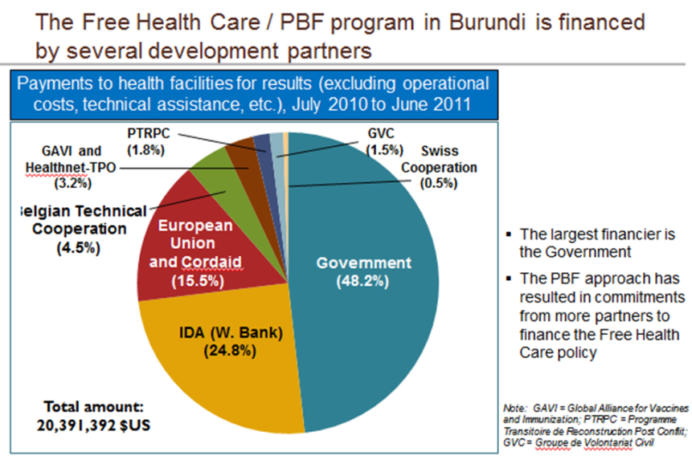
Where did funds come from to build the systems to oversee the P4P initiative?  (E.g. donor funds, government) | See table above

RESULTS AND CHALLENGES | BURUNDI
What results are available from the routine information system.  (e.g. service delivery, availability of (changes in key indicators over time). | A web-enabled database has been created and allows for accurate and transparent data collection, data analysis, strategic purchasing, contract management, and invoicing. Data on indicators, amount of services delivered, quality of services delivered, achievement of targets and health outcomes over time can be analyzed from data base.
Has the initiative been evaluated? If so, specify type of evaluation as well as summarize the results. | No impact evaluations have been conducted. A large longitudinal household survey (2006-2010) documenting changes in PBF and non-PBF provinces, is available. In addition, baseline nationwide surveys of households and health facilities were conducted just before the national rollout in April 2010. Furthermore, a comprehensive review overseen by a team of external experts (with precise recommendations provided) took place in September 2010. An independent expert visits Burundi once a year
Is there any other information that suggests whether the scheme is working and having impact. | A quality of care study carried out in March 2010, before the generalization of the PBF/fee exemption scheme, but when nine provinces were already running PBF pilots, showed that 43.9 percent of the health centers in the pilots suffered stock outs relative to 59.2 percent outside the pilots. At the hospital level, the contrast was even greater, 19% suffering stock outs within the pilots, and 31.8 percent outside
What are the top three challenges you have faced and how were they overcome? | 1) Sustainability was a major challenge but cost control measures were identified and tariffs reduced.  2) Making it national: challenge to agree with government and all different stakeholders on same framework.  3) Bank supervision: project requires intense Bank supervision but faces budget constraints. Team applied for Trust Funds to obtain additional sources for supervision.
What are the current plans for further scaling up the initiative and how is this going to be done? Are any changes anticipated in the scaled-up version of the initiative (if so, specify)? | There are no current plans for further scaling up due to financial constrains (no additional services can be added). No changes are anticipated in this initiative.

OVERVIEW | EGYPT
Title of initiative  Implementing and support agencies  (include contact information) | EGYPT: Payment for Performance (P4P) as part of the Health Sector Reform Program  Implemented by the Ministry of Health and Population with support from the European Union, USAID World Bank, African Development Bank
Statement of objectives of the initiative | The Payment for Performance (P4P) Scheme aimed to improve: i) inadequate antenatal care utilization levels; ii) low contraceptive use; iii) low rates of delivery with skilled attendant; iv) high child morbidity from diarrhea and respiratory infections; v) low immunization levels and low usage of integrated management of childhood illness programs; vi) low TB case detection and treatment completion rates; vii) high burdens of diabetes, hypertension, obesity, and addiction to drugs and tobacco; viii) high stigma around and low awareness of mental health issues.
List types of recipients of performance payments and numbers in each category.  (e.g.: health centers [5 public, 5 private]; CHMT, pregnant women) | No information available.
Population catchment area covered  (Nr. and % of districts and/or regions, and nr and % of the population covered) | 2001: 5 governorates
Start and end dates, any expansion that has taken place since original implementation | 2001: P4P was incorporated into reform initiative in the five governorates where health sector reform was being piloted.
Current cost per capita (covered population), of which: incentive payments per capita and administrative costs per capita | No information available.

INDICATORS, TARGETS AND PAYMENT RULES | EGYPT
Target Population(s)  (e.g.: women of childbearing age, pregnant women, children under 5, etc.) | Pregnant women, children, family planning, Tuberculosis (TB), immunization, chronic conditions.
Indicators that are rewarded:  BE SPECIFIC and describe the indicators for each type of recipient and target population | - Number of children fully vaccinated in the catchment area  - Number of new users of all types of modern contraceptive methods among married women of reproductive age in the catchment area  - Number of pregnant women receiving regular antenatal care visits compared to the total number of pregnant women in the catchment area  - Number of drugs per visit (target is less than 2)  - Rate of patient referral to the district hospital (target is between 1–8%)  - Number of visits per day (target is between 20 and 48)  - Rate of completion of visit encounter forms (target is over 98%)  - Rate of completion of medical records data (target is over 90%)  - Patient satisfaction rate (target is over 90%)  - Patient waiting time (target is less than 20 minutes)
Targets or Target setting rules if performance rewards are linked to achieving targets.  If fees for units of service provided, describe.  Specify rules for obtaining rewards. | Targets vary among health care facilities and depend on historic and future utilization patterns, demographic and epidemiological profiles of the population. However, some targets are the same, such as immunization rate which should be over 95 percent. Minimum target levels are set on the basis of national and governate program goals.
Payment mechanisms: amount for each indicator/target; frequency of payment; maximum amount for each recipient | The contract between the Family Health Fund and the contracted health facility agrees on the prices of services for each intervention in the Basic Benefit Package. The calculation for the payment is the following:  - Interventions that are part of the Basic Benefit Package are divided into two categories: i) visits (visit fee) and other interventions.  - Visits: To promote service utilization and improve efficiency of health care facilities, the rate is increasing the more visits/day.  To avoid unnecessary utilization, there is a maximum payment of five visits per working hour.  - For preventive care visits such as immunization, antenatal care, and family planning services, there is a slightly different fee and copayment structure that varies between$0.09 and $0.36 according to the type of visit/service and the category of health worker performing the service.  - Other interventions (dental services, laboratory investigations, and radiology) payments are made through transferring a percentage (40–60 percent) of the collected fees to the health care facility.  All the above amounts in claims (visit fees + preventive services + other interventions) are totaled and 60–70 percent of that amount is transferred to the health care facilities; the remaining 30-40 percent is paid against performance indicators and/or beneficiaries’ complaints to ensure the quality of service and client satisfaction.  In addition, a numerical score is being used in order to calculate the actual incentive to be disbursed to each provider. The score takes into account a weighting system that differentiates three categories of staff in a facility: health-care providers (physicians and nurses), administrative staff and clerks.
  First 10 visits/day | $0.18
  15 visits/day | $0.36
  20 visits/day | $0.55
  25 visits/day | $0.73
  30 visits/day | $0.91
Payment rules: rules for distribution within recipient category.  (e.g.; 25% to facility investment and 75% to individual workers according to following rule…) | If certain targets are being achieved by a health facility, the facility manager receives a cash payment which then will be distributed to the staff involved in achieving the target. Each facility has its own predetermined protocol, based on a point system, to determine which staff participated in achieving the goals. The point system is based on certain variables, such as qualifications, experience, number of days worked, and efforts made to achieve the indicators in each area.  The total of the payments made to the health care facility is divided by the sum of the points earned by the staff and multiplied by the number of points for each individual. This determines the amount of financial incentive each individual receives each month. All staff working in a health care facility receives a base salary, in addition to an incentive payment, and all health facility personnel (doctors, nurses, technicians, administrators, other health workers, and support staff) are eligible to receive incentives, which can account for as much as 250 percent of worker salary. Incentives are paid monthly and are determined according to the monthly supervision reports.  Each health care facility has the autonomy to use the incentive payments as deemed appropriate with no constraints. In addition to bonuses, transfers can be used to acquire inputs such as drugs, and medical and non-medical supplies. The District Health Authority may support health care facilities in this process.

REPORTING | EGYPT
Performance data reported by each recipient including: source of information, who receives reported information, frequency of reports | Health care facility reports amount of patients, type of services provided/indicators achieved to the Family Health Fund on a monthly basis. The Family Health Fund then audits the data, conducts analysis and requests payment from the Technical Support Office.
Is performance data part of the country’s DHIS? Is reporting part of the routine reporting system? Please describe. | Information systems, which have two major components, were developed for the Family Health Fund. The first component is the clinical information system which captures the utilization data of the beneficiaries. The second component is the Family Health Fund information system for managing the flow of funds and payments to providers.
Who receives reported performance data from each recipient. Please describe the systems used to track reported data and compare against targets. | Three supervisory teams from the Family Health Fund, the Directorate for Health at the governorate level, and the District Health Authority supervise health care facilities, monitor their activities, and report their achievements. One supervisor visits each facility on a monthly basis in order to determine performance indicators and if targets have been achieved.  - On a monthly basis health care facilities submit a list of enrollees and targets achieved to the Family Health Fund.  - Each quarter the Family Health Fund audits all documents that were submitted by health facilities and conducts random visits to confirm the validity of all documents submitted, accuracy of data provided and the application of all instructions and procedures stated in the operational manual.  - The Family Health Fund compiles and submits data on governorate level and facility level and a request for payment to the Technical Support Team and Technical Support Office.  - The Technical Support Team sends a copy of all the documents that were submitted by the Family Health Fund to an External Concurrent Auditor who conducts a technical audit. In addition, the Technical Support Team performs a random review of the documents submitted. The review aims to verify: i) all documents were prepared based on the instructions of the operations manual; ii) all poor and uninsured patients are certified by the Ministry of Social Solidarity (MOSS) and the Family Health Fund; iii) The list of the poor uninsured patients and the list of the uninsured patients excluding the poor do not include any duplicate names; iv) The signature of an enrolled patient in the enrolled register and the visit register match. In case there is any cancellation of this audit, a report with justification is prepared for each Family Health Fund.  - When the data validation process is completed, each Family Health Fund reviews the report to determine the actual achievement of targets and determine the size of the incentives to be paid to each health care facility.  This process generally takes two months after the end of each quarter.
Is there a system for internal verification? For example, do supervisors review and approve data before it is submitted? | No information available.
Is data verified by an external process? Please describe how this works? | Yes, data is verified by an external concurrent auditor. Please see two sections above point 4).
What is the time gap between reporting and issuance of performance payments? | There is an approximate time gap of two months.

MANAGEMENT AND FUNDING | EGYPT
Who has overall responsibility for management of the P4P scheme? | The Ministry of Health and Population through the Family Health Fund is responsible for the management of the P4P scheme.
How are recipients of the performance payments selected and who manages this?  (For example, do facilities have to meet preconditions? is there a competitive process? etc.) | Only facilities that are accredited can participate in the program.
Who designs the performance agreements/contracts?  (share a copy of a contract template) | The Family Health Fund with support from donors (mainly EU and World Bank) designed performance agreements between the Family Health Fund and health districts and facilities. The contracts are signed on an annual basis.
Who negotiates the terms of the performance agreements/contracts and who signs them? | The conditions and terms of the performance agreements are standardized but the targets differ.
Who monitors attainment of performance measures? Where does this system sit? How is it staffed? | The Technical Support Office monitors performance. It sits in the Ministry of Health and Population.
Who manages the contract with the external verifier? | The Technical Support Office
Do recipients have separate bank accounts? What are the processes to approve spending of performance payments?  (E.g. Who are the signatories? Are Health Facility Governing Committees involved? etc.) | Manager of health care facility receives cash payment and facility has autonomy how to use it.
Who transfers funds to recipients once performance information is verified? | Payments are transferred from the Technical Support Office (which sits within the Ministry of Health and Population) to the Family Health Fund which is responsible for managing the funds. A cash payment will then be made to the facility manager.
Where do the funds come from to pay the performance payments? (e.g. donor) | EU supported the funding of the incentives.
Where did funds come from to build the systems to oversee the P4P initiative?  (E.g. donor funds, government) | The Health Sector Reform Program, including the P4P program, was financed by USAID (USD$80 million), the World Bank (US$90 million), the EU (USD$120 million), and the African Development Bank (USD$14 million). The government contributed with about USD$100 million. The largest share of this funding was used for the rehabilitation and reorganization of the health service delivery system in the pilot governorates. Approximately USD$50 million from the EU were directly used to finance the P4P scheme.

RESULTS AND CHALLENGES | EGYPT
What results are available from the routine information system.  (e.g. service delivery, availability of (changes in key indicators over time). | Amount of services provided, performance of each health facility in regards to individual indicators, trend analyses, district-level data, etc.
Has the initiative been evaluated? If so, specify type of evaluation as well as summarize the results. | An evaluation conducted by McKinsey in 2007 found that the P4P model improved the quality of health care in participating health care facilities, particularly because only facilities that are accredited can participate in the program. Furthermore, it was found that health care providers were more satisfied in their jobs which led to lower turn-over rates. Supervision of health care facilities improved, and so did information and reporting systems among participating facilities.
Is there any other information that suggests whether the scheme is working and having impact. | World Bank assessment of the Health Sector Reform Program pilot found that a key strength of the P4P model was to include institutional indicators such as attainment of accreditation status, enrollment levels, and patient satisfaction. Furthermore, the assessment suggested that P4P resulted in a more responsive payer-provider relationship and introduced new and better behaviors and attitudes towards patients among providers.
What are the top three challenges you have faced and how were they overcome? | Providers only focused on quantitative targets and less on improving quality. Once this was realized, the list of indicators was expanded to include quality indicators as well.
What are the current plans for further scaling up the initiative and how is this going to be done? Are any changes anticipated in the scaled-up version of the initiative (if so, specify)? | The Ministry of Health and Population is proceeding with scaling up the pilot to other governorates through its own resources. However due to the end of EU funding, the government faces the challenge to mobilize sufficient resources to fully scale up the pilot. The government’s budget structure doesn’t allow for paying incentives to civil servants.

OVERVIEW | INDIA
Title of initiative  Implementing and support agencies  (include contact information) | Janani Suraksha Yojana (JSY) Program  The JSY program was designed as a part of the Reproductive and Child Health II (RCH II) program of the (Ministry of Health and Family Welfare) MOHFW, Government of India (GOI). The RCH II program was a key component of the National Rural Health Mission (NRHM) and was supported by a range of development partners, financially and technically. Three development partners pooled funds with the GOI (DfID, UNFPA and the World Bank) for the entire RCH II program, though JSY was not an eligible expenditure.
Statement of objectives of the initiative | The JSY program aims to reduce maternal and infant mortality through increasing institutional delivery and access, especially for poor women, to quality antenatal and postpartum health care.
List types of recipients of performance payments and numbers in each category.  (e.g.: health centers [5 public, 5 private]; CHMT, pregnant women) | Public and accredited private facilities across the country.
Population catchment area covered  (Nr. and % of districts and/or regions, and nr and % of the population covered) | All 28 states are covered by the program.  The program had 700,000 beneficiaries when it first started and by 2011 it reached more than ten million women every year.
Start and end dates, any expansion that has taken place since original implementation | The program was introduced in 2005 and merged the previous National Maternity Benefit Scheme (gave nutritional support to pregnant women) into the JSY program.
Current cost per capita (covered population), of which: incentive payments per capita and administrative costs per capita | Approximately 7 percent of central funds provided to states are used to cover administrative costs. At the district level, 1 percent and at the facility level 3 percent can be used for administrative costs.

INDICATORS, TARGETS AND PAYMENT RULES | INDIA
Target Population(s)  (e.g.: women of childbearing age, pregnant women, children under 5, etc.) | Pregnant women and infants.
Indicators that are rewarded:  BE SPECIFIC and describe the indicators for each type of recipient and target population | Payments for Performance (P4P) go to two different types of recipient:  - Women for receiving maternal and newborn health services at public or accredited private health facilities;  - Individual Accredited Social Health Activists (ASHA).  The states are divided into two categories. A) Low Performing States (LPS) and B) High Performing States (HPS). Eligibility criteria in those two categories are different. In LPS, all pregnant women who deliver in a public or accredited health facility are eligible to receive the financial incentive through the JSY program. In HPS pregnant women who are from a scheduled cast/tribe communities and pregnant women who are below the poverty line and older than 19 years are eligible. In 2006 the program was expanded and also started to include pregnant women who were above the poverty line. Incentives to ASHA are only being paid in LPS.
Targets or Target setting rules if performance rewards are linked to achieving targets.  If fees for units of service provided, describe.  Specify rules for obtaining rewards. | The Auxiliary Nurse Midwifes (ANMs) set monthly targets for institutional delivery for the village and design a work schedule for ASHAs to meet those targets.  According to the JSY guidelines, the indicators for measuring performance of the ASHAs are:  - Identify pregnant women as beneficiaries for the program and facilitating registration in the program.  - Assist pregnant woman in the process of obtaining necessary documentation  - Develop and following birth plans for enrolled women. (At least three ANC visits, including Tetanus Toxid injections and iron-foliate tablets).  - Identify a functioning government health center or an accredited private health center for referral and delivery.  - Provide counseling to promote institutional delivery.  - Escort the beneficiary to the predetermined health center and remain by her side until the woman is discharged.  - Arrange for immunization of the newborn from birth until 10 weeks.  - Inform Auxiliary Nurse Midwife about the birth or death of the child or mother when necessary.  - Arrange a postnatal visit within 7 days of delivery and track the mother’s health.  - Provide counseling for initiation of breast feeding within one hour of delivery and its continuance until 3-6 months, and promote family planning.  Payment to ASHA is only made if she accompanies pregnant woman to health facility and waits until discharge.
Payment mechanisms: amount for each indicator/target; frequency of payment; maximum amount for each recipient | Amount of payment depends on whether beneficiary is in LPS or HPS state and if district is rural or urban. Payments in rural areas are higher than in urban in order to compensate for higher transportation costs.
Payment rules: rules for distribution within recipient category.  (e.g.; 25% to facility investment and 75% to individual workers according to following rule…) | Doesn’t apply in this case.

REPORTING | INDIA
Performance data reported by each recipient including: source of information, who receives reported information, frequency of reports | On the seventh day of each month, the ANM submits a progress report to the Medical Officer of the primary or community health clinic. Block officers consolidate the reports and submit them to the district nodal officer. District composite reports, along with other financial reports, are submitted bi-annually to the nodal division of the government. The JSY Implementation Committee (IC) reports data and progress to the Government of India (GOI).
Is performance data part of the country’s DHIS? Is reporting part of the routine reporting system? Please describe. | Yes, it is. This is measured through the NRHM MIS and the HMIS.  http://nrhm.gov.in/
Who receives reported performance data from each recipient. Please describe the systems used to track reported data and compare against targets. | GOI
Is there a system for internal verification? For example, do supervisors review and approve data before it is submitted? | ANMs collect data and submit progress report to Medical Officer for verification.
Is data verified by an external process? Please describe how this works? | No, there is no external verifier.
What is the time gap between reporting and issuance of performance payments? | In general, poor women should be paid once discharged from hospital after delivery and community health worker has two installments. The first after delivery and the second after the house visit.

MANAGEMENT AND FUNDING | INDIA
Who has overall responsibility for management of the P4P scheme? | Ministry of Health and Family Welfare (MOHFW)
How are recipients of the performance payments selected and who manages this?  (For example, do facilities have to meet preconditions? is there a competitive process? etc.) | The priority target group is poor pregnant women, particularly those living in the 10 Low Performing States (LPS), as determined by health and demographic indicators and reported institutional birth rates. Community health workers have to identify eligible women. Private facilities go through accreditation process.  For each block (a defined geographic region within each district), the district government may accredit two private institutions. The GOI provides general criteria as an example for accreditation criteria, but it is left to the discretion of the state and district authorities to specify the criteria.  The district health authorities accredit facilities based on an assessment tool.
Who designs the performance agreements/contracts?  (share a copy of a contract template) | GOI
Who negotiates the terms of the performance agreements/contracts and who signs them? | Memorandum of Understanding is signed by District Health Society of each state.
Who monitors attainment of performance measures? Where does this system sit? How is it staffed? | District reports along with other financial reports are submitted bi-annually to the nodal division of the government
Who manages the contract with the external verifier? | There is no external verifier.
Do recipients have separate bank accounts? What are the processes to approve spending of performance payments?  (E.g. Who are the signatories? Are Health Facility Governing Committees involved? etc.) | At the beginning of the program all beneficiaries received their payments in cash. However, due to fraud issues, they now receive cheques since that way there is another written record of disbursement. Receiving the payment through a cheque was for some beneficiaries difficult since they had to open a bank account. Some states still make the payment partially in cash and by cheque.  The funds for the payments are kept in the facility’s sub-center bank account.
Who transfers funds to recipients once performance information is verified? | The appropriate district authorities deposit the payment into the health facility’s bank account. The mid-wife then pays the mother. The government recommends paying the ASHA in two installments, first at the delivery and second one month after the delivery when ASHA conducted home visit and ensured that newborn receives immunization.
Where do the funds come from to pay the performance payments? (e.g. donor) | GOI , the World Ban, DfID and UNFPA support the Reproductive and Child Health Program II (RCH II) of the Government of India, of which JSY is a key feature.
Where did funds come from to build the systems to oversee the P4P initiative?  (E.g. donor funds, government) | From the RCH II program that was funded by GOI and 3 pooling partners. Now states have to also contribute from their own budget. Districts submit financing requests to their counterparts on the state level which are then forwarded to the national government for annual budget planning

RESULTS AND CHALLENGES | INDIA
What results are available from the routine information system.  (e.g. service delivery, availability of (changes in key indicators over time). | Pregnant Women  Location Details (State, District, Block, Address)  Identification details (Name, DOB, Phone No, JSY, caste)  Health Provider details (HSC, ANM, ASHA, Linked facility for delivery)  ANC details (LMP, ANC dates, TT, IFA, Anemia, complications )  Pregnancy Outcome (Place, delivery date, JSY benefits)  PNC Details - dates  Infant details  Children  Location Details (State, District, Block, Address)  Identification details (Name, DOB, Phone No, JSY, caste)  Health Provider details (HSC, ANM, ASHA)  Immunization details (Dates for BCG, OPV, DPT, Hepatitis, Measles, MR Vit A)  https://nrhm-mis.nic.in/
Has the initiative been evaluated? If so, specify type of evaluation as well as summarize the results. | Yes, the Gates Foundation funded an Impact Evaluation which was conducted in 2010.  Data from the nationwide district-level household surveys done in 2002–04 and 2007–09 were used to assess receipt of financial assistance from JSY as a function of socioeconomic and demographic characteristics; and used three analytical approaches (matching, with-versus-without comparison, and differences in differences) to assess the effect of JSY on antenatal care, in-facility births, and perinatal, neonatal, and maternal deaths.  For JSY, the findings of this evaluation 2–3 years into the implementation of the program are encouraging. JSY has greatly increased the proportion of pregnant women delivering in a health facility. Furthermore, the findings suggest that the program is reducing perinatal and neonatal mortality; however, its effect on maternal mortality remains unknown. With the increased coverage of in facility delivery and the increased workloads for health personnel, the national and state governments need to intensify efforts to maintain and improve the quality of obstetric care available to women in health facilities to achieve their ultimate goal of reducing the numbers of neonatal and maternal deaths. Continued independent monitoring and evaluation of progress towards these goals is crucial in the coming years as the financial and political commitment to JSY intensifies. Therefore, the Government of India needs to consider investing in the development of appropriate mechanisms of data gathering, as part of the health information system, that will enable conclusive assessment on a continued basis as to whether JSY is resulting in a reduction in the numbers of neonatal and maternal deaths—ie, the ultimate goals of the program.
Is there any other information that suggests whether the scheme is working and having impact. | Assessments of the program in different states have been conducted. In 2007 a study in Rajasthan state (LPS) showed that the numbers of deliveries in public sector facilities increased by 36 percent during the first year of the program.
What are the top three challenges you have faced and how were they overcome? | 1. Payment mechanisms: The challenge was to balance the trade-off between fiduciary control and providing access to women at the point of delivery without much difficulty. Most of India, especially the high focus states have very poor access to banking or financial systems and hence cash payments were made at the beginning. This led to concerns whether this would actually reach the beneficiary and on leakages. After much debate, the system was moved to bearer cheques, which beneficiaries could issue at a bank branch, even if they did not hold an account. There was also electronic transfer of funds introduced in many states that also maintained a MIS in expenditures.  2. Supply side constraints: While there was increased demand generated, the supply side expansion in terms of functionality and quality were key concerns. These were raised as key issues during review missions and facility level surveys were conducted. States have since taken corrective steps in identifying basic 24X7 and referral facilities to upgrade them in terms of functionality, though quality still varies widely.  3. Grievance redress: Given the huge scale of such scheme, an effective grievance redress mechanism was envisaged but this took a long time to implement in many states. This still remains a huge concern.
What are the current plans for further scaling up the initiative and how is this going to be done? Are any changes anticipated in the scaled-up version of the initiative (if so, specify)? | There are no scaling up plans since it is already a country wide program.

Kenya
OVERVIEW | KENYA KfW Voucher Program | KENYA PBF World Bank
Title of initiative  Implementing and support agencies  (include contact information) | Kenya Voucher program implemented by the Government of Kenya and supported by BMZ (Federal Ministry for Economic Cooperation and Development), German Development Bank (KfW), IGES (Institut for Health and Social Research) and University of Berkley. | PBF Kenya implemented by the Government of Kenya and supported by DANIDA and the World Bank.
Statement of objectives of the initiative | The objectives of the voucher program are to offer quality reproductive health care services in five pilot sites for economically disadvantaged populations through a voucher system. The program aims to support the reduction of maternal and infant mortality rates in Kenya. The program sells safe motherhood vouchers and family planning vouchers and offers gender-based violence counseling vouchers for free (also for non-poor). | 1. To assess any change in Maternal Child Health (MCH) and reproductive health services utilization and quality of care at facilities implementing PBF compared to similar facilities in Samburu East and North Districts; and  2. To assess the impact of PBF on facility management compared to similar facilities in Samburu East and North Districts;
List types of recipients of performance payments and numbers in each category.  (e.g.: health centers [5 public, 5 private]; CHMT, pregnant women) | Phase 1: 54 facilities were accredited (public and private; 18 in Kisumu, 17 in Kiambu, 12 in Nairobi and 7 in Kitui)  Phase 2: 25 facilities were added (six in Kisumu, five in Kiambu, one in Nairobi and 13 in Kitui). Five facilities left the program during phase 2 (due to various reasons such as fraud or dissatisfaction with the level of reimbursement).  In total 10 hospitals were accredited to provide gender based violence voucher services.  Phase 3: A total of 150 contracted facilities in equal numbers from public and private sector in the counties of Kitui, Kiambu, Kisumu, Kalifi and Nairobi) | Samburu Central District, which had 18 Government of Kenya (GoK) dispensaries, 6 FBO dispensaries and 1 GoK health center at the launch in 2011
Population catchment area covered  (Nr. and % of districts and/or regions, and nr and % of the population covered) | In phase 1 the program included three rural districts and two slums in Nairobi and covered approximately 3 million people. In phase two four rural districts participated. | Samburu County, a county with significant geographic and socio-economic challenges.
Start and end dates, any expansion that has taken place since original implementation | 2005-2009: First Phase (Pilot)  2009-2012: Second Phase  Third Phase started in 2012 | Jan 2011, still ongoing
Current cost per capita (covered population), of which: incentive payments per capita and administrative costs per capita | Safe motherhood: 200 Ksh, $2.70  Family planning: 100 Ksh, $1.35  Administrative costs including VMA costs, voucher distribution, trainings, accreditation, audits, and evaluations:  Phase 1: 20 percent of the total costs  Phase 2: 27 percent of the total costs  Within the administrative costs for phase 2, the largest component is made up of VMA costs, accounting for 33 percent of total administrative costs, professional consulting services (28 percent) and costs associated with geographical expansion (17 percent). | No information available.

INDICATORS, TARGETS AND PAYMENT RULES | KENYA KfW Voucher Program | KENYA PBF World Bank
Target Population(s)  (e.g.: women of childbearing age, pregnant women, children under 5, etc.) | Poor women and children under the age of five. In order to target the poorest, voucher distributors assess potential future patients with a poverty grading tool on criteria ranging from housing, water sources and sanitation, to daily income, and number of meals per day.  Voucher services offered: (1) safe motherhood: antenatal care, facility-based deliveries and post-natal care (2) modern methods of long-term family planning | Poor pregnant women and children
Indicators that are rewarded:  BE SPECIFIC and describe the indicators for each type of recipient and target population | Safe Motherhood Services: basic essential obstetric care, comprehensive essential obstetric care, basic newborn care, comprehensive newborn care, ambulance/taxi charges, home to facility (emergencies such as ante-partum hemorrhage and eclampsia), facility to facility transfer for further management, maternal medical conditions: pre-eclampsia and eclampsia, hypertension in pregnancy, anemia in pregnancy, diabetes in pregnancy, cardiac disease in pregnancy, bad obstetric history, sickle cell disease in pregnancy, ante-partum hemorrhage, post-partum hemorrhage, puerperal sepsis, ectopic pregnancies, incomplete abortion, prevention of mother to child HIV-AIDS transmission in pregnancy and treatment of opportunistic infections, post-delivery care, family planning.  Family Planing Services: initial counseling and education on available family planning methods, method specific counseling (before and immediately after provision of services); explaining and demonstrating of use of condoms as well as other barrier methods by using visual aids; prescription and supply of family planning methods of choice; prescription, insertion and removal of IUCD; prescription, insertion and removal of Norplant/Jadelle Implants; voluntary surgical contraceptives (bilateral tubal ligation and vasectomy); social behavior associated with STI and HIV infections; follow-up counseling during return visits on level of satisfaction with use of contraceptive method; client assessment: Taking up relevant (medical) history and if considered necessary, a physical examination will be conducted.  Gender-Based Violence Recovery Services: Counseling; Emergency contraceptives; Post exposure prophylaxis (PEP) for HIV infection: The Kenyan guidelines on rape and sexual violence recommend a duo-therapy for 28 consecutive days; History taking, documentation and record keeping  During phases 1 and 2, only structural quality/facility preparedness, as measured through accreditation tools, was subject to reward/sanction, with the reward being to get the ability to participate in the program and thereby benefiting from reimbursement fees for providing health services to voucher patients.  During phase 1 and phase 2, the accreditation tools assessed several areas including i) facilities offered the services that were included in the voucher program; ii) structure itself met national standards; iii) necessary inputs were available and in operating condition; iv) basic standards of cleanliness and privacy existed; v) human resources were sufficient | Output indicators include:  1. Pregnant women receiving a least 4 ANC visits  2. Deliveries conducted by skilled health attendants in health facilities  3. Children under 1 year of age fully immunized  4. Women of reproductive age receiving FP commodities  5. Children under 5 years attending child wellness clinics (CWC) for growth monitoring  6. Population counseled and tested for HIV: voluntary counseling and testing (VCT), provider-initiated testing and counseling (PITC), and diagnostic testing and counseling (DTC)  - 10 clinical quality scores  - 22 cross-cutting quality scores
Targets or Target setting rules if performance rewards are linked to achieving targets.  If fees for units of service provided, describe.  Specify rules for obtaining rewards. | $13 for prenatal care  $66 for normal delivery  $276 for complicated delivery (incl. caesarean)  $13 - $39 for family planning, depending on method | Incentives for aggregated service delivery are quality-adjusted and paid on a quarterly basis.  Data are essentially facility-level indicators of outputs and quality. Payments are not based on generating new users who would not likely have used service in the absence of the subsidy.
Payment mechanisms: amount for each indicator/target; frequency of payment; maximum amount for each recipient | The actual reimbursement rates are negotiated with each service provider individually based on the respective cost situation. In the case of additional expense due to medical complications, the health facility must provide adequate documentation in order for them to be covered by the VMA. Payment occurs 30 days after submission of documents from facilities to VMA. | Incentives for aggregated service delivery are quality-adjusted and paid on a quarterly basis.  Data are essentially facility-level indicators of outputs and quality. Payments are not based on generating new users who would not likely have used service in the absence of the subsidy.
Payment rules: rules for distribution within recipient category.  (e.g.; 25% to facility investment and 75% to individual workers according to following rule…) | There are no rules on how health care providers use the profit, but many use funds to upgrade or expand facilities, buy equipment and hire new staff. | PBF payment will supplement funding for operations and maintenance costs provided by HSSF and should not exceed annual HSSF contribution (< KSH 225,000/year for dispensaries, < KSH 450,000 for health centers).  No additional information was available.
REPORTING | KENAY KfW Voucher Program | KENYA PBF World Bank
Performance data reported by each recipient including: source of information, who receives reported information, frequency of reports | Once services are administered, providers submit their vouchers to the Voucher Management Agency (VMA) for reimbursement. One of the tasks of the VMA is to set up claims processing software that calculates and monitors services rendered by each provider and automatically processes payments to providers. The claims processing software checks claims for completeness and plausibility according to specified criteria and then flags any suspected false or fraudulent claims. | Facilities report data to District Health Management Team (DHMT) by the 5th of each month. DHMT reports data to Provincial Health Management Team (PHMT). Data is essentially facility-level indicators of outputs and quality.
Is performance data part of the country’s DHIS? Is reporting part of the routine reporting system? Please describe. | No information available. | The output and quality indicators are in line with priorities of the Division of Primary Health Services (DPHS) in the MoPHS and currently captured in the Health Management Information System (HMIS). Six key output indicators of PBF are recorded through the DHIS. The PBF report is then send to HSSF Secretariat.
Who receives reported performance data from each recipient. Please describe the systems used to track reported data and compare against targets. | Price Waterhouse Cooper (PWC) was selected as VMA primarily due to its financial management and auditing expertise, which comprises fraud monitoring and the ability and experience to design and implement reimbursement systems. PWC uses a database to track technical and financial information from claims and connect claims data with reimbursements and voucher distribution data. By looking at data from different sources, the data base serves as a monitoring tool to prevent fraud by providers or distributers. Furthermore, PWC and MSIU field staff visit providers and distributors and also conducts home visits to voucher recipients to detect fraud. In addition to this, PWC also conducts client exit interviews and compares responses with provider claims. | Facilities report data to District Health Management Team (DHMT) by the 5th of each month. The purchaser is the Provincial Health Management Team (PHMT, later the County HMT). The purchaser enters into performance contracts with each health facility participating in the PBF pilot.
Is there a system for internal verification? For example, do supervisors review and approve data before it is submitted? | Before documents arrive at the central VMA office, the VMA field manager verifies the record of sold vouchers against the number of vouchers that were initially distributed to the distributors for sale. | No
Is data verified by an external process? Please describe how this works? | Data is only verified by PWC who acts as VMA in the program. PWC uses a database to track technical and financial information from claims and connect claims data with reimbursements and voucher distribution data. | Quarterly DHMT verification visits are made to each facility to confirm infrastructure, equipment, and overall facility readiness
What is the time gap between reporting and issuance of performance payments? | Payment should happen within a month of presenting claims with proper documentation. | Incentives for aggregated service delivery are quality-adjusted and paid on a quarterly basis.

MANAGEMENT AND FUNDING | KENYA KfW Voucher Program | KENYA PBF World Bank
Who has overall responsibility for management of the P4P scheme? | The VMA administers the program and has the following main responsibilities: i) accrediting providers; ii) contracting providers upon successful accreditation; iii) ensuring quality care by means of regular (e.g. quarterly) quality monitoring; iv) distributing vouchers to clients, for example VMA trained community based distributors; v) marketing and raising awareness of the voucher system to the target population; vi) targeting a specific segment of the population, where applicable, and processing provider claims and conducting fraud control.  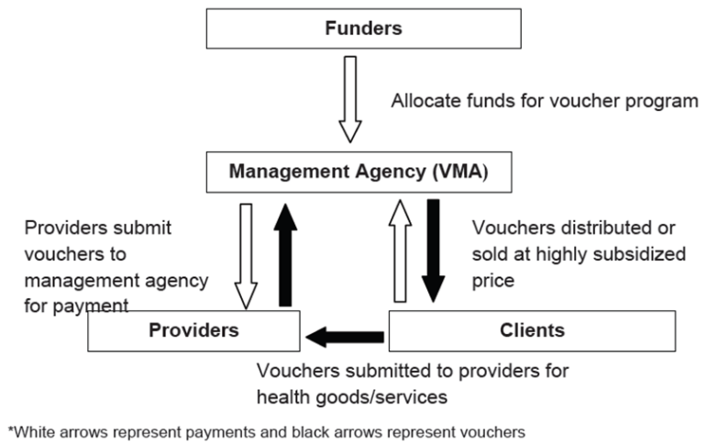 | Pilot is managed by the Division of Primary Health in coordination with the HSSF Secretariat. Division of Primary Health Services (DPH) reports to Director, Ministry of Public Health and Sanitation (MOPHS).
How are recipients of the performance payments selected and who manages this?  (For example, do facilities have to meet preconditions? is there a competitive process? etc.) | Service providers in project districts were mapped by independent consultants who were contracted to identify eligible providers and generate information on their capacity to deliver voucher services. Providers (public and private) who met pre-specified commercial, administrative and technical criteria which include infrastructure, equipment, and staffing requirements were accredited and invited to join the voucher programs. Providers who accepted were formally contracted by the VMA through contracts which specify reimbursement rates, quality, monitoring, and reporting protocols with which the providers must comply. Providers also have to participate in training in order to improve quality of services.  During phase 1 the National Hospital Insurance Fund (NHIF), (responsible for accrediting hospitals in Kenya) was contracted to accredit facilities. The NHIF developed special accreditation tools, which measured facilities using standards based on internationally recognized accreditation schemes, but these tools, were not specifically focused on reproductive health services. Furthermore, in Phase 1, a number of facilities that fell slightly short of the required accreditation standards were admitted to the scheme with a plan of activities in place to improve quality over a given time frame.  In 2008, the accreditation responsibility was given to a committee assembled by the Ministry of Public Health and Sanitation’s (MOPHS) Division of Reproductive Health and consisted of members from the Nursing Council of Kenya, Clinical Officers Council of Kenya, Medical Practitioners and Dentist Board, the Division of Reproductive Health, and the VMA, PricewaterhouseCoopers (PwC). The committee also adapted the NHIF tools but made them specific to reproductive health. Facilities are being evaluated in terms of human resources, drugs, operating theaters, infection prevention, referral protocol, sexual violence recovery services, equipment, and infrastructure. | All public facilities are allowed to participate because they are government-owned; there is no accreditation requirement. FBOs were permitted following a policy review.  PBF intentionally launched in Samburu Central to serve the often neglected Northern Arid Lands. No beneficiary identification is done.
Who designs the performance agreements/contracts?  (share a copy of a contract template) | Government and Donor | District Commissioner is responsible for the (i) signing of PBF agreements with health facilities and the approval of the performance reports.(ii) Signing the agreements with the internal verification team (PHMT & DHMT), the counter verification organizations (local NGOs) This consist of: (i) monthly verification of registers at health facility level; (ii) development of contracts with grassroots level NGOS for the counter-verification of health facility results; (iii) coaching & training of health facilities in using the business plans and the indices management instrument.
Who negotiates the terms of the performance agreements/contracts and who signs them? | The VMA identifies potential facilities, oversees means testing to determine patients eligible for subsidies through vouchers, manages contracts and voucher distributors, processes claims, and disburses reimbursements. Patient surveys are used to verify eligibility of patients, and claims are scrutinized by medics for irregularities. Once voucher claims have been verified, facilities receive fees for services delivered, which they can then use to reinvest in the facility. | County Health Management Teams. Purchasing is agreed to in MOU between facility and CHMT.
Who monitors attainment of performance measures? Where does this system sit? How is it staffed? | The VMA is responsible for monitoring quality of care. The PWC acts as VMA and has a team of experienced employees. (In order to see where VMA/PWC sits please see graph in reporting section). | Reporting systems managed by Health Sector Services Fund (HSSF). Joint verification teams visit PBF and control facilities quarterly measure “cross cutting” quality, measure clinical quality linked to PBF indicators, and record PBF outputs in facility registers  In case there are discrepancies in HMIS and joint verification team visits, they are settled by accepting only verification data. Ideally, sufficiently detailed identification should be available to permit follow-up in the community. Participating implementing partners in the future may perform community-based verification.  Quarterly data is verified at the health facility by reviewing records (routine quality data audit for all services purchased).
Who manages the contract with the external verifier? | There is no external verifier. | There is no external verifier.
Do recipients have separate bank accounts? What are the processes to approve spending of performance payments?  (E.g. Who are the signatories? Are Health Facility Governing Committees involved? etc.) | Public facilities get reimbursed through the district health office although under new health sector reforms, they have begun to open bank accounts and manage their own finances. Private facilities receive transfer on bank account. | No information available.
Who transfers funds to recipients once performance information is verified? | Once services are being provided and vouchers received, providers submit their vouchers, completed service claim form, discharge summary or medical report, copy of patient’s identification card, and the original statement of account on the invoices to the VMA for reimbursement. One of the tasks of the VMA is to set up claims processing software that calculates and monitors services rendered by each provider and automatically processes payments to providers. The claims processing software checks claims for completeness and plausibility according to specified criteria and then flags any suspected false or fraudulent claims | The HSSF Secretariat transfers funds to facilities, district commissioner and Provincial Health Management Team (PHMT) and District Health Management Team (DHMT).
Where do the funds come from to pay the performance payments? (e.g. donor) | The program is financed by the German Development Bank (KfW) with US$8.4 million for phase I (2005-2008), and $13 million for phase II (2008-2012). The scheme is currently undergoing a redesign in which new providers will be contracted and service packages developed. | Derived from World Bank loan to GoK
Where did funds come from to build the systems to oversee the P4P initiative?  (E.g. donor funds, government) | Donor Funds and Treasury | Derived from World Bank loan to GoK
RESULTS AND CHALLENGES | KENYA KfW Voucher Program | KENYA PBF World Bank
What results are available from the routine information system. (e.g. service delivery, availability of (changes in key indicators over time). | Data are based individual claims for single episodes at facility. Claims contain client identifiers, clinical details, and service costs. | Aggregate HMIS data already routinely collected.  Data are essentially facility-level indicators of outputs and quality. Payments are not based on generating new users who would not likely have used service in the absence of the subsidy.
Has the initiative been evaluated? If so, specify type of evaluation as well as summarize the results. | Several assessments have been conducted but no formal Impact Evaluation | No impact evaluation but a verification has been conducted and a comprehensive evaluation, conducted by an external agency, has been proposed but this will not be an impact evaluation.
Is there any other information that suggests whether the scheme is working and having impact. | - Enhanced accountability in program management.  - Use of provincial administration vital for creating awareness and for distribution.  - Use of poverty grading tool ensured appropriate targeting of the poor.  - Instances of leakage to non-poor women.  - Lack of adherence to guidelines by providers partly contributed to delays in claims processing and reimbursement.  - Staff transfers posed additional challenges to the claims and reimbursement process.  - Improved capital investment at the facility level.  - Public health facilities faced challenges utilizing money from the program to improve service quality.  - Average per visit reimbursement rates remained constant 2006-2010 but slightly higher in private facilities.  - Some private providers felt that the reimbursable amount was not enough  - Greater use of services by poor women from communities near voucher facilities.  - Distance to the accredited facilities and lack of support for transport posed challenges to some voucher clients.  - Reduced socio-economic inequities in service utilization among voucher clients. | Two rounds of facility-based verification of the PBF pilot program in Samburu County have been conducted covered three quarters: October-December 2011, January-March 2012, and April-June 2012. The verification activities compared output and quality indicators in the 24 dispensaries and 2 health centers in Samburu Central District with 11 control dispensaries in Samburu North. Major findings include:  1. Remarkable discrepancies between the data reported in the District Health Information System (DHIS) and data verified in the facility registers during each quarter.  2. According to DHIS data, there was increased achievement of several PBF output indicators (antenatal care, deliveries at health facilities, and immunization services) while the number of women receiving contraceptives and the number of people tested and counseled for HIV declined during the first two quarters.  3. According to the verification data, use of antenatal care and child welfare services showed consistent increases during the first three quarters of PBF.  4. Average utilization of antenatal care and child welfare services consistently increased in PBF facilities during the three quarters while non-PBF facilities experienced declining trends in these indicators during the first two quarters before slightly increasing during the third quarter.  5. Consistent improvements in the average clinical quality scores for family planning, antenatal care, child welfare services, and HIV counseling and testing during the three quarters. In addition, the average cross-cutting quality score consistently improved during the same period.  6. There were significant administrative challenges that delayed the implement the program and management costs were higher than would be expected if the project were implemented in a region more accessible to the province and national levels.  7. Verification costs were initially budgeted at 50% of the value of the total PBF disbursement for that quarter. Careful review of the budget reduced that cost to 22% of the first PBF disbursement. However, future verification in the communities will present a new challenge to collect information cost-effectively.
What are the top three challenges you have faced and how were they overcome? | - During the first two years of phase 1, distributors from non-governmental organizations (NGOs) were used distribute vouchers. These distributors received a commission for each voucher sold which led to vouchers being sold to non-eligible (non-poor) women. This strategy was abandoned and in the final year of the phase, vouchers were sold through salaried distributors.  - Getting government buy-in for RBF in a functional health system.  - Implementing RBF in a very remote and hard to reach area. | Getting government buy-in for RBF in a functional health system. Implementing RBF in a very remote and hard to reach area.
What are the current plans for further scaling up the initiative and how is this going to be done? Are any changes anticipated in the scaled-up version of the initiative (if so, specify)? | No information available. | The program is now being scaled up to 3 more counties. Further expansion is envisaged using the HRITF steam 1 grant and GAVI HSS grant.

OVERVIEW | RWANDA
Title of initiative  Implementing and support agencies  (include contact information) | Rwanda Payment For Performance (PFP)  Ministry of Health with the support of development partners: Belgium, United States (PEPFAR), World Bank, CORDAID, HealthNet, TPO, BTC, Management Science for Health  Ministry of Health  Address: P.O. Box 84 Kigali, Rwanda  Telephone: +250 577458
Statement of objectives of the initiative | 1) Focus on maternal and child health (MDGs 4 & 5); 2) Increase quantity and quality of health services provided; 3) Increase health worker motivation.
List types of recipients of performance payments and numbers in each category.  (e.g.: health centers [5 public, 5 private]; CHMT, pregnant women) | Health facilities and hospitals across the country.  Special focus on pregnant women and children.
Population catchment area covered  (Nr. and % of districts and/or regions, and nr and % of the population covered) | Nationwide in 2008. Population of Rwanda: 10,942,950 (2011)
Start and end dates, any expansion that has taken place since original implementation | - The Cyangugu Performance Based Financing (PBF) pilot by Cordaid/Memisai in the former Cyangugu province in 2002 covered a total population of 620,000. 26 health centers (with 14 health posts and 19 private dispensaries as second-tier contracts) and four district hospitals participated in the scheme.  - The Butare PBF pilot by HNI-TPOii in the former Butare province in 2002 covered a total population of 384,209 and 36 health centers and (later) 3 district hospitals.  - The Kigali Ngali PBF pilot by the BTCiii in five central provinces in 2005 covered a total population of 1,402,306 people. The project worked in 75 health centers and four district hospitals.  Based on lessons from these initial pilots, the government adopted a performance based approach as a national policy in 2005. Its scale-up plan to reach national coverage was promptly launched, with a targeted completion date of May 2008.
Current cost per capita (covered population), of which: incentive payments per capita and administrative costs per capita | The information available now is related to the cost to purchase indicators (2012 figures):  1.52 US$ per capita for the health facilities PBF (which include basic health care services indicators, HIV/AIDS indicators, TB and complementary services at district hospitals level indicators)  0.72 US $ per capita for the community PBF (which go the CHW through their cooperatives).  Administrative cost: There is only partial information available on the overhead costs of the entire PBF system. According to the 2007 PBF budget, the total overhead costs amount to over 20%.

INDICATORS, TARGETS AND PAYMENT RULES | RWANDA
Target Population(s)  (e.g.: women of childbearing age, pregnant women, children under 5, etc.) | Pregnant women and children in order to reduce maternal and child mortality.
Indicators that are rewarded:  BE SPECIFIC and describe the indicators for each type of recipient and target population | 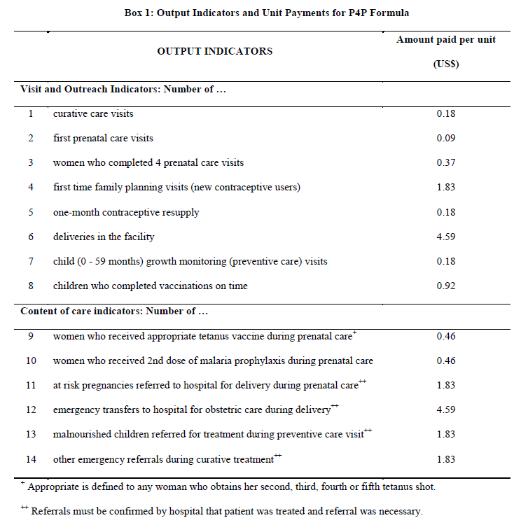  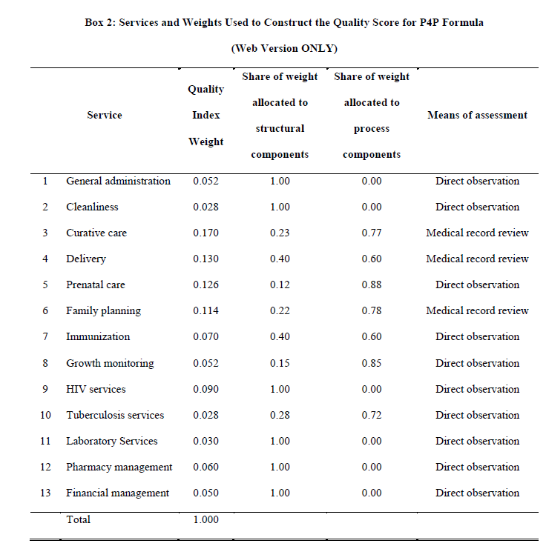  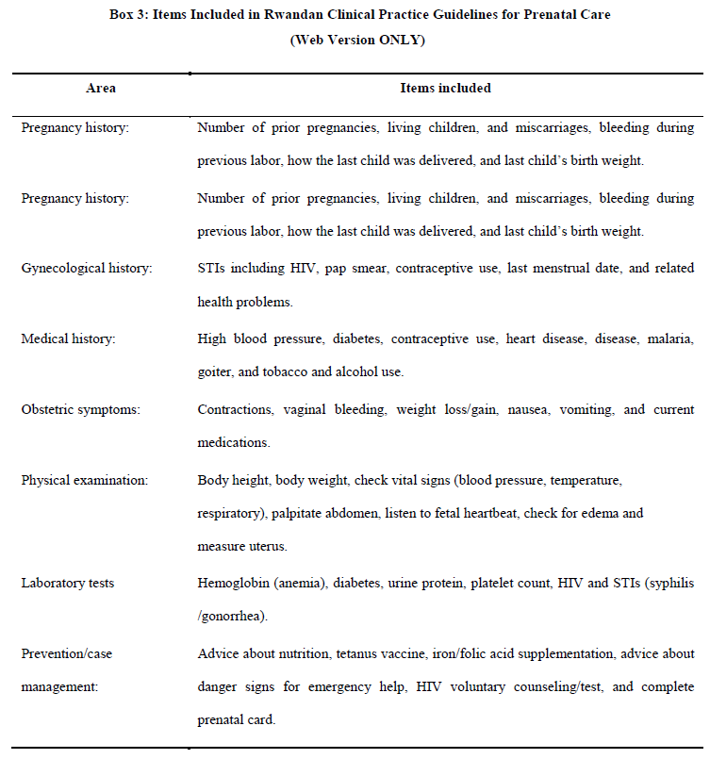
Targets or Target setting rules if performance rewards are linked to achieving targets.  If fees for units of service provided, describe.  Specify rules for obtaining rewards. | Health Centers get reimbursed for the quantity of health services provided according to a standardized fee structure for a list of fourteen services, adjusted by a composite quality score. Health centers can increase revenues by providing more services and improving the quality. The bonus payments are calculated as follows: Health center (Performance Based Financing) PBF earnings = (fees*quantity) * (% quality score)  Quality is assessed quarterly by a team from the district hospital using a supervisory check list that measures 13 services and 185 variables. A score of 100 percent would provide health centers with their full payment. Scores of less than 100 percent discount the payment proportionately.  Quality at hospitals is assessed through a peer review system (a team from a peer hospital assesses the quality of another similar hospital). Hospitals are provided points for achievements along a checklist of fifty one composite indicators organized into three main categories: 1) administration, 2) quality assurance, 3) clinical activities. All hospitals have a specific point value (as determined by their individual prospective global budgets), and 100 percent performance is equivalent to the maximum number of points that can be gained. Roughly 30 percent of the budget is allocated for outputs, 30 percent for quality, and 20 percent for administration. Hospitals that provide HIV/Aids services have the opportunity to earn additional revenues by providing HIV/Aids services included on a specific list. These added revenues are calculated by multiplying the quantity of each service on a list by the assigned fee, discounted by the quality score assigned to the hospital in that quarter.
Payment mechanisms: amount for each indicator/target; frequency of payment; maximum amount for each recipient | Fee structure is standardized and a certain amount is paid per unit. Please see Box 1 above. Hospital budgets are determined prospectively, based on an annual value of about $600 per bed.
Payment rules: rules for distribution within recipient category.  (e.g.; 25% to facility investment and 75% to individual workers according to following rule…) | A ministerial guideline was published in April 2007 to regulate and clarify payment practices of bonuses to health workers. A minimum of 25 percent has to be used for investment and staff capacity building. However, this is differs among facilities depending on the operational and business plan.

REPORTING | RWANDA
Performance data reported by each recipient including: source of information, who receives reported information, frequency of reports | - The health facility management reports the quantity or volume of services (primarily preventive) provided in a month in a PBF invoice.  - Once a quarter a member of the District Hospital supervisory team, using a checklist assesses and scores the performance related to the quality of the conditions to provide care.  - The District PBF Steering Committee (made up of representatives of civil society, technical assistants from NGO/fund holders, MOH district and local government, the district AIDS commission, and delegations of public and faith-based managed health centers) meets quarterly to reconcile the electronic and paper versions of the data
Is performance data part of the country’s DHIS? Is reporting part of the routine reporting system? Please describe. | Data entry and retrieval are performed through the Internet. PBF assessment data is collected through the routine reporting tools (registers and files). Only PBF assessment results are reported through a separate reporting system (that allows automatically producing invoices and financial information about facilities like bank account for the payment and allowing the consolidation of quantitative and qualitative results). However, Rwanda is in the transition to implement the DHIS-2 platform with the aim to move all different health programs database including PBF database into the same DIHS-2 platform.
Who receives reported performance data from each recipient. Please describe the systems used to track reported data and compare against targets. | The P4P approach has multiple interlinked performance frameworks:  1) At the health center level (fee for service conditional on quality of care);  2) At the district hospital (including the performance based execution of the quality controls at the health centers), this a balanced score card approach  3) For the district PBF steering committee  4) For the national MOH project support unit  The health facility management reports the quantity or volume of services (primarily preventive) provided in a month in a PBF invoice. There are about twenty-four services that are purchased: 14 from the basic package of health services, and ten HIV services. The facility in-charge and the President of the Health Management Committee, a community representative, together confirm the accuracy of the invoice and sign it before sending it to district level. At district level, a health “controller” from the local government office visits the health facility to ascertain the accuracy of the invoice by comparing it to the data in the registers. Each purchased service has its own primary register, such as a Voluntary Counseling and Testing (VCT) register. Secondary registers, such as a laboratory register for VCT testing), can be used when problems arise with the primary register.  Once a quarter a member of the District Hospital supervisory team, using a checklist assesses and scores the performance related to the quality of the conditions to provide care. The reason for separating the internal verification of quantity and quality of services is to ensure the involvement of both local government authorities and the district health management team, with the aim of lessening the potential for conflict of interest and to ensure a balance of power in the district health system. The clinic invoice data and summary results from the quality checklists are then entered at district level into a web-based, real time PBF management information system to calculate entitlement. The system also provides a set of tools that allow comparisons of district performance. Each district can view the performance of other districts.  The District PBF Steering Committee (made up of representatives of civil society, technical assistants from NGO/fund holders, MOH district and local government, the district AIDS commission, and delegations of public and faith-based managed health centers) meets quarterly to reconcile the electronic and paper versions of the data. The Steering Committee also discusses numerous issues related to the performance of the health facilities as well as other health-related matters. Upon a satisfactory reconciliation, the Committee sends a request for payment to the relevant fund holders.  Following a rapid confirmation that all procedures have been followed appropriately, the fund holders pay the invoice. Upon receipt of payment, the Committee deposits the funds into the bank accounts of the individual health facilities. The payment cycle is quarterly. The health facilities follow standard rules and regulations that help them convert these earnings into performance bonuses, which they distribute monthly. The Committee is held accountable for its actions through a multi-lateral contract with the district mayor. The Committee has become the most important decentralized district planning platform for health in Rwanda.
Is there a system for internal verification? For example, do supervisors review and approve data before it is submitted? | Yes. The facility in-charge and the President of the Health Management Committee, a community representative, together confirm the accuracy of the invoice and sign it before sending it to district level.
Is data verified by an external process? Please describe how this works? | Every quarter, a third-party agent, contracted by one fund holder, validates that services reported to have been delivered were actually received by patients (ex post verification). The agent applies a standard protocol that incorporates a multi-stage, random sampling methodology. Districts and facilities are chosen, using a random number generator, during a plenary meeting with representatives of the MOH and civil society. Four (of 30) districts are randomly selected and 25% of health facilities in these districts are chosen. At the health center level, three services from the basic health package and three HIV services are chosen randomly (from a total of 24 purchased services). Six services from the basic packages are chosen when no HIV services are provided. Using the primary patient registers, six months’ worth of services are selected, and 15 clients are randomly selected. The agent compares “reported” services (drawn from the registers) with “paid” services (drawn from the electronic invoice system). A grassroots organization, preferably consisting of people living with HIV, is selected from the catchment area of the health center (according to a set of objective criteria) to follow patients. For each client traced and interviewed in the community, the organization receives $2. Data are compiled and entered in a database (EPIINFO). Feedback is provided at community, district and central levels. Semi-annually, the degree of accuracy of the quality checklist is also verified (ex post). The evaluation is conducted by a group of technical assistants from a national coordinating body, which is predominately staffed by non-state actors.
What is the time gap between reporting and issuance of performance payments? | The payment cycle is quarterly. The time gap between reporting and issuance of payment is 42 days.

MANAGEMENT AND FUNDING | RWANDA
Who has overall responsibility for management of the P4P scheme? | Performance-Based Financing Support Cell (Cellule d’Appui a l’Approche Contractuelle)/MoH
How are recipients of the performance payments selected and who manages this?  (For example, do facilities have to meet preconditions? is there a competitive process? etc.) | National Program
Who designs the performance agreements/contracts?  (share a copy of a contract template) | MoH (Contract sample on page 69 attached at bottom of this document)
Who negotiates the terms of the performance agreements/contracts and who signs them? | District steering committees negotiate three types of performance contracts: 1) between the Ministry of Health and the thirty administrative districts. 2) Performance contracts between the steering committees and the health center management committees. 3) Motivation contracts between the health center committees and individual health workers.
Who monitors attainment of performance measures? Where does this system sit? How is it staffed? | The district hospital team checks quality on a quarterly basis. The PBF steering committees validate invoices quarterly. Data are validated by specially trained data agents from the district health department (under the Ministry of Local Administration) or from a specially designated team from the district hospital. The PBF steering committees validate bills and send them to the Ministry of Health to approve quarterly payments, through the Ministry of Finance, into health center bank accounts.
Who manages the contract with the external verifier? | The fund holders are mandated by the MOH to contract a third party and the MOH is involved in the negotiations of the output-based contract with the third party.
Do recipients have separate bank accounts? What are the processes to approve spending of performance payments?  (E.g. Who are the signatories? Are Health Facility Governing Committees involved? etc.) | Both government and other purchasers use the same health facility bank accounts to transfer quarterly payments. PBF steering committee validates bills and sends them to the Ministry of Health to approve quarterly district payments, through the Ministry of Finance, into health center bank accounts.
Who transfers funds to recipients once performance information is verified? | The MoH through the Ministry of Finance into health center bank accounts
Where do the funds come from to pay the performance payments? (e.g. donor) | For clinical PBF, 41 percent of the total budget is from the government and 59 percent is from donors (mainly global fund, USAID and CDC). Donors are much more involved in paying programs indicators (HIV, TB) and the government the general packages indicators.
Where did funds come from to build the systems to oversee the P4P initiative?  (E.g. donor funds, government) | Donor funds (several NGOs and World Bank) and Government

RESULTS AND CHALLENGES | RWANDA
What results are available from the routine information system.  (e.g. service delivery, availability of (changes in key indicators over time). | The Government and stakeholders selected two types of indicators: quantity and quality indicators. Quantity indicators have two subsets: 1) 14 core for general basic health package services (such as: curative consultations, immunization, family planning, etc.) and 2) 10 HIV specific indicators related to voluntary counseling and testing, prevention of mother- to-child transmission, ARVs, and TB/HIV interventions. There are about 140 quality indicators that cover areas from general management of health facilities (hygiene, financial management, drug management, etc.) to quality of specific clinical interventions (family planning, curative consultation, immunization, referrals, etc.).
Has the initiative been evaluated? If so, specify type of evaluation as well as summarize the results. | Evaluation Study by World Bank:  The data were collected from 166 facilities and a random sample of 2158 households. P4P had a large and significant positive impact on institutional deliveries and preventive care visits by young children, and improved quality of prenatal care. The authors find no effect on the number of prenatal care visits or on immunization rates. P4P had the greatest effect on those services that had the highest payment rates and needed the lowest provider effort. P4P financial performance incentives can improve both the use of and the quality of health services. Because the analysis isolates the incentive effect from the resource effect in P4P, the results indicate that an equal amount of financial resources without the incentives would not have achieved the same gain in outcomes.
Is there any other information that suggests whether the scheme is working and having impact. | Yes, see section above on World Bank Evaluation Study.
What are the top three challenges you have faced and how were they overcome? | - Once the P4P was scaled up nationwide, a big challenge was to agree on one model since there were many competing models.  - Sustainability: When P4P started donors were the major funders of the programs but now more and more the Government is taking responsibility.  - The third challenge was how to implement a verification mechanism, which is not parallel to the existing health information system. The challenge was overcome. MSH was instrumental in building a website that captured all this information in one place. The information is flowing back and forth and it has become powerful. Data from the health districts are input and the committee reviews it—and, once the results are approved, the money is automatically transferred into each health facility account. The web platform also increases the availability of real-time data to improve reporting and compare results.
What are the current plans for further scaling up the initiative and how is this going to be done? Are any changes anticipated in the scaled-up version of the initiative (if so, specify)? | There are no current plans for scaling up.

OVERVIEW | TURKEY
Title of initiative  Implementing and support agencies  (include contact information) | Performance-Based Supplementary Payment System (PBSP)  Implemented by the Ministry of Health of Turkey
Statement of objectives of the initiative | The main objective of the PBSP system is to encourage job motivation and productivity among public sector health personnel.
List types of recipients of performance payments and numbers in each category.  (e.g.: health centers [5 public, 5 private]; CHMT, pregnant women) | Initially piloted in 10 hospitals and one provincial health directorate and later expanded to all Ministry of Health (MoH) facilities. All 850 MoH hospitals and approximately 6000 primary health-care facilities have implemented the PBSP system (University and military hospitals don’t participate).
Population catchment area covered  (Nr. and % of districts and/or regions, and nr and % of the population covered) | Entire country
Start and end dates, any expansion that has taken place since original implementation | The pilot started in 2003 and was expanded to all public health facilities in 2004.
Current cost per capita (covered population), of which: incentive payments per capita and administrative costs per capita | In 2011 per capita cost for primary health care was approximately $13 USD. 20 percent was allocated towards performance. Performance payments are not additional to the per capita allocation. Cost per capita for hospital performance is not available.

INDICATORS, TARGETS AND PAYMENT RULES | TURKEY
Target Population(s)  (e.g.: women of childbearing age, pregnant women, children under 5, etc.) | Mainly medical doctors but also nurses.
Indicators that are rewarded:  BE SPECIFIC and describe the indicators for each type of recipient and target population | The system has identified 5 300 different medical procedures with different coefficients based on the difficulty of the procedure and the time it demands. In 2005 the MoH established five categories of indicators to measure the institutional performance of hospitals, each of which carry equal weight: i) access to examination rooms; ii) hospital infrastructure and process; iii) patient and caregiver satisfaction; iv) institutional productivity (bed occupancy, average length of stay); and v) institutional service targets (caesarian-section rate, share of doctors working full time, surgery points per surgeon and per operating room, and the reporting of scores for the performance monitoring system to the MoH). (See table at the end of document).  For primary health care facilities, the provision of preventive services was added to the measurement of performance in addition to curative services.
Targets or Target setting rules if performance rewards are linked to achieving targets.  If fees for units of service provided, describe.  Specify rules for obtaining rewards. | Individual bonuses for staff are capped at a certain multiple of basic salary.  The total (capped) amount is subsequently adjusted based on institutional performance of the hospital (0-1).  An individual level performance score is calculated for each staff member.  Total points score for a physician is adjusted by a job title coefficient  Individual performance measure:  - Each service is rated with a score  - Each clinician collects scores from his/her tasks (load of service)  The total points score for a physician is adjusted by: i) a job title coefficient: to measure workload aside from providing clinical care (i.e. administrative duties, teaching etc.), ii) the number of days the person has worked in that month and iii) depending on whether the person is doing private practice or not (0.4/1.0).
Payment mechanisms: amount for each indicator/target; frequency of payment; maximum amount for each recipient | The monthly coefficient is determined by the revolving fund committee by dividing the money that would be distributed to the personnel from the revolving fund by the total net performance points of all staff. How the amount is calculated please see the section above.
Payment rules: rules for distribution within recipient category.  (e.g.; 25% to facility investment and 75% to individual workers according to following rule…) | The hospital management is responsible for deciding how much will be allocated for performance based payments but by law, only 40 percent of revolving fund revenues can be distributed to health personnel, and only institutions achieving 1 as their institutional performance coefficient can access this maximum of 40 percent.

REPORTING | TURKEY
Performance data reported by each recipient including: source of information, who receives reported information, frequency of reports | These are routinely checked by an Inspection Commission (led by the Deputy Head Doctor for Staff) internal to the hospital whose duties are “to inspect procedures and scores according to professional ethics and compatibility”. This leads to obtaining inspected invoices and an average hospital service score for the month.  After this step the inspected invoice is inspected again externally by the Social Security Institution which leads the subsequent monthly hospital gross income.  The gross amount available for distribution is then adjusted for organizational performance as measured through the Institutional Performance score whose maximum value is 1.  After adjustment for performance, the net amount available for distribution is internally reviewed by the Revolving Fund Commission made up mostly of the hospital top management whose duties are to evaluate areas such as total income, total expenditures, balance, loans etc. before the final amount to be distributed is fixed
Is performance data part of the country’s DHIS? Is reporting part of the routine reporting system? Please describe. | Yes, data on performance is part of the national core resource management system.
Who receives reported performance data from each recipient. Please describe the systems used to track reported data and compare against targets. | All hospitals are assessed on quality annually as part of the Performance Based Supplementary Payment System. This includes assessment of service quality, patient satisfaction and institutional efficiency  The Invoicing/Recoding has two check points. First at the Examination Commission and then at the Social Security Institution through Medula. Medula is a claims and utilization management system which has been established to process claims for all the health insurance funds.
Is there a system for internal verification? For example, do supervisors review and approve data before it is submitted? | Yes, supervisors review and approve data before it is being submitted.
Is data verified by an external process? Please describe how this works? | No. But there has been an increase in the amount of public and private health facilities who have volunteered to participate in external quality assessments in order to obtain certification that national quality standards are being met.
What is the time gap between reporting and issuance of performance payments? | One month.

MANAGEMENT AND FUNDING | TURKEY
Who has overall responsibility for management of the P4P scheme? | MoH Performance Management and Quality Improvement Unit
How are recipients of the performance payments selected and who manages this?  (For example, do facilities have to meet preconditions? is there a competitive process? etc.) | All public hospitals (except Military and University hospitals) participate.
Who designs the performance agreements/contracts?  (share a copy of a contract template) | MoH Performance Management and Quality Improvement Unit
Who negotiates the terms of the performance agreements/contracts and who signs them? | MoH
Who monitors attainment of performance measures? Where does this system sit? How is it staffed? | The MoH (through the Performance Management and Quality Improvement Unit) assesses hospitals three times a year according to the established quality criteria. In addition, quality units have been established at the ministerial, provincial and organizational levels.
Who manages the contract with the external verifier? | There is no external verifier.
Do recipients have separate bank accounts? What are the processes to approve spending of performance payments?  (E.g. Who are the signatories? Are Health Facility Governing Committees involved? etc.) | Performance Payment part of hospital’s revolving fund.
Who transfers funds to recipients once performance information is verified? | Social Security Institution.
Where do the funds come from to pay the performance payments? (e.g. donor) | The base salary is paid from the MoH line item budget (under health personnel salaries). The performance-based payments are paid from the revolving funds.
Where did funds come from to build the systems to oversee the P4P initiative?  (E.g. donor funds, government) | Government of Turkey

RESULTS AND CHALLENGES | TURKEY
What results are available from the routine information system.  (e.g. service delivery, availability of (changes in key indicators over time). | In 1997, a core resource management system was developed to manage the Ministry of Health’s human, material, financial and pharmaceutical resources and the system started to be used through the Internet in 2005. The system has several subsystems that cover different areas such as medical equipment and materials recording, Green Card information, performance monitoring and hospital information forms.
Has the initiative been evaluated? If so, specify type of evaluation as well as summarize the results. | A report for the WHO Europe was prepared in December 2011. The evaluation showed that the objectives that were sought through this system were achieved. These positive results were mostly achieved through an increase in physicians’ motivation, commitment and involvement, and satisfaction with their income. The study also shows that caution has to be exercised so that too much emphasis on increasing volume doesn’t have a negative impact on the quality of care. Furthermore it also highlights that the system is very physician centered to the extent that other provider’s resentment may also negatively influence quality through a negative organizational climate. In addition, the system is primarily individual centered rather than teams.
Is there any other information that suggests whether the scheme is working and having impact. | The new system has brought a major reduction in part-time private practice from 89 percent to 7 percent between 2002 and 2010 and a substantial increase in the income of specialists. In the same period, the number of patients per physician has decreased by 25 percent. The number of patients seen at public hospitals has increased by 75 percent between 2002 and 2006.
What are the top three challenges you have faced and how were they overcome? | No information found.
What are the current plans for further scaling up the initiative and how is this going to be done? Are any changes anticipated in the scaled-up version of the initiative (if so, specify)? | It is already being implemented on national level.

OVERVIEW | ZAMBIA
Title of initiative  Implementing and support agencies  (include contact information) | Health Results Based Financing Project, Ministry of Health Zambia and World Bank (Health Results Innovation Trust Fund (HRITF
Statement of objectives of the initiative | Improve maternal and child health outcomes in ten targeted rural districts in Zambia. The project supports contracting of health facilities for the delivery of a specified package of preventive and curative maternal and child health services using a “fee-for-service” payment mechanism.
List types of recipients of performance payments and numbers in each category.  (e.g.: health centers [5 public, 5 private]; CHMT, pregnant women) | 204 health centers  8 District Medical Offices (DMOs)
Population catchment area covered  (Nr. and % of districts and/or regions, and nr and % of the population covered) | The pilot phase, which started in April 2012, is operational in 11 rural districts (including Katete), representing 8 provinces, 204 health facilities, and a total catchment population of 1,691,240. The expected direct beneficiaries are 67,650 children aged 0-11 months, 338,248 children aged below 5 years, and 372,073 women in the child-bearing age.
Start and end dates, any expansion that has taken place since original implementation | Start: April 2012  End: July 2014
Current cost per capita (covered population), of which: incentive payments per capita and administrative costs per capita | There are no figures yet for the pilot phase. For the Katete pre-pilot, the range was from $US0.23 per capita per quarter at the start of the pre-pilot project to $US1.82 per capita per quarter at the end of the pre-pilot.

INDICATORS, TARGETS AND PAYMENT RULES | ZAMBIA
Target Population(s)  (e.g.: women of childbearing age, pregnant women, children under 5, etc.) | Children under 5 and women of child-bearing age
Indicators that are rewarded:  BE SPECIFIC and describe the indicators for each type of recipient and target population | Nine (9) facility level Quantity Indicators  - Institutional deliveries by skilled birth attendant  - Curative consultation  - ANC prenatal and follow up visits  - Postnatal visit  - Full immunization of children under 1  - Pregnant women receiving 3 doses of malaria IPT  - Family planning users of modern methods at the end of the month  - Pregnant women counseled and tested for HIV  - HIV pregnant women given Niverapine and AZT.  Ten (10) service areas for quality improvements (Quality Assessment)  - Curative Care  - Antenatal Care  - Family Planning  - Immunization  - Delivery Room  - HIV/AIDS  - Supply Management  - General Management  - Health Management Information System  - Community Participation
Targets or Target setting rules if performance rewards are linked to achieving targets.  If fees for units of service provided, describe.  Specify rules for obtaining rewards. | There are no set targets for achieving results. For each unit of service provided, a payment is made. However, to encourage quality, health facilities are rewarded on a staggered basis for improvements in quality. This is applicable when a quality score of above 50% has been attained:  - 51%-60% (Extra 15% of amount earned from quantity assessment)  - 61%-75% (Extra 20% of amount earned from quantity assessment)  - 76%-100% (Extra 25% of amount earned from quantity assessment)
Payment mechanisms: amount for each indicator/target; frequency of payment; maximum amount for each recipient | The incentive is a fee-for-service scheme with quarterly performance payments paid to the health facility based on the total number of incentivized interventions delivered in a given quarter. The fees are paid as a group bonus to all members of the health center team. The current fee table being used is:
   | Indicator | Unit Price (US$)
  1 | Curative Consultation | 0.2
  2 | Institutional Deliveries by Skilled Birth Attendant | 6.4
  3 | Antenatal Care (prenatal and follow up visits) | 1.6
  4 | Postnatal visit | 3.3
  5 | Full immunization of children under one year | 2.3
  6 | Pregnant women receiving 3 doses of malaria IPT | 1.6
  7 | Family Planning users of modern methods at the end of the month | 0.6
  8 | Pregnant women counselled and tested for HIV | 1.8
  9 | Number of HIV pregnant women given anti-retroviral therapy prophylaxis | 2.0
Payment rules: rules for distribution within recipient category.  (e.g.; 25% to facility investment and 75% to individual workers according to following rule…) | The performance incentive payments are used to pay incentives for health workers (up to a maximum of 75%) as well as for activities to improve service delivery at the health center (minimum of 25%). The 25% investment component may be used for a variety of activities such as conducting outreach services; recruitment of volunteers, data clerks, midwives/nurses; hiring transport; purchasing minor equipment, linen, sundries, stationary. On the demand side, health centers usually spend part of their performance incentives payments on Traditional Birth Attendants, pregnant mothers, undernourished children etc. These payments can either be in-kind or cash.

REPORTING | ZAMBIA
Performance data reported by each recipient including: source of information, who receives reported information, frequency of reports | Health Facilities report quantities of health services they have provided to the District Medical Office on a monthly basis using the Health Management Information System (HMIS). The District Medical Office (DMO) then conducts a quantity audit to internally verify the data. On the other hand, the DMOs contract hospitals to conduct quality assessments at all the health centers in a district within a quarter. The District RBF Steering Committee (an assembly of various stakeholders from the community, government, donors, and Civil Service Organizations) then holds a quarterly meeting to go through the quantity and quality data reports before submitting invoices for payments at the Provincial RBF Steering Committee. Apart from internal controls, there is an independent external verification firm, which periodically verifies the data.
Is performance data part of the country’s DHIS? Is reporting part of the routine reporting system? Please describe. | Yes, results of data are reported through existing HMIS system on a monthly basis.
Who receives reported performance data from each recipient. Please describe the systems used to track reported data and compare against targets. | See explanation above.
Is there a system for internal verification? For example, do supervisors review and approve data before it is submitted? | Yes. Quantity of services provided is validated by the District Medical Office, while the district hospital does the quality assessment. The District Medical Office and the District Hospital act as internal regulators and they conduct quantity and quality assessments, respectively. The District RBF Steering Committee then holds a quarterly meeting to verify the data before submitting invoices for payments at the Provincial RBF Steering Committee.
Is data verified by an external process? Please describe how this works? | The District RBF Steering Committee is the first point at which the data is externally verified. In addition, there is an independent external verification firm, which periodically verifies the data.
What is the time gap between reporting and issuance of performance payments? | 45 days

MANAGEMENT AND FUNDING | ZAMBIA
Who has overall responsibility for management of the P4P scheme? | Project Implementation Unit (PIU) at the Ministry of Health
How are recipients of the performance payments selected and who manages this?  (For example, do facilities have to meet preconditions? is there a competitive process? etc.) | All the health centers in the 11 targeted districts are eligible to be part of the RBF project. However, only health centers with AT LEAST ONE QUALIFIED health worker have been included on the RBF project. This is because availability of qualified health workers is a critical element in determining the success or failure of the RBF project.
Who designs the performance agreements/contracts?  (share a copy of a contract template) | Ministry of Health
Who negotiates the terms of the performance agreements/contracts and who signs them? | The Provincial Medical Office (PMO) negotiates the contract between the Ministry of Health and the District Medical Offi cer  The District Medical Office (DMO) negotiates the Contract between the District Medical Office and the Health Centers  The DMO negotiates the contract between the District Medical Office and the District/General Hospital  The District Medical Officer negotiates the Motivation Contract for District Medical Office Staff  The Heath Center-in-Charge negotiates the Motivation Contract for Health Center Staff
Who monitors attainment of performance measures? Where does this system sit? How is it staffed? | Quantity of services provided is validated by the District Medical Office, while the district hospital does the quality assessment. The Provincial Steering Committee approves payment.
Who manages the contract with the external verifier? | The Ministry of Health with assistance from the RBF PIU
Do recipients have separate bank accounts? What are the processes to approve spending of performance payments?  (E.g. Who are the signatories? Are Health Facility Governing Committees involved? etc.) | All the participating health centers in the RBF implementing districts have opened and maintained RBF-specific bank accounts. The signing arrangements and operation of the bank account is as follows:  The Health Centre In-Charge and another officer from the Health Centre operate the bank account on Panel A while the Health Centre Committee Chairperson and another Committee Member operate the bank account on Panel B. For a payment to go through, each cheque is signed by one person from each panel representing both the Health Centre and the community.  The health center staff in consultation with the health center committees decides how to spend the performance incentive payments. However, a minimum of 25% has to be spent on investments while a maximum of 75% on staff bonuses.
Who transfers funds to recipients once performance information is verified? | Ministry of Health
Where do the funds come from to pay the performance payments? (e.g. donor) | The funds are from the World Bank through the Health Results Innovation Trust Fund (HRITF). The HRITF is funded by the governments of Norway and the UK. The total value for the Zambia HRITF RBF project is $US17 million.
Where did funds come from to build the systems to oversee the P4P initiative?  (E.g. donor funds, government) | See above.

RESULTS AND CHALLENGES | ZAMBIA
What results are available from the routine information system.  (e.g. service delivery, availability of (changes in key indicators over time). | All the nine indicators used in the RBF project come from the HMIS which is a routine health information system. The HMIS has been operational since 1996 and provides service delivery (disease morbidity and mortality) and health system performance data.
Has the initiative been evaluated? If so, specify type of evaluation as well as summarize the results. | An Impact Evaluation (IE) will be conducted. The main questions the IE will address:  - What is the causal effect of the Zambian HRBF on the health outcomes of interest?  - Do higher incentive payments in rural/remote areas result in increased health outcomes and greater retention of staff?  - How does the likelihood of audit/external verification of results affect the accuracy of reported data?
Is there any other information that suggests whether the scheme is working and having impact. | Several technical reviews were conducted to evaluate the Katete pre-pilot project. The Katete pre-pilot RBF project contributed to the strengthening of the health system, and improvements in health outputs (quantity and perceived quality). Health service coverage increased while perceived quality of care was high. The increase in incentivized indicators ranged from 7% to 54% while for the non-incentivized indicators the range was from 6% to 53%. Other notable features were increased client satisfaction, community participation, staff motivation, and managerial and financial autonomy at health facility level
What are the top three challenges you have faced and how were they overcome? | The pilot phase for RBF only commenced in April 2012.
What are the current plans for further scaling up the initiative and how is this going to be done? Are any changes anticipated in the scaled-up version of the initiative (if so, specify)? | After the pilot phase, and the impact evaluation, it will be decided whether to scale the program up to the remaining districts. If the results are positive, the MOH has indicated that it would integrate the program into the overall district financing mechanism. The challenge will be to find the best way to integrate the program into overall district performance, linking it to the already existing performance assessment and technical support system and to the rural retention scheme.

Annex 3: Pwani time series of results
The following slides are prepared by the Pwani P4P Project Implementation Team and present data from the Pwani pilot cycles.

Annex 4: Interview Instruments

Health workers

Introduction:
Explain purpose of interview, why the respondent was selected, what types of questions to expect.

- Please begin by telling us how long you have been in practice and how long you have been at this facility. [This is to get a sense of the respondent’s experience. Perhaps not necessary if the respondents are selected specifically to have worked in the facility a long time/have experience with P4P pilot.]

- Could you explain in your own words the main purpose and components of the P4P program?
  - When did you first hear about a P4P program starting at your facility?
  - How was it introduced to you and your colleagues?
    - What kind of information and/or training were you provided after this program was introduced in your facility?
    - From whom and under what circumstances?

- Can you describe how the P4P program was first implemented?
* Inquire about accountability structures, reporting requirements, payment timeliness and adequacy, worker morale, general work environment, and administrative burdens*
  - What worked well?
  - What didn’t work well/was unclear?
  - What are elements which were hardest to put in place/implement?

- How is the P4P program working now?
* Inquire about accountability structures, reporting requirements, payment timeliness and adequacy, worker morale, general work environment, and administrative burdens*
  - How has your daily work/responsibilities changed since this program was introduced at your facility?
  - How has your work environment changed since this program was introduced at your facility?

- What do you think are the strengths of the P4P program at this facility?
  - In your opinion, what works best in this program?

- What do you think are the challenges of the P4P program at this facility?
  - In your opinion, could be improved in this program?
  - What do you wish you have known more about when the program was first introduced?

- If you could advise the MOHSW in the national scale up of P4P, what would you recommend?
  - Which elements of this program would you recommend be scaled up? Please explain the reasoning behind your recommendation.
  - How would you change the P4P program at your facility if it would be scaled up?

Public sector health facility governing committee
Introduction:
Explain purpose of interview, why the respondent was selected, what types of questions to expect.

- Please begin by telling us how long you have been part of this governing committee and what the main activities of the committee are.

- Could you explain in your own words the main purpose and components of the P4P program?
  - How was it introduced to you and your colleagues?
    - What kind of information were you provided after the program was introduced?
    - From whom and under what circumstances?

- Could you explain the role that your committee plays in the P4P program?
  - How are committee members selected, by whom?
  - What is the role that you were intended to play when the P4P program was first launched?
  - Could you provide an example of how you oversee facilities throughout the P4P cycle?
    - How does the committee interact/liaise with health facilities? The community? The Council Health Management Team? Other actors?
    - What tools and mechanisms does the committee have access to in order to fulfill its mandate?
  - If applicable, how has your role changed during the implementation of the P4P program?

- From your perspective, could you describe how the P4P program and your committee’s role have evolved during implementation?
* Inquire about accountability structures, reporting requirements, payment timeliness and adequacy, worker morale, general work environment, and administrative burdens*
  - What worked well?
  - What didn’t work well/was unclear?
  - What are elements which were hardest to put in place/implement?
  - How has the work environment changed since this program was introduced at your facility?

- What do you think are the strengths and weaknesses of the P4P program?
  - In your opinion, what works best in this program?
  - In your opinion, could be improved in this program?
  - What do you wish you have known more about when the program was first introduced?

- What are the strengths and weaknesses of the health facility governing committees?
  - What are the most successful elements of your committee’s oversight of P4P facilities?
  - What would you recommend improving?
  - What are the greatest challenges in ensuring that your committee represents the community at large?

- If you could advise the MOHSW in the national scale up of P4P, what would you recommend?
  - Which elements of this program would you recommend be scaled up to a national scale? Please explain the reasoning behind your recommendation.
  - How would you change the P4P program at your facility if it would be scaled up?

Council Health Management Team
Introduction:
Explain purpose of interview, why the respondent was selected, what types of questions to expect.

- Please begin by telling us how long you have been working in this council/on this council health management team.

- Could you explain in your own words the main purpose and components of the P4P program?
  - When did you first hear about a P4P program starting in your district?
  - How was it introduced to you and your colleagues?
    - What kind of information and/or training did you receive?
    - From whom and under what circumstances?

- Can you describe how the P4P program was first implemented?
* Inquire about accountability structures, reporting requirements, payment timeliness and adequacy, worker morale, general work environment, and administrative burdens*
  - What worked well?
  - What didn’t work well/was unclear?
  - What are elements which were hardest to put in place/implement?

- How is the P4P program working now?
* Inquire about accountability structures, reporting requirements, payment timeliness and adequacy, worker morale, general work environment, and administrative burdens*
  - How has your daily work/responsibilities changed since P4P was introduced?

- What do you think are the strengths of the P4P program?
  - In your opinion, what works best in this program?

- What do you think are the challenges of the P4P program?
  - In your opinion, could be improved in the program?
  - What do you wish you had known more about when the program was first introduced?

- If you could advise the MOHSW in the national scale up of P4P, what would you recommend?
  - Which elements of this program would you recommend be scaled up? Please explain the reasoning behind your recommendation.
  - How would you change the P4P program if it were to be scaled up?

- Could you describe the process of yearly funding allocation in your council?
  - How do you decide which service delivery actors receive council funding and how much? What criteria are used?
  - How do you implement PPP in your council?
  - What are the main challenges in funding allocation, as related to PPPs?

- Are you familiar with any Service Level Agreements? *If yes, see probes below; if no, go to Q4*
  - Have you ever been involved in setting up SLAs?
  - How many SLA’s are currently active in your council?
  - Please describe the process of setting up the SLA and how it works in the context of the P4P programs in your district.
  - What are the strengths of SLAs?
  - What are the challenges of SLAs?
  - What do you think of their usefulness in public-private partnerships?
  - How would you change the SLA if it would be implemented more widely?
  - What other mechanisms, besides SLAs, would you recommend to facilitate PPPs?

Capacity Assessment – Support Organization (actual or potential)

Introduction:
Explain to respondent(s) the purpose of interview, why the organization was selected, what types of questions to expect.

- Name of organization:_______________________________________________________

Name(s) and title(s) of respondent(s)___________________________________________
_________________________________________________________________________

- Function(s) for which organization is being considered (choose among the following functions: Authorizing payment; Database maintenance; Developing contracts; Internal verification; External verification; Making payments; Managing contracts; Monitoring and evaluation; Selecting indicators; Setting payment rules; Setting targets; Training:
  - Function A:___________________________________________________________
  - Function B:___________________________________________________________
  - Function C:___________________________________________________________

- Ownership and mission/main function of the organization:
- Governance structure:
- Staffing (total and #of staff doing work related to function(s) if any):

- Does your organization have experience in this/these function(s)? (Describe briefly):
- If so, what is the value/size/number/purpose of the work your organization does related to this function(s)?
- Please describe the process, including frequency, approach, who is involved in the process:
- If your organization is not currently involved with this function(s), are there factors that in your view would make this organization suitable to undertake this function(s)? Explain:
- In your view, what capacities need to be improved (or would need to be improved) in order to carry out this function(s)?
- Are there any other of the above functions that you think your organization could take on, and if so which ones and why?
- Do you have any additional thoughts about how the P4P program should be scaled up or other observations you could share with the team?
Additional instructions to the interviewer:
Please add your own observations about the organization assessed. Which functions if any do you think this organization would be able to take on? How much capacity exists; what sort of capacity building would be required; and what level of effort would be needed?

Annex 5: Matrix of field interview findings

- What the numbers represent: All interviews were with groups of people with numbers that ranged from 5 to 15. Each number in the tables below represent an answer from a group interview and in most cases represent the responses from up to 15 times the number of people.

- Tenure: The majority of health workers and supervisors interviewed had been working in their districts for a number of years, though some had changed positions. In the non-Pwani areas, some members were in current function since P4P was introduced in 2008. Others were in the region in other functions.
- Purpose of P4P: How do respondents understand the objectives of P4P?
 | Total Pwani | Non-Pwani
Meet MDG goals/MCH goals | 7 | 2
Motivate Health Workers | 5 | 5
Catalyst of routine activities | 2
Improve quality of care | 4 | 2
Empower staff | 3
Improve data timeliness | 1
Improve data quality | 2
Improve facilities (e.g. solar panels for light in delivery wards at night) | 1
Create internal competition between departments |  | 1
Retention mechanism |  | 3
Strengthen supervision |  | 1
Minimal or no knowledge | 1*
* response was from a Health Facility Governing Committee
- How did respondents say they learned about P4P
 | Pwani | Non-Pwani
Orientation for leaders and District Directors | 1
RHMT and CHMT were trained on what is P4P and how to make it function | 1
Trained by CHMT | 1 | 1
2 members from each facility were trained during an HMIS training (2 days HMIS, 1 day P4P add on) | 3 | 2
Training by CHAI and MOHSW | 7
Before Pwani pilot, received a letter from MOH (or PMO-RALG?) in 2009 to allocate money for P4P in CCHP, tried but DPs told them to reallocate this money for drugs | 1 | 2
CCHP Guidelines |  | 1
Not Familiar |  | 2

- What do respondents feel are the strengths of the current P4P system? How is it working?
 | Pwani | Non-Pwani
More timely recording and reporting | 2 | 1
RHMT provides more direct support to facilities/ targeted support to underperforming facilities | 2
HMT is now asked to transfer staff to more remote areas | 1
Staff are more motivated | 6 | 1
Improved HW retention |  | 1
CHMT collect data monthly | 1
Staff appreciate the bonuses | 3
HW monitor their own performance | 3
Increased efficiency- because no results no money | 2 | 1
More proactive to solve facility problems including drug availability | 4 | 1
HFGCs not well informed | 2
Accountability has improved | 1
No funding = no implementation |  | 6
Included in CCHP and funded by QUAMM |  | 1
Included in CCHP and funded by OC funds (after told not to use basket) |  | 1
Not applicable (not currently working) |  | 8

- Strengths
 | Pwani | Non-Pwani
Timely reporting | 3
Motivated people | 6 | 4
HW have more job satisfaction | 3
HW allocation and retention | 1 | 1
Improved HMIS | 2 | 2
Staff are better supported in lower resourced councils | 1
Improved service delivery | 4 | 2
Improved performance |  | 2
Staff more committed to quality | 3
Better use of partographs to identify emergencies | 2
Buy drugs with 25% | 3
Innovations to increase demand (presents to TBAs, pregnant women, solar panels to improve lighting) | 1
CHF enrollment up | 1
Enhanced accountability |  | 2
More team work | 1
Reduced maternal and child mortality | 1
Not applicable (not currently working) |  | 8

- Challenges and Implementation Difficulties
 | Pwani | Non-Pwani
Shortage of skilled RCH staff | 2 | 1
(but- some medical attendants perform better than skilled attendants when they have guidance from supervisors) | 2
Hard to reach facilities- hard for supervision | 2
CHMTs / irregular supervision
MSD weaknesses that result in shortages of SP and reagents | 4 | 3
Irregular supply of data management tools | 4 | 1
Score card not displayed in a public place | 5
Training could have been more effective- more focused on how to achieve the results | 3 | 6
reduce user fees | 1
Facilities should open bank accounts before beginning P4P | 1
Late budget disbursement impedes supervision (money for fuel) | 2 | 2
Consider compensation for HFGC | 1
HFGC Requested meeting with staff to understand challenges by in-charge hasn’t arranged it. | 1
HFGC members don’t understand P4P | 1
No process to dispute scores | 1
Training not fully effective | 4
Insufficient focus on how to achieve results | 1
Too much emphasis on data/data verification takes up to 3 hours per facility/ is time consuming | 5
Data maintenance- reporting, tracking etc not enough registers | 2
Insufficient funds for supervision (but DMO was forced to raise funds and this is seen as a success) | 2
Health workers not involved in decisions about how 25% facility funds are used | 1
Broken refrigerator for 6 months | 1
Supervision not supportive enough (or even police like) | 2
Unreliable funding |  | 5
Some targets not realistic |  | 2
Potential to demoralize those not receiving bonuses |  | 2
Other incentives also needed (like housing for HW) |  | 2
Enhanced intensity of data monitoring |  | 1

- Recommendations for scale up
 | Pwani | Non-Pwani
Improve training | 6 | 3
HMIS-specific training |  | 2
Train HFGC and health workers together | 1
Strengthen supply system | 2 | 1
Build on national system (zone, region, council) | 1
Zones assist in data verification | 1
Stress more use of partographs | 1
OR to understand why maternal deaths have fallen and perinatal deaths not | 1
More advocacy/ sensitization with Leaders and DED | 1
Supply register books for multiple years | 2
Revise CCHP guidelines to coincide with current P4P approach | 1
Provide resources to enable supportive supervision- esp fuel and vehicles | 2
Engage PMO-RALG | 1
Reliable funding (no delays) | 2 | 3
Enhance collaboration with M&E department of MOH and with the DHIS | 1
Post scorecard in a public place | 2
Consider Collection of CHF as an indicator | 1
Pwani RMT could train other regions | 1
Provide guidelines on how bonuses should be allocated | 2
Review guidelines on allocating bonuses: consider more discretion and or consider bonuses based on days present | 2 | 3
Broaden indicators beyond RCH (e.g. TB or malaria) | 1
Broaden targets to include services provided by non-RCH staff | 1
Modify hospital indicators | 1 | 2
Include revised quality indicators |  | 2
Remove CHMT indicator tied to performance of facilities | 1 | 1
Other (non-financial) recognition also valuable | 1
Consider cost share, CHIF, NHIF funding plus Council own funds as a source | 1
Use basket funds (later transition to other sources) |  | 2
Keep payment frequency as each 6 months | 1
Double dispensary payment | 1
Base incentive amount on number of HWs in a facility |  | 1
Need process for facilities to dispute scoring | 1
Phase in scale up |  | 2

Annex 6: Assessment team field visit schedule

P4P SCHEDULE FOR FIELD VISIT - April 9 - 19, 2013

Group A : Iringa, Mvomero, Morogo, Rufiji
- Rosina Liphoga
- Nancy Pielemeier
- Emmanuel Malangalila
Group B: Arusha, Moshi, Same, Bagamoyo
- FatumaMganga
- EliurdMwaiteleke
- Rena Eichler
Date | Place | Group | Activity | Time | Remarks
9/4 | MOHSW | A + B  A+ B  A  B | Meet P4P Taskforce  Join Health Financing Committee  Drives to Iringa  Flies to Arusha | 8.00 am  9.00 am  10.00 am  Morning & evening | A- leaves at 10.00 am  B- leaving evening stays  Hotel New Ruaha  Hotel at Kibo/New Arusha
10/4 | Arusha  Moshi  Same  Iringa | B  B  B  B  B  A  A  A  A  A | Meets CEDHA  Zonal NHIF  RHMT  KCMC  Arrival  Meet RHMT/HMC  CHMT/Municipal  CHMT/DC  Regional NHIF  Zonal Resource Centre | 8.00 am  9.00 – 10.00 am  11.00 – 1.00 pm  2.00 – 3.00 PM  Before 6.00 pm  9.00 – 10.00  10- 11.30  11.30 – 1.00  - – 2.00 pm  3.00 – 4.00pm | Trainers of Codaid  Hotel (TBC)  Also interview staff, patients and facility committees  ……… Do…………….  ………..Do………….
11/4 | Same  Iringa  Mvomero | B  A  A  A  A | CHMT with visits to hospital, health centre and dispensary  Departures  Meet CHMT  Visit nearby Health center  Travel to Morogoro | Timetable to be worked out by the DMO with the team upon arrival  Arrival Mvomero  before 11.00 am  1i.00 am  1.00 – 2.00 pm | Also interview staff, patients and facility committees and night at Same  Hotel TBD
12/4 | Same  Mvomero | B  A  A | Travel to KIA  DDH/FBO at Turiani  Meet HMT and nearby dispensary  Travel to Morogoro | Flight at 3.30 pm  9.00 am | Also interview staff, patients and facility committees and night at Same  Hotel TBC
13/4 | Morogoro  Dar-es-salaam | A  B | ZHRC  Meet Langhe | Morning | Before departure to Dar
14/4 | Rufiji | A | Arrival | Evening and meet DMO | Hotel TBC
15/4 | Rufiji  Bagamoyo | A  B | CHMT, HMT, visit to Health centre and dispensary  CHMT, HMT, DHIMS focal person , visit nearby Dispensary and health centre | Whole day  Whole day | Also interview staff, patients and facility committees  ……….do……………
16/4 | Rufiji  Bagamoyo | A  B | Ikwiriri health centre, and dispensary  CHMT, HMT, DHIMS focal person , visit nearby Dispensary and health centre | Morning and afternoon  Whole day | After wards travel to dar  Second day to complete interviews
17/4 | Dar-es-salaam | B  A | Interview MOHSW  And write report  PO-PSM, TWAWEZA, WAJIBIKA and write report | Whole day  Whole day | CSSC, HMIS, District/Regional coordinator
18/4 | Dar-es-salaam | A  B  A + B | Interview National Microfinance bank (NMB)  Interview NHIF, CHAI  Share draft Reports | Morning  Morning  Afternoon
19/4 | Dar-es-Salaam | A + B | Wrap –up with P4P Taskforce | Afternoon ( 2.00 pm)

Annex 7: People interviewed
Support organizations
NMB bank
Japhet Justin |  | Senior Manager, Branch Operations and Controls | (japhet.justine@nmbtz.com; tel 255-22-2161158; cell 255 756 359 204)
Elieza Msuya |  | Senior Relationship Manager, Government Business | (0767347656)
PO-PSM
Mary K. Kinyawa |  | Acting Director of Policy Development | (felista_m@yahoo.co.uk; tel 0755708675)
Mafutah D. Bunini |  |  | (mafutabunini@estabs.gotwz ; bunimafuta@yahoo.co.uk ; tel 0767934803)
Twaweza
Kees de Graaf |  | Regional Programs Manager | (kdegraff@twaweza.org; tel. 2552226430)
Youdi Schipper |  | Research Unit
Wajibika Project
Dr. Peter Kilima |  | Project Director | (pkilima@wajibika.org; 2550784620620/255065523130)
Mr. Kituala |  | Finance Officer
Mrs. Fictima |  | Former Mentor Coordinator
Mrs. Mary Kasonga |  | Director for Strategic Planning
Morogoro ZHRC
Upendo Kilume |  | Principal
PHCI Iringa
Dr. Haji Shemhilu |  | Director (and staff)
NHIF Iringa
Ennanuel Mwikabwe |  | Acting Regional Manager
NHIF Arusha
Anicia E.Ng’weshemi |  | RFM
CEDHA Arusha
Dr. M Masatu |  | Principal
Dr. B Mboya |  | Tutor
Dr. B Leone |  | Tutor
Dr.M Jiyenze |  | Tutor
IVD-Immunization Vaccine Development
Dr. Dafrosa Lyimo |  | IVD Manager
Dr. David Manyanga |  | IVD Surveillance officer
CHAI- Clinton Health Access Initiative
Revocatus Mtesigwa |  | data analyst
Jessica GM |  | Senior Associate
Sia Marandu |  | Programme Office
Dr. Esther Mtambuka |  | Country Director
Geofrey Nyombi |  | Programme Manager
Johnson Kisanga |  | Ass./Data Analyst
LAGHE CONSULT
Leopold G.Bulondo |  | Managing Director
Adme - MOHSW
Claud Kumalija |  | HIMS Specialist
KCMC
Dr.Manaongi
RHMTs/CHMTs
RHMT Iringa/HMT Iringa Regional Hospital
Dr. Robert Salim |  | RMO RHMT | 0754377176
China Mbilimji |  | Lab RHMT | 0756580943
Rustica Tungomsi |  | Hosp matron Iringa Hospital | 0754014430
Lucy Millimga |  | S/Accountant Iringa Hospital | 0754550690
Alphonsina Kaduma |  | RN/OPD Iringa Hospital | 0754994038
Faustine Gwanchele |  | MOI Rep (AMO) Iringa Hospital | 0754378992
Adeodefus Mhyama |  | RHS RHMT | 0754855169
Mathias Mahenge |  | Physiotherapist HMT | 0717612237
Dr. Ngalla Mwalysamba |  | Med Department HMT | 0758257600
Damisia Ngatte |  | RSHCO RHMT | 0754767452
Marram Mohamed |  | RRCHCO/CBHCO RHMT | 0754315941
Robert Chiteji |  | RNO RHMT | 0757183046
Samuel Nyagawa |  | SWO RHMT | 0655514134
Khadija Haroun |  | RHO RHMT | 0717006742
Festo Mnego |  | Radiographer HMT | 0682444610
Tereza Dotto |  | HS HMT | 0787301222
Dr. Abbas Nyenzi |  | RDO RHMT | 0757581647
Iringa Municipal CHMT
Dr. Hassan Mtami |  | MOI – Council Hospital | 0754570540 drmtami@gmail.com
Christian Ndenga |  | EHO/MIVO | 0717802017 ndengachriss@yahoo.com
Anzaely Msigwa |  | MNO | 0653788826  anzaben@yahoo.com
Alfred Antony |  | Pharmacist | 0765776680  manyiro2002@yahoo.com
Julitha Majenge |  | MDO | 0754767421 julizpink@yahoo.com
Prisca Mutayoba |  | MNO | 0754804153 priscamutayoba@yahoo.com
Zaina Sanga |  | NUT | 0762333563 zainasanga@ymail.com
David Mpagama |  | MHS | 0784787834 davidmpagama@yahoo.com
Dr. May Alexander |  | MMOH-IMC | 0768174242 may1otz@yahoo.com
Severini Tarimo |  | HO | 0767471760 tarimoseverini@yahoo.com
Iringa Rural CHMT
Dr Mowe |  | DMO
Firma Ambros Kisika |  | DRCH-co | 0754652628
Dr Manuela Straneo |  | CUAMM
Mvomero CHMT
Agnes A. Mbio |  | DRCHO | 0754530836
Verediana Kajala |  | DHS | 07540713-694145
Jumanne Teggo |  | DNO | 0754632742
Agripina Apolinary |  | DHBC.CO | 0756686298/0785525399
Rwechungura Liberatus |  | DACC | 0717333565/0754367734
Dr. N. P. Chiduo |  | DMO | 0715548070
Emmi Hussein |  | SWO | 0718105560
RHMT Kilimanjaro
Hawa Nyanga |  | RNO
Mary Ringo |  | RMHC
Sophia A.Makame |  | RNWO
Dr. Osca O. |  | RMAL
Alfred J.Mcharo |  | RHO
Khowe Maleger |  | RSWO
N.S.Salema |  | H.Pharm
Dr.K.B. Saganda |  | M.O.LA
Boniface F.Lyimo |  | HS
Gresta K.Sodoka |  | Coordinator????
Magdalena Chuwa |  | Coordinator????
Angelista Matee |  | Lab Manager
Mwanahamisi Mwalumambo |  | Medical Recorder
Hamida Mvuta |  | Hospital Matron
Dr. Mary Mlau |  | Dental I/C
Same CHMT
(Rena?)
Rufiji CHMT
Dr Sasi P. Josen |  | Acting DMO | 0784839747
Rasmo D. Msabaha |  | DHS | 0786524793
Eliwaja Apollo |  | SWO | 0789725814
Mohamed Abubacar |  | HMIS-FP | 0712361123
Gloria Mshana |  | DRCH-IO | 0715294956
Nicolaus D. Sillanda |  | DLT | 0788908078
Juliana Mwambeje |  | Asst. DRCHCO | 0784444236
Ismael Sajiani |  | FBISCO | 0784550487
Ali R. Nihuka |  | DHO | 0784956413
Mathius Malinda |  | DMHCO
Judith H. Kimaya |  | Acting DNO | 0783318518
Joseph Bundala |  | MMAMCO
RHMT Coast Region
Aden .A Mpangule |  | RTLC
Grace Chuwa |  | RRCHCO
Mhando .Muya |  | RMFP
Dr. Romilus Kahwil |  | RDO
A.Mwaga |  | RHS
Joyce M.Gordon |  | RNO
Dr.Beatrice Byalugaku |  | RMO
Jehovaness John |  | RM & EO
Bagamoyo CHMT
Dr. Kusesenah A.Job |  | DACC
Joyce A.Shishira |  | DRCHO
Clara Masamilo |  | Ag.Matron
Dr.Zena Mtajuka |  | Ag.MO I/C
Bonaventure Sagamilwa |  | DHS
Dotto Selasela |  | Ag.DNO
Dr. Waziri A.Waziri |  | Ag.HS
Yazid Kachwamba |  | Lab.Manager
Ludamila Mgalula |  | Ag.DHO
Sikujua Mturo |  | Ass.DRCHO
Shadrack Maximilian |  | HMIS-CO
Health Facilities
Wami-Dakawa Dispensary (Mvomero District)
Catherine Madaha |  | Public health nurse
Mvomero Health Centre
Ally Muhombolage |  | Clinical Officer
Modesta Tilya |  | Nurse RCH
Hedalu Health Centre
Fredy R.Kaduma
Daniel Denko Daniel
Hashim S.Msumari
Clement E.Ngoka
Francis Kazeni
Godson S.Mangare
Rukia John |  | EN
Eliakesian Mbaga |  | M/ATT
Scolastic M.Swai |  | EN
Mawole Dispensary Same District
Chausiku E.Kuhabwa |  | CO
Zainabu Manentho |  | ACO
Mzwakwe Mdungi |  | EN
Theodora Z. Hyoya |  | M.ATT
Elizabeth Wward |  | M.ATT
Billhuda Msofe |  | Health Ass.
Sakina Kimbo |  | Chairperson of HFGC
Fikanueli Mweta |  | Member of HFGC
Mary Mkombo |  | Member of HFGC
Credo Stephene |  | Village Chairperson
Hidaya Hausi |  | Member of HFGC
Rehema Huseni |  | VEO
Enkondo Ally |  | Member of HFGC
Rufiji District Hospital
Fatuma B. Mchuchuri |  | PHN | 0655039929
Mariam A. Chauma |  | RN | 0789663375
Cornez Supol |  | RN | 0783110390
Mohamed Mlanizi |  | Pharm Tech | 0716717133
S.M. Massuerly |  | Lab | 0688222122
Neema Thomas |  | NO | 0787139961
Ikwiriri Mission Dispensary and Clinic
M. Kilozo |  | Lab technician | 0784210637
Flora Haule |  | Clinical officer | 0716954595
Ester Kulingamila |  | EN | 0784826445
Elly David Mremu |  | R/Nurse | 0717423051
Ikwiriri Health Centre
Dr. Iddy Malinda |  | Health Center in-charge
Mrs. Muesa
Ikwiriri Health Centre Governing Committee
Mussa S. Penya |  | Mjumbe | 0653282938
Moza R. Gumbo |  | Mjumbe | 0782820009
Mohamed S. Mkima |  | Mjumbe | 0714589398
Bungu Dispensary
Lilian T Machimu |  | Clinical Officer | 0786940599
Subira Mutulie |  | PHN B | 0787355800
Magieth Sewando |  | Medical Attendant | 0683664832
Sarah Mwinga |  | MIA | 0786175374
Ally Mwimbe |  | C/O Field Supervisor, IHI | 0784949535
Jerr Chessy |  | Asst Field Supervisor, IHI | 0712024503
Fukayosi Dispensary
Bagamoyo District
Sihaba Z.Kombora |  | N/A
Salvatory Mahimbali |  | CO
Mariam Mkalipa |  | N/A
Shumu Said |  | N/A
Richard Kilepo |  | Lab.Technician
Salum M.Mkecha |  | Member of HFGC
Mwashamba Rabu |  | Chaiperson of HFGC
Chalinze Health Centre
Jane Msemwa |  | H/A
Debora Andrew |  | Data Clerk
Bernadetha Sangu |  | N/A
H. Luwamba |  | NM
Edward Kiday |  | AMO
Julius Maganza |  | Security Guard
Rwezahura B.Merchiory |  | ALT
Imelda Hyera |  | NM
Agness Martin |  | Member of HFGC
Anna Daniel |  | Member of HFGC
David Tema |  | Chairperson of HFGC
Joas Mmbaga |  | Ag. HF I/C
Beatha Mchopa |  | RN
July 2013 Assessment
Geofrey Nyombi | P4P Program Director |  |  | CHAI
Sia Marandu | P4P Team |  |  | CHAI
Dr. Rosina Lipyoga | Director P4P Unit |  |  | MoHSW
Zohra Bolsara | Technical Advisor |  |  | USAID/Tanzania
Mary Jane Lacoste | Country Director |  |  | Jhpiego/Tanzania
Dominic Haazen | Lead Health Policy Specialist |  |  | World Bank
Dr. Anna Nswilla | Coordinator District Health Services and System Strengthening |  |  | MOHSW
Olivier Praz | Deputy Director, Development Cooperation-Head, Health Sector |  |  | Swiss Agency for Development Cooperation
Kira Thomas | Health Sector |  |  | Swiss Agency for Development Cooperation
Jo Borghi | Ifakara Health Institute and London School of Hygiene and Tropical Medicine
Sally Lake
Deo Kimera | Country Director Supply Chain Management System (SCMS) |  |  | John Snow Inc.
Ibadat Dhillon | Health Advisor |  |  | DANIDA
Dr. Neema Rusibamayila | Director of the Department of Reproductive Health |  |  | MOHSW
Marasi Mwencha | Deputy Country Director- Organizational and Systems Strengthening |  |  | SCMS
Ssanyu Nyindoni | Deputy Country Director- PGC |  |  | SCMS
Hamisi I.Z. Mdee | Deputy Director General/ Acting Director |  |  | NHIF
Ali Othman | Director of Information Services |  |  | NHIF
Dr. Frank V.O. Lekey | Director of Medical and Technical Services |  |  | NHIF
Zabron Abel | e-Learning and Marketing Manager |  |  | Tanzanian Training Centre for International Health- Ifakara
Emmanuel Malangalila | Consultant
Joshua Levens | Technical Advisor for the Global Fund |  |  | CDC
Tatanya Peterson | Senior Fund Portfolio Manager |  |  | Global Fund
Yoko Akachi |  |  |  | Global Fund

Annex 8: PowerPoint to P4P Task force and HF working group on field findings
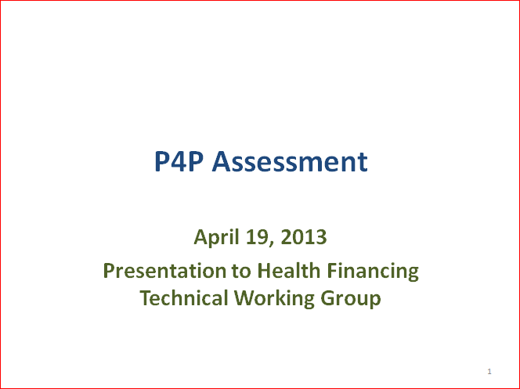
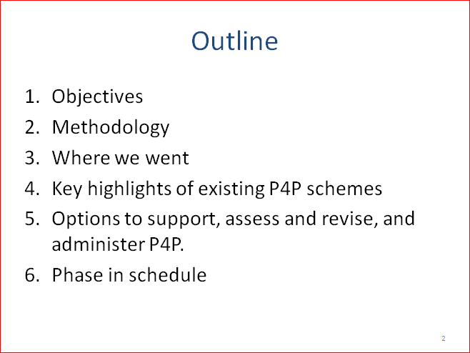
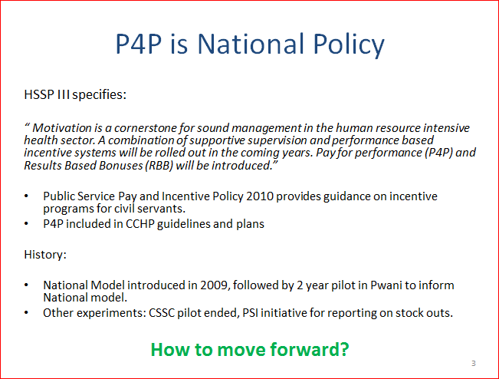

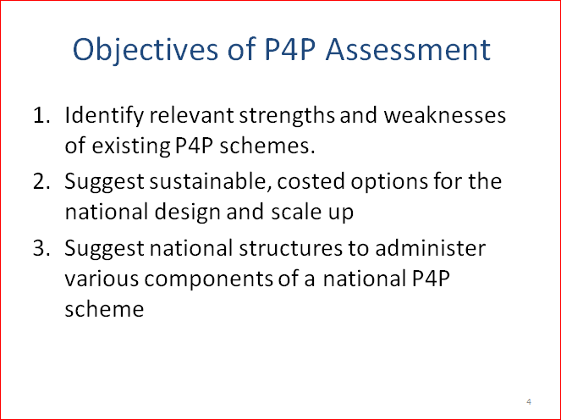
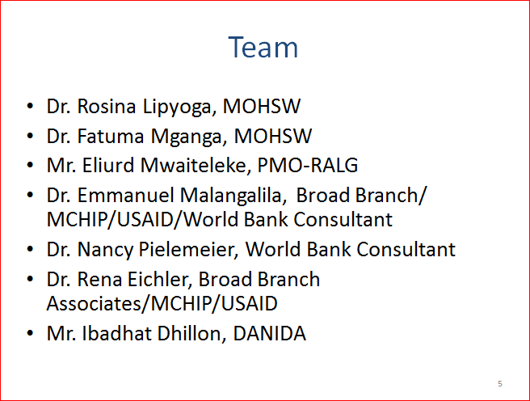
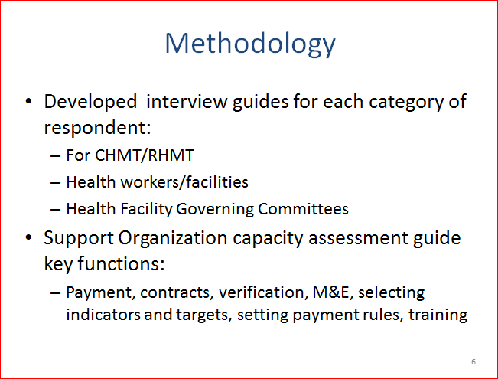
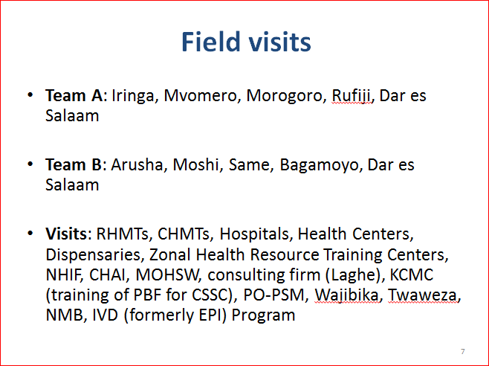
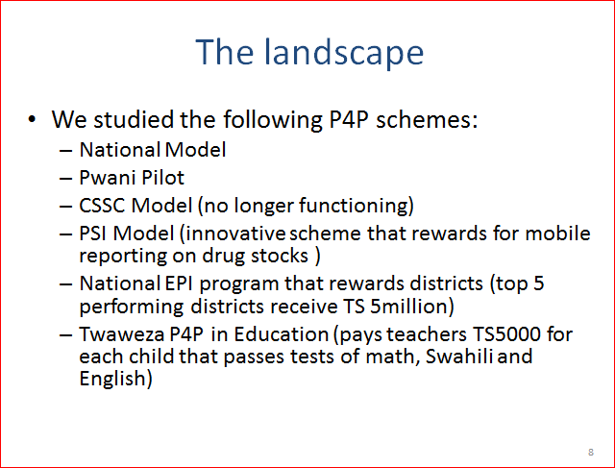
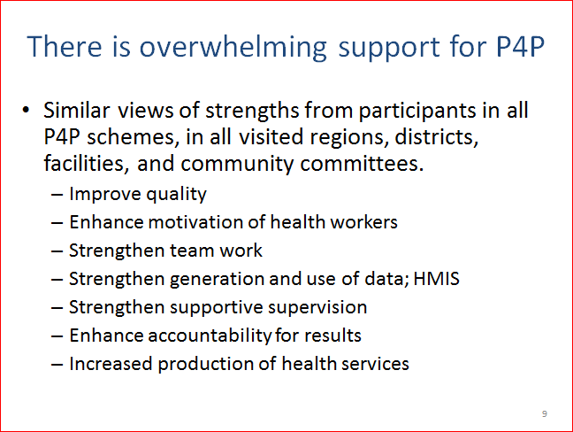
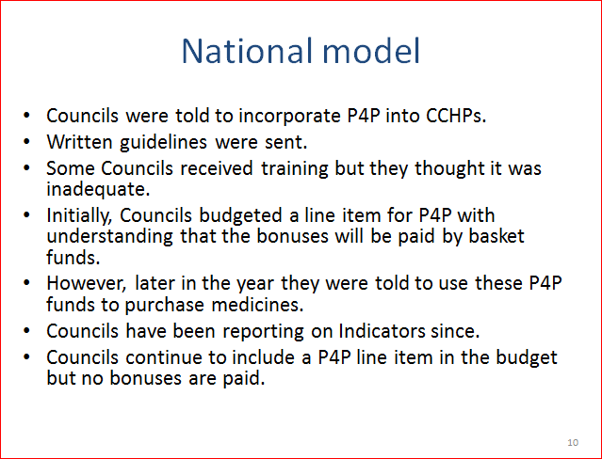
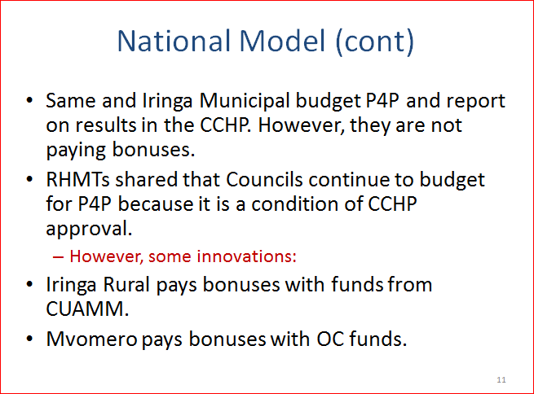
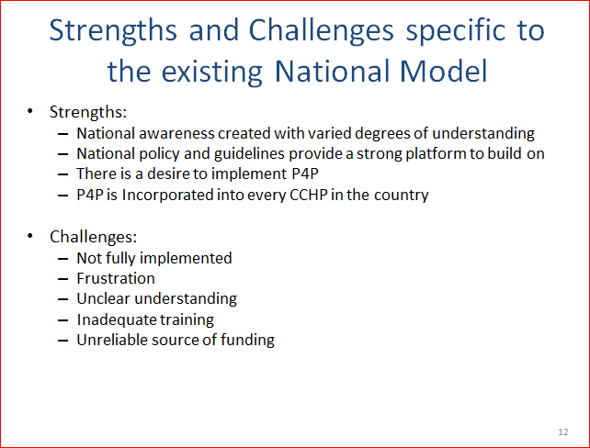
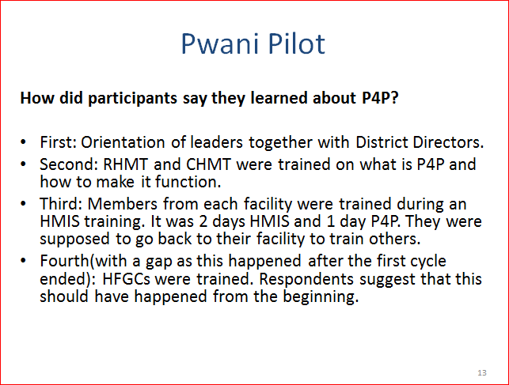
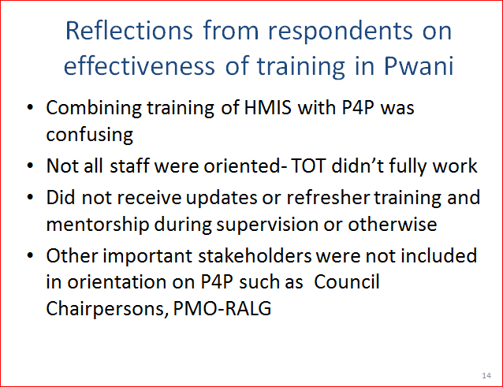
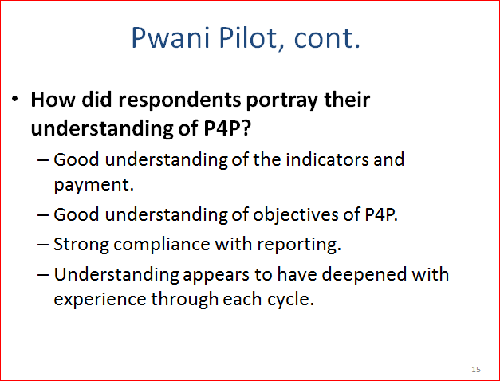
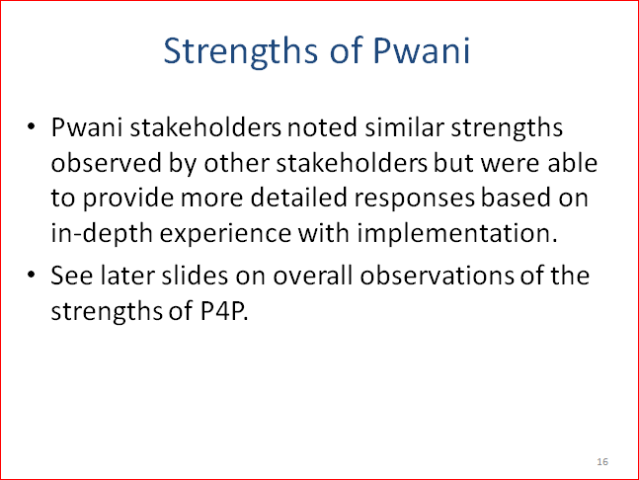
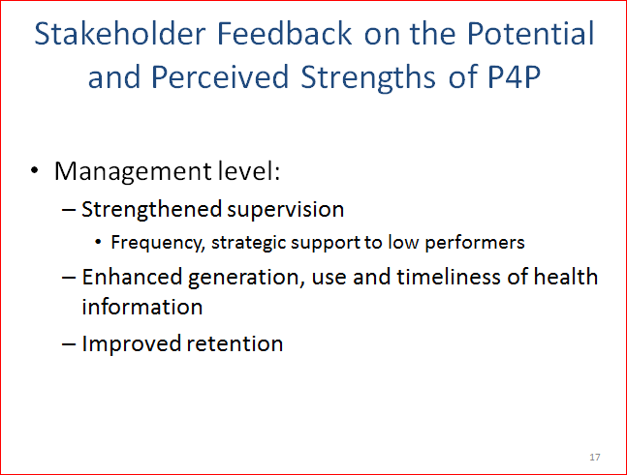
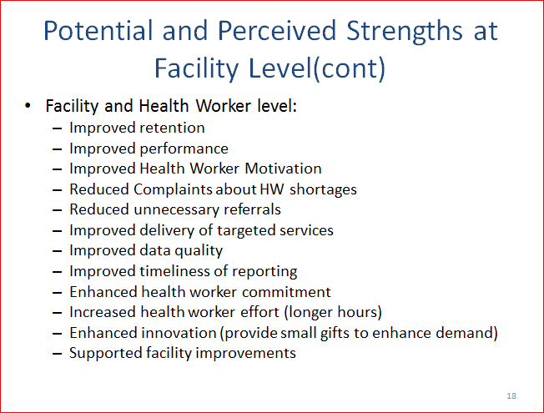
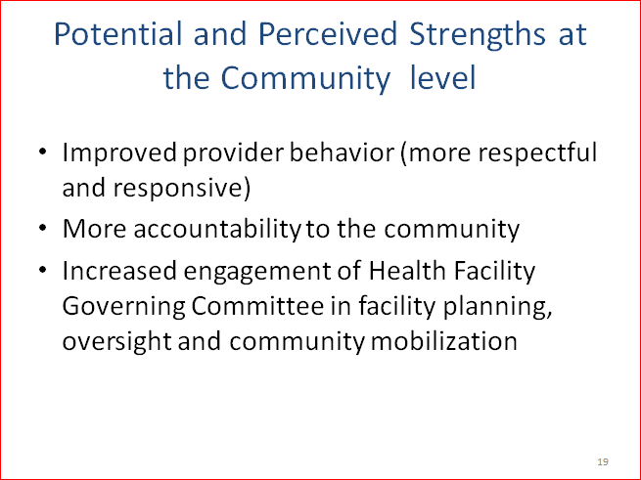
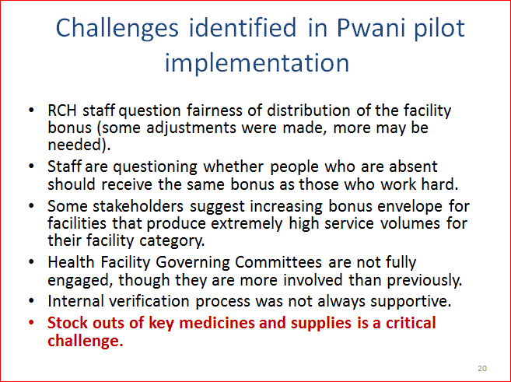
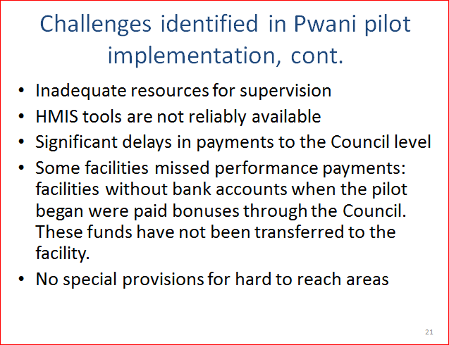
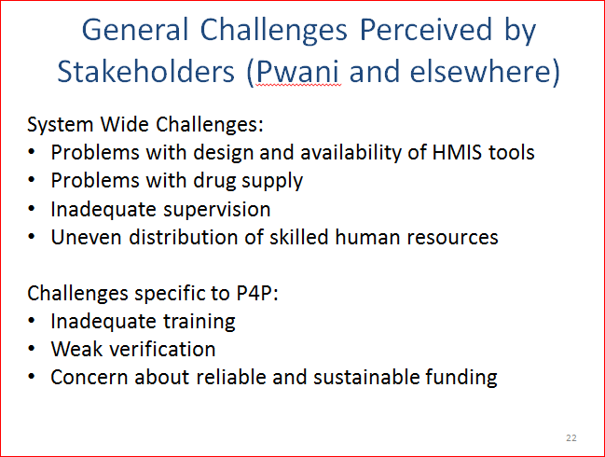
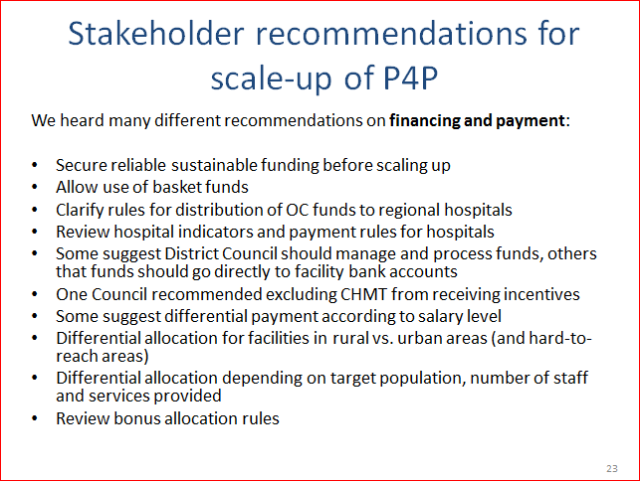
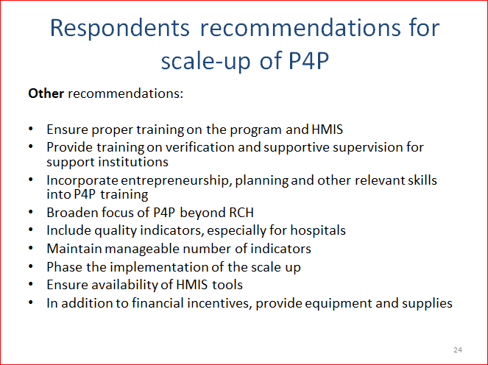
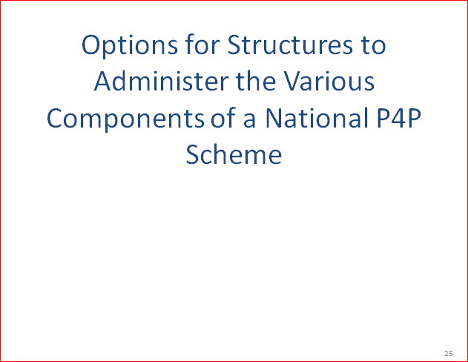
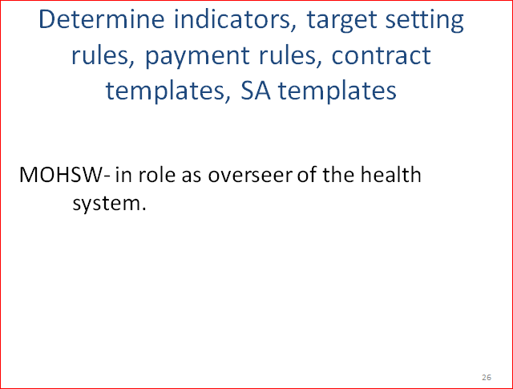
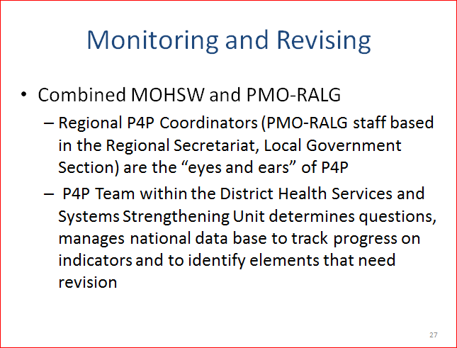
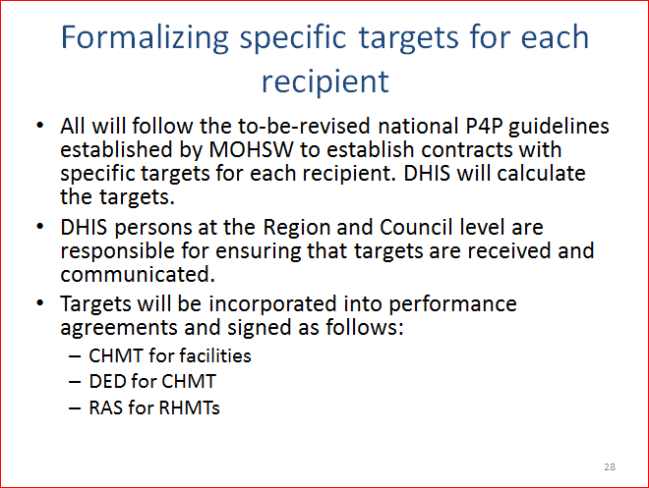
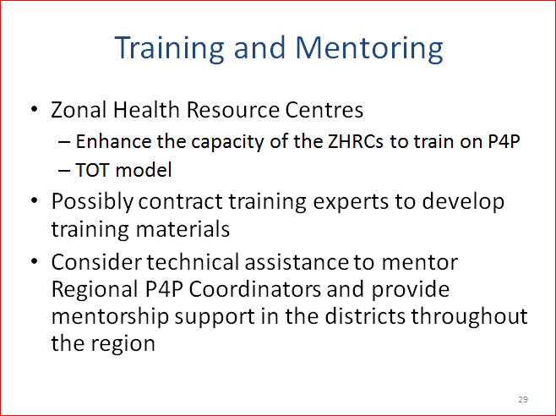
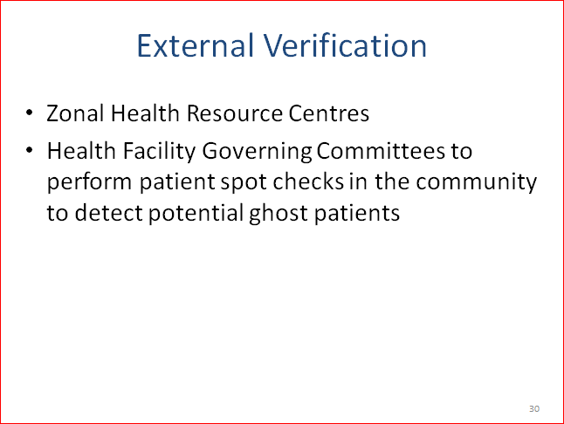
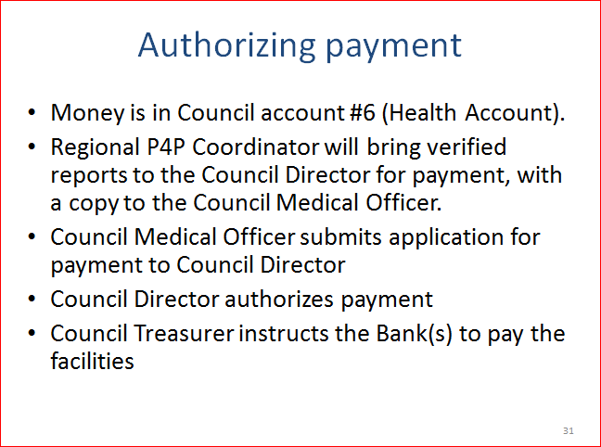
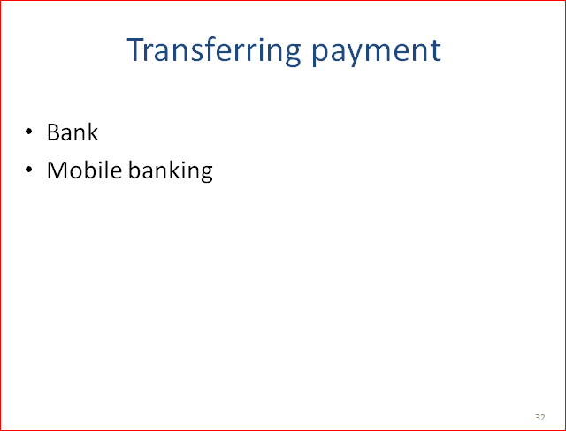
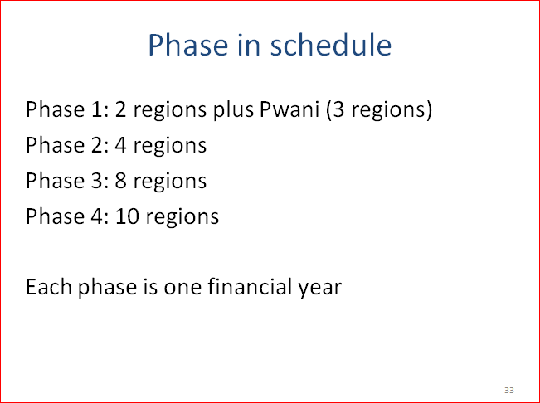
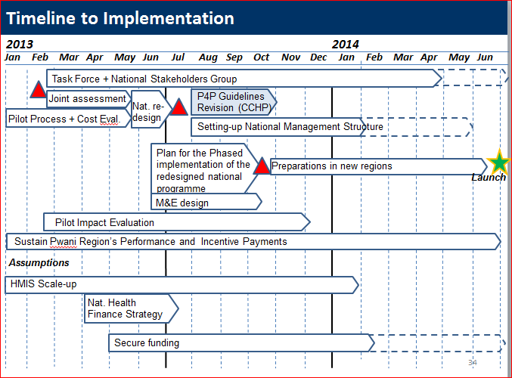


From the Center for Global Development Performance Based Incentives Working Group. See http://www.cgdev.org/section/initiatives/_active/ghprn/workinggroups/performance. Rena Eichler and Ruth Levine, eds., Performance Incentives for Health: Potentials and Pitfalls, Center for Global Development, 2009.
The United Republic of Tanzania: Ministry of Health and Social Welfare, Implementation Guideline: Payment for Performance, Agenda No. 5.2, December 2008.
The United Republic of Tanzania: Ministry of Health and Social Welfare, The Pwani Region Payment for Performance (P4P) Pilot Design Document, July 2011. There is another indicator of No. of ANC clients tested for HIV/ all ANC clients attended in that particular period. This indicator was added for facilities which had no HIV clients on medication.
Borghi, Josephine, Susan Makawia and August Kuwawenaruwa, “The Administrative Costs of Community Health Insurance: A Case Study of the Community Health Fund in Tanzania, (submitted paper that is under review in August 2013)
Kisimbo, Daniel T., Zabron Abel and George Rweyemamu, Pay for Performance- Pwani Region Pilot: Independent Verification for Cycle 3 and Cycle 4, Final Report, July 2013.
Obras Sociales are provincial union-based health insurance organizations.
Martinez, Sebastian, Paul Gertler, and Adam Ross,2010, “Plan Nacer Impact Evaluation Background Report: the case of Misiones and Tucuman.” World Bank, Washington DC.
El-SAharty S., J. Antos, and N. Hafez, 2004, “Egypt’s Health Sector Reform and Financing Review”, The World Bank
Center for Operations Research and Training, April 2007. Assessment of ASHA and Janani Suraksha Yojana in Rajasthan.
WHO http://www.who.int/health_financing/documents/hsfr_e_09-rwanda.pdf
Gertler P. et al., Policy Research Working Paper 5190, Paying Primary Health Care Centers for Performance in Rwanda, 2010
“The Hospital Performance Based Supplementary Payment System in Turkey, a theory driven mixed methods evaluation”, Champagne F et al. December 2011
In Chalinze HC the RCH staff are angry that the funds aren’t used to improve RCH services and that they are not involved in the decisions. They feel that they work hard, achieve the targets, and the bonuses go to everyone and the facility funds are decided through a process that they don’t contribute to.

