Public Financial Management and Health Financing Alignment: Why is this important, and what can we do?
WHAT IS THE ISSUE?
In recent years, many countries have adopted universal health coverage (UHC) as a national policy priority. However, ensuring movement towards UHC will require stable, adequate and flexible financial resources. More funding for health and UHC alone will not achieve sector objectives. For countries, this means not just mobilizing new domestic, private and international resources, or even stretch existing funds to go further. Public budget revenues, and the public financing systems that manage these funding flows have a crucial role to play in directing money efficiently and effectively towards health priorities. But budgeting for health requires more flexibility than other sectors. Health needs are highly variable across populations and geography, and they are difficult to predict from year to year. And the utilization, costs of services, and the clinical quality are influenced greatly by health worker decisions and population choices.
The rules and systems governing the management of public funds can often be at odds with how health financing systems function. Health financing systems need to be able to pool funds for equity and purchase services with incentives for efficiency and quality. This can be challenging in traditional public financing systems designed to finance infrastructure and inputs to public services (e.g. salaries, drugs and other commodities, utilities, supplies, transport). Public Financial Management systems must provide broad rules that govern across sectors, which often pose bottlenecks for the unique needs of health financing but affect other sectors as well particularly related to matching payment to priority services. For instance, countries that budget and pay by input-based line items will have challenges initiating strategic purchasing or output-based payment reforms for health that can increase efficiency and incentivize higher quality service delivery; or pooling resources across multiple streams of fragmented revenue that come from domestic sources, donors including vertical programs. Conversely, health officials may not know about the existing flexibilities that may be leveraged within the budget law and Public Financial Management system, and how to use these to their advantage. Health Financing objectives and Public Financial Management systems need to be well aligned for public funds to be used effectively to achieve common objectives.
WHY IS THIS IMPORTANT?
Despite misalignments, Health and Public Financial Management actors do have the same ultimate goal: Both Health Financing and Public Financial Management systems are in place to make effective use of public funds. In health, this means that funds are spent efficiently and equitably, and used to purchase quality interventions that generate good health.
Fostering alignment between Health Finance and Public Financial Management perspectives is important for a number of reasons (Figure 1).
- For health policy makers - more efficiency spending, increased allocation to priority populations
- For public budget officials - allocation and expenditure is transparent, accountable, maximized
- For providers – flexibility in determining mix and use of funds to provide care better aligned to population need
- For the population - receive access to predictable, quality, affordable services
- For donors - funds are used effectively and accountably, rationale for more on budget funding
- For in-country development partners - vehicle for moving forward feasible policy solutions
FIGURE 1. Alignment Between Budget Cycle/Public Financial Management System and Health Financing Policy
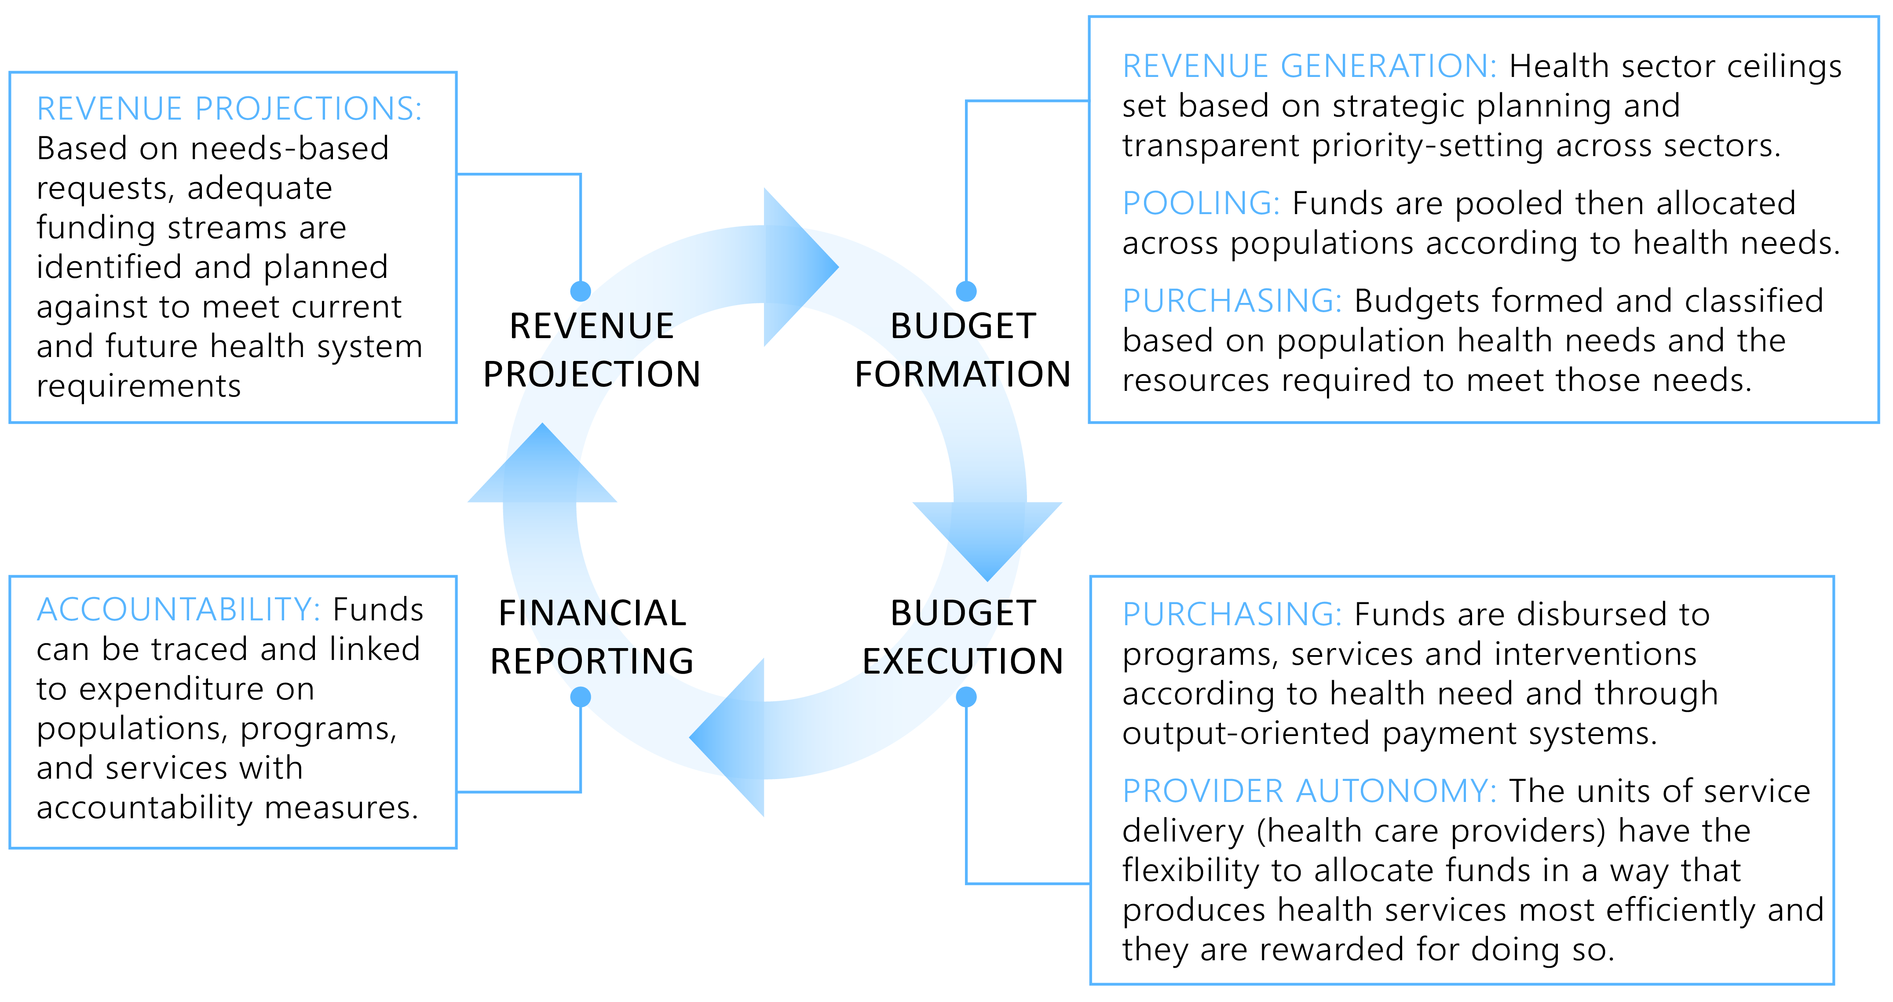
WHAT CAN WE DO?
Improved alignment between the Health Financing and Public Financial Management systems is essential, how can this happen.
- Improve the dialogue between health and finance
- Co-identify opportunities for change
- Take forward a joint agenda in countries that supports mutual goals
To move forward, tools exist that can help to foster this dialogue and achieve joint Public Financial Management and Health Financing objectives. A framework and diagnostic guide has been created to help do three things: 1) gain a better understanding of the health and financing environment in a country and resulting bottlenecks, 2) to create a collaborative roadmap for action that will allow countries to strengthen alignment 3) to have a lasting and constructive impact on dialogue between health and finance officials.
The process guide for alignment between budgeting practices, Public Financial Management systems and Health Financing policy objectives presents a stepwise method for countries to bring together MOH and MOF stakeholders to define the universe of policy objectives, answer specific questions that countries can pick and choose from to identify alignment issues related to bottlenecks around these policy objectives, and provide a way to compare existing issues to benchmarks for good alignment across stages of the budget cycle.
The outcome of the guide is a policy roadmap that defines a way forward to remove bottlenecks. Through a joint process, Health and Finance stakeholders will be able to select priorities that will help to remove bottlenecks towards achieving existing joint policy objectives.

